BodySite Model
Name | BeModelBodySite
Title | BodySite Model
Canonical URL | https://www.ehealth.fgov.be/standards/fhir/core-clinical/StructureDefinition/BeModelBodySite
Version | 1.3.0
Status | active
Parent model | Base
Publisher | eHealth Platform

Body site model

Class diagram
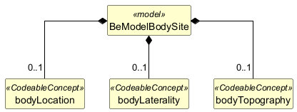

Structure
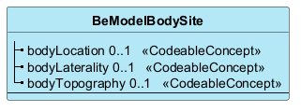

Elements
Element | Card. | Type | Value set | Description
bodyLocation | 0..1 | CodeableConcept |  | Code that identifies the anatomical location of the specimen on the subject's body
bodyLaterality | 0..1 | CodeableConcept |  | The laterality of a body site - the side of the body
bodyTopography | 0..1 | CodeableConcept |  | The topography of the location of the specimen on the subject's body

