Child Report model
Name | BeModelChildReport
Title | Child Report model
Canonical URL | https://www.ehealth.fgov.be/standards/fhir/childreport/StructureDefinition/BeModelChildReport
Version | 1.0.2
Status | active
Parent model | BeModelDocument
Publisher | eHealth Platform

A logical model representing child report data elements.

Class diagram
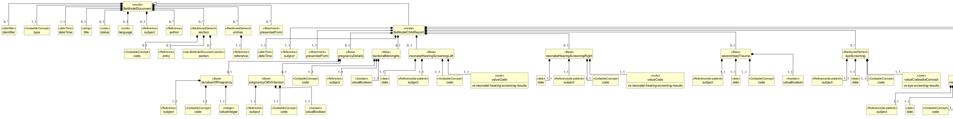

Structure
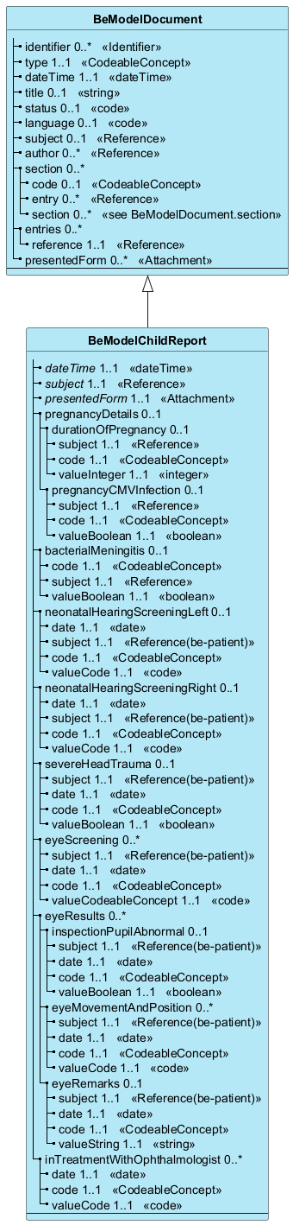

Elements
Element | Card. | Type | Value set | Description
dateTime | 1..1 | dateTime |  | Document date/time
subject | 1..1 | Reference |  | Child that the report is about  Subject
presentedForm | 1..1 | Attachment |  | Child report PDF file  A base64 encoded PDF file with the remaining child report information (biometric data, charts, etc.).
pregnancyDetails | 0..1 |  |  | Pregnancy details  Details about the pregnancy.
durationOfPregnancy | 0..1 |  |  | [BeClinicalObservation] The duration of pregnancy in weeks, as an observation.
subject | 1..1 | Reference |  | Child  subject
code | 1..1 | CodeableConcept |  | Length of gestation at birth
valueInteger | 1..1 | integer |  | The duration of pregnancy in weeks
pregnancyCMVInfection | 0..1 |  |  | [BeClinicalObservation] Pregnancy CMV infection  Indicates whether CMV infection occurred during pregnancy.
subject | 1..1 | Reference |  | Child  subject
code | 1..1 | CodeableConcept |  | CMV infection during pregnancy
valueBoolean | 1..1 | boolean |  | Indicates whether CMV infection occurred during pregnancy.  The value indicates whether the mother had a CMV infection during pregnancy.
bacterialMeningitis | 0..1 |  |  | [BeClinicalObservation] Bacterial meningitis  Indicates whether bacterial meningitis occurred during pregnancy.
code | 1..1 | CodeableConcept |  | Code
subject | 1..1 | Reference |  | Child  subject
valueBoolean | 1..1 | boolean |  | Indicates whether bacterial meningitis occurred during pregnancy.  The value indicates whether the mother had a bacterial meningitis during pregnancy.
neonatalHearingScreeningLeft | 0..1 |  |  | [BeClinicalObservation] Left ear result  Result of neonatal hearing screening for the left ear.
date | 1..1 | date |  | Date of neonatal hearing screening  The date of neonatal hearing screening.
subject | 1..1 | Reference(be-patient) |  | Child that the report is about  The child that the report is about.
code | 1..1 | CodeableConcept |  | Result of neonatal hearing screening - left
valueCode | 1..1 | code | vs-neonatal-hearing-screening-results | Result of neonatal hearing screening (left ear)  Neonatal hearing screening result for the left ear.
neonatalHearingScreeningRight | 0..1 |  |  | [BeClinicalObservation] Right ear result  Result of neonatal hearing screening for the right ear.
date | 1..1 | date |  | Date of neonatal hearing screening  The date of neonatal hearing screening.
subject | 1..1 | Reference(be-patient) |  | Child that the report is about  The child that the report is about.
code | 1..1 | CodeableConcept |  | Result of neonatal hearing screening - right
valueCode | 1..1 | code | vs-neonatal-hearing-screening-results | Result of neonatal hearing screening (right ear)  Neonatal hearing screening result for the right ear.
severeHeadTrauma | 0..1 |  |  | [BeProblem] Severe head trauma  Indicates whether severe head trauma was identified.
subject | 1..1 | Reference(be-patient) |  | Child that the report is about  The child that the report is about.
date | 1..1 | date |  | Date of reporting the trauma.
code | 1..1 | CodeableConcept |  | Code
valueBoolean | 1..1 | boolean |  | Indicates whether severe head trauma was identified.  The value indicates whether severe head trauma was identified in the child.
eyeScreening | 0..* |  |  | [BeClinicalObservation] Eye screening  Details about the eye screening.
subject | 1..1 | Reference(be-patient) |  | Child that the report is about  The child that the report is about.
date | 1..1 | date |  | Date of eye screening  The date of eye screening.
code | 1..1 | CodeableConcept |  | Code
valueCodeableConcept | 1..1 | code | vs-eye-screening-results | Result of eye screening  Result of eye screening.
eyeResults | 0..* |  |  | Eye  Details about the eyes.
inspectionPupilAbnormal | 0..1 |  |  | [BeClinicalObservation] Inspection pupil abnormal  Details about the inspection of the pupil.
subject | 1..1 | Reference(be-patient) |  | Child that the report is about  The child that the report is about.
date | 1..1 | date |  | Date of abnormal pupil inspection finding  Date of abnormal pupil inspection finding.
code | 1..1 | CodeableConcept |  | Inspection pupil abnormal
valueBoolean | 1..1 | boolean |  | Inspection pupil abnormal
eyeMovementAndPosition | 0..* |  |  | [BeClinicalObservation] Findings about the eye movement and position
subject | 1..1 | Reference(be-patient) |  | Child that the report is about  The child that the report is about.
date | 1..1 | date |  | Date of eye movement and position results  The date of eye movement and position results.
code | 1..1 | CodeableConcept |  | Code
valueCode | 1..1 | code | vs-eye-movement-and-position | Result of testing eye movement and position  Result of testing eye movement and position.
eyeRemarks | 0..1 |  |  | [BeClinicalObservation] Eye remarks  Free text remarks about the eyes.
subject | 1..1 | Reference(be-patient) |  | Child that the report is about  The child that the report is about.
date | 1..1 | date |  | Date of eye remarks  The date of eye remarks.
code | 1..1 | CodeableConcept |  | Eye remark
valueString | 1..1 | string |  | Eye remarks
inTreatmentWithOphthalmologist | 0..* |  |  | [BeClinicalObservation] In treatment with ophthalmologist  Details about treatment with an ophthalmologist.
date | 1..1 | date |  | Date of remarks about treatment with ophthalmologist.
code | 1..1 | CodeableConcept |  | Code
valueCode | 1..1 | code | vs-ophthalmologist-treatments | Treatment with ophthalmologist  Treatment with ophthalmologist.

Inherited from BeModelDocument
Element | Card. | Type | Value set | Description
identifier | 0..* | Identifier |  | Document identifier
type | 1..1 | CodeableConcept |  | Document type
dateTime | 1..1 | dateTime |  | Document date/time
title | 0..1 | string |  | Title
status | 0..1 | code |  | Status
language | 0..1 | code |  | Language
subject | 0..1 | Reference |  | Subject
author | 0..* | Reference |  | Author(s)
section | 0..* |  |  | Document content sections
code | 0..1 | CodeableConcept |  | Section classification
entry | 0..* | Reference |  | Referenced resources  FHIR references to CareSets, e.g. CarePlan/1, Observation/2
section | 0..* | see BeModelDocument.section |  | Child sections
entries | 0..* |  |  | Entries (CareSets) in the document
reference | 1..1 | Reference |  | FHIR reference (e.g., CarePlan/1, Observation/2)
presentedForm | 0..* | Attachment |  | A narrative easy-to-read representation of the full data set, e.g. PDF-version of a document

