BE Model ClinicalReport
Name | BeModelClinicalReport
Title | BE Model ClinicalReport
Canonical URL | https://www.ehealth.fgov.be/standards/fhir/patient-dossier/StructureDefinition/BeModelClinicalReport
Version | 1.0.0
Status | draft
Parent model | Base
Publisher | eHealth Platform

Logical model of the CareSet ClinicalReport: a clinical report that collects the essential information for the follow-up of a patient over a defined period, consolidates the referenced clinical observations, reports and documents around a well-defined medical context, and may carry a clinical interpretation. It is intended to be shared between health professionals.

Class diagram

Structure
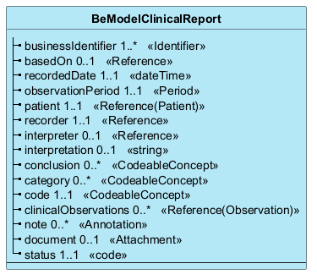

Elements
Element | Card. | Type | Value set | Description
businessIdentifier | 1..* | Identifier |  | Business identifier of the report  Business identifier of the report.
basedOn | 0..1 | Reference |  | Reference to the request underlying the report  Reference to the request that is the basis of the report. E.g. a referral prescription (telemonitoring).
recordedDate | 1..1 | dateTime |  | Date the report was recorded / last updated  Date of the last (functional) update of the report.
observationPeriod | 1..1 | Period |  | Period the report covers  From-date to-date corresponding to the period the report covers.
patient | 1..1 | Reference(Patient) |  | The patient the report is about  The person who is the subject of the healthcare the record (CareSet) refers to. See BR PP 'Identification of a physical person'.
recorder | 1..1 | Reference |  | Who recorded the report  The health professional or organisation that records the information and takes responsibility for its content. See BR PP 'Identification of a physical person'.
interpreter | 0..1 | Reference |  | Who interprets the observations of the report  The care provider who interprets the observations of the report. E.g. endocrinologist, general practitioner. See BR PP 'Identification of a physical person'.
interpretation | 0..1 | string |  | Textual interpretation of the observations and/or the thought process that leads to a conclusion
conclusion | 0..* | CodeableConcept |  | Clinical conclusion (interpretation) of the results  Clinical conclusion (interpretation) of the test results, expressed as a code or as free text. This element is provided by the care provider who performs the interpretation. See BR RIN.
category | 0..* | CodeableConcept | be-vs-clinicalreport-category | Clinical/functional classification of the report  A category is a classification attribute of a data element in a CareSet, defined by a standardised ValueSet, allowing information to be grouped according to its clinical or functional meaning. E.g. Glucose monitoring, Cardiology. See VS_Rep_Category.
code | 1..1 | CodeableConcept | be-vs-clinicalreport-code | Code of the report  Code of the report. It indicates the type of procedure that leads to the production of the primary values (measurement clinical observations) of this report. See VS_Rep_Code.
clinicalObservations | 0..* | Reference(Observation) |  | Referenced clinical observations  List of references to the different ClinicalObservations that are part of the report.
note | 0..* | Annotation |  | Free-text additional information  Additional information about the content of the CareSet, in free text format.
document | 0..1 | Attachment |  | PDF document of the complete report  PDF document containing the complete report (text, graphics, derived observations, conclusions, ...).
status | 1..1 | code | diagnostic-report-status | Status of the report  Status of the report. The default is 'final' (Final report). See VS_Status.

