Medication (model)
Name | BeModelMedication
Title | Medication (model)
Canonical URL | https://www.ehealth.fgov.be/standards/fhir/medication/StructureDefinition/BeModelMedication
Version | 1.1.1
Status | active
Parent model | Base
Publisher | eHealth Platform

Logical data model for medication.

Class diagram
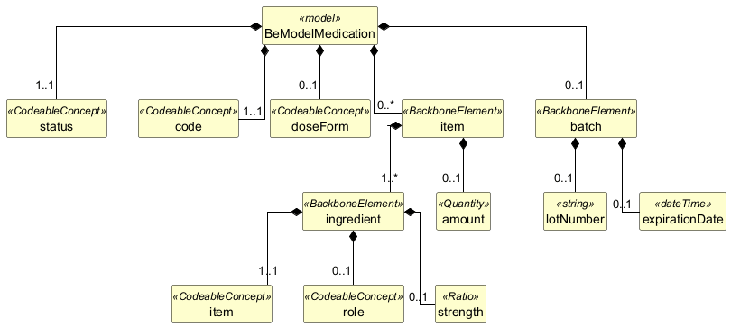

Structure
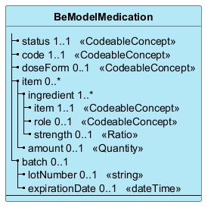

Elements
Element | Card. | Type | Value set | Description
status | 1..1 | CodeableConcept |  | Status of the medication (active, inactive, etc.)
code | 1..1 | CodeableConcept |  | Code for the medication that is actually being specified. This can be a product code, a virtual product code, or a package code.
doseForm | 0..1 | CodeableConcept |  | Dose form(s) on a product level. Dose form for a single package item is defined below.
item | 0..* |  |  | A medication item. For combination packs, this can be manufactured items with each item having its own dose form and ingredients+strengths defined
ingredient | 1..* |  |  | Ingredients
item | 1..1 | CodeableConcept |  | Substance or product that is ingredient
role | 0..1 | CodeableConcept |  | Role (active ingredient, excipient). Typically excipients are not needed, so by default active ingredients are expected.
strength | 0..1 | Ratio |  | Concentration or presentation strength of the precise active ingredient
amount | 0..1 | Quantity |  | Number of such manufactured items in this product (5 vials)
batch | 0..1 |  |  | Batch or production information for the product
lotNumber | 0..1 | string |  | Batch number
expirationDate | 0..1 | dateTime |  | Expiry date

