Medication Dispense (model)
Name | BeModelMedicationDispense
Title | Medication Dispense (model)
Canonical URL | https://www.ehealth.fgov.be/standards/fhir/medication/StructureDefinition/BeModelMedicationDispense
Version | 1.1.1
Status | active
Parent model | Base
Publisher | eHealth Platform

This is the logical model for the Dispense Record entry - the information that can be captured upon the act of dispensing - in a hospital pharmacy, or a community pharmacy. This is not for a future dispense, rather a record of an actual dispense.

Class diagram
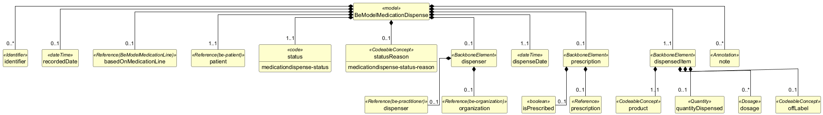

Structure
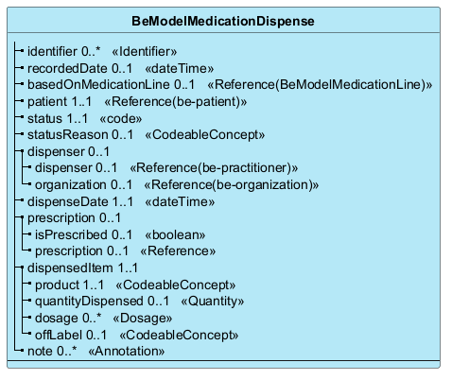

Elements
Element | Card. | Type | Value set | Description
identifier | 0..* | Identifier |  | The business identifier(s) for the medication dispense record  The business identifier(s) for the medication dispense session, also known as Session GUID (SGUID).
recordedDate | 0..1 | dateTime |  | The date (or date+time) when the dispense was recorded
basedOnMedicationLine | 0..1 | Reference(BeModelMedicationLine) |  | The medication line that this dispense is related to
patient | 1..1 | Reference(be-patient) |  | The person for which the medication is dispensed  The person for which the medication is dispensed.
status | 1..1 | code | medicationdispense-status | The status of the dispense record
statusReason | 0..1 | CodeableConcept | medicationdispense-status-reason | The reason why the dispense was not performed, if it was not performed
dispenser | 0..1 |  |  | The dispenser, if known and relevant
dispenser | 0..1 | Reference(be-practitioner) |  | Reference to person that performed the recording or reporting
organization | 0..1 | Reference(be-organization) |  | Reference to person that performed the recording or reporting
dispenseDate | 1..1 | dateTime |  | The date (or date+time) when the dispense ocurred
prescription | 0..1 |  |  | Information about a prescription related to the dispense
isPrescribed | 0..1 | boolean |  | Whether this dispense was performed against a prescription
prescription | 0..1 | Reference |  | The prescription identification
dispensedItem | 1..1 |  |  | Each product that was dispensed
product | 1..1 | CodeableConcept |  | The product that was dispensed - coded or not (e.g. for magistral preparations)
quantityDispensed | 0..1 | Quantity |  | The amount of product that was dispensed
dosage | 0..* | Dosage |  | The structured dosage or text instructions for use
offLabel | 0..1 | CodeableConcept |  | Text or coded reason for different dosage
note | 0..* | Annotation |  | Additional information about the dispense - this can be relevant history, any remarks by the patient or professional, etc.

