BeModelTask
Name | BeModelTask
Title | BeModelTask
Canonical URL | https://www.ehealth.fgov.be/standards/fhir/patient-care/StructureDefinition/BeModelTask
Version | 1.1.0
Status | active
Parent model | Base
Publisher | eHealth Platform

Logical model for Task.

Class diagram
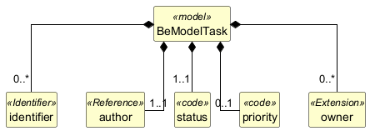

Structure
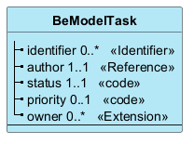

Elements
Element | Card. | Type | Value set | Description
identifier | 0..* | Identifier |  | Business identifiers of the task
author | 1..1 | Reference |  | Author of the task
status | 1..1 | code |  | Status of the task
priority | 0..1 | code |  | Priority of the task
owner | 0..* | Extension |  | Owners of the task (can be individuals or teams)

