PSS Consent
Name | PSSConsentModel
Title | PSS Consent
Canonical URL | https://www.ehealth.fgov.be/standards/fhir/pss/StructureDefinition/PSSConsentModel
Version | 1.1.0
Status | active
Parent model | Base
Publisher | eHealth Platform

Consent statement about using PSS and agreeing with (or opting out of) the Terms and Conditions.

Class diagram
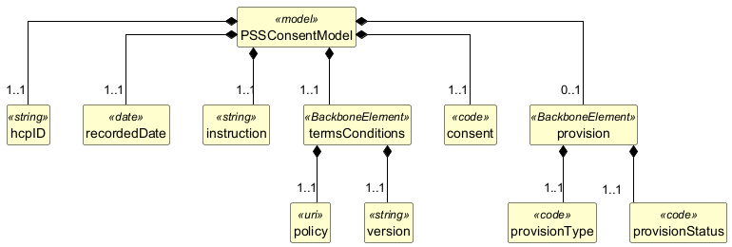

Structure
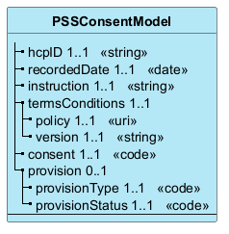

Elements
Element | Card. | Type | Value set | Description
hcpID | 1..1 | string |  | The anonymised ID of the healthcare professional
recordedDate | 1..1 | date |  | Date on which the information was recorded
instruction | 1..1 | string |  | The instruction to the HCP
termsConditions | 1..1 |  |  | Terms and Conditions
policy | 1..1 | uri |  | Link to the Terms and Conditions
version | 1..1 | string |  | Version of the Terms and Conditions
consent | 1..1 | code |  | accepted, rejected
provision | 0..1 |  |  | Provision of the consent
provisionType | 1..1 | code |  | opt-in, opt-out
provisionStatus | 1..1 | code |  | accepted, rejected

