PSS Request
Name | PSSRequest
Title | PSS Request
Canonical URL | https://www.ehealth.fgov.be/standards/fhir/pss/StructureDefinition/PSSRequest
Version | 1.1.0
Status | active
Parent model | Base
Publisher | eHealth Platform

Request for PSS (Prescriber Support System) results.

Class diagram
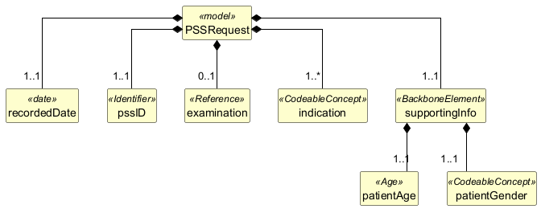

Structure
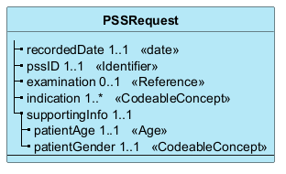

Elements
Element | Card. | Type | Value set | Description
recordedDate | 1..1 | date |  | Date on which the information was recorded
pssID | 1..1 | Identifier |  | Identifier of the exchange session
examination | 0..1 | Reference |  | The ID of the examination the prescriber wants to prescribe
indication | 1..* | CodeableConcept |  | Indication that triggers the PSS request, from structured list or free text
supportingInfo | 1..1 |  |  | Information useful for PSS proposals
patientAge | 1..1 | Age |  | Age of the patient
patientGender | 1..1 | CodeableConcept |  | Gender of the patient

