Allergy Intolerance Logical Model
Name | BeModelAllergyIntolerance
Title | Allergy Intolerance Logical Model
Canonical URL | https://www.ehealth.fgov.be/standards/fhir/allergy/StructureDefinition/be-model-allergyintolerance
Version | 1.2.1
Status | active
Parent model | Element
Publisher | eHealth Platform

Allergy / Intolerance information model

Class diagram
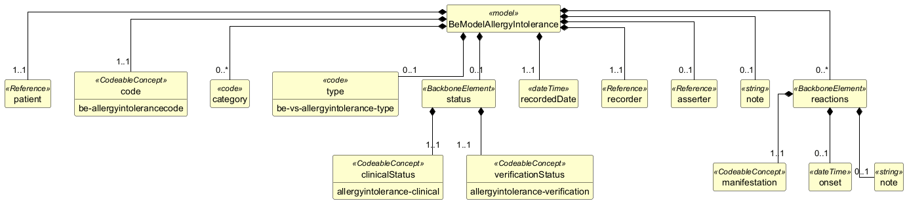

Structure
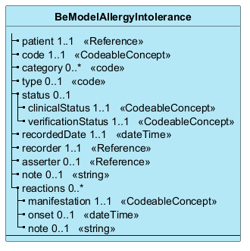

Elements
Element | Card. | Type | Value set | Description
patient | 1..1 | Reference |  | The person that has the allergy
code | 1..1 | CodeableConcept | be-allergyintolerancecode | The substance that the person is allergic to  The substance - from a lst of substances - that the person is allergic to. It is possible to use free text but for the products indicated, a code must be used
category | 0..* | code |  | The category of the risk (food, medication, environment, biological,...). This information will not be encoded by the Recorder but can automatically be added using the SNOMED-CT code from causative agent
type | 0..1 | code | be-vs-allergyintolerance-type | The Type - whether it is an allergy or intolerance  the type of risk (allergy, intolerance...). When it is not possible to distinguish between a real allergy, a non-allergic hypersensitivity or an intolerance you can use the 'Intolerance' type, but code the VerificationStatus as 'Unconfirmed'
status | 0..1 |  |  | The status of the allergy
clinicalStatus | 1..1 | CodeableConcept | allergyintolerance-clinical | The status of the allergy - if it is active or resolved
verificationStatus | 1..1 | CodeableConcept | allergyintolerance-verification | The verification status of the allergy - if it is confirmed or suspected or refuted
recordedDate | 1..1 | dateTime |  | when the allergy/intolerance was recorded
recorder | 1..1 | Reference |  | Who recorded the allergy
asserter | 0..1 | Reference |  | Who asserted the allergy  Is the person at the source of the information (eg the patient, the general practitioner, a family member, the healthcare professional who registers the information himself, ...). He is represented as much as possible by a unique identification number, namely the national register number (INSZ) or the BIS number. However, when it comes to a parent or family member, only the role (e.g. father, mother, neighbor, caregiver, friend, etc.) is coded to meet the requirements of the GDPR.
note | 0..1 | string |  | Additional text note about the allergy or intolerance
reactions | 0..* |  |  | known past reactions to the allergen
manifestation | 1..1 | CodeableConcept |  | How the reaction manifested itself  How the reaction manifested itself, e.g. rash, breathing difficulty...
onset | 0..1 | dateTime |  | Manifestation date  For each manifestation it is possible to specify an actual date or approximate date (age, period, interval, ...) of each suspected manifestation of the risk
note | 0..1 | string |  | Additional text note about the allergic reaction

