PSS Feedback
Name | PSSFeedbackModel
Title | PSS Feedback
Canonical URL | https://www.ehealth.fgov.be/standards/fhir/pss/StructureDefinition/PSSFeedbackModel
Version | 1.1.0
Status | active
Parent model | Base
Publisher | eHealth Platform

Feedback containing the acceptance of the PSS results.

Class diagram
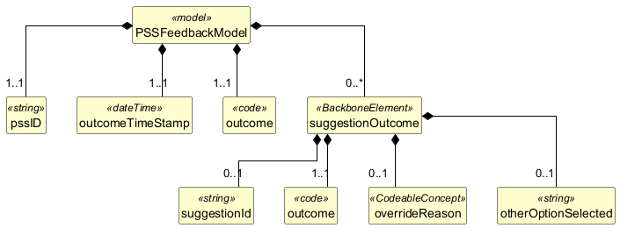

Structure
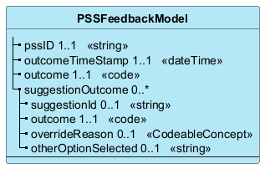

Elements
Element | Card. | Type | Value set | Description
pssID | 1..1 | string |  | The uuid from the response - the ID of the RequestGroup
outcomeTimeStamp | 1..1 | dateTime |  | The time when the feedback is given
outcome | 1..1 | code |  | accepted, rejected, overridden
suggestionOutcome | 0..* |  |  | List of suggestions provided by PSS for which feedback is given
suggestionId | 0..1 | string |  | The suggestion ID - or 'other' if the prescriber preferred another option
outcome | 1..1 | code |  | accepted or overridden
overrideReason | 0..1 | CodeableConcept |  | The reason for overriding - code or text
otherOptionSelected | 0..1 | string |  | A brief description of another option selected by the prescriber. Only present if the suggestionId is 'other'.

