BeModelGoal
Name | BeModelGoal
Title | BeModelGoal
Canonical URL | https://www.ehealth.fgov.be/standards/fhir/patient-care/StructureDefinition/BeModelGoal
Version | 1.1.0
Status | active
Parent model | Base
Publisher | eHealth Platform

Logical model for Goal.

Class diagram
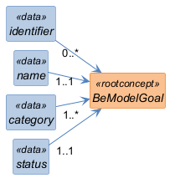

Structure
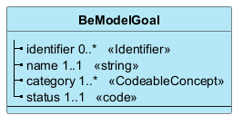

Elements
Element | Card. | Type | Value set | Description
identifier | 0..* | Identifier |  | Identifiers assigned to this goal
name | 1..1 | string |  | Human-readable name for the goal
category | 1..* | CodeableConcept |  | Category of goal
status | 1..1 | code |  | Status of the goal

