Medication prescription (model)
Name | BeModelMedicationPrescription
Title | Medication prescription (model)
Canonical URL | https://www.ehealth.fgov.be/standards/fhir/medication/StructureDefinition/BeModelMedicationPrescription
Version | 1.1.1
Status | active
Parent model | Base
Publisher | eHealth Platform

Logical model for medication prescription (or some other form of order)

Class diagram
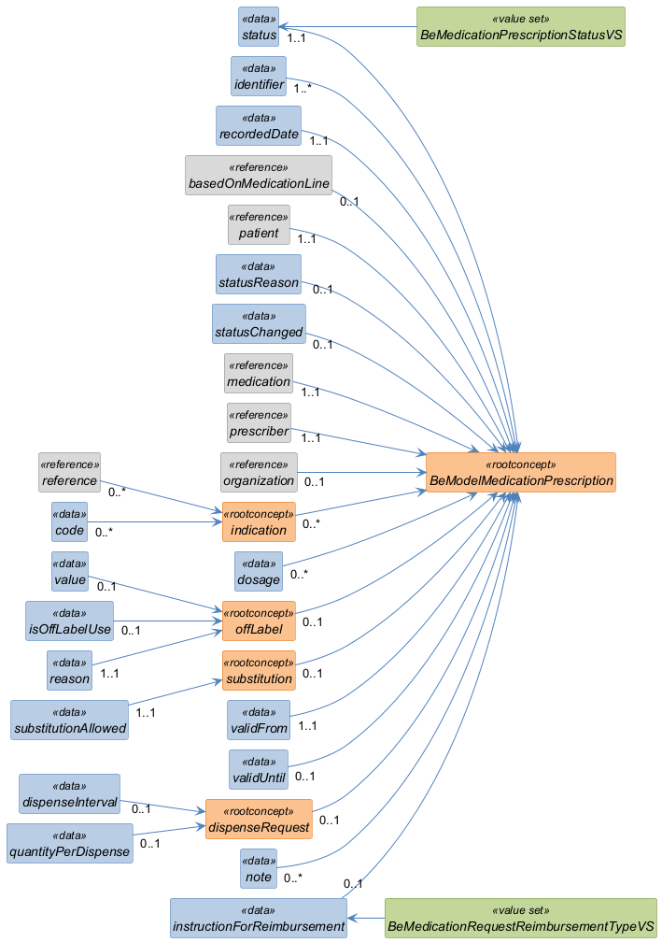

Structure
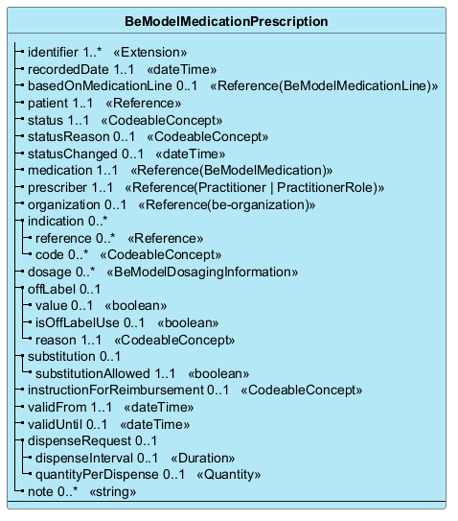

Elements
Element | Card. | Type | Value set | Description
identifier | 1..* | Extension |  | Business identifier(s) for the prescription
recordedDate | 1..1 | dateTime |  | Time of authoring the prescription/draft in the information system
basedOnMedicationLine | 0..1 | Reference(BeModelMedicationLine) |  | Link to the Medication Line from which this request is based
patient | 1..1 | Reference |  | The person for whom the medication is prescribed/ordered
status | 1..1 | CodeableConcept | BeMedicationPrescriptionStatusVS | Status of the prescription, this should not be status of treatment
statusReason | 0..1 | CodeableConcept |  | Reason for the current status of prescription, for example the reason why the prescription was made invalid
statusChanged | 0..1 | dateTime |  | Date and time when the status of the prescription was changed
medication | 1..1 | Reference(BeModelMedication) |  | Prescribed product, branded, generic, virtual, extemporaneous, etc
prescriber | 1..1 | Reference(Practitioner | PractitionerRole) |  | The person who made the prescription, and who takes the responsibility of the treatment  Question: would we want to add basic Practicioner model?
organization | 0..1 | Reference(be-organization) |  | The organization from which the prescriber issues the prescription.
indication | 0..* |  |  | Reason for the prescription (typically diagnosis, or a procedure)
reference | 0..* | Reference |  | Reason for the prescription (typically diagnosis, or a procedure)
code | 0..* | CodeableConcept |  | Reason or text for the prescription (typically diagnosis, or a procedure)
dosage | 0..* | BeModelDosagingInformation |  | Dosaging and administration instructions
offLabel | 0..1 |  |  | Off-Label / Dosage Override
value | 0..1 | boolean |  | Primitive value for boolean  The actual value
isOffLabelUse | 0..1 | boolean |  | Off-Label / Dosage Override
reason | 1..1 | CodeableConcept |  | Dosage Override reason
substitution | 0..1 |  |  | Whether substitution is allowed, and reason
substitutionAllowed | 1..1 | boolean |  | Substitution of the product is allowed.
instructionForReimbursement | 0..1 | CodeableConcept | BeMedicationRequestReimbursementTypeVS | Instructions for reimbursement
validFrom | 1..1 | dateTime |  | Effective date of the prescription. The prescription is not dispensable before this date. In most cases this information repeats issueDate
validUntil | 0..1 | dateTime |  | The validity period end date. The prescription is not dispensable after this date.
dispenseRequest | 0..1 |  |  | Dispense Request or authorization for the prescribed medication
dispenseInterval | 0..1 | Duration |  | Minimum period of time between dispenses
quantityPerDispense | 0..1 | Quantity |  | Amount of medication to supply per dispense
note | 0..* | string |  | Additional information or comments

