BeModelPatient
Name | BeModelPatient
Title | BeModelPatient
Canonical URL | https://www.ehealth.fgov.be/standards/fhir/core/StructureDefinition/BeModelPatient
Version | 2.2.0
Status | active
Parent model | Base
Publisher | eHealth Platform

Data about a patient, according to the [National Register of Persons (Ministry of the Interior)](https://www.ibz.rrn.fgov.be/fileadmin/user_upload/nl/rr/bestand-rr/bestand-RR.pdf), and possibly other sources to be mentioned when used.

Class diagram
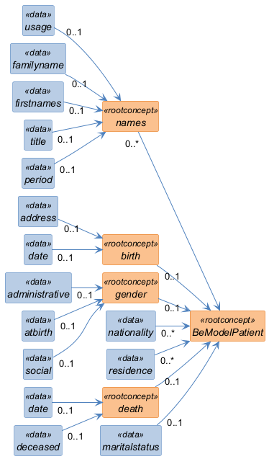

Structure
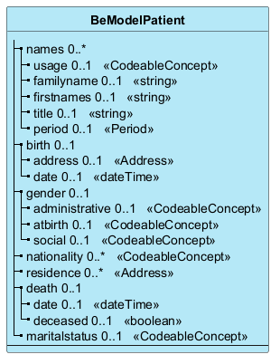

Elements
Element | Card. | Type | Value set | Description
names | 0..* |  |  | Names
usage | 0..1 | CodeableConcept |  | Usage context of the name (e.g. NR 11, if the name is used as a pseudonym)
familyname | 0..1 | string |  | Surname (NR 10)
firstnames | 0..1 | string |  | Given names (NR 10)
title | 0..1 | string |  | Title of nobility (NR 12)
period | 0..1 | Period |  | Period of validity of the name (e.g. NR 13 Change of name, first names and title of nobility)
birth | 0..1 |  |  | Birth data
address | 0..1 | Address |  | Place of birth (NR 100 or NR 101)
date | 0..1 | dateTime |  | Date of birth (NR 100 or NR 101)
gender | 0..1 |  |  | Gender
administrative | 0..1 | CodeableConcept |  | Gender (integrated in the identification no.: 000)
atbirth | 0..1 | CodeableConcept |  | Gender at birth, accounts for gender changes and errors (NR 2 and NR 4)
social | 0..1 | CodeableConcept |  | Gender the person identifies with
nationality | 0..* | CodeableConcept |  | Current nationality (and dual nationality) (NR 31, NR 32)
residence | 0..* | Address |  | Main and other residences (NR 1, 3, 5, 18, 19, 20,22, 23, 24, 26, 27). NR 252 will be covered by other privacy rules.
death | 0..1 |  |  | Date and state of death (place of death is not clinically relevant, and we only care about factual death, not absence (NR 151) or administrative/judicial death (NR 150))
date | 0..1 | dateTime |  | Date of death
deceased | 0..1 | boolean |  | The person is deceased
maritalstatus | 0..1 | CodeableConcept |  | Marital Status

