BeModelTreatmentStatus
Name | BeModelTreatmentStatus
Title | BeModelTreatmentStatus
Canonical URL | https://www.ehealth.fgov.be/standards/fhir/drp/StructureDefinition/BeModelTreatmentStatus
Version | 1.1.1
Status | active
Parent model | Base
Publisher | eHealth Platform

Logical model with the information for the status of the treatment.

Class diagram
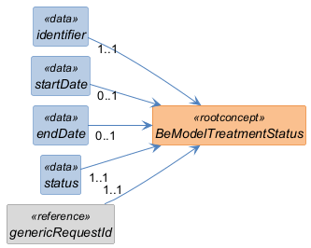

Structure
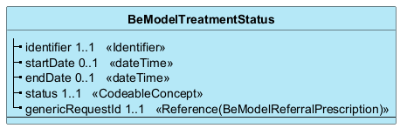

Elements
Element | Card. | Type | Value set | Description
identifier | 1..1 | Identifier |  | UUID (see Doc: https://docs.google.com/document/d/13qamEPfdQ2HgUiXmjwHQNchpEU3LsQHF5MN9jKufX2g/edit?usp=sharing ) Absent during creation by client software, otherwise always present.
startDate | 0..1 | dateTime |  | Start date of processing
endDate | 0..1 | dateTime |  | End date of processing
status | 1..1 | CodeableConcept |  | Status of the task
genericRequestId | 1..1 | Reference(BeModelReferralPrescription) |  | Reference to the associated referral prescription

