**Tutoring Center**

**Software Requirements Specification**

**CEN 3031 Fall 2018**

**Modification history:**

|  |  |  |  |
| --- | --- | --- | --- |
| Version | Date | Who | Comment |
| v1.0 | 10/13/2018 | Martin Marks,Hunter Danielson, Brian Withrow, Tomas Vergara,Carlos Reyes | Templates for each page that will be implemented in the project. Visual implementations are all present but the back end functionality is not implemented. |
| v2.0 | 11/19/2018 | Brian Withrow, Hunter Danielson | Back end functionality finishing touches, scrapping calendar GUI in favor of providing dates and times of events exclusively.  Requirements changed: 1, 3, 4, 5, 7, 8, 9, 13, 16, 17, 19, 20.  Requirement changes include: Removal of Calendar, removal of manager login, design element removals/re-writes, specifying graph details and functionality. |
| V2.1 | 11/26/2018 | Brian Withrow, Hunter Danielson, Carlos Reyes | Complete functionality overview, checked through for our completed SRS requirements, and adjusted any to more accurately describe our program. |

**Team Name:** Gutterboyz & Son

**Team Members:**

* Hunter Danielson: [hcdanielson6313@eagle.fgcu.edu](mailto:hcdanielson6313@eagle.fgcu.edu)
* Martin Marks: [mbmarks2816@eagle.fgcu.edu](mailto:mbmarks2816@eagle.fgcu.edu)
* Brian Withrow: [bdwithrow2115@eagle.fgcu.edu](mailto:bdwithrow2115@eagle.fgcu.edu)
* Tomas Vergara: [tavergera0828@eagle.fgcu.edu](mailto:tavergera0828@eagle.fgcu.edu)
* Carlos Reyes: [careyes4820@eagle.fgcu.edu](mailto:careyes4820@eagle.fgcu.edu)

**Contents of this Document**

Introduction

* Software to be Produced
* Definition, Acronyms, and Abbreviations

Product Overview

* Assumptions
* Use Case Diagram
* Use Case Descriptions

Specific Requirements

**SECTION 1: Introduction**

Software to be Produced:

* The software will perform the functionality of a tutoring center. It will organize information about the tutors and students. The software will place students with tutors that match their style based on an entry quiz. Students will meet with tutors for one on one sessions, the times of which will be recorded and stored.

Definitions, Acronyms, and Abbreviations:

* JSON - JavaScript Object Notation
* OS - Operating System
* JAR - Java Archive

**SECTION 2:** **Product Overview**

Assumptions:

* This product will utilize the JavaFX and “json-simple-1.1.1” libraries. This will be included in the final product as a JAR file.
* Java 8.1 or higher is installed on the computer. (Includes the JavaFX package)
* The user has one of the following operating systems:
  + Linux
  + Mac OS X
  + Windows 7, 8, 10
* Minimum hardware specifications:
  + AMD Athlon 64 X2 processor or higher
  + 4 GB RAM
  + 500 Mb+ available space

Use Case Diagram:

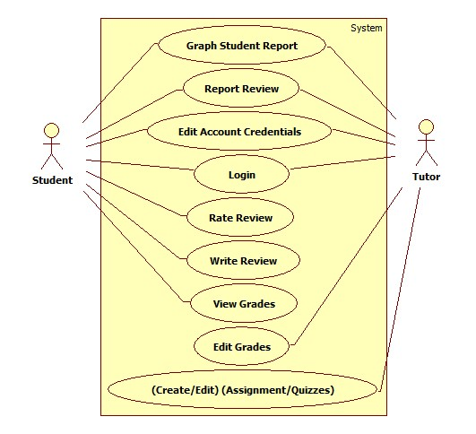

Use Case Descriptions:

* **Graph Student Report** - Creates a graphical representation of the students grades and attendance.
* **Report Review** - Reviews can be flagged by students and tutors as inappropriate.
* **Edit Account Credentials** - Users can change their account username, password, email, and name.
* **Login** - All users will have access to a login system using a username and password.
* **Increment/Decrement Rating of Review** - Reviews can be rated by students based on usefulness. Each student can increment the review rating by one or decrement by one.
* **Write a Review** - Student users will be able to write text reviews of tutors.
* **Create/Edit Quizzes/Assignments** - Tutors will be able to create and edit assignments and quizzes containing prompts or questions for their students to complete.
* **View Grades** - Students will be able to view their grades assigned by their tutors.
* **Edit Grades** -Tutors will be able to adjust the grades they assigned to their students.

**SECTION 3: Specific Requirements**

|  |
| --- |
| **No:** 1 |
| **Statement:** The system shall store student’s attendance and grades and present them on a graph for students. These graphs will include a student’s individual overall attendance and grades. |

|  |
| --- |
| **No:** 2 |
| **Statement:** The system shall allow all users to report reviews that violate FGCU’s student guidelines. |

|  |
| --- |
| **No:** 3 |
| **Statement:** The system shall grant students the ability to increment or decrement a review rating for a tutor review. |

|  |
| --- |
| **No:** 4 |
| **Statement:** The system shall grant access to the application with an associated username and password for an account. The username and password are 6-32 characters long and are chosen by the user. |

|  |
| --- |
| **No:** 5 |
| **Statement:** The system shall grant students the ability to add events to the appointments list. |

|  |
| --- |
| **No:** 6 |
| **Statement:** The system shall include a function that allows students to schedule tutoring sessions depending on their chosen subject, date, time, location, comment, and tutor. |

|  |
| --- |
| **No:** 7 |
| **Statement:** The system shall have a feature where students can write reviews on their tutors. |

|  |
| --- |
| **No:** 8 |
| **Statement:** All users shall have the ability to view reviews for tutors, organized by tutor name. |

|  |
| --- |
| **No:** 9 |
| **Statement:** The system shall include customizable quizzes for tutors to fill in multiple choice questions and answers for their students. |

|  |
| --- |
| **No:** 10 |
| **Statement:** The system shall have a profile customization feature so that students and tutors can edit passwords, icons, and their about me section. |

|  |
| --- |
| **No:** 11 |
| **Statement:** The system shall grant Students access to view grades. |

|  |
| --- |
| **No:** 12 |
| **Statement:** The system shall grant Tutors access to view grades. |

|  |
| --- |
| **No:** 13 |
| **Statement:** The system shall produce graphs on attendance of students and their grades. |

|  |
| --- |
| **No:** 14 |
| **Statement:** The system shall grant tutors the ability to create assignments. |

|  |
| --- |
| **No:** 15 |
| **Statement:** The system shall record every instance in which a user logs in and logs out and will store the timestamp. |

|  |
| --- |
| **No:** 16 |
| **Statement:** Tutors will be able to create assignment for students, including the assignment name, max points, points received, assignment type, comments, date, and time. |

|  |
| --- |
| **No:** 17 |
| **Statement:** The system shall allow students and tutors to change their role to either a student or tutor respectively on the profile tab. |

|  |
| --- |
| **No:** 18 |
| **Statement:** The system shall allow new users to create an account by entering the fields: username, password, email, first and last name. |

|  |
| --- |
| **No:** 19 |
| **Statement:** The system shall allow students and tutors to update their profile picture with a randomly generated solid color. |

|  |
| --- |
| **No:** 20 |
| **Statement:** The system shall allow users to check in for their appointments on the appointments tab. |

Template created by G. Walton ([GWalton@mail.ucf.edu](mailto:GWalton@mail.ucf.edu)) on Aug 30, 1999 and last updated Aug 15, 2000; updated by A. Koufakou, Aug 2014

This page last modified by Hunter Danielson ([hcdanielson6313@eagle.fgcu.edu](mailto:hcdanielson6313@eagle.fgcu.edu)), Martin Marks([mbmarks2816@eagle.fgcu.edu](mailto:mbmarks2816@eagle.fgcu.edu)), Brian Withrow ([bdwithrow2115@eagle.fgcu.edu](mailto:bdwithrow2115@eagle.fgcu.edu)), Tomas Vergara ([tavergera0828@eagle.fgcu.edu](mailto:tavergera0828@eagle.fgcu.edu)), Carlos Reyes ([careyes4820@eagle.fgcu.edu](mailto:careyes4820@eagle.fgcu.edu)), on 12/2/2018