Fun with Data

Natalie Bright
College of Information and Communication
University of South Carolina
JOUR 701: Methods in Mass Communication
Dr. Brett Roberston
November 12, 2025

Substantive Hypothesis for a Correlation

H1: Songs with higher Beats Per Minute (BPM) will be associated with greater popularity.

Sample Size and Type of Data

The dataset used for this analysis contains information on 30 popular songs from contemporary artists. Each entry includes the songs title, performing artist, ranking position, and tempo measured in beats per minute (BPM). The dataset was compiled from Apple Music’s Top Hits and is meant to explore the potential relationship between a song’s musical characteristics and its popularity.
The two variables selected for this analysis are:
- Popularity: A continuous variable representing each song’s position on Apple Music’s Top Hits Chart. A lower number indicates higher popularity.
- BPM (Beats Per Minutes): A continuous variable that quantifies the tempo of a song. Higher BPM values correspond to faster songs, while lower values indicate slower songs.
Due to both variables being continuous and numerical, I have chosen to assess the potential statistically significant relationship between a song’s BPM and its popularity by competing a correlation test.

Results
H1: Songs with higher Beats Per Minute (BPM) will be associated with greater popularity.
The results from this correlation analysis did not support the hypothesis stated above. There is no evidence of a correlation between a songs beats per minute (BPM) and its popularity, r (28) = .12, p = .54. An alpha level of .05 was used for this test to determine statistical significance.
Conclusion
This analysis explored whether a song’s beats per minute (BPM) is associated with its popularity. The results did not support the hypothesis: there was not a meaningful correlation between BPM and popularity. This means that, within this dataset, a songs BPM does not seem to influence its popularity.
Several limitations of this study should be considered. First, the dataset included a relatively small number of songs and represents a limited time frame, which may not encapsulate wider trends in a listener’s preference. Additionally, other elements such as lyrics, genre, artist recognition could influence popularity. For example, the dataset included three songs by Taylor Swift, whose most recent album was released within the last month. The popularity of these songs could be influenced by the recognition of Taylor Swift as well as the albums marketing. Other factors that could influence a song’s popularity could be external such as cultural trends, social media promotion, algorithmic recommendations, and release timing. Another external factor that could influence a song’s placement in the charts is seasonal trends. As I conducted this test in early November, I was surprised to not see holiday music.
Further research could address these limitations by selecting a larger dataset which spans multiple years – possibly even decades. In addition, including internal factors such as other musical characteristics and external factors such as the promotion of a song could be considered. This would likely provide a larger scope of the relationship between music and its popularity.

The scatterplot below, Figure 1, visually represents the relationship between BPM and popularity. Each point corresponds to a single song, with BPM on the x-axis and popularity on the y-axis. As shown, the points are widely dispersed, showing no discernible trend. This reinforces the statistical finding that BPM alone is not a predictive measure of a song’s popularity.
Figure 1
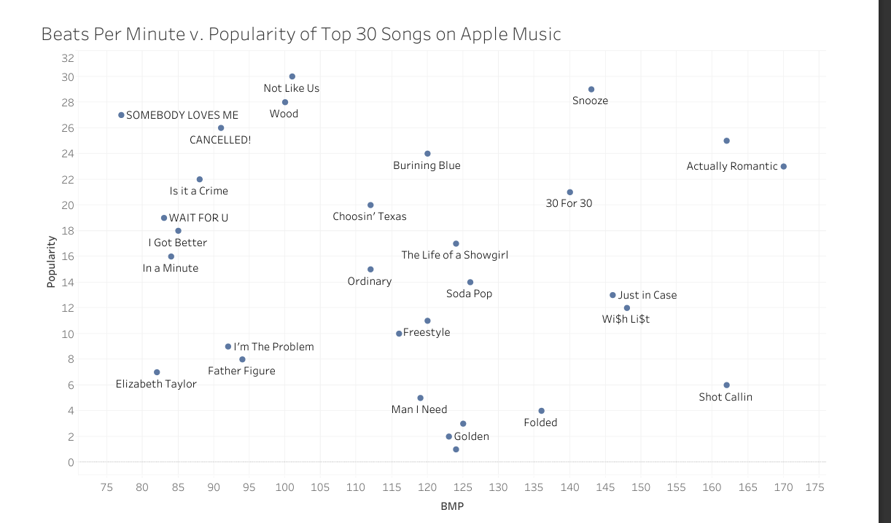
Appendix 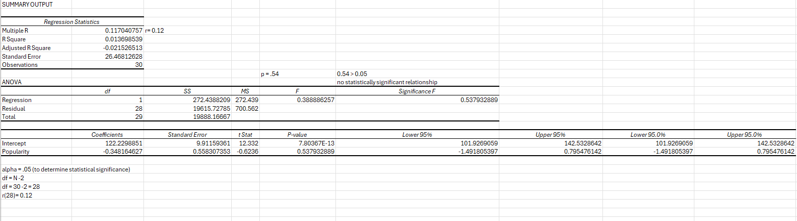
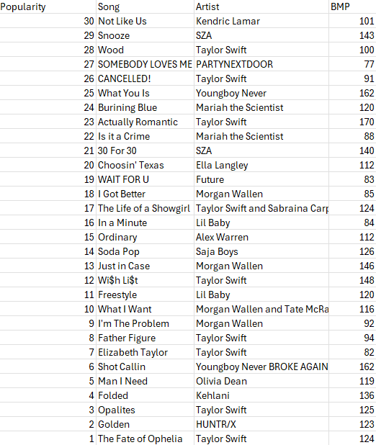
Works Cited
Apple Inc. (n.d.). Top songs – Apple Music (U.S.). Apple Music. https://music.apple.com/us/new/top-charts/songs

