VK HARDWARE ONLINE SHOP
1
DEPARTMENT OF COMPUTER APPLICATION
1. INTRODUCTION

1.1 OVERVIEW OF THE PROJECT

VK Hardware is an buisness firm. The objective of this project is to automate the hardware shoping in to online shopping. A fully functional website is developed to make the shopping of the users very easy. Users can buy the products at any time since this is an online shopping platform. It also helps the users to buy the products according to the market price.
VK HARDWARE ONLINE SHOP
2
DEPARTMENT OF COMPUTER APPLICATION

VK HARDWARE ONLINE SHOP
3
DEPARTMENT OF COMPUTER APPLICATION

2. SYSTEM STUDY

2.1 BACKGROUND ANALYSIS

One major area of wholesale distribution is the Construction Materials Industry. The construction materials industry includes suppliers of the raw materials used by construction firms when building commercial and residential properties. This means that basic materials such as brick, stone, concrete and cement in addition to wood, lumber, wood paneling and mill work products fall into this category. This is a competative field were a lot of dealers are in the market for buisness.

VK HARDWARE ONLINE SHOP
4
DEPARTMENT OF COMPUTER APPLICATION
2.2 EXISTING SYSTEM

The exisiting system contains the dealers taking the materials form the company and sell it to the customers accordingly. There are times when the avilabilty of the raw materials, pricehike,transportation cost, strike affects the business.

2.3 PROPOSED SYSTEM

In an online shopping era we are changing the market not just to a native area but to a wider area were a lot of busy customers are awating for the change. Through the online shop customerscan choose their product without vising the shop. It also help the contracters as well as the customers who buy in bulk. Discounts and categories of the products can be seen through the catlog. The customers can navigate throught the products and find out the prices for each of the available brands. An online payment gateway manages the online transactions on each purchase .Tracking system is available for the customer to check the prouduct checkout.

2.4 TECHNOLOGIES USED

The technologies used for this project is following

Backend:
Mysql
Python (Django )

Frontend:
HTML
CSS
JS
Bootstrap

Mysql:
MySQL is a relational database management system (RDBMS) developed by Oracle that is based on structured query language (SQL).

Python:
Python is a general purpose and high-level programming language. You can use Python for developing desktop GUI applications, websites and web applications. Also, Python, as a high- level programming language, allows you to focus on core functionality of the application by taking care of common programming tasks. The simple syntax rules of the programming language further make it easier for you to keep the code base readable and application maintainable. There are also a number of reasons why you should prefer Python to other programming languages.

Django:
Django is a high-level Python Web framework that encourages rapid development and clean pragmatic design. A Web framework is a set of components that provide a standard way to develop websites fast and easily. Django’s primary goal is to ease the creation of complex database-driven websites.

HTML:
Hypertext Markup Language is the standard markup language for documents designed to be displayed in a web browser. It can be assisted by technologies such as Cascading Style Sheets and scripting languages such as JavaScript, ASP and PHP.

CSS:
Cascading Style Sheets is a style sheet language used for describing the presentation of a document written in a markup language like HTML. CSS is a cornerstone technology of the World Wide Web, alongside HTML and JavaScript.
VK HARDWARE ONLINE SHOP
5
DEPARTMENT OF COMPUTER APPLICATION

3.SYSTEM ANALYSIS
VK HARDWARE ONLINE SHOP
6
DEPARTMENT OF COMPUTER APPLICATION

3.1 FEASIBILITY STUDY
VK HARDWARE ONLINE SHOP
7
DEPARTMENT OF COMPUTER APPLICATION
VK HARDWARE ONLINE SHOP
7
DEPARTMENT OF COMPUTER APPLICATION

Technical Feasibility:
The project is technically able to fulfill all the requirements as well as the ability to implement it in a industrial basis. The users should be able to access the website bug free and easy accessable . The project requires the development of a user-friendly e-commerce platform that displays products, allows customers to filter and sort products, and provides a secure online payment system.

Ecnomic Feasibility:
The project is ecnomically feasible if the maintainance part and development part is completed according to the budget.

Operational Feasibility:
The operational feasibility of the project refers to whether the project can be integrated into the existing business operations of the organization. The project requires the establishment of a supply chain and logistics system to handle product orders, inventory management, and order fulfillment.

Leagal Feasibility:

The legal feasibility of the project refers to whether the project can be implemented in with existing laws and regulations. The project must accomply with laws related to online transactions, data privacy, and consumer protection. The development and operation of the website will be conducted by satisfying the lawpersuits.

Based on the feasibility studies, the project is technically, economically, operationally, and legally feasible. Therefore, the VK Hardware Online shopping website project is valuable investment for the organization.

3.2 REQUIREMENT SPECIFICATION
The process of jotting down all the system and user requirements in the form of a document. These requirements must be clear, complete, comprehensive, and consistent.
Functional Requiremnets :
- The webite must be fully functional and user friendly. Users of any type must be able to use the website without hassle.
- The website should allow to view a quality images of the products .Must contain a navihgation system.
- The website should make users able to add products ,remove the products ,view orders,write review, track the orders.
- The user must be able to pay through a standard payment geteway with provides data security.
- The website should provide customers with order confirmation and delivery tracking information.
- The website should allow customers to leave reviews and ratings for products they have purchased.

Non-Functional Requirements:
- The website should be responsive and accessible on different devices such as desktops, laptops, tablets, and smartphones.
- The website should have a fast loading speed to ensure a smooth user experience.
- The website should provide a reliable and secure online payment system to protect customer information and prevent fraud.
- The website should comply with data privacy laws and regulations to protect customer data and information.

Design Requirements:
- The website should contain a simple and standard UI design
- Forms and google map integration should be included in the website.
- High quiality images should included and page navigation must be user friendly.

VK HARDWARE ONLINE SHOP
8
DEPARTMENT OF COMPUTER APPLICATION

4.SYSTEM DESIGN

VK HARDWARE ONLINE SHOP
9
DEPARTMENT OF COMPUTER APPLICATION

4.1 MODULE SPECIFICATION
VK HARDWARE ONLINE SHOP
10
DEPARTMENT OF COMPUTER APPLICATION

- Admin module

Manages the registered users , manages the product details.
Manages the order details ,add new categories and featured products in to the website.

- User module

User can login and register in to the website .
User can view products , add the products to the cart, make orders .

- Shopping cart module
This module will manage the shopping cart functionality for customers.
It will allow customers to add and remove products from their cart.
It will also calculate the total cost of the products in the cart and provide a checkout process.

- Payment module

This module will provide a secure online payment system for customers.
User can pay for the produts through the payment gateway.
It will also manage payment history and receipts.

4.2 UML DIAGRAM
DEPARTMENT OF COMPUTER APPLICATION
11
VK HARDWARE ONLINE SHOP

USECASE DIAGRAM
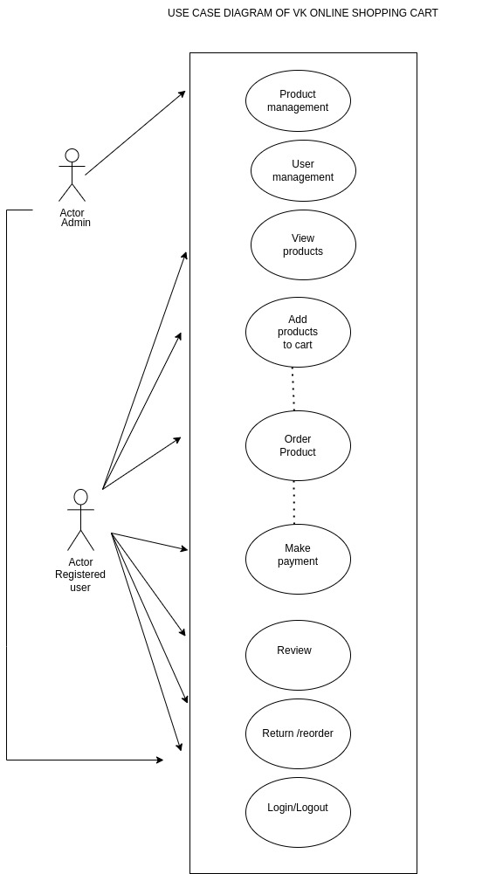
ACTIVITY DIAGRAM
DEPARTMENT OF COMPUTER APPLICATION
12
VK HARDWARE ONLINE SHOP

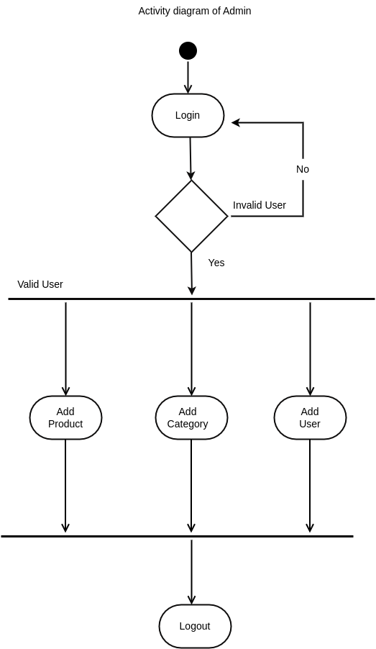

DEPARTMENT OF COMPUTER APPLICATION
13
VK HARDWARE ONLINE SHOP
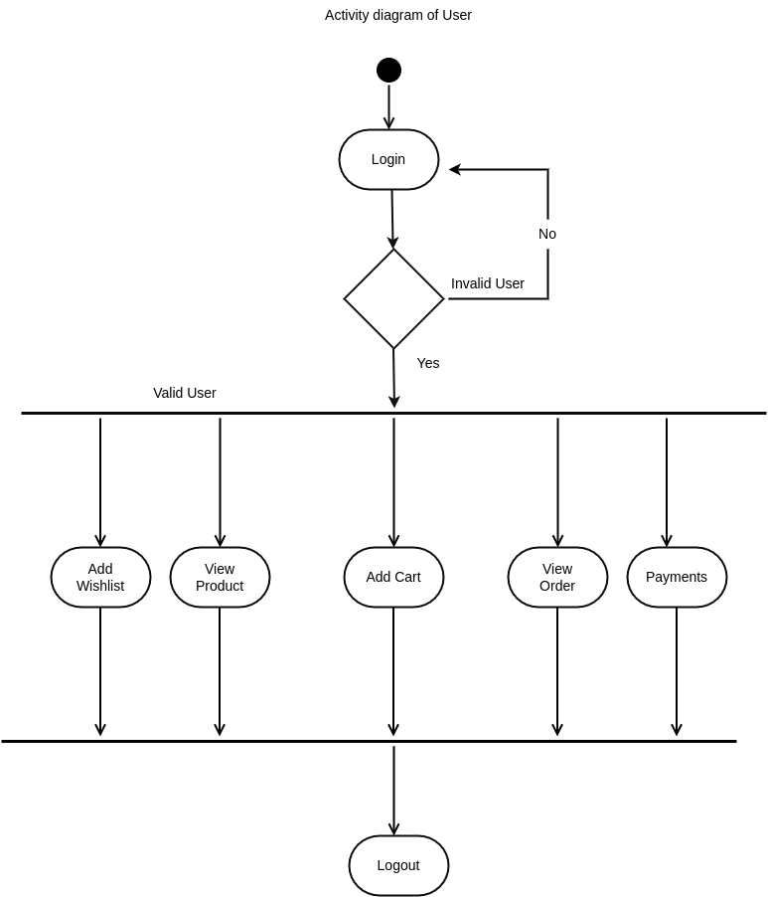

4.3 DATABASE DESIGN
DEPARTMENT OF COMPUTER APPLICATION
14
VK HARDWARE ONLINE SHOP

TABLE – 1 USER
FIELD NAME | DATA TYPE | CONSTRAINT
id | INT | PRIMARY KEY
username | VARCHAR | UNIQUE
first_name | VARCHAR | NOT NULL
last_name | VARCHAR | NOT NULL
email | VARCHAR | NOT NULL
password | VARCHAR | NOT_NULL
is_staff | TINYINT | DEFAULT
is_active | TINYINT | DEFAULT
is_superuser | TINYINT | DEFAULT
last_login | DATETIME | NULL
date_joined | DATETIME | DEAFULT

TABLE – 2 ADDRESS
FIELD NAME | DATA TYPE | CONSTRAINT
id | INT | PRIMARY KEY
user_id | INT | FOREIGN KEY
localilty | VARCHAR | NOT NULL
city | VARCHAR | NOT NULL
state | VARCHAR | NOT NULL

TABLE – 3 CATEGORY
FIELD NAME | DATA TYPE | CONSTRAINT
id | INT | PRIMARY KEY
title | VARCHAR | NOT NULL
slug | VARCHAR | NOT NULL
description | TEXT | NOT NULL
category_image | VARCHAR | NOT NULL
is_active | TINYINT | NOT NULL
is_featured | TINYINT | NOT NULL
created_at | DATETIME | DEFAULT
updated_at | DATETIME | DEFAULT

TABLE – 4 PRODUCT

15
DEPARTMENT OF COMPUTER APPLICATION
DEPARTMENT OF COMPUTER APPLICATION
15
VK HARDWARE ONLINE SHOP
FIELD NAME | DATA TYPE | CONSTRAINT
id | INT | PRIMARY KEY
title | VARCHAR | NOT NULL
slug | VARCHAR | NOT NULL
sku | VARCHAR | NOT NULL
short_description | VARCHAR | NOT NULL
detail_description | VARCHAR | NOT NULL
product_image | VARCHAR | NOT NULL
price | DECIMAL | NOT NULL
category_id | INT | FOREIGN KEY
is_active | TINYINT | NOT NULL
is_featured | TINYINT | NOT NULL
created_at | DATETIME | DEFAULT
updated_at | DATETIME | DEFAULT

TABLE – 5 CART
FIELD NAME | DATA TYPE | CONSTRAINT
id | INT | PRIMARY KEY
user_id | INT | FOREIGN KEY
product_id | INT | FOREIGN KEY
quantity | INT | NOT NULL

TABLE – 5 ORDER
FIELD NAME | DATA TYPE | CONSTRAINT
id | INT | PRIMARY KEY
user_id | INT | FOREIGN KEY
address_id | INT | FOREIGN KEY
product_id | INT | FOREIGN KEY
quantity | INT | NOT NULL
status | VARCHAR | NOT NULL

TABLE – 5 PAYMENT
DEPARTMENT OF COMPUTER APPLICATION
16
VK HARDWARE ONLINE SHOP

FIELD NAME | DATA TYPE | CONSTRAINT
id | INT | PRIMARY KEY
user_id | INT | FOREIGN KEY
order_id | INT | FOREIGN KEY
amount | INT | NOT NULL
status | INT | NOT NULL

T

17
DEPARTMENT OF COMPUTER APPLICATION

5.SYSTEM DEVELOPMENT

5.1 SOFTWARE DEVELOPMENT
DEPARTMENT OF COMPUTER APPLICATION
18
VK HARDWARE ONLINE SHOP

The important key steps involved in the development of this project are:

An development environment:
Creating an environment for the development of the project. An environment is an inportnat aspect an development environment provides developers an interface and convenient view of the development process which includes writing code, testing the same and packaging the build so that it can be deployed.

Creating a Django project:
The basic django file structure is created in this step where the python framework django is installed throught he command line interface.

Design a database schema:
Designing a database schema is an important part in developing a project. All the tables should contain primarykey as well as the tables should be normalized.

Implementing Functionalities:
The core of the project were the code for each of the functional modules are created with logic such as Authentication , integration of Payment gateway, User management etc.

Creating Views and Templates: Views and templates are an integral part of any Django project. Views are Python functions that handle HTTP requests and return HTTP responses. Templates are HTML files that define the structure and layout of the web pages.

Testing and Debugging: Once the software development is complete, testing and debugging will be performed to ensure that the project is working as expected.

Deployment: The final step is to deploy the project to a web server. The project can be deployed to a cloud-based platform or a dedicated server.
Throughout the software development process, version control will be used to manage the codebase. Git is the most popular version control system and will be used in this project. Continuous integration and deployment (CI/CD) will also be set up to automate the testing and deployment process. CI/CD helps to ensure that the project is always in a deployable state and any bugs are caught early in the development process.

5.2 SOFTWARE ENVIRONMENT
DEPARTMENT OF COMPUTER APPLICATION
19
VK HARDWARE ONLINE SHOP

Software Requirement

    - Operating System: Linux/Windows

    - Framework: Python Django

    - Browser used: Google chrome, Mozilla Firefox

Hardware Requirement

    - Processor: AMD 3020e with Radeon Graphics 1.20 GHz

    - RAM: 4.00 GB (3.44 GB usable)

    - Hard disk capacity:320gb

    - CD-ROM Drive:52X

    - Mouse: Any compactable one

6.SYSTEM TESTING
DEPARTMENT OF COMPUTER APPLICATION
20
VK HARDWARE ONLINE SHOP

6.1 INTRODUCTION
21
VK HARDWARE ONLINE SHOP
DEPARTMENT OF COMPUTER APPLICATION
Software testing is an essential part of software development that helps ensure that the software meets its requirements and performs as expected. In the context of this project, testing will be performed to verify that the system functions correctly, meets user requirements, and is free from defects or errors. The testing process will be broken down into several phases, including unit testing, integration testing, system testing, and acceptance testing.
Unit Testing:
BYWHEELS ONLINE STORE
DEPARTMENT OF COMPUTER APPLICATION
21
Unit testing is a process in which individual components or units of the software are tested in isolation to ensure that they function correctly. In this project, unit testing will be performed using Django's built-in testing framework to test each model, view, and utility function to ensure that they work as intended.
Integration Testing:
Integration testing is the process of testing how different components or modules of the software interact with each other. In this project, integration testing will be performed to ensure that different modules, such as the front-end and back-end, work together seamlessly.
System Testing:
System testing involves testing the entire system as a whole to ensure that it meets all of the user requirements and performs as expected. In this project, system testing will be performed to verify that the entire system, including all components and modules, works correctly and meets all user requirements.
Acceptance Testing:
Acceptance testing is the final stage of testing, where the system is tested by the end-users to ensure that it meets their requirements and is fit for their intended use. In this project, acceptance testing will be performed by the project stakeholders to ensure that the system meets all their needs and requirements.
To support the testing process, a testing plan will be created that outlines the testing activities, including the test cases, test data, testing environment, and the expected results. This testing plan will be used to guide the testing process and ensure that all aspects of the system are thoroughly tested.

7. SYSTEM IMPLEMENTATION
DEPARTMENT OF COMPUTER APPLICATION
22
VK HARDWARE ONLINE SHOP

7.1 INTRODUCTION
VK HARDWARE ONLINE SHOP
DEPARTMENT OF COMPUTER APPLICATION
23
BYWHEELS ONLINE STORE
23
DEPARTMENT OF COMPUTER APPLICATION
A product software implementation method is a blueprint to get users and/or organizations running with a specific software product. The method is a set of rules and views to cope with the most common issues that occur when implementing a software product: business alignment from the organizational view and acceptance from human view. The implementation of product software, as the final link in the deployment chain of software production, is in a financial perspective of a major issue. The project can be implemented in a lower cost by using any hosting providers. If you need access more than a platform, you can choose cloud providers like AWS and Azure. This project is currently in a development server. You can implement the project after using a production server like Gunicorn.

7.2 DEPLOYMENT
Deployment is the process of making a software application available to users after it has been developed, tested, and prepared for release. In the case of this project, it is planned to be deployed on DigitalOcean.
DigitalOcean is a cloud hosting platform that provides a simple and easy-to-use interface for deploying web applications. To deploy this project on DigitalOcean, the following steps will be taken:

- Create a new Droplet (virtual machine) on DigitalOcean.
- Choose the appropriate operating system, such as Ubuntu or CentOS.
- Install the necessary software packages for the project, such as Python, Django, and MySQL.
- Set up a firewall to allow incoming traffic to the web application.
- Configure the DNS settings for the project domain name to point to the IP address of the Droplet.
- Upload the project files to the Droplet.
- Configure the project settings, such as the database connection and secret key.
- Run the necessary database migrations and collect the static files.
- Start the web server and test the application.
- Monitor the web server and troubleshoot any issues that arise.
Once the application has been deployed, it will be available to users to access via the project domain name.

8. SCOPE FOR FURTHER DEVELOPMENT
DEPARTMENT OF COMPUTER APPLICATION
24
VK HARDWARE ONLINE SHOP

The current state of the project is fullyfunctional according to the user needs . Eventhoughit is fully functional we can implement new ideas and integrate it into the system if the organisation demands Some of the scope for further development is:

Mobile Application: Developing a mobile application for the project would allow customers to shop on the go, making it more convenient for them to access the platform from their mobile devices.

Offers and Prises: Add more seasonal offers and benefits to attract the users.

Stability in Tracking: A Stable tracking system with advance features .

Social Media Integration: Integrating the project with social media platforms like Facebook and Instagram would allow businesses to connect with customers and promote their products through social media marketing.

25
VK HARDWARE ONLINE SHOP
DEPARTMENT OF COMPUTER APPLICATION

DEPARTMENT OF COMPUTER APPLICATION
26
VK HARDWARE ONLINE SHOP

9. CONCLUSION

In conclusion, the project has successfully developed a fully functional e-commerce website using Django. The website allows users to browse through various product categories, add items to their cart, and make payments using a secure payment gateway. The project has also successfully integrated third-party libraries such as django-crispy-forms and django-storages to enhance the user experience.
DEPARTMENT OF COMPUTER APPLICATION
27
VK HARDWARE ONLINE SHOP
27
DEPARTMENT OF COMPUTER APPLICATION

In addition, the project has provided scope for further development, such as the implementation of social media integration and other features. Finally, the project has been deployed on Digital Ocean, providing users with an accessible and reliable platform to shop online. Overall, this project has been a valuable learning experience in the field of web development and e-commerce.

VK HARDWARE ONLINE SHOP
DEPARTMENT OF COMPUTER APPLICATION
28

10. BIBLIOGRAPHY

- https://docs.djangoproject.com/en/4.1/

- https://medium.com/analytics-vidhya/how-to-build-a-django-web-app-from-scratch-tutorial-20034f0a3043

- https://stackoverflow.com/questions/45724006/django-reverse-for-not-found-is-not-a-valid-view-function-or-pattern-na

- https://stackoverflow.com/questions/14829788/function-object-has-no-attribute-user-error-in-django

DEPARTMENT OF COMPUTER APPLICATION
29
VK HARDWARE ONLINE SHOP

DEPARTMENT OF COMPUTER APPLICATION
30
VK HARDWARE ONLINE SHOP
11. APPENDIX

SCREENSHOTS

DEPARTMENT OF COMPUTER APPLICATION
31
VK HARDWARE ONLINE SHOP

