Supplementary Material

Supplementary Materials

Supplementary Tables

Table S1. Full Pairwise Cross-Cohort AUC Matrix
Pairwise AUC-ROC for single-cohort train → single-cohort test transfer experiments. All 4×4 combinations excluding diagonal (within-cohort). Values are AUC-ROC with 95% bootstrap confidence intervals (1,000 resamples) on the test cohort predictions.
Table S1A — Logistic Regression
Train Test | Zhuang 2018 | Ling 2020 | Zhu 2022 | Kazakhstan
Zhuang 2018 | — | 0.583 [0.50–0.67] | 0.696 [0.54–0.82] | 0.566 [0.44–0.69]
Ling 2020 | 0.538 [0.41–0.66] | — | 0.879 [0.77–0.96] | 0.593 [0.47–0.72]
Zhu 2022 | 0.579 [0.46–0.70] | 0.760 [0.68–0.83] | — | 0.547 [0.43–0.67]
Kazakhstan | 0.539 [0.42–0.67] | 0.739 [0.66–0.81] | 0.652 [0.50–0.78] | —
Table S1B — LightGBM
Train Test | Zhuang 2018 | Ling 2020 | Zhu 2022 | Kazakhstan
Zhuang 2018 | — | 0.598 [0.51–0.68] | 0.604 [0.46–0.74] | 0.493 [0.37–0.61]
Ling 2020 | 0.617 [0.49–0.74] | — | 0.861 [0.77–0.94] | 0.602 [0.47–0.72]
Zhu 2022 | 0.528 [0.41–0.65] | 0.591 [0.50–0.68] | — | 0.405 [0.28–0.53]
Kazakhstan | 0.522 [0.40–0.64] | 0.580 [0.49–0.67] | 0.603 [0.45–0.75] | —
Notable observations: The highest pairwise logistic regression AUC is Ling 2020 → Zhu 2022 (AUC=0.88), reflecting transfer between two large Chinese fecal cohorts. Kazakhstan → Ling 2020 also transfers reasonably (logistic regression AUC=0.74). Most pairwise AUCs cluster between 0.54 and 0.70, consistent with the overall pattern of limited cross-cohort transferability documented in Section 3.3.

Table S2. Per-Cohort DADA2 Processing Statistics
Statistics from DADA2 amplicon sequence variant (ASV) inference pipeline. Paired-end cohorts underwent quality filtering, error learning, denoising, merging, and chimera removal; Kazakhstan (single-end) omitted the merging step.
Cohort | Country | Mode | N Samples | Reads Input | Reads Non-chimeric | % Retention | 16S Region | Platform
Zhuang 2018 | China | Paired-end | 86 | 3,260,213 | 2,551,870 | 78.3% | V3–V4 | MiSeq 2×300
Ling 2020 | China | Paired-end | 171 | 8,556,209 | 4,100,210 | 47.9% | V3–V4 | MiSeq 2×300
Zhu 2022 | China | Paired-end | 180 | 7,275,079 | 5,485,811 | 75.4% | V3–V4 | MiSeq 2×300
Kim 2022 | South Korea | Paired-end | 78 | 13,514,374 | 6,117,631 | 45.3% | V3–V4 | MiSeq 2×300
Kaiyrlykyzy 2022 | Kazakhstan | Single-end | 84 | 9,467,007 | 6,531,362 | 69.0% | V3–V4 | NovaSeq
Total |  |  | 599 | 42,072,882 | 24,786,884 | 58.9%
Notes: (1) Reads input = reads passing initial quality cutoff prior to DADA2 filtering. (2) Retention rates for Ling 2020 (47.9%) and Kim 2022 (45.3%) are lower than typical for MiSeq 2×300 V3–V4 data; inspection of quality profiles showed elevated error rates in these cohorts’ reverse reads at positions >150–180 bp, which may reflect sequencing run-specific quality variation. (3) Kazakhstan single-end processing used truncLen=250 after quality profile inspection; see Supplementary Note S2. (4) ASV count per cohort and per-sample read depth statistics not shown here; final post-harmonization genus matrix contains 396 genera across 509 fecal samples (90 blood microbiome samples from Zhu 2022 excluded prior to analysis).

Table S3. Full PERMANOVA Results
All PERMANOVA models used 9,999 permutations with Type III (marginal) sums of squares (vegan adonis2, by="margin"). Aitchison distance = Euclidean distance on CLR-transformed values. Bray-Curtis computed on relative abundances. With 9,999 permutations, the minimum attainable permutation p-value is 1/(9,999+1) = 0.0001; p-values reported below as 0.0001 indicate no permuted statistic met or exceeded the observed value (i.e., the true p-value is at or below this resolution limit, not literally less than it).
Model 1: Cohort only (all 5 cohorts, Aitchison distance)
Term | Df | Sum of Squares | R² | F | p-value
Cohort | 4 | 67,760.8 | 0.193 | 30.13 | 0.0001
Residual | 504 | 283,347.1 | 0.807 | — | —
Model 1B: Cohort only (all 5 cohorts, Bray-Curtis dissimilarity)
Term | Df | Sum of Squares | R² | F | p-value
Cohort | 4 | 20.80 | 0.136 | 19.80 | 0.0001
Residual | 504 | 132.36 | 0.864 | — | —
Model 2: Cohort + Diagnosis (4 labeled cohorts, Aitchison, marginal R²)
Term | Df | Sum of Squares | R² (marginal) | F | p-value
Cohort | 3 | 45,476.8 | 0.172 | 28.03 | 0.0001
Diagnosis | 1 | 3,689.7 | 0.014 | 6.82 | 0.0001
Note: Marginal R² values for cohort and diagnosis do not sum to total R² because marginal effects are estimated independently (Type III SS), adjusting for the other variable. The sum of marginal R² values underestimates total explained variance. “Cohort” here is a composite study-of-origin variable (platform, library prep, recruitment site, diagnostic ascertainment, diet, and other unmeasured differences bundled together); this model does not, and cannot, decompose the cohort term into technical versus biological components (Section 2.6). See Table S11 for a sensitivity analysis showing this cohort-vs-diagnosis disparity is highly sensitive to which cohorts are included.
Model 3: Within-cohort Diagnosis effects (Aitchison distance)
Cohort | Term | Df | R² | F | p-value
Zhuang 2018 | Diagnosis | 1 | 0.017 | 1.47 | 0.066
Ling 2020 | Diagnosis | 1 | 0.053 | 9.53 | 0.0001
Zhu 2022 | Diagnosis | 1 | 0.094 | 6.01 | 0.0001
Kazakhstan | Diagnosis | 1 | 0.022 | 1.83 | 0.069
Zhu 2022 analysis restricted to fecal samples only (n=60 binary: 30 AD + 30 CN). Blood microbiome samples excluded prior to all analyses. Zhuang 2018 (p=0.066) and Kazakhstan (p=0.069) did not reach α=0.05 significance for within-cohort diagnosis effect.
Beta-Dispersion Test (Aitchison distance, all 5 cohorts)
Metric | Value
F-statistic | 13.93
Numerator df | 4
Denominator df | 504
p-value (permutation, 9,999 perms) | 0.0001
Interpretation | Within-cohort dispersions differ significantly; PERMANOVA R² reflects both centroid shift and spread heterogeneity

Table S4. Training-Only Feature-Selection Sensitivity
Genus retention (≥20% prevalence) re-derived independently within every split, using only that split’s training-side samples (Section 2.5.1), compared against the main analysis’s global (all-five-cohort) feature selection.
LOCO
Test Cohort | Model | Original (Global-Feature) LOCO AUC | Training-Only LOCO AUC | Δ | N Retained Genera (Training-Only)
Zhuang 2018 | LogReg | 0.5041 | 0.5057 | +0.0016 | 370
Zhuang 2018 | LGBM | 0.5646 | 0.5960 | +0.0314 | 370
Ling 2020 | LogReg | 0.6775 | 0.6794 | +0.0019 | 370
Ling 2020 | LGBM | 0.6735 | 0.6534 | −0.0201 | 370
Zhu 2022 | LogReg | 0.8133 | 0.8122 | −0.0011 | 373
Zhu 2022 | LGBM | 0.7578 | 0.7878 | +0.0300 | 373
Kazakhstan | LogReg | 0.5644 | 0.6092 | +0.0448 | 150
Kazakhstan | LGBM | 0.5905 | 0.5247 | −0.0658 | 150
Within-cohort nested CV
Cohort | Model | Original (Global-Feature) AUC | Training-Only AUC | Δ
Zhuang 2018 | LogReg | 0.6333 | 0.6647 | +0.0314
Zhuang 2018 | LGBM | 0.6349 | 0.6733 | +0.0384
Ling 2020 | LogReg | 0.8648 | 0.8896 | +0.0248
Ling 2020 | LGBM | 0.8618 | 0.8415 | −0.0203
Zhu 2022 | LogReg | 0.9978 | 0.9956 | −0.0022
Zhu 2022 | LGBM | 0.9789 | 0.9700 | −0.0089
Kazakhstan | LogReg | 0.7657 | 0.7368 | −0.0289
Kazakhstan | LGBM | 0.6943 | 0.6109 | −0.0834
The retained genus count for LOCO training-only selection is lower when Kazakhstan is excluded from feature selection (150 genera) than when it is included in the training pool (370–373 genera), reflecting that Kazakhstan alone passes the 20%-prevalence threshold for many genera the Chinese/Korean-pipeline cohorts do not. No cohort–model combination changes qualitative classification (near-chance, intermediate, robust) between the global and training-only designs.
Source data: results/tables/within_cohort_auc_training_only.csv, results/tables/loco_auc_training_only.csv, results/tables/pairwise_auc_training_only.csv, results/tables/training_only_feature_sensitivity_summary.csv, results/tables/training_only_feature_counts.csv, results/tables/training_only_feature_lists.csv (full per-split retained-genus lists).

Table S5. Within-Cohort AUC on Batch-Corrected Data: Label-Blind vs. Label-Informed
Within-cohort nested-CV AUC (Section 2.4 procedure) computed on batch-corrected features, under both correction designs (Section 2.7). The label-blind comparison is free of diagnosis-label leakage during correction; the label-informed comparison is not (Section 3.5) and is shown only for completeness/continuity with the original analysis.
Cohort | Model | Uncorrected | ComBat-seq (label-blind) | MMUPHin (label-blind) | ComBat-seq (label-informed, exploratory) | MMUPHin (label-informed, exploratory)
Zhuang 2018 | LogReg | 0.6333 | 0.6604 | 0.6171 | 0.6647 | 0.6393
Zhuang 2018 | LGBM | 0.6349 | 0.6479 | 0.6247 | 0.6544 | 0.5765
Ling 2020 | LogReg | 0.8648 | 0.8701 | 0.8690 | 0.8754 | 0.8863
Ling 2020 | LGBM | 0.8618 | 0.8255 | 0.8689 | 0.8659 | 0.8844
Zhu 2022 | LogReg | 0.9978 | 0.9878 | 0.9900 | 0.9956 | 0.9933
Zhu 2022 | LGBM | 0.9789 | 0.9533 | 0.9600 | 0.9622 | 0.9650
Kazakhstan | LogReg | 0.7657 | 0.6926 | 0.7663 | 0.7839 | 0.7879
Kazakhstan | LGBM | 0.6943 | 0.6829 | 0.5621 | 0.7351 | 0.6858
Source data: results/tables/within_cohort_auc_corrected_labelblind.csv, results/tables/within_cohort_auc_corrected.csv, results/tables/within_cohort_auc.csv.

Table S6. Logistic-Regression Coefficient Sign Stability: Screened Candidates and the Akkermansia Negative Control
Per (cohort, genus), counts of positive/negative/zero fitted coefficients across the 10 outer OOF folds (Section 2.8). sign_stability uses the pre-specified ≥8/10-fold threshold. This is a descriptive screen, not a hypothesis test: the 10 outer folds share overlapping training data and are not independent replications, so no p-value is assigned to any row. Full table (1,584 cohort×genus rows) in results/tables/logreg_coefficient_stability.csv; below, Romboutsia (the cleanest cohort-level pattern among the eight genera meeting the screen; Section 3.6) and Akkermansia (a negative-control illustration: appears to flip under the old, invalid mean-SHAP statistic but does not meet the coefficient-based screen; Section 3.6, Section 4.4).
Cohort | Taxon | n_positive/10 | n_negative/10 | Median Coefficient | Sign Stability
Zhuang 2018 | Romboutsia | 0 | 10 | −0.0107 | stable_negative
Ling 2020 | Romboutsia | 0 | 10 | −0.1166 | stable_negative
Zhu 2022 | Romboutsia | 0 | 10 | −0.0190 | stable_negative
Kazakhstan | Romboutsia | 9 | 1 | 0.0109 | stable_positive
Zhuang 2018 | Akkermansia | 10 | 0 | 0.0124 | stable_positive
Ling 2020 | Akkermansia | 10 | 0 | 0.1181 | stable_positive
Zhu 2022 | Akkermansia | 10 | 0 | 0.0709 | stable_positive
Kazakhstan | Akkermansia | 10 | 0 | 0.0682 | stable_positive
Romboutsia is stable-negative in all three Chinese cohorts and stable-positive in Kazakhstan — the cleanest observed cross-cohort pattern among the eight genera meeting the screen. Akkermansia’s coefficient is stable and positive in all four cohorts — it does not meet the screen at all, despite its pooled mean SHAP value appearing to reverse sign (Section 3.6). See the full CSV for the corresponding rows for each of the eight genera meeting the descriptive screen (Agathobacter, Bifidobacterium, Coprococcus, Dorea, Lactobacillus, NK4A214 group, Romboutsia, Ruminococcus gnavus group) and for logreg_directional_flips_stable.csv, which lists, per candidate taxon, which cohorts carried a stable positive vs. stable negative coefficient.
Source data: results/tables/logreg_coefficient_stability.csv, results/tables/logreg_directional_flips_stable.csv.

Table S7. Matched-Null (Shared-Pool) Jaccard Overlap Across Top-N Thresholds
Observed statistic = mean of the six unique pairwise Jaccard similarities among the four labeled cohorts’ top-N SHAP taxa sets. Null = 100,000 replicates, each drawing four independent random top-N gene sets from the shared 396-genus pool and averaging the same six pairwise Jaccards among them (Section 2.8). Empirical one-sided p = (1 + #{null ≥ observed}) / (n_perm + 1). See Table S13 for the prevalence-restricted (per-cohort eligible universe) sensitivity analysis, which reverses the LightGBM result reported here.
Model | Top-N | Observed Mean (6 pairs) | Null Mean | Null 95% CI | Empirical p
LogReg | 10 | 0.0850 | 0.0134 | [0.0000, 0.0361] | <0.0001
LogReg | 20 (primary) | 0.1350 | 0.0265 | [0.0085, 0.0491] | <0.0001
LogReg | 50 | 0.2296 | 0.0680 | [0.0491, 0.0895] | <0.0001
LightGBM | 10 | 0.0175 | 0.0135 | [0.0000, 0.0361] | 0.4494 (not significant)
LightGBM | 20 (primary) | 0.0584 | 0.0265 | [0.0085, 0.0491] | 0.0048
LightGBM | 50 | 0.1430 | 0.0680 | [0.0492, 0.0894] | <0.0001
LightGBM’s overlap is significant at N=20 and N=50 but not at N=10 under this shared-pool null. Table S13 shows this result does not survive a prevalence-restricted null model.
Source data: results/tables/jaccard_null_corrected.csv.

Table S8. Zhu 2022 Repeated Nested Cross-Validation (Fold-Assignment Stability)
50 repetitions of the 10-fold outer / 5-fold inner nested-CV partition, each under a different pre-specified seed, strict training-only genus selection re-derived within every outer fold of every repetition (Section 2.4.1). This is a fold-assignment stability check on the same 60 participants, not an independent-sample replication.
Model | Historical Single-Partition AUC | Training-Only Single-Partition AUC | Repeated-CV Mean | SD | Median | P2.5 | P97.5 | Min | Max | N Repeats
LogReg | 0.998 | 0.9956 | 0.9955 | 0.0027 | 0.9956 | 0.9900 | 0.9989 | 0.9889 | 0.9989 | 50
LGBM | 0.979 | 0.9700 | 0.9760 | 0.0103 | 0.9767 | 0.9519 | 0.9917 | 0.9378 | 0.9944 | 50
Source data: results/tables/zhu_repeated_nested_cv.csv (per-repeat), results/tables/zhu_repeated_nested_cv_summary.csv.

Table S9. Zhu 2022 Label Permutation Test
Label-permutation test under the strict training-only pipeline and the fixed outer-fold partition (random_state=42; Section 2.4.1). Empirical p = (1 + #{null AUC ≥ observed}) / (n_perm + 1).
Model | Observed AUC (Training-Only) | N Permutations | Null Mean | Null SD | Null P2.5 | Null P97.5 | Empirical p | p Resolution Floor
LogReg | 0.9956 | 1000 | 0.4731 | 0.1017 | 0.2800 | 0.6734 | 0.000999 | 0.000999
LGBM | 0.9700 | 1000 | 0.4719 | 0.1094 | 0.2643 | 0.6878 | 0.000999 | 0.000999
No permutation among the 1,000 drawn reached the observed AUC for either model; the empirical p-value is therefore at the resolution floor for this permutation count (1/1,001) and should not be interpreted as more precise than that floor.
Source data: results/tables/zhu_label_permutation.csv (per-permutation), results/tables/zhu_label_permutation_summary.csv.

Table S10. Formal Within-Cohort vs. LOCO AUC Difference (Paired, Diagnosis-Stratified Bootstrap)
Paired, diagnosis-stratified, participant-level bootstrap (10,000 replicates; Section 2.5.2). Δ (= AUC-within minus AUC-LOCO) is computed on identical resampled participants for both AUC values in each replicate. “Proportion Δ≤0” is the fraction of bootstrap replicates with a non-positive delta.
Cohort | Model | N | AUC Within | AUC LOCO | Observed Δ | Bootstrap Mean Δ | 95% CI | Proportion Δ≤0
Zhuang 2018 | LogReg | 86 | 0.6333 | 0.5041 | 0.1293 | 0.1280 | [−0.047, 0.303] | 0.0787
Zhuang 2018 | LGBM | 86 | 0.6349 | 0.5646 | 0.0703 | 0.0705 | [−0.100, 0.239] | 0.2138
Ling 2020 | LogReg | 171 | 0.8648 | 0.6775 | 0.1873 | 0.1871 | [0.097, 0.277] | 0.0001
Ling 2020 | LGBM | 171 | 0.8618 | 0.6735 | 0.1883 | 0.1886 | [0.096, 0.284] | 0.0001
Zhu 2022 | LogReg | 60 | 0.9978 | 0.8133 | 0.1844 | 0.1848 | [0.072, 0.312] | 0.0000
Zhu 2022 | LGBM | 60 | 0.9789 | 0.7578 | 0.2211 | 0.2211 | [0.111, 0.346] | 0.0000
Kazakhstan | LogReg | 84 | 0.7657 | 0.5644 | 0.2014 | 0.2013 | [0.044, 0.357] | 0.0051
Kazakhstan | LGBM | 84 | 0.6943 | 0.5905 | 0.1038 | 0.1038 | [−0.049, 0.255] | 0.0917
Five of eight pairs have a 95% CI excluding zero (Ling 2020 both models, Zhu 2022 both models, Kazakhstan LogReg). Three (Zhuang 2018 both models, Kazakhstan LGBM) show the same-signed delta with a CI that includes zero and are not formally significant at this sample size.
Source data: results/tables/within_vs_loco_auc_difference_bootstrap.csv, results/tables/within_cohort_auc_ci_stratified_bootstrap.csv, results/tables/loco_auc_ci_stratified_bootstrap.csv.

Table S11. PERMANOVA Sensitivity: Chinese Paired-End MiSeq Cohorts Only (Zhuang 2018 + Ling 2020 + Zhu 2022)
Marginal PERMANOVA (Aitchison distance, by="margin", 9,999 permutations), binary AD/CN only, restricted to the three cohorts that are more technically comparable to one another (same country, same paired-end MiSeq V3–V4 platform; Section 2.6). n=317 (zhuang2018=86, ling2020=171, shanghai2022/Zhu 2022=60).
Term | Df | Sum of Squares | R² (marginal) | F | p-value
Cohort | 2 | 17,532.9 | 0.0588 | 10.05 | 0.0001
Diagnosis | 1 | 6,821.2 | 0.0229 | 7.83 | 0.0001
Compare to the full four-cohort marginal model (Table S3, Model 2): cohort R²=0.172, diagnosis R²=0.014 (~12-fold disparity). Restricted to this more technically comparable three-cohort subset, the disparity falls to ~2.6-fold (0.0588/0.0229). Beta-dispersion on this subset: F=7.946, p=0.0004 (9,999 permutations); pairwise (Table S12): zhuang2018 vs. ling2020 p=0.0001, zhuang2018 vs. shanghai2022 p=0.026, ling2020 vs. shanghai2022 p=0.343 (not significant).
Source data: results/tables/permanova_chinese_miseq_sensitivity.csv, results/tables/betadisper_chinese_miseq_sensitivity.csv, results/tables/betadisper_chinese_miseq_pairwise.csv.

Table S12. Pairwise Beta-Dispersion Post-Hoc Comparisons (All Five Cohorts, Aitchison Distance)
All 10 pairwise betadisper comparisons among the five cohorts (9,999 permutations per pair), with Holm and Benjamini-Hochberg (BH) multiplicity adjustment across the 10 comparisons (Section 2.6). Sorted by unadjusted p.
Comparison | F (observed) | p (unadjusted) | p (Holm) | p (BH)
kazakhstan2022–ling2020 | 1.434×10⁻⁸ | 0.0001 | 0.0010 | 0.000333
kbase2022–ling2020 | 4.178×10⁻⁹ | 0.0001 | 0.0010 | 0.000333
ling2020–zhuang2018 | 5.442×10⁻⁵ | 0.0001 | 0.0010 | 0.000333
kazakhstan2022–shanghai2022 | 1.313×10⁻³ | 0.0009 | 0.0063 | 0.00225
kbase2022–shanghai2022 | 1.670×10⁻³ | 0.0018 | 0.0108 | 0.0036
ling2020–shanghai2022 | 8.277×10⁻³ | 0.0084 | 0.0420 | 0.0140
kazakhstan2022–zhuang2018 | 1.047×10⁻² | 0.0101 | 0.0420 | 0.01443
kbase2022–zhuang2018 | 2.507×10⁻² | 0.0216 | 0.0648 | 0.0270
shanghai2022–zhuang2018 | 2.213×10⁻¹ | 0.2197 | 0.4394 | 0.2441
kazakhstan2022–kbase2022 | 3.487×10⁻¹ | 0.3544 | 0.4394 | 0.3544
Ling 2020 differs significantly in dispersion from every other cohort (all Holm-adjusted p≤0.0063) and is the cohort driving most of the overall significant dispersion difference (Section 3.4). shanghai2022 (Zhu 2022) vs. zhuang2018 and kazakhstan2022 vs. kbase2022 are not significantly different in dispersion after adjustment.
Source data: results/tables/betadisper_pairwise.csv.

Table S13. Prevalence-Restricted Jaccard Null Sensitivity
Per-cohort eligible universe = genera reaching ≥20% prevalence within that cohort’s own AD/CN-labeled samples (eligible universe sizes: zhuang2018=131, ling2020=126, shanghai2022=115, kazakhstan2022=356). 100,000 replicates per (model, N) combination (Section 2.8). This supersedes the shared-pool null (Table S7) as the more realistic sensitivity check; the two null models disagree for LightGBM.
Model | Top-N | Observed Mean (6 pairs) | Null Mean | Null 95% CI | Empirical p
LogReg | 10 | 0.0850 | 0.0260 | [0.0000, 0.0624] | 0.001670
LogReg | 20 (primary) | 0.1350 | 0.0522 | [0.0261, 0.0841] | 0.000030
LogReg | 50 | 0.2308 | 0.1422 | [0.1140, 0.1737] | 0.000010
LightGBM | 10 | 0.0175 | 0.0260 | [0.0000, 0.0624] | 0.799592 (not significant)
LightGBM | 20 (primary) | 0.0629 | 0.0522 | [0.0261, 0.0841] | 0.240838 (not significant)
LightGBM | 50 | 0.1665 | 0.1422 | [0.1140, 0.1737] | 0.061309 (not significant)
Logistic regression remains significant at all three thresholds under this more realistic null. LightGBM is not significant at any of N=10/20/50 under this null, reversing the shared-pool-null result at N=20/50 (Table S7). We report this reversal directly: LightGBM’s apparent cross-cohort top-predictor overlap is not distinguishable from chance once the null model accounts for each cohort’s own genus-prevalence structure.
Source data: results/tables/jaccard_prevalence_restricted_null.csv.

Supplementary Figures

Figure S1. Zhu 2022: Fecal-Only Within-Cohort AUC
Caption: Within-cohort AUC-ROC for Zhu 2022 fecal samples only (n=60 binary: 30 AD + 30 CN), estimated using standard StratifiedKFold 10-fold nested cross-validation. Blood microbiome (B_*) samples were excluded from all analyses; each participant appears exactly once in the fecal-only dataset, making standard StratifiedKFold appropriate. Logistic regression achieves AUC=0.998 [0.99–1.00] and LightGBM achieves AUC=0.979 [0.94–1.00]. The near-perfect within-cohort AUC should be interpreted cautiously given the small sample size (30 per class); see Section 3.2 and Section 4.3 for discussion. Error bars = 95% CI from the diagnosis-stratified, participant-level bootstrap (10,000 replicates; Section 2.5.2), matching Table 2.
Source data: results/model_outputs/within_cohort_cv/shanghai2022_*.csv 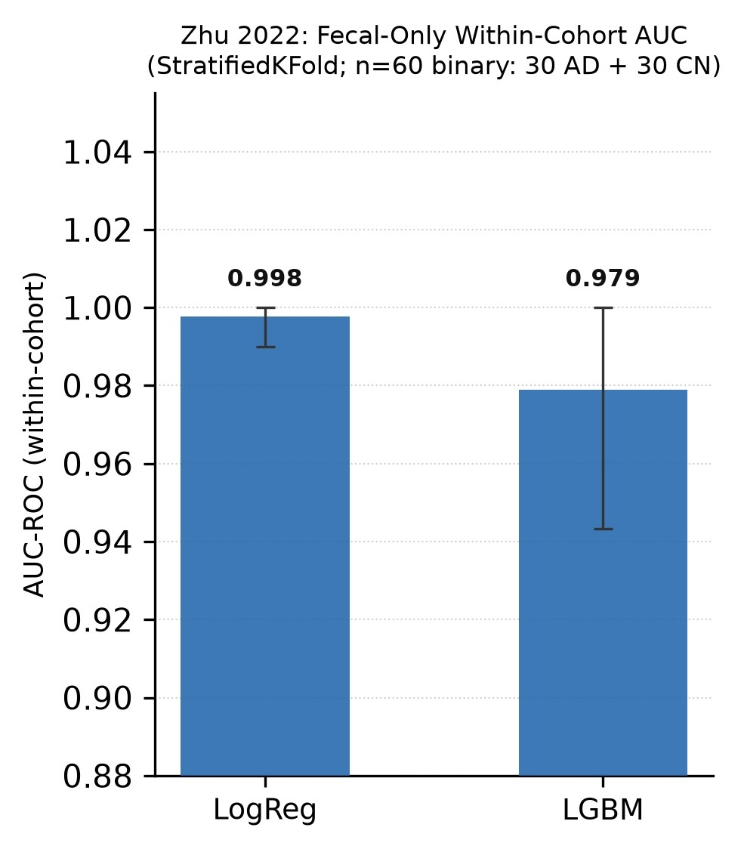
Source figure: results/figures/final_supplementary/Figure_S1.jpg

Figure S2. Top-15 SHAP Taxa Per Cohort (LightGBM, Out-of-Fold)
Caption: Horizontal bar charts showing mean |SHAP| value (CLR units) for the top-15 genera by importance in each of the four labeled cohorts under out-of-fold LightGBM evaluation. Bars are a single neutral color and show feature-importance magnitude only — no AD/CN direction is assigned, because a tree ensemble has no single coefficient-like global direction and LightGBM’s SHAP-feature relationships may be nonlinear or non-monotonic (Section 2.8). Top taxon per cohort (by |SHAP| magnitude only): Lachnoclostridium (Zhuang 2018, |SHAP|=0.560), Akkermansia (Ling 2020, |SHAP|=0.947), Bacteroides (Zhu 2022, |SHAP|=1.243), Castellaniella (Kazakhstan, |SHAP|=0.614). Mean pairwise Jaccard similarity at top-20: 0.058, significant against the shared-pool null (p=0.0048 at N=20; not significant at N=10, p=0.45; Table S7) but not significant at any N against the prevalence-restricted null (Table S13). No LightGBM directional-flip claim is made anywhere in this paper, because a tree ensemble has no single coefficient-like global direction (Section 2.8).
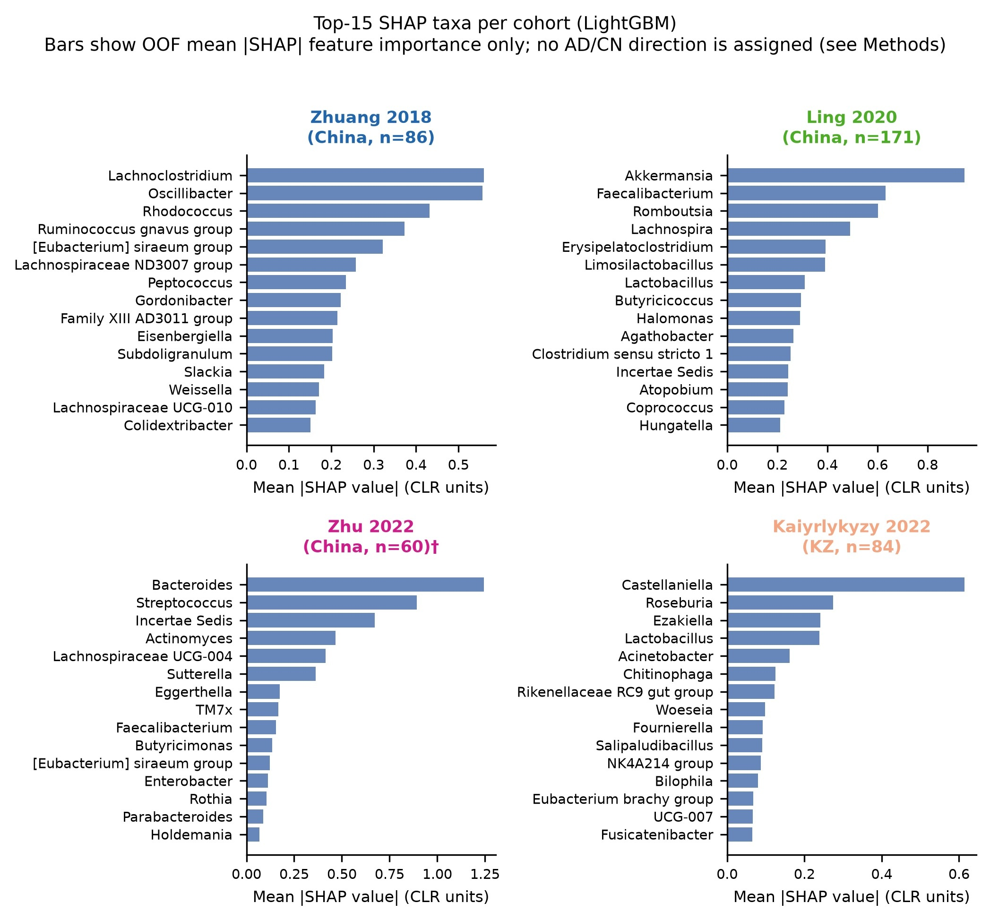
Figure S2
Source figure: results/figures/final_supplementary/Figure_S2.jpg

Figure S3. Sensitivity Analysis: LOCO AUC Under Cohort Exclusion
Caption: Sensitivity analysis: LOCO AUC under three cohort exclusion configurations. Each panel shows the 3-cohort LOCO experiment with one cohort excluded from the full analysis. Left: excluding Kazakhstan (Zhuang+Ling+Zhu trained, each held out in turn). Center: excluding Zhuang 2018. Right: excluding Ling 2020. Error bars = 95% bootstrap CI (1,000 resamples on the test-set predictions; the non-stratified procedure described in Section 2.5, not the diagnosis-stratified 10,000-replicate procedure used for the main four-cohort LOCO results). Generalization degradation persisted across all three prespecified cohort-exclusion configurations.
Source data: results/tables/sensitivity_loco.csv 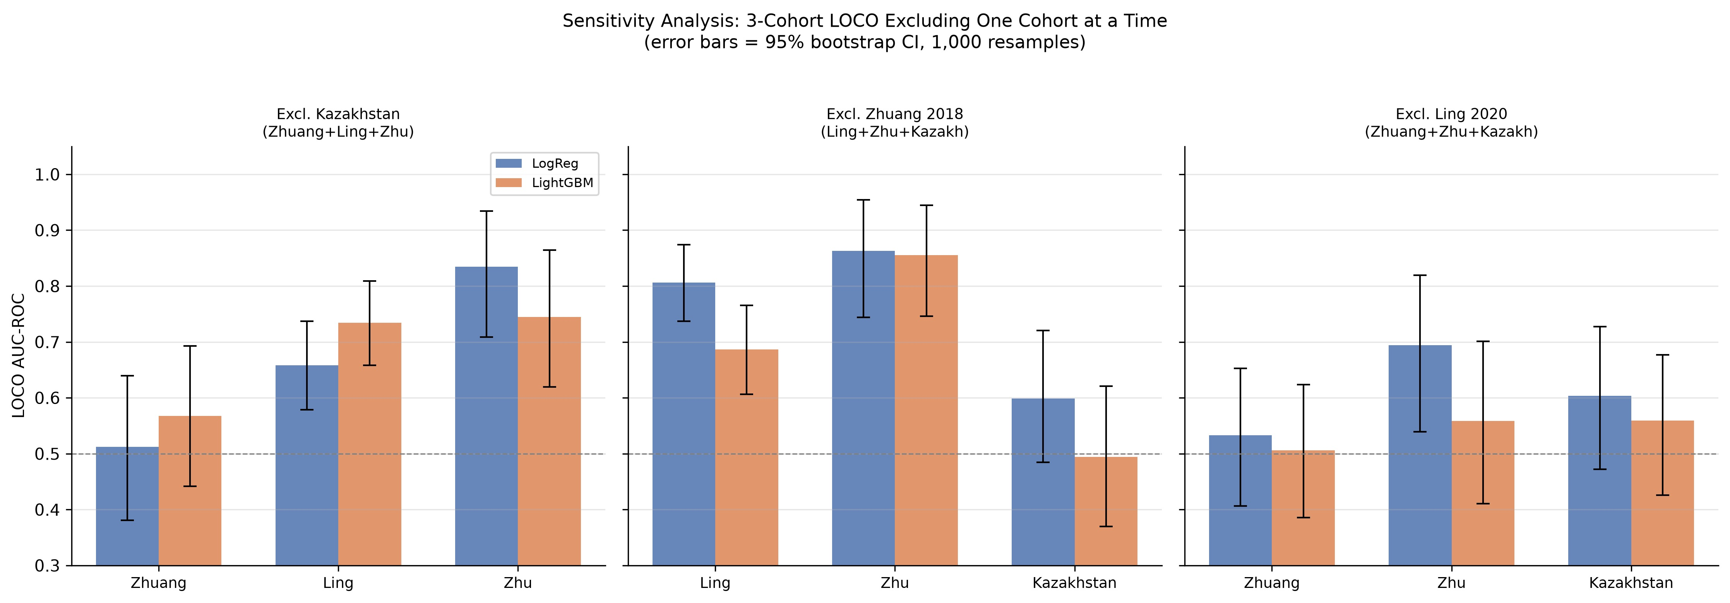
Source figure: results/figures/final_supplementary/Figure_S3.jpg

Figure S4. Batch Correction, Label-Informed Design (Exploratory Sensitivity)
Caption: LOCO AUC-ROC under the label-informed transductive batch-correction design (ComBat-seq/MMUPHin fit using every sample’s own true diagnosis label; Section 2.7), shown for (A) logistic regression and (B) LightGBM. Error bars = 95% bootstrap CI (1,000 resamples on the test-set predictions, the same non-stratified procedure used for Table 4/Figure 5; not part of the diagnosis-stratified 10,000-replicate regeneration in Section 2.5.2). This design is retained as an explicitly-labeled exploratory sensitivity analysis only, because a correction step that is fit using every sample’s own true diagnosis label cannot estimate prospective external-validation performance, and because the resulting within-cohort AUC on corrected data cannot be used as evidence that genuine, correction-independent biological signal survived (Section 3.5). The main-text Figure 5 shows the label-blind design (no diagnosis information used during correction), which is the paper’s primary batch-correction result. Note the severe, cohort-specific degradation visible here (e.g., Kazakhstan logistic regression LOCO AUC=0.308) that is not reproduced under the label-blind design (Kazakhstan label-blind LOCO AUC=0.560, closely matching the uncorrected value of 0.564) — indicating this degradation was driven substantially by the label-informed design itself.
Source data: results/tables/auc_comparison_table.csv, results/tables/loco_auc_corrected.csv 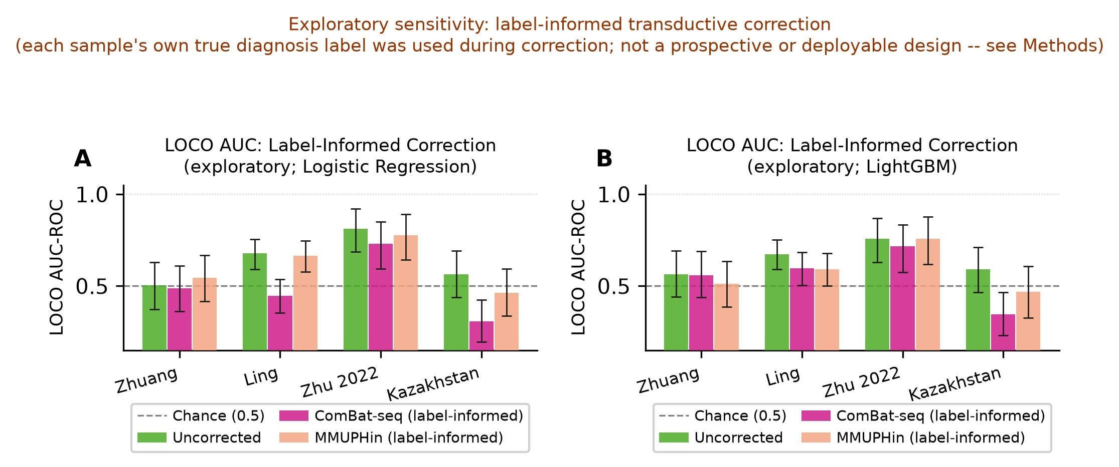
Source figure: results/figures/final_supplementary/Figure_S4.jpg

Figure S5. Zhu 2022 Robustness: Repeated Cross-Validation and Label Permutation
Caption: Robustness analyses for Zhu 2022’s near-perfect within-cohort AUC (Section 2.4.1, Section 3.2), both run under the strict training-only feature-selection pipeline. Top row: distribution of pooled-OOF AUC across 50 repetitions of the nested-CV partition (different pre-specified seed per repetition) for logistic regression (left) and LightGBM (right), with the single-partition training-only AUC marked. Bottom row: null distribution of pooled-OOF AUC under label permutation (labels shuffled, class balance preserved, entire training-only pipeline re-run inside every outer fold for each permutation), with the observed single-partition AUC marked and the empirical p-value shown in the panel title. The repeated-CV panels quantify sensitivity to fold assignment on the same 60 participants (not independent replication); the permutation panels are the formal test of whether the observed AUC exceeds a chance-label null.
Source data: results/tables/zhu_repeated_nested_cv.csv, results/tables/zhu_label_permutation.csv. 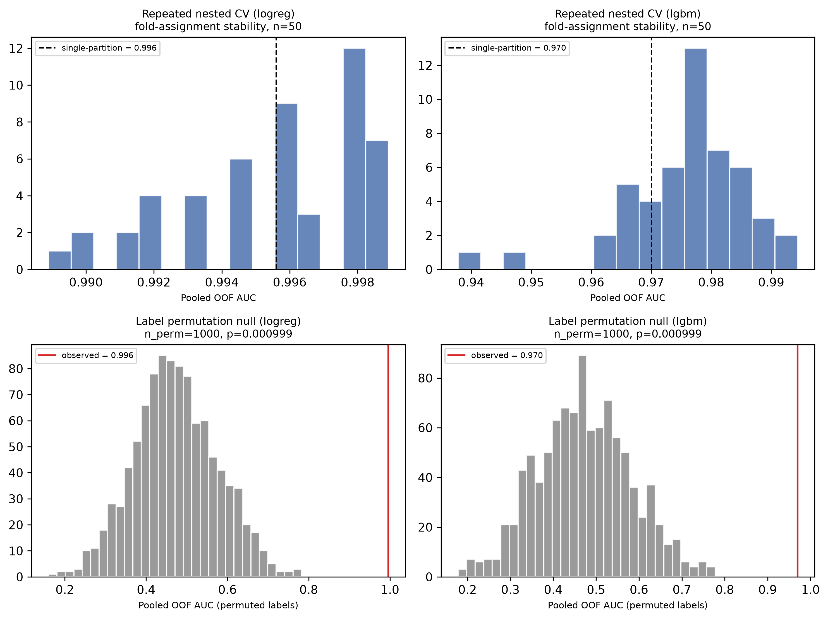
Source figure: results/figures/final_supplementary/Figure_S5.png

Supplementary Notes

Note S1. Kim/KBASE 2022 (PRJEB50447) — IRB Restriction on Per-Sample Diagnosis Labels
Summary: The Kim/KBASE 2022 cohort (78 participants; South Korea; 18 amyloid-PET positive preclinical AD, 60 cognitively normal) was excluded from all supervised classifier analyses because per-sample amyloid-PET status and group labels are not publicly deposited in any data archive.
Documentation of exhaustive metadata search conducted 2026-06-20:
The following metadata sources were queried for per-sample diagnosis labels:
- ENA Portal filereport (https://www.ebi.ac.uk/ena/portal/api/filereport?accession=PRJEB50447&result=read_run&fields=all): All sample fields including sample_alias, sample_title, scientific_name, sample_description — no diagnostic labels present. Fields contain sequencing run identifiers only.
- ENA BioSample XML: Retrieved individual BioSample records via ENA Browser. Attributes present: collection date, geographic location, library strategy/layout — no diagnosis, amyloid status, or clinical phenotype fields.
- NCBI SRA runinfo (via esearch -db sra -query "PRJEB50447" | efetch -format runinfo): Confirmed SRA runinfo does not contain phenotype data beyond SRA-standard fields. Disease column is empty for all runs.
- Sample alias and title fields: sample_alias values are coded identifiers (e.g., “KBASE-CN-001”) without diagnostic information inferrable from the coding scheme.
Published paper finding: The corresponding publication (Kim et al., 2022; PRJEB50447) reports group-level counts (18 amyloid-positive preclinical AD; 60 cognitively normal) and notes that per-sample data are withheld under institutional IRB protocol. The amyloid-PET classifications are considered clinical data and are protected. The published paper does not provide a supplementary file with per-sample labels.
Consequence for analysis: kbase2022 was included only in PERMANOVA variance decomposition (Phase 4), where cohort identity — not per-sample diagnosis — is the grouping variable of interest. All supervised classifier training, evaluation, batch correction, and SHAP analyses were restricted to the four labeled cohorts (Zhuang 2018, Ling 2020, Zhu 2022, Kazakhstan).
Additional caveat: Even if per-sample labels were available, direct comparison with the other four cohorts would require caution. Kim/KBASE 2022 uses amyloid-PET positivity as the case definition (preclinical AD — cognitively normal by neuropsychological testing but amyloid-positive), while the other four cohorts use clinical AD diagnosis (cognitive impairment criterion). These phenotype definitions are not equivalent.
Recommendation for future analyses: Researchers wishing to include Kim/KBASE 2022 in supervised analyses should contact the study team (KBASE Consortium / corresponding author of Kim et al., 2022) to request a data use agreement for per-sample amyloid-PET status.
Cohort search strategy and full inclusion/exclusion record: The cohort identification search (Section 2.1) queried NCBI SRA and EBI-ENA for studies deposited before January 2025, using the following search string in the SRA search interface: ("Alzheimer's disease" OR "Alzheimer disease" OR "mild cognitive impairment" OR "MCI" OR "dementia") AND ("gut microbiome" OR "gut microbiota" OR "intestinal microbiome" OR "16S rRNA") AND ("Homo sapiens"). For supervised analyses, inclusion required: (1) per-sample diagnosis labels (AD, MCI, or CN) accessible in public metadata; (2) raw FASTQ files or quality-filtered reads deposited in a public archive; (3) a minimum of 40 participants per cohort. Studies were excluded from supervised analyses if per-sample labels were IRB-restricted, if data had not been publicly released at the time of analysis, or if samples represented a tissue compartment other than fecal microbiome as the primary analyte; shotgun metagenomic cohorts meeting all other criteria were identified but excluded to avoid mixing amplicon and whole-genome sequencing platforms within the same analysis. Beyond the Kim/KBASE 2022 IRB restriction documented above, one further identified cohort was excluded on public-availability grounds: ALBION 2025 (Maraki et al., Journal of Alzheimer’s Disease, 2025; PRJNA1297934), a Greek cohort of 99 participants (50 MCI, 49 CN; V3–V4) — the only European 16S cohort identified in the search — was confirmed as the correct accession from the published paper, but NCBI BioProject reported the deposit as not yet publicly released as of the search date. ALBION was therefore excluded from the active cohort set; it remains the most direct candidate for a future sixth cohort should the data be released.

Note S2. Kazakhstan Single-End Processing Rationale
Summary: The Kazakhstan cohort (PRJNA811324; Kaiyrlykyzy et al., 2022) was confirmed as single-end sequencing and processed using the DADA2 single-end workflow. This document explains the processing decisions made.
Confirmation of single-end format: After downloading all 84 samples with fasterq-dump, output files were SRR*_1.fastq only (no SRR*_2.fastq files). This was independently confirmed by inspecting SRA metadata (LibraryLayout=SINGLE). The original publication describes NovaSeq sequencing of V3–V4 amplicons.
Truncation length decision (250 bp): Quality profile inspection of Kazakhstan reads showed a characteristic NovaSeq quality pattern: high-quality bases through approximately position 250 bp, with rapid quality decline thereafter. MiSeq 2×300 bp paired-end reads for V3–V4 have effective merged read lengths of approximately 400–450 bp; single-end NovaSeq reads truncated at 250 bp cover a shorter portion of the amplicon. The truncLen parameter was set to 250 bp after visual inspection of perposition quality score profiles across 10 representative samples.
Implications for taxonomic resolution: Single-end reads provide lower taxonomic resolution than paired-end merged reads for the same amplicon region, because the additional bases from the reverse read improve amplicon coverage and reduce ambiguous taxonomic assignments. This means genus-level assignments for Kazakhstan may be slightly less accurate than for the four paired-end cohorts, and species-level analysis would be more affected than genus-level. We acknowledge this as a limitation of the mixed-library-design dataset.
DADA2 workflow difference: The single-end workflow did not include mergePairs(). The full single-end DADA2 pipeline applied: filterAndTrim() → learnErrors() → dada() → makeSequenceTable() → removeBimeraDenovo(). Error learning was performed independently on Kazakhstan samples; sharing error models across cohorts would be inappropriate because error profiles differ by sequencer and run.
Interaction with batch correction: The single-end/paired-end asymmetry is an additional source of between-cohort technical heterogeneity that batch correction methods cannot fully address, because the fundamental difference in read length and sequencing chemistry affects all genera’ abundance estimates rather than a subset. This is a study limitation that applies to any analysis including Kazakhstan and should be acknowledged in the Methods section of any manuscript using this dataset.

Note S3. LOCO SHAP Direction Not Reported
No figure or table showing a signed AD/CN direction for LOCO SHAP values is included in this paper. Mean signed SHAP is not a valid direction statistic in general (Section 2.8), and this is especially severe for LOCO SHAP specifically: the SHAP background (the three pooled training cohorts) and the evaluation set (the held-out cohort) are drawn from systematically different populations by construction, so the sign of a LOCO mean SHAP value is confounded with the raw cross-cohort compositional difference quantified by PERMANOVA (Section 3.4), independent of anything the model learned. No coefficient-based replacement direction is offered for LOCO SHAP either, because LOCO models are refit on pooled multi-cohort training data each time and a single stable-fold coefficient analysis analogous to Section 2.8’s within-cohort procedure is not part of this design.
LOCO SHAP feature importance (mean |SHAP|, magnitude only, no direction) remains available and is unaffected by this issue: see results/tables/shap_loco_importance.csv. For reference, the top-importance genus per held-out cohort is: Zhuang 2018 — Akkermansia (logistic regression |SHAP|=0.470); Ling 2020 — Subdoligranulum (|SHAP|=0.269); Zhu 2022 — Akkermansia (|SHAP|=0.372); Kazakhstan — Christensenellaceae R-7 group (|SHAP|=0.368); no genus ranked first across all four held-out conditions for either model (Section 3.6).

End of Supplementary Materials

