

Practices for Secure Software Report

Table of Contents
Document Revision History 3
Client 3
Instructions 3
Developer 4
1. Algorithm Cipher 4
2. Certificate Generation 4
3. Deploy Cipher 4
4. Secure Communications 4
5. Secondary Testing 4
6. Functional Testing 4
7. Summary 4
8. Industry Standard Best Practices 4

Document Revision History

Version | Date | Author | Comments
1.0 | 08/04/2023 | Carlos Affonso

Client



Instructions

Submit this completed practices for secure software report. Replace the bracketed text with the relevant information. You must document your process for writing secure communications and refactoring code that complies with software security testing protocols.

- Respond to the steps outlined below and include your findings.
- Respond using your own words. You may also choose to include images or supporting materials. If you include them, make certain to insert them in all the relevant locations in the document.
- Refer to the Project Two Guidelines and Rubric for more detailed instructions about each section of the template.

Developer
Carlos Affonso

Algorithm Cipher

When it comes to encryption methods, they are two groups that you can choose from, and that’s symmetric or asymmetric. Symmetric favors speed and uses one key to encrypt and decrypt, while asymmetric is slower and contains two keys, one public to encrypt, and one hidden to decrypt data. Because this project is user facing, I chose to take a symmetric algorithm, trading some security for speed. For this, I chose AES, which works by transforming an input’s bytes by a given key. To add another layer of security, I hashed the key with SHA-256.

Certificate Generation
Insert a screenshot below of the CER file.

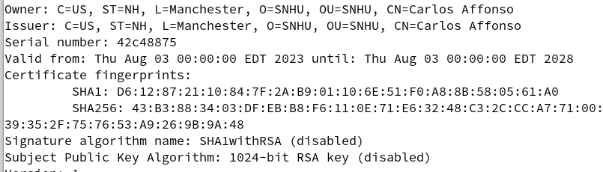

Deploy Cipher
Insert a screenshot below of the checksum verification.

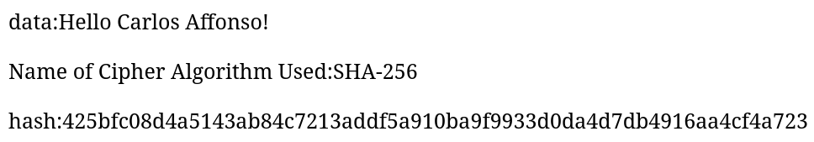

Secure Communications
Insert a screenshot below of the web browser that shows a secure webpage.


Secondary Testing
Insert screenshots below of the refactored code executed without errors and the dependency-check report.

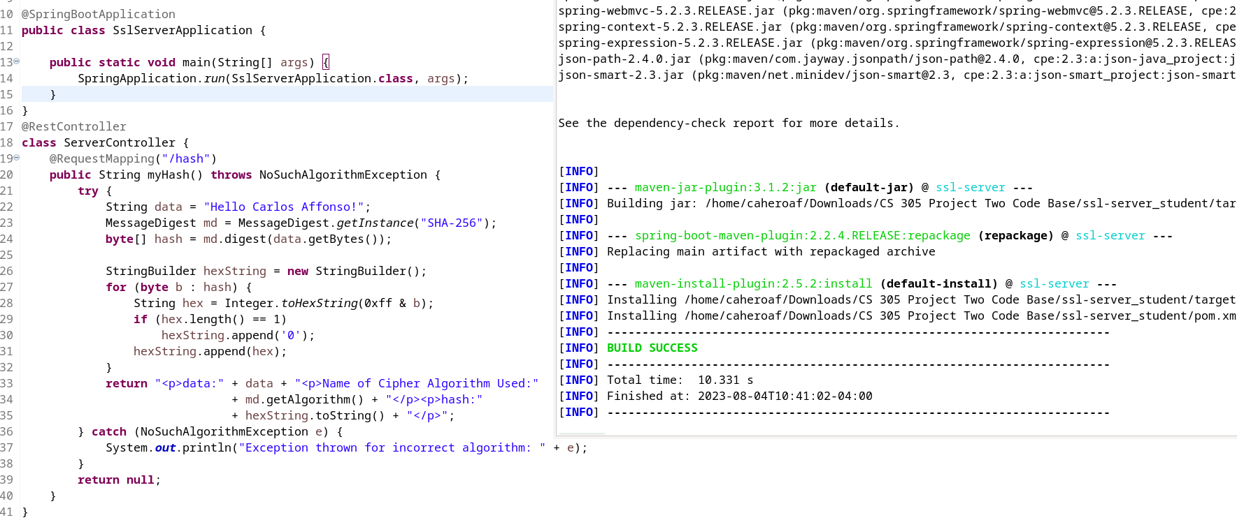
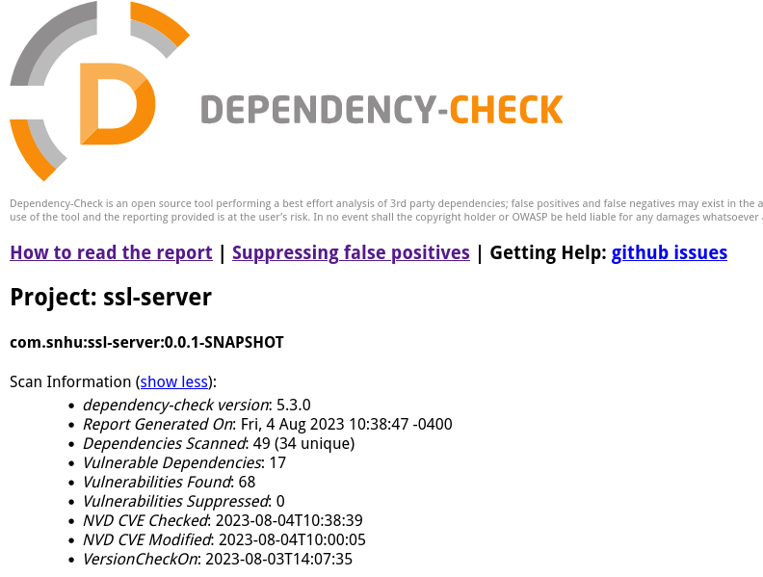

Summary

I addressed the code by migrating it to Java 17, and then using the latest version of the spring framework. I then suppressed the remaining vulnerabilities, which included an issue with two dependencies, for which I could do nothing to fix.

Industry Standard Best Practices

Refactoring the code was done securely and added no new vulnerabilities. I made sure to not use deprecated methods or classes. Ensuring that we use best practices keeps our code maintainable and resistant to any exploits that may surface in the future.

