My program creates a Linked List based on two structures: the node, and the list. The node contains the data (I chose to use an integer), and a pointer to the next node. The Linked List struct contains a pointer to the head node of the list, the tail node of the list, and the pthread mutex variable. In main, the list variable is declared using the predefined struct. When the makeList function is called, the parameter sent is the list variable—by reference. The head and tail are assigned to null, and the mutex variable is initialized for threading. Back in main, a thread is initialized and created, with the threadFunction as its role and the list created as its object. It’s then joined again to synchronize everything.
The program doesn’t require input. The output should print counts from 0 to 100 and back down to 1 once, then do it again, skipping the first 10, and then again with -99 at the beginning. The entire list is then deleted, and an extra deletion is attempted once the list is empty. It prints once after deleting -99, then again after deleting the first 0-99, then when 0 is attempted for deletion, it prints an error message, and the last print outputs nothing except the List: prompt, because the list is empty.

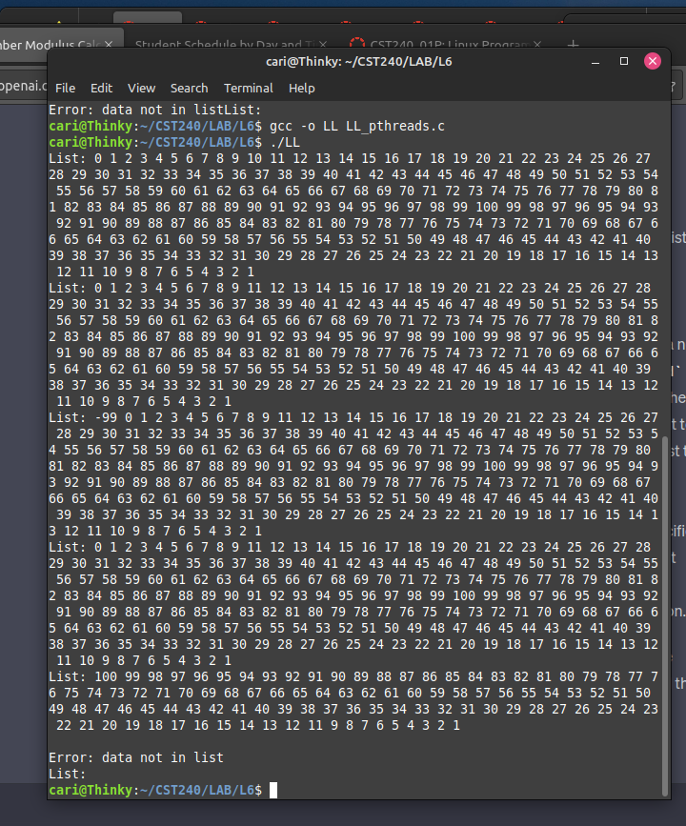
I asked chat GPT for help with writing some of this code. I am genuinely proud for fixing and writing what I did, given my feelings about linked lists and how incredibly confusing I find pThreads.
The list doesn’t sort, insert anywhere except the head or tail, and it doesn’t handle anything except integers. The deleteNode code, as it’s written, once it finds the first instance of an integer in the linked list, deletes that and no more. So, if the list is 10, 10, 10, 10, after trying to delete 10, it’s 10, 10, 10. It handles negative numbers. Trying to add non-integer data just causes the code not to compile, so that’s no fun.

I have no idea what else to write here, but here’s a screenshot of a run:

