O r e g o n I n s t i t u t e o f T e c h n o l o g Y

S m a r t S t e p p e r
W i t h B I o f e e d b a c k f o r t o e - w a l k e r s

P r o p o s a l b y :
Cari Blaker
Ismael Hernandez Hernandez
Ian Gaffney
Zachary Elliott

Table of Contents
List of figures 2
List of tables 3
1.0 Abstract 4
2.0 Requirements 6
2.1 Hardware 6
2.2 Software 7
3.0 Device Overview 7
3.1 hardware modules 8
3.1.1 Seeed Studio nRF52840 Microcontroller 8
3.1.1.1 IMU: LSM6DS3tR 10
3.1.1.2 Bluetooth 12
3.1.3 Haptic Vibrator 15
3.1.4 Bangle.Js 2.0 smart Watch 15
3.1.5 Power 17
3.1.6 3d Filaments 19
3.1.6.1 Thermoplastic elastomers (TPE) 19
3.1.6.2 Thermoplastic polyurethane (TPU) 20
3.2.1 Bangle.js 2 – JavaScript via ESPRUINO 21
3.2.2 Smart Phone Apps 22
3.2.3 Seeed board - Arduino (C) 23
3.2.3 Prusa Slicer 2.6.1 & Fusion 360 25
4.0 Costs 25
5.0 Technical Problems 27
6.0 Product Markets 32
Appendix A: Schematics 33

List of figures
Figure Number | Figure Name | Page
Figure 1 | Device Overview Block Diagram | 8
Figure 2 | Seeed Microcontroller Diagram | 11
Figure 3 | IMU Pinout | 12
Figure 4 | NFCT Control Register Block Diagram | 14
Figure 5 | NFCT overview | 15
Figure 6 | Additional NRF capacitance requirement diagram | 15
Figure 7 | NRF additional capacitance requirement equations | 16
Figure 8 | Bangle.JS 2 hardware diagram | 17
Figure 9 | MCP73833 Charger Diagram | 20
Figure 10 | Problems Hierarchical Diagram | 34

List of tables
Table Number | Table Name | Page
Table 1 | Seeed studio Microcontroller Specifications | 10
Table 2 | IMU Pin Description | 13
Table 3 | Smart Watch Power Analytics | 18
Table 4 | TPE pro/con list | 22
Table 5 | TPU pro/con list | 23
Table 6 | Preliminary Physical Costs | 28

1.0 Abstract
This project entails the design and assembly of a shoe and insole with embedded sensors to measure a person’s gait, connected to an app (for both a phone and a smart watch) that measures the amount of toe strikes vs. heel strikes, as well as providing a game to encourage the user to practice walking with a healthy gait. The team is working with Dr. Marybeth GrantBeuttler and her staff to achieve her mission of helping children who walk on their toes-- "toe-walkers.”
Toe-walking, according to Marybeth, is a concern that affects five percent of the population—leading to other health problems over time. Currently, beyond this project and Marybeth’s previous related work, there are no solutions to toe-walking that have proven effective. Physical therapy only works while the child is in the building--they leave on their toes and walk back in on their toes. Other versions of these digital insoles/shoes have shown significant improvement in the small sample size Marybeth has worked with, and this project version is designed to make an even bigger impact.
Each shoe (there will be two) is planned to contain an insole, created by the project team, with five piezoelectric sensors, a haptic vibrator, a microcontroller, and a battery. The sensors will provide input to the microcontroller. The microcontroller will be programmed to output to the haptic vibrator based on the sensor input; the vibration will remind the user to adjust their gait if necessary. The microcontroller will Bluetooth to a smart watch, and there will be an app designed for phones, as well. The smart watch will be programmed to show feedback from the day’s collected gait information and real-time feedback via interactivity. An interactive game will encourage users to practice their walking while having fun! Phone apps will contain all collected feedback over the device's life and transmission options to share this information with health care providers.
The team for this project consists of Cari Blaker, Ismael Hernandez, Zachary Elliott, and Ian Gaffney. Each of us has reached Junior standing at the Oregon Institute of Technology and have taken this challenge as our Junior Project. We are privileged and excited to work on something innovative that will make a real difference in the world, impact global health, while also collaborating with a new program for the first time in our campus’s history.
This proposal aims to detail the hardware and software requirements, identify all markets, recognize all potential problems, pre-empt solutions for those problems, as well as perform a detailed cost-analysis of the project, identify all markets, recognize all potential problems, pre-empt solutions for those problems, as well as perform a detailed cost-analysis of the project.

2.0 Requirements

2.1 Hardware
The hardware used for the project should meet the following requirements:
- Bluetooth capability
- On-chip memory in case Bluetooth signal is lost
- Wireless operation
- Battery life of greater than twelve hours
- Recharging capability
- Cooling/aeration system
- Battery, sensor, and chip protection
- Input/Output for Piezoelectric sensors and Haptic Vibrator—at least 5 analog input ports
- Calibration
- Real Time Feedback to User
- Discreet enough not to be obviously a medical device to avoid social stigma.

2.2 Software
The software used for the project should meet the following requirements:
- Cross-device compatibility
- Real Time Clock
- Data export and security
- Companion app
- User profiles
- Game logic

3.0 Device Overview
The block diagram below details the design of one shoe, which is mirror-duplicated in another shoe. Five piezo electric sensors in each shoe connect to their respective microcontrollers through I/O pins. The SEEED microcontroller is powered by a 3.7V battery. A haptic vibrator connects to each microcontroller through I/O pins, providing vibrational feedback based on the input of the sensors. Each microcontroller is Bluetooth connected to a Bangle.JS smart watch, which is also Bluetooth connected when in range to a smart phone—calibrated through the app.
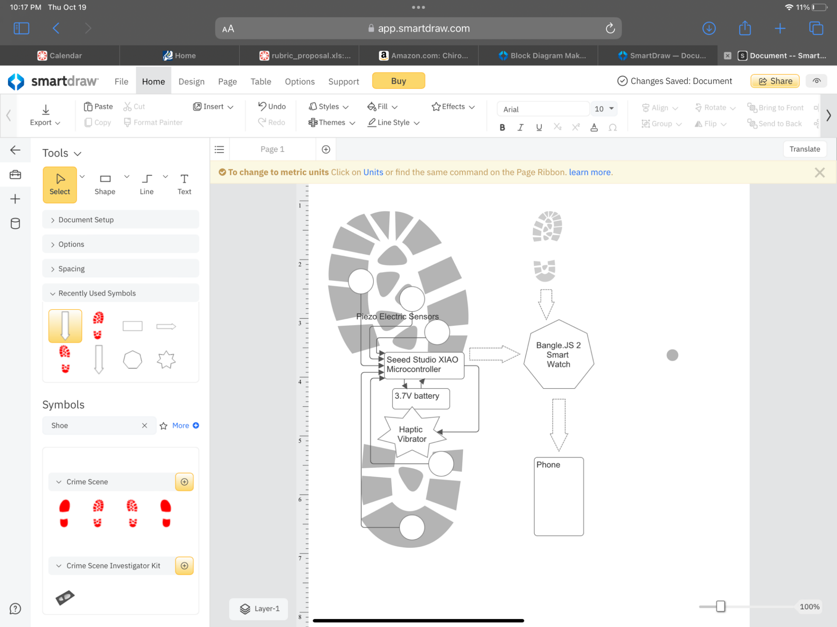
Figure 1: Device Overview Block Diagram

3.1 hardware modules

3.1.1 Seeed Studio -Microcontroller
The relevant specifications for this microcontroller are detailed in the table below:
Feature | Specifications
Nordic nRF52840 chip w/ FPU | 62 MHz, ARM Cortex –M4 32-bit processor
Onboard Bluetooth 5.0 antenna | -95 dBm sensitivity in 1 Mbps Bluetooth low energy mode  -103 dBm sensitivity in 125 kbps low energy mode (long range  -20 to +8 dBm TX power, configurable in 4 dB steps  128-bit AES/ECB/CCM/AAR co-processor (on-the-fly packet encryption)  4.8 mA peak current in TX, 4.6 mA peak current in RX
Power | Circuit operating voltage: 3.3V@200mA  Charging current: 50mA/100mA  1.7 to 5.5 V supply voltage range  1.8 to 3.3 V regulated supply for external components  Standby power consumption: <5μA
Size | 21x17.5 mm
On-chip Memory | 1 MB flash  256kB RAM
Onboard Memory | 2 MB QSPI flash
I/O | 11 digital pins (can be configured for PWM)  6 analog pins  all pins have a max rating of 3.3V
Software compatibilities | Arduino, Micropython, CircuitPython
Dimensions | 21 x 17.5 mm
Sensors | Onboard 6-axis IMU
Table 1: Seeed studio Microcontroller Specifications
The Seeed Studio microcontroller receives feedback through five analog I/O ports from five piezoelectric sensors. The sensor feedback is used for digital output signal to the haptic vibrator. The IMU is used to sense the tilt of the board, for further feedback about the user’s gait. Onboard memory is used to store information from the sensors and the IMU. This information is then transmitted via Bluetooth connection. The exact type of Bluetooth connection and the TX method is to be determined later.
The small form factor of 21mm X 17.5mm makes this chip ideal for small projects such as this. With five piezoelectric sensors and one haptic feedback motor, this project uses five out of six of the onboard analog pins. If, during testing, it is determined that larger numbers of analog devices are required for accurate feedback, and consolidation of these devices onto fewer pins is not possible, then the board may need to swap to a larger board (such as the Adafruit Feather 32u4 Bluefruit, which is much larger but has significantly more pins due to that increase in surface area). See Figure 2 for seeed board pinouts, and Appendix A Part 1 & 2.
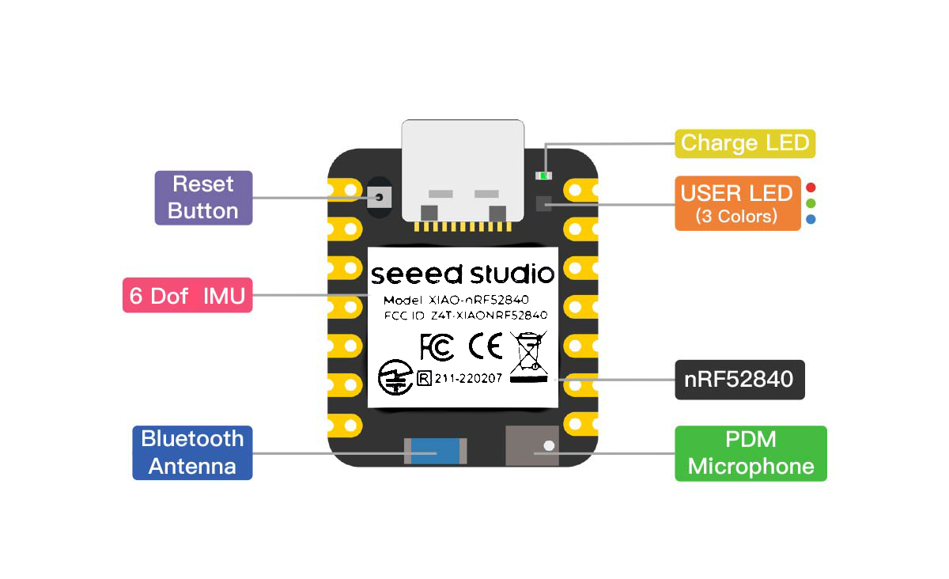
Figure 2: Seeed Microcontroller Diagram

3.1.1.1 IMU: LSM6DS3tR
This IMU is used in the project for detection of foot tilt. It is the iNEMO inertial module: always-on 3D accelerometer and 3D gyroscope. It is an embedded component on the Seeed Studio nRF52840 Microcontroller. While the sensors measure pressure on five distinct parts of the foot, the built-in IMU in the Seeed microcontroller provides further detail about exactly how a user’s foot is moving in space and hitting the ground. It detects when the angle between a selectable accelerometer semi-axis and the horizontal plane becomes higher than a user-selectable value.
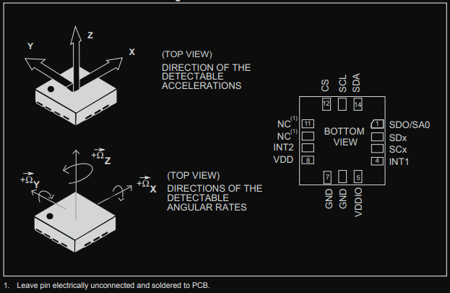
Figure 3: IMU Pinout

Pin# | Name | Mode 1 Function | Mode 2 function
1 | SDO/SA0 | SPI 4-wire interface serial data output (SDO) I²C least significant bit of the device address (SA0) | SPI 4-wire interface serial data output (SDO) I²C least significant bit of the device address (SA0)
2 | SDx | Connect to VDDIO or GND | I²C serial data master (MSDA)
3 | SCx | Connect to VDDIO or GND | I²C serial clock master (MSCL)
4 | INT1 | Programmable interrupt 1
5 | VDDIO⁽¹⁾ | Power supply for I/O pins
6 | GND | 0 V supply
7 | GND | 0 V supply
Pin# | Name | Mode 1 Function | Mode 2 function
9 | INT2 | Programmable interrupt 2 (INT2)/ Data enable (DEN) | Programmable interrupt 2 (INT2)/ Data enable (DEN)/ I²C master external synchronization signal (MDRDY)
10 | NC⁽³⁾ | Leave unconnected
11 | NC⁽³⁾ | Leave unconnected
12 | CS | I²C /SPI mode selection (1: SPI idle mode / I²C communication enabled; 0: SPI communication mode / I²C disabled) | I²C /SPI mode selection (1: SPI idle mode / I²C communication enabled; 0: SPI communication mode / I²C disabled)
13 | SCL | I²C serial clock (SCL) SPI serial port clock (SPC) | I²C serial clock (SCL) SPI serial port clock (SPC)
14 | SDA | I²C serial data (SDA) SPI serial data input (SDI) 3-wire interface serial data output (SDO) | I²C serial data (SDA) SPI serial data input (SDI) 3-wire interface serial data output (SDO)
Table 2 IMU Pin Description

3.1.1.2 Bluetooth
The seeed board’s Bluetooth capabilities have been tested for a reliable 100 meters, but only without obstruction. The Bluetooth connection for this project has obstacles—namely, a shoe and a body. This could pose connection issues. This is a hurdle that must be crossed in real time.
The NFCT peripheral has NFC-A listen-mode operation at a 13.56 MHz input frequency and a bit rate of 106 kbps. The frame timing controller is programmable, and there is integrated automatic collision resolution (which can be enabled or disabled), cyclic redundancy check, parity functions, and a built-in frame disassembly/assembly unit. The two pins used for the antenna on the device (J24 [NFC2] & L24 [NFC1]) are shared with GPIOs; those GPIOs are not used in our design specifically to avoid voltage conflicts that would disable Bluetooth functionality.
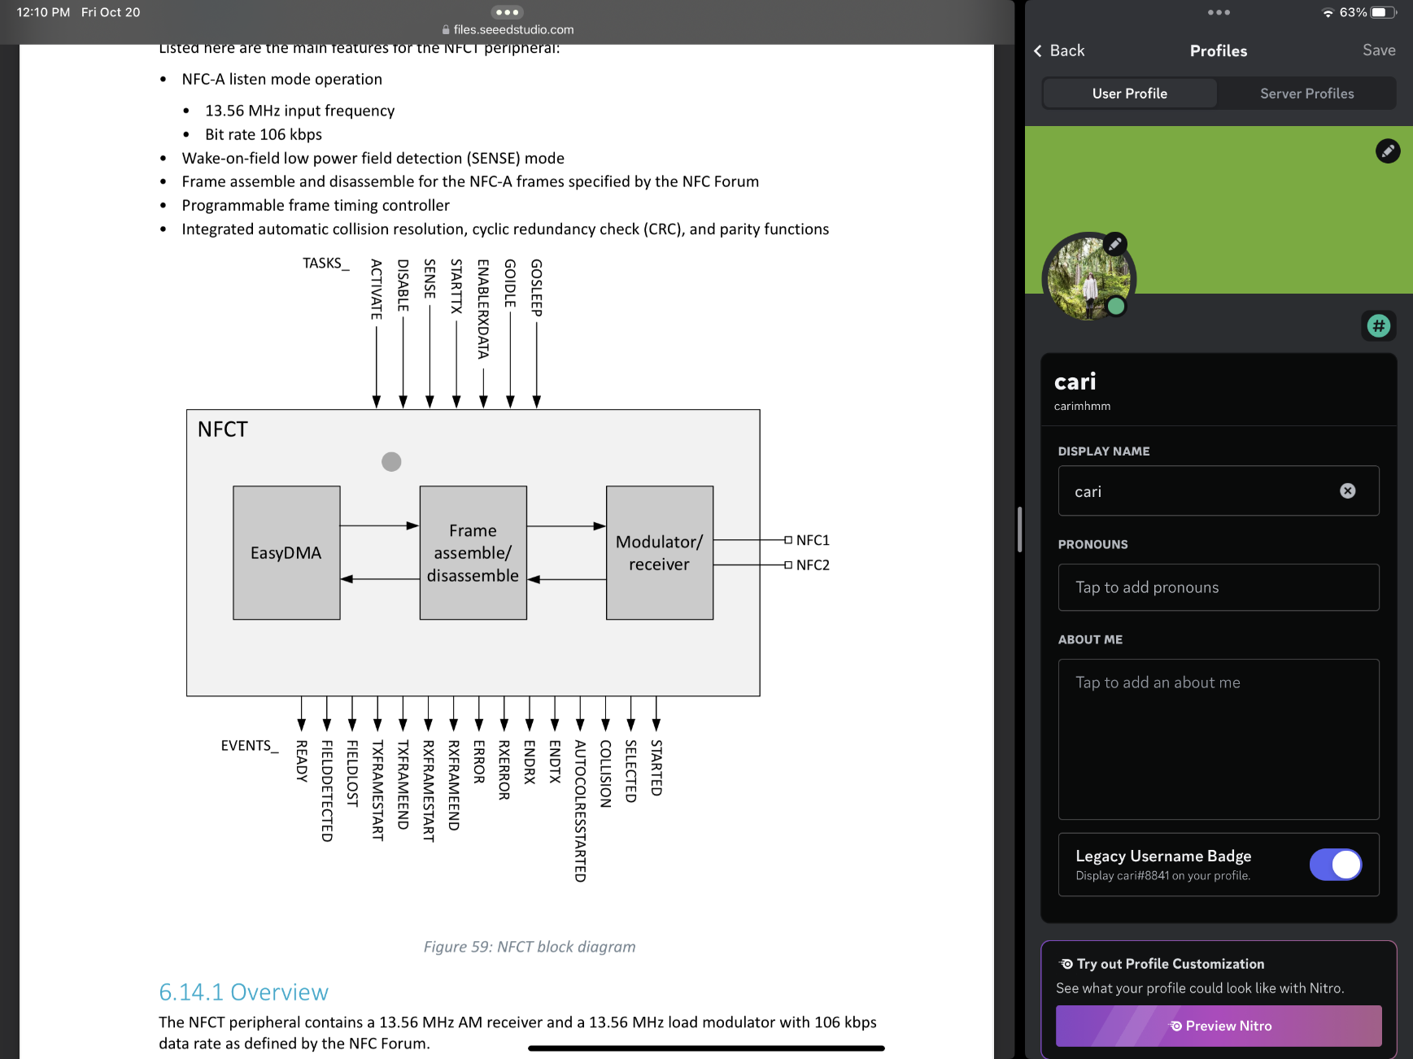
Figure 4: NFCT Control Register Block Diagram
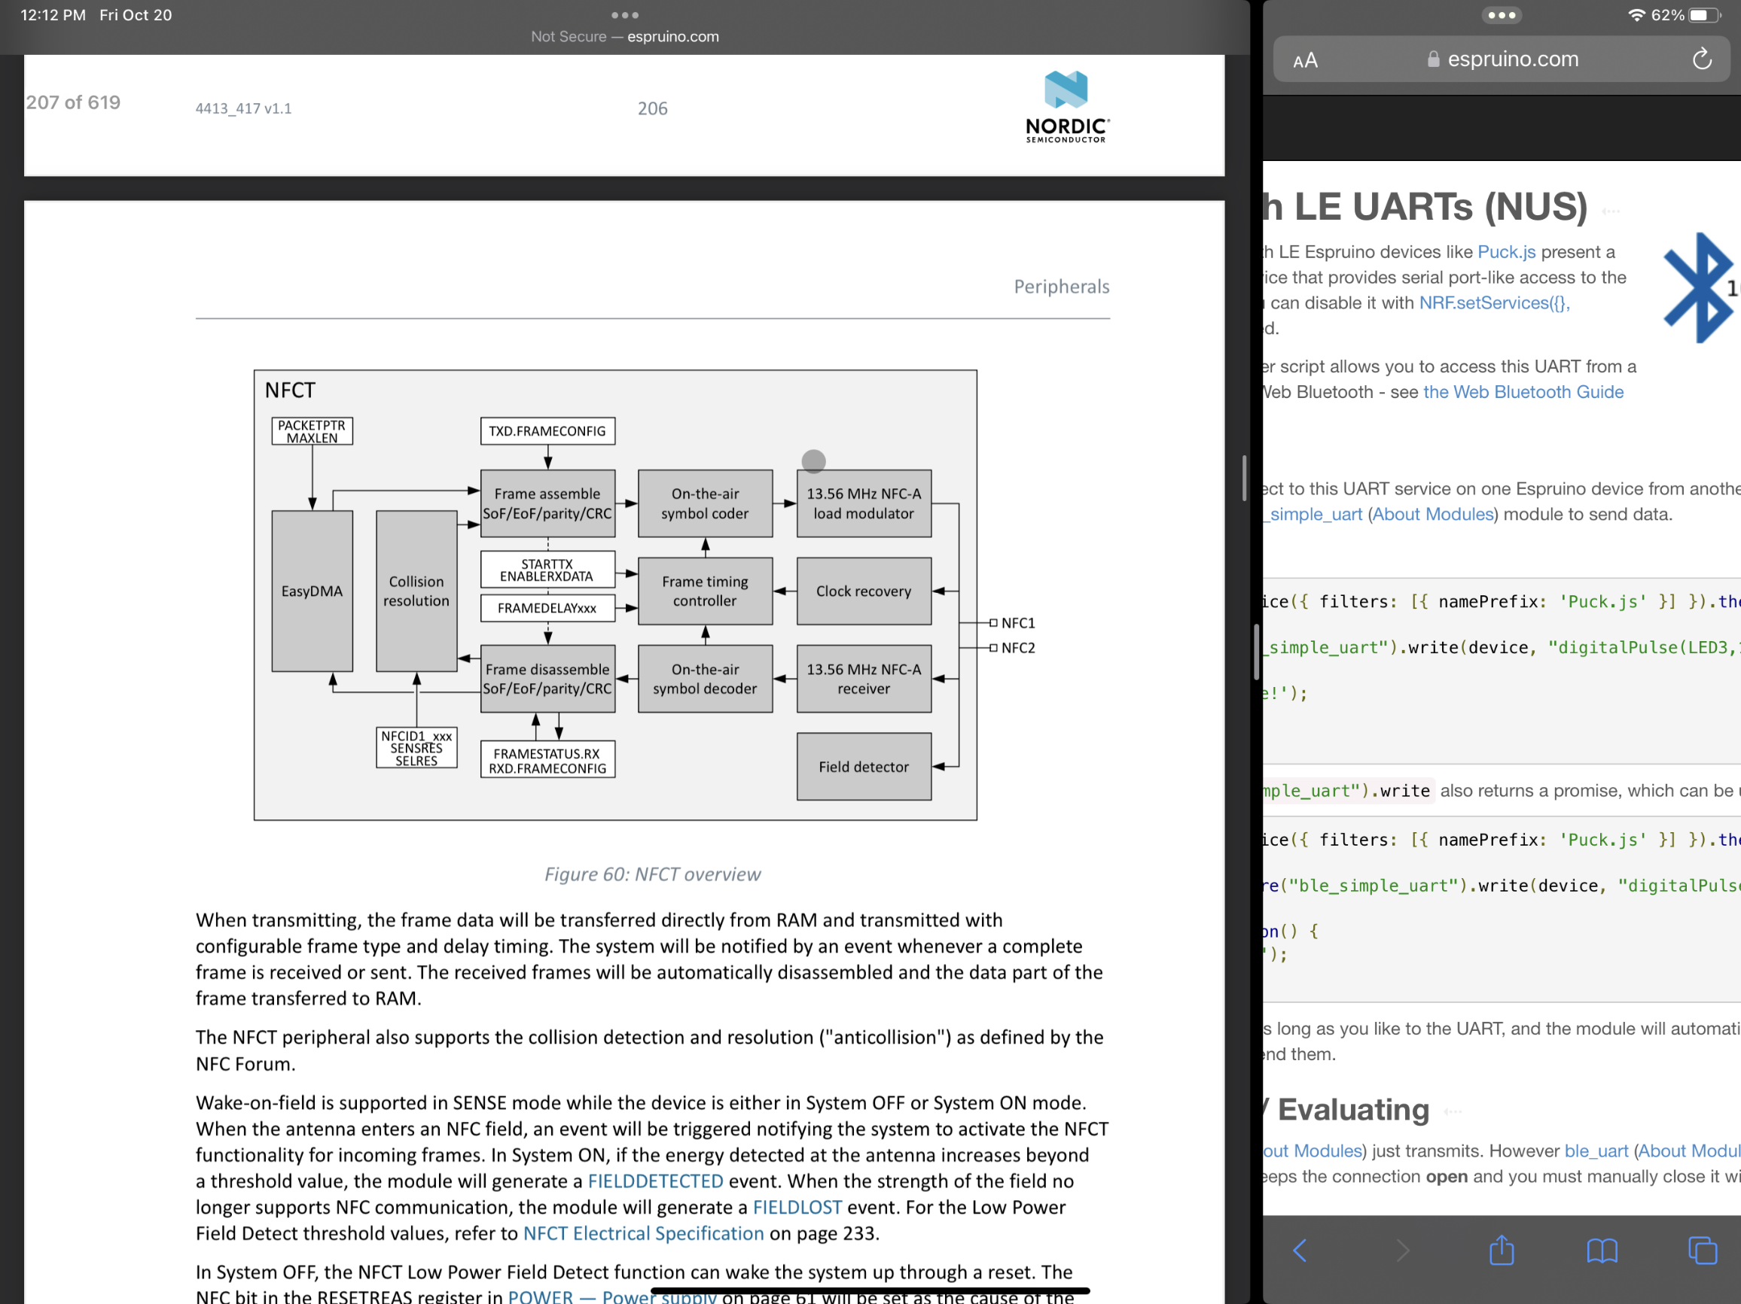
Figure 5: NFCT overview
The NFCT antenna coil must be connected differential between NFC1 and NFC2 pins of the device. Two external capacitors are used in the project’s design to tune the resonance of the antenna circuit to 13.56 MHz.
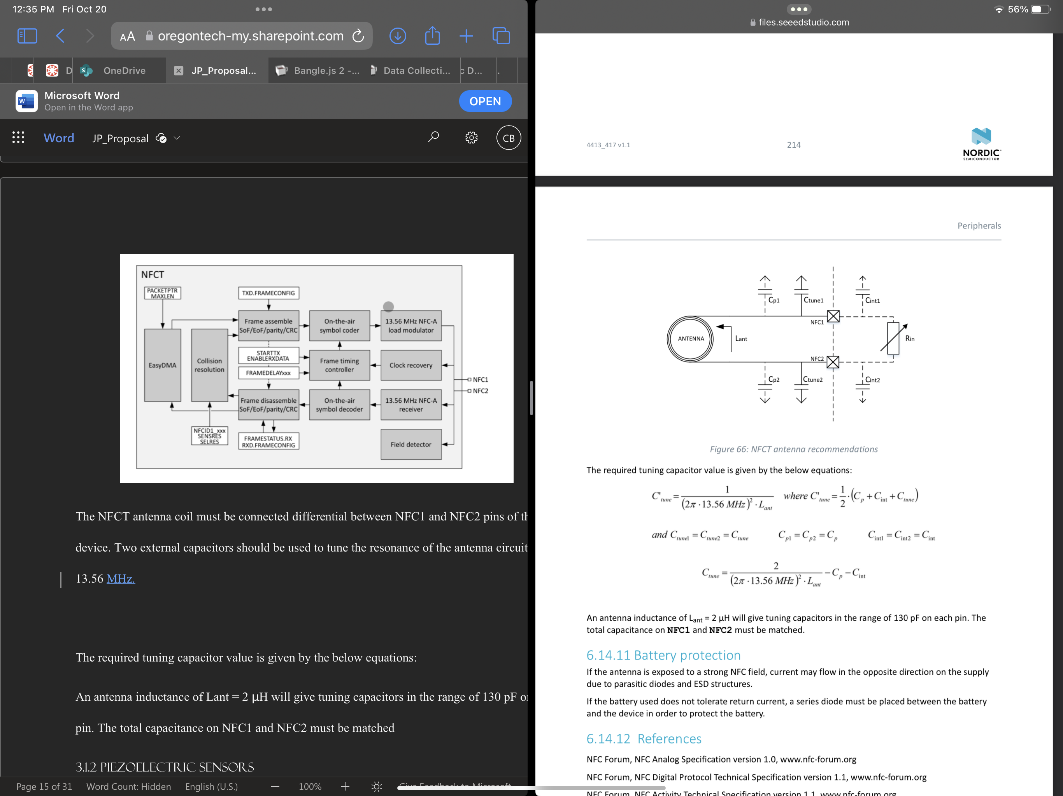
Figure 6: additional NRF capacitance requirement diagram

The required tuning capacitor value is given by the below equations:

Figure 7: NRF additional capacitance requirement equations
An antenna inductance of Lant = 2 μH will give tuning capacitors in the range of 130 pF on each pin. The total capacitance on NFC1 and NFC2 must be matched.

3.1.2 Piezoelectric Sensors
The current project plan uses the Chironal 20mm Piezoelectric Sensor. The technical specifications are difficult to ascertain as there does not appear to be any publicly available datasheet regarding this component. As such, this may be swapped out later in the design process for another similar part, such as the MPX2300DT1 Piezoelectric sensor.

3.1.3 Haptic Vibrator
We are using the 1547-1244-ND. This part provides feedback to the user about their walking in real time. It is rated for voltages from 2.5V to 3.5V DC. The battery provides a nominal voltage of 3.7V, up to 4.2V at a full charge (see section 3.1.5). Given the terminal resistance of 75 Ω, this will be kept within tolerance with a small resistor (~15 Ω). This component’s maximum power draw is 80 mA during normal operation. It has an operating temperature of –20 to 70 degrees Celsius. This component’s small form factor and relatively low cost (see section 4) mean this part is unlikely to need substitution.

3.1.4 Bangle.Js 2.0 smart Watch
We are using the Bangle.Js 2.0 Smart watch to coordinate with the microcontrollers in the shoes via Bluetooth. From a Hardware perspective, the Bangle.JS operates as a standalone component, interacting with all other components exclusively via Bluetooth.
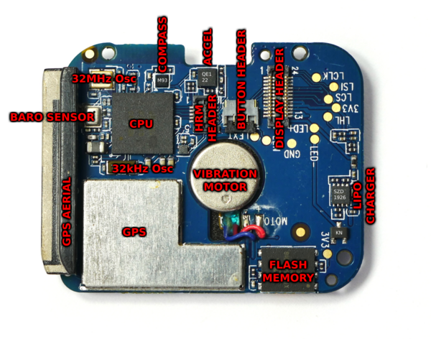
Figure 8: Bangle.JS 2 hardware diagram

The power consumption of the individual components can be seen in Table 3, below. A list of the components necessary for the project, as well as those that cannot be turned off, is comprised of the:
- Accelerometer
- Bluetooth Low Energy system in high Bandwidth mode
- CPU
- LCD screen
Assuming a worst-case scenario (simultaneous usage of all the above-listed components at their maximum), the Bangle.JS has a 47.85 mA draw. With a 350-mA internal battery, this allows approximately 7 hours of continuous usage with a single charge. This would not meet the requirement for 12 hours of continuous usage. However, the LCD display is the most power-intensive component by a significant margin, and continuous usage is not the expected use case. At 50% usage, the battery would instead be able to run for 12.5 hours, achieving the required duration. Used 25% of the time, it would last approximately 19.5 hours.
Use Case | Current Consumption
Idle, accelerometer on 12.5Hz | 0.35mA
Idle, accelerometer on 1.25Hz | 0.15mA (default if not moved)
BLE Connected in high bandwidth mode | 0.5mA
Compass on | 2mA
Heart rate monitor on | 2.5mA
100% CPU usage running JavaScript | 7mA
GPS on | 30mA
LCD on | 40mA
Turned off | 0.08mA (0.6mA if turned off via Bootloader)
Table 3 Smart Watch Power Analytics

The Bangle.JS fulfills all technical requirements for the smart watch on this project, and as such is the single part least likely to be replaced by any alternative components. Its technical specifications indicate it has sufficient battery life, it can communicate with multiple devices via a BLE mesh network, and its LCD display is applicable for user feedback and interactive games.

3.1.5 Power
The battery chosen for this project is the LIPO785060 2500mAh 3.7V Lithium Ion Battery. It provides a nominal voltage of 3.7V. It provides a maximum voltage of 4.2V at a full charge and has a minimum discharge voltage of 3.0V. It has a maximum constant charging/discharging current of 1500mA. It has a form factor of 50mm x 60mm x 7.3mm.
The battery charging system is a lightly modified MCP73833 system sold by the same manufacturer as the battery. It provides a 500mA charge, though can be modified to provide anywhere from 100mA to 1000mA charge by soldering an on-board resistor. See Figure 5.
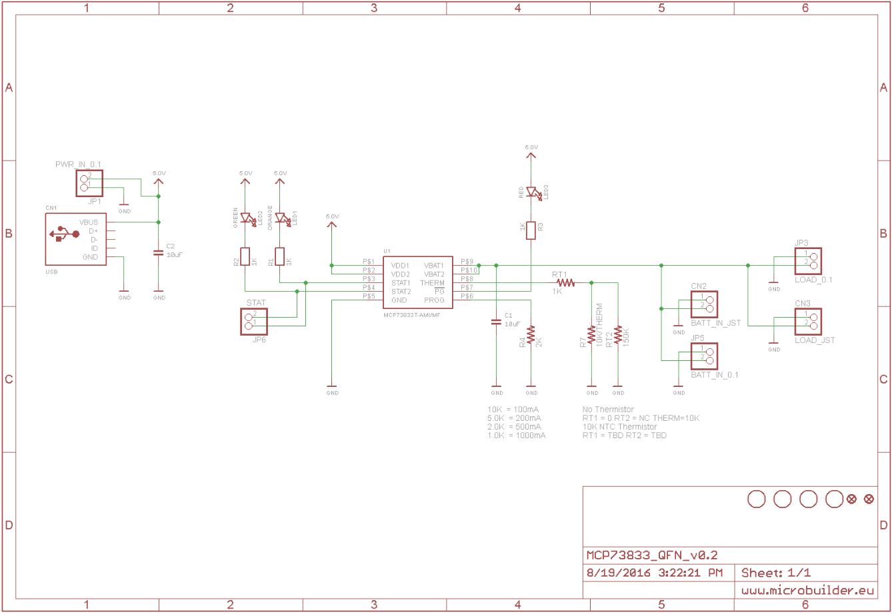
Figure 9: MCP73833 Charger Diagram
The battery and the charging cable are the two components most likely to be swapped for alternatives. During testing, it may be discovered that the battery provides excess capacity and so we may swap it for a smaller model to save on space, or we may discover that the onboard electronics require more power than expected, and so a larger battery will need to be acquired. In the event a smaller battery is chosen, the 503562 model would be the first choice. It would allow reuse of the same charging cable and has a similar but slimmer form factor of 34mm x 62mm x 5mm. A large alternative might be the 5000 mAh 905090 battery, but it is much larger at 90mm x 50mm x 9mm, making that an undesirable choice if avoidable. Regardless, so long as the voltage characteristics remain constant, swapping batteries should have minimal impact on the project's electrical design.

3.1.6 3d Filaments
This device is inside of a shoe—and therefore continuously stepped on. There needs to be an encasement that protects the electronics while maintaining wearability—comfortable enough that a child will want to continuously wear it. The encasement should also be adapted based on the insole/shoe size needed. The best way of completing these requirements is 3D printing. With diverse types of filaments, testing can determine the product best suited for our needs in this project.
3D printing allows the design to be scaled and changed as we see fit. If there are airflow issues or anything similar, the design can be easily modified. Safety and protection of electronics can also be managed by creating thicker walls between electronics, while finding ways to create comfort and safety.
The major safety issue to review is the battery and chip heat. If the battery is not properly protected, there is risk of damage to both user and electronics. There also needs to be a way to regulate heat in the casing, so ventilation is a strong consideration when choosing a 3D printing design for the insole.

3.1.6.1 Thermoplastic elastomers (TPE)
A flexible and rubber like material that is soft. When complete you get a rubber like finish also making it highly tear resistant. It has high vibration dampening that can be something that makes our project easier or creates difficulty for the sensors.
Pros | Cons
- Heat Tolerance  - Tear resistance  - Flexible  - Grippy  - Impact resistance | - Hard to print  - Harder finish
Table 4 TPE Pros and Cons

3.1.6.2 Thermoplastic polyurethane (TPU)
When compared to TPE, TPU is a lot more rigid—however, it provides more abrasion resistance. It has previously been used in watch bracelets and sportswear. The material is hygroscopic meaning that it can absorb moisture and there are specific kinds made to be more breathable. It retains elasticity and shape, and handles cold weather better.

Pros | Cons
- Scratch and abrasion resistance  - Breathable  - Smooth finish  - Impact resistance  - High heat tolerance | - Hard to print  - Less flexible
Table 5 TPU Pros and cons

3.2 Software Modules

3.2.1 Bangle.js 2 – JavaScript via ESPRUINO
The smartwatch software module receives packets of information via Bluetooth from the microcontroller. Bluetooth is transmitted/received via a serial port; the data from the shoes is received in serial fashion. This information is used in two ways: firstly, to display a histogram of the day’s heel strikes vs. toe strikes, and secondly, to use the stored information to play a Tamagotchi-like game, encouraging kids to try harder to fix their gait.
There is an online IDE through Espruino for programming. Code is downloaded to the watch through Web Bluetooth via this IDE. Because of this Bluetooth connection, there is an “editor” side of the IDE, and the other side which live-programs.
The code can be uploaded to RAM, Flash, or file Storage. RAM is recommended for development, then storage for final apps—and Flash memory comes with a warning to avoid it.
The team must decide whether to write two separate apps—one for the game and another for the data display—or to write one app with both functions built in. Containing both modules in one app has the benefit of acquiring the Bluetooth data just once and using it for both functions. However, the watch screen is small, and it may be beneficial to have separate apps for the functionality of the interface itself.
If the latter function is chosen, the app containing the histogram data is a wise choice for also transmitting data to the smart phone—its final destination, for our purposes. That app can have information further formatted to display the same type of histogram on the phone app. Either way, an app must transmit the data it received serially in the same fashion: serially.
The Bluetooth configuration has several options—there is a way to automatically download data via Bluetooth connection. UART is a viable option, which provides buffering to prevent data loss. Once the Bluetooth connection is calibrated for both devices, the input data is stored in memory. This data is accessed to display a histogram of the day’s gait and provide game functions. The more healthy steps taken, the more functionality the game will provide. A pet can be given treats and walked based on the number of heel-strikes accomplished.
Both apps require the use of graphics. None of the team has much experience writing in JavaScript—however, because the Bangle.JS is an open-source project using an Espruino board, there are highly detailed examples and videos from Espruino online with specific code and classes available for programming the watch in JavaScript, with expanded classes that are specific to Espruino boards, as well. There is a graphics class, a Bluetooth Device class, and a Bangle class—all of which are used heavily in any apps created for this project.

3.2.2 Smart Phone Apps
Android app – Kotlin via Compose
Apple app – Swift
The Smart Phone app(s) is used by a child’s parent (or authority figure—i.e., health care professional) to download the data from the Bangle.js over Bluetooth. It keeps and displays a history of the child’s progress. This way the parent can help the child keep up with their therapy. This app data will also be used by the doctor in charge of the child’s therapy to monitor progress.
Dr. Marybeth GrantBeuttler’s team has already started on an Android app, so we would need to help complete that one, then translate it for an iPhone app in Swift—Apple's programming language.
Bluetooth configuration must match that of the Bangle.JS. Automatic vs. Manual connection for transmission is a consideration to be made. The app for the smart phone must accept Bluetooth data, store it, and display it much like the histogram for the smartwatch app—however, because phones have larger memory capacities, and the phone app is for progress over longer periods of time for use by parents/medical professionals, this histogram must have access to the stored data from all of the previously received data, and display the data for longer periods of time. The phone app requires no transmission of data.

3.2.3 Seeed board - Arduino (C)
The seeed board’s software will take input from the piezoelectric sensors and the IMU, output feedback to the haptic vibrator as well as a Bluetooth connection to the smart watch. This data need not be more than the tilt of the foot and the sensors triggered.
Bluetooth connection requires data encryption and decryption. Cipher block chaining is handled in CCM mode in the seeed board. Before a new packet encryption can occur, a new key-stream needs to be generated. To do this, the CNFPTR must be configured, and the MODE changed for encryption, Afterward, the KSGEN task can be triggered, and an ENDKSGEN event is generated once the key-stream is complete. The SCRATCHPTR is assigned to the temporary memory area containing the key-stream. The default length of a packet is 27 bytes. Our team must decide on the length of packet best to send. The maximum packet payload size is 251 bytes.
In summary, the Seeed board’s software needs to:
- read in piezoelectric sensor information
- output live feedback for the haptic vibrator
- Store that data for Bluetooth transmission
- Follow Bluetooth transmission protocols:
- Enable CCM mode
- MODE register (offset 0x504) must contain a 0 in bit number 0
- Choose data rate (MODE register bits 16 & 17)
- Choose length (default is MODE register bit 24 = 0 [length of 5 bits for 27-byte packet payloads], otherwise MAXPACKETSIZE value is read for packet payloads, with 8-bit packets)
- Wait for ENDKSGEN flag
- Point INPTR to address of stored data to be transmitted
Packet encryption can occur simultaneously with transmission, so timing is not an issue—if no shortcuts are used, and the key is generated before transmission begins.

3.2.3 Prusa Slicer 2.6.1 & Fusion 360
These are the tools to be used to print out project designs. Fusion 360 is a program to create 3D models. Insoles are created, edited, and improved with Fusion. Once completed, the design is used to create an STL file of our design. Prusa 3 printer prints the design, along with its slicer (Prusa slicer). Prusa 3 translates the design into code for the 3d printer. From there, infill settings and temperatures are set to get the desired finish and density.

4.0 Costs
The following table lists the projected definite costs of the Smart Stepper.
Product | Units | Price Per Unit | Cost
Bangle.JS 2 Smart Watch | 1 | $93.22 | $93.22
Seeed Studio Microcontroller | 2 | $15.99 | $31.98
3.7V Lithium Ion Battery | 2 | $14.95 | $29.90
Piezo Electric Sensor | 10 | $0.79 | $7.99
Haptic Vibrator | 2 | $1.20 | $2.40
Shoes (pair) | 1 | $29.99 | $29.99
Filament TPU Roll | 1 | $52.99 | $52.99
Total Physical Cost |  |  | $248.47
Table 6 Preliminary Physical Costs

While this table gives an accurate estimate, there are possibilities of unforeseen costs. The battery, for example, should be protected and perhaps ventilated—requiring (an) extra part(s) not listed here. Unsure of exactly how that problem will be tackled, we cannot plan for the additional cost of this encasement and/or aeration system.
It is also true that an entire roll of filament may not be used, and future replications of this product would likely use less than an entire roll—decreasing overall cost.
As previously mentioned, the piezoelectric sensors have yet to be tested, and their specifications have not been found. Should the team need to replace this part, additional costs are required. However, sensors are some of the least expensive items in our parts list.
Not accounted for are even smaller parts—including resistors and wires, as well as their soldering requirements.
Another cost not currently considered is the protection of the lithium-ion battery. It is inside of a sneaker, with a soft bottom. Should the user step on a nail and pierce the battery, there are dangerous associated risks. The battery should be protected as well as possible. Given that placement is yet to be determined, the protection for the battery is also a future decision. Placing the battery inside the tongue of the shoe, for example, may eradicate the need for further protection. Both the microcontroller and the external battery need some amount of aeration to prevent overheating, and these systems’ cost cannot be forecasted until they are built and tested.
Beyond physical costs, there are also engineering and labor costs. Projecting a 40-hour workweek at $40/hour per person for our campus group, assuming the product is done end of February, and taking out holiday breaks, the total engineering cost is approximately $25,000.

5.0 Technical Problems
5.1 Power system
A 12-hour runtime requirement means that power is at a premium. Given a 200mA operating current for the Seeed Microcontroller and the 2500 mAh capacity of the battery means there is extraordinarily little margin for other devices. To minimize power consumption where possible, the shoe will utilize piezoelectric sensors which do not require any active current supplied to them to function. Given the 80-mA maximum current draw for the haptic feedback system, assuming a 10% Duty Cycle over the course of those 12 hours, we will be able to just barely maintain the 12-hour requirement.
Testing will need to be done to verify the current draw of all components.

5.1.1 Power Supply protection
The most dangerous problem in the project is the protection of the lithium-ion battery. It is inside of a sneaker, with a soft bottom. Should the user step on a nail and pierce the battery, there are dangerous associated risks. The battery should be protected as well as possible.
Given that placement is yet to be determined, the protection for the battery is also a future decision. Placing the battery inside the tongue of the shoe, for example, may eradicate the need for further protection. The battery and its wires would then have to be embedded into the fabric of the shoe. This increases production costs, and may pose battery overheating problems, but would make piercing the structure much less likely. The battery could, also, theoretically, stand up on the side or back of the shoe. This may require the user to increase the size of their shoe from their normal, but it would also decrease the likelihood of piercing the battery.
Should the battery remain in the bottom of the shoe, underfoot, encasing is necessary to prevent piercing. Metal mesh, high molecular weight polyurethane, and fiberglass are all considerations for materials to protect the battery.
5.2 overheating
Given the fully enclosed nature of the system, overheating in general is a large potential problem. Ventilation is not an easily viable solution because any holes for airflow would just as easily allow water to affect the delicate electronics. As such, passive heat radiation may be necessary to deal with any overheating that occurs. A flexible wire mesh inserted into the insole could provide additional protection to the internals and act as a passive radiator to disperse heat away from critical systems. Active systems are not currently deemed viable due to their negative impact on the device's limited battery life. However, if overheating proves great enough a problem, a larger battery could be substituted to allow powering of small fand in the heel to help disperse heat.

5.2.1 Battery Warmth
Anywhere the battery is placed, additional heat is a potential problem that must be addressed. Should the battery be placed in the bottom of the shoe, the protection method and its breathability play a significant role in mitigating or increasing the temperature. A cooling system/fan mechanism may need to be installed to reduce heat, but as mentioned in section 5.1, there is little budget for active components.
In the event battery protection is solved by inserting the battery into the tongue of the shoe, the warmth of the battery may be uncomfortable to a user but would be better for cooling the systems as a whole. This could be mitigated with further padding or a passive heat dispersal system, but this may not be enough of a problem to justify the added complexity.

5.3 discreet active feedback
One of the major requirements for this device is to provide active feedback to the user. For the device to be most effective, it cannot be obvious that it is a medical device. Dr. GrantBeuttler has made it clear that children will not use a device if it is not discreet. Early ideas for feedback involved light or sound, but these were deemed too conspicuous. The device, therefore, uses a haptic feedback device to create vibration to communicate with the user. Testing will need to be done to ensure this does not create a significantly noticeable amount of noise. The smartwatch is also an imperceptible manner for the user to receive feedback.
The biggest limiter for feedback in-shoe is likely to be the limited power available for additional systems, so a single haptic feedback motor is going to be the limit initially.

5.4 Signal loss
One major problem is the potential loss of signal between the Bangle.JS and its connected devices. Dropped connections could result in loss of data that should be collected for medical purposes. This problem is solved by including a data buffer in the Seeed device that will retransmit until receipt by the Bangle.JS is confirmed. Even significant periods of signal loss could be compensated for, as the Seeed microcontrollers have 1MB flash memory, which is a significant amount given the minimal quantity of data that needs to be stored.

5.5 structural flexibility VS rigidity
Previous ideas for the structure of the main body of the project involved rigid materials that would not be suitable for use as flexibility is a significant requirement for any quality shoe insert/sole. However, more flexible materials offer less protection to internal electronics from both crushing and puncturing effects. A flexible and compressible material is a hard requirement, however, so we will attempt to mitigate this by enclosing the core of the electronics in a more rigid shell embedded within a larger, flexible structure. However, it may not be fully possible to mitigate all risks to the internal electronics.

5.6 Multiple Bluetooth connections at once
Normal Bluetooth only allows data streaming from one device at a time (if you have multiple connections, you need to cycle through the devices). One solution is to use BLE (Bluetooth Low Energy), which supports multiple connections (even creation of a mesh network). However, this may add to our signal loss issue, as BLE only has an optimal range of 50 meters instead of the normal Bluetooth’s range of 100 meters.
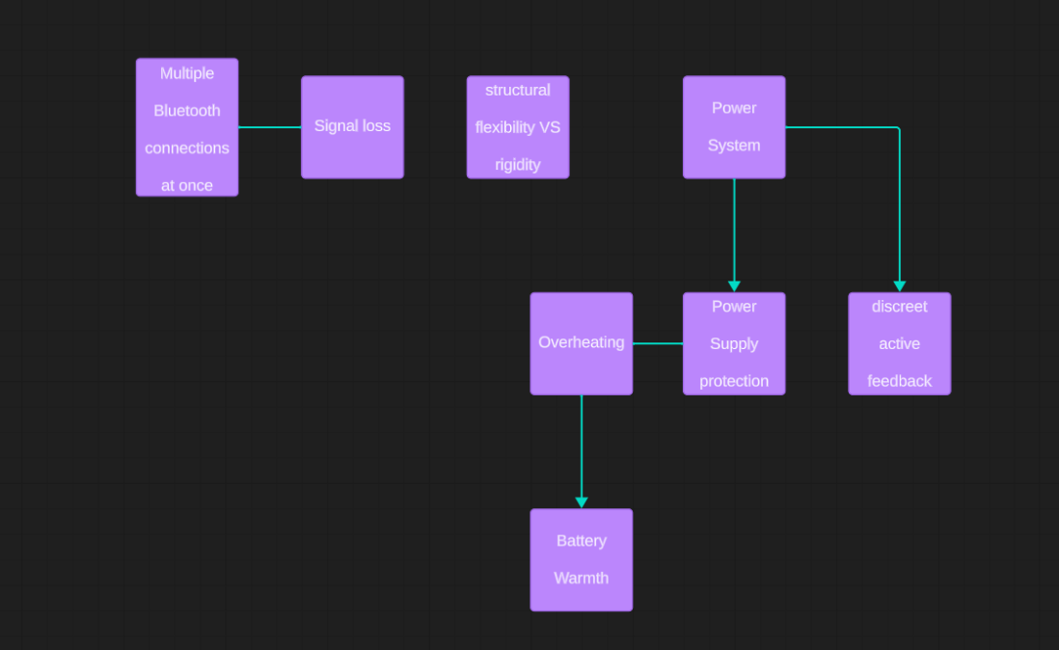
Figure 10: Problems Hierarchical Diagram

6.0 Product Markets
Dr. Marybeth GrantBeuttler has traveled the world, speaking at conferences about physical therapy and toe-walking, and to medical professionals about previous designs and ideas for this project. She has worked with countless parents of children afflicted with toe-walking, as well as adults who have continued toe-walking into maturity. Dr. GrantBeuttler has worked with surgeons and students alike—all of this to say that thousands of parties have already expressed interest in this product. They include all the abovementioned markets.
The future of this product is not limited to strictly toe-walking markets, however. It is important to recognize that a much larger portion of people have gait issues. Anyone who has had surgery or injuries on their lower half, and any physical therapists or other medical professionals who work with such people would be thrilled to hear of a product that could help normalize a person’s gait. Runners and all forms of athletes could benefit from ensuring that their gait is healthy. Let’s keep it a secret from Nike—for now.

Appendix A: Schematics
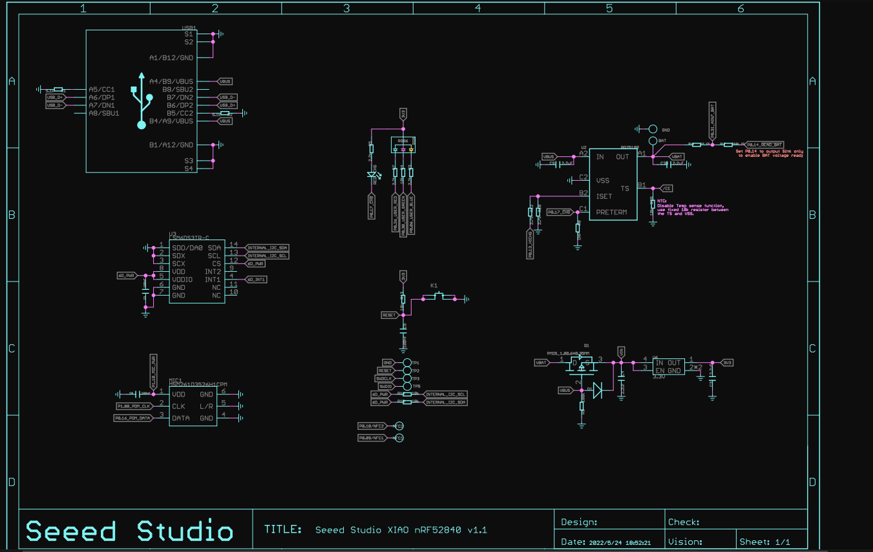
Schematic 1: Seeed board Schematic Part 1
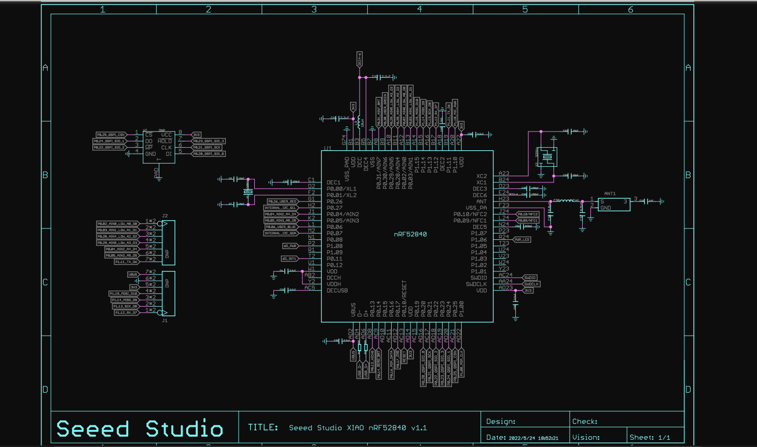
Schematic 2: Seeed board Schematic Part 2

