Forest Inventory Abandoned Mineland

Cari Ficken

2020-10-27

These are exploratory analyses conducted by Cari to examine how legacies of mining and forest reclamation (and farming) are related to current forest composition.

## How does richness and biomass of *mature trees* differ across habitats and sites?

For differences across sites: ANOVA or Kruskal-Wallis

For differences across habitats: mixed effects model with Site as random effect, and habitat as main effect.

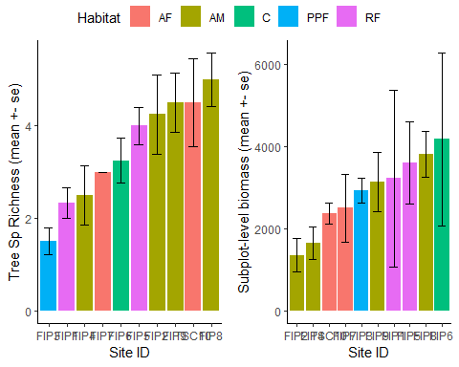

## How does composition of *mature trees* differ across habitats and sites?

Note: relative abundances not standardized. Should we do this to reduce pull by abundant species (nonnatives?)?

