DASM-AFP: Computer-based Document Archiving and Security Management for Armed Forces of the Philippines
A Capstone Project
Presented to the Faculty of the
Information and Communications Technology Program
STI College Cubao

In Partial Fulfilment
of the Requirements for the Degree
Bachelor of Science in Information Technology
Angelo Kyle S. Pinlac
Cherish Love A. Faeldin
Dominic Anthony M. Rabano
May Ann R. Villadar

May 17, 2026

ENDORSEMENT FORM FOR PROPOSAL DEFENSE

TITLE OF RESEARCH: DASM-AFP: Computer-based Document
Archiving and Security Management for Armed Forces of the Philippines

NAME OF PROPONENTS: Angelo Kyle S. Pinlac
Cherish Love A. Faeldin
Dominic Anthony M. Rabano
May Ann R. Villadar

In Partial Fulfilment of the Requirements
for the degree Bachelor of Science in Information Technology
has been examined and is recommended for Proposal Defense.

ENDORSED BY:

Mr. Michael Jericho Nemedez
Capstone Project Adviser

APPROVED FOR PROPOSAL DEFENSE:

Engr. John Ivan D. Bachiller
Capstone Project Coordinator

NOTED BY:

Mr. Rhene Ryan John Q. Obra
Program Head

APPROVAL SHEET

This capstone project proposal titled DASM-AFP: Computer-based Document Archiving and Security Management for Armed Forces of the Philippines, prepared and submitted by Angelo Kyle S. Pinlac, Cherish Love A. Faeldin, Dominic Anthony M. Rabano, and May Ann R. Villadar, in partial fulfillment of the requirements for the degree of Bachelor of Science in Information Technology, has been examined and is recommended for acceptance and approval

Mr. Michael Jericho Nemedez
Capstone Project Adviser
Accepted and approved by the Capstone Project Review Panel
in partial fulfillment of the requirements for the degree of
Bachelor of Science in Information Technology

Ms. Katherine Macatiag | Ms. Mary Joy Banal
Panel Member | Panel Member

Mr. Brian H. Calata, LPT
Lead Panelist
Noted:
Engr. John Ivan D. Bachiller | Mr. Rhene Ryan John Q. Obra
Capstone Project Coordinator | Program Head

May 17, 2026

Table of Contents
 |  | Page
Title Page
Endorsement form for Proposal Defense |  | i
Approval Sheet |  | ii
Table of Contents |  | iii
Introduction |  | 1
 | Project Context | 1
 | Purpose and Description | 2
 | Objectives | 3
 | Scope and Limitations | 4
 | Review of Related Literature/Studies/Systems | 5
Methodology |  | 8
 | Technical Background | 9
 | Requirements Analysis | 14
 | Requirements Documentation | 15
 | Design of Software, System, Product, and/or Processes | 17
References |  | 28
Appendices |  | 29
 | Appendix A: Prototype Design | 29

Introduction
Project Context
The Armed Forces of the Philippines (AFP) is a vast organization responsible for national security and defense, a mandate that necessitates the handling of a massive volume of sensitive paperwork on a daily basis. These records, which range from personnel files and medical histories to mission-critical operational documents, constitute the institutional memory of the organization. Currently, the majority of these documents are maintained through traditional manual filing methods, stored in physical folders and steel filing cabinets. While this system has been the standard for decades, it is increasingly inadequate for the demands of modern military administration.
The reliance on a physical filing infrastructure creates significant operational vulnerabilities. Paper-based records are inherently fragile and susceptible to various forms of physical degradation. Environmental factors such as humidity, heat, and potential water damage pose a constant threat to the integrity of the records. Furthermore, physical documents are prone to misplacement or loss during handling, creating gaps in critical information. This "old-fashioned" approach to record-keeping introduces a high level of risk, as the physical loss of a document is often permanent and irreversible.
Beyond physical risks, the current system is characterized by profound operational inefficiencies. When authorized personnel require access to a specific file, they must often engage in labor-intensive manual searches through voluminous stacks of paper. This process is not only time-consuming but also creates bottlenecks in the administrative workflow, slowing down office productivity, and hindering the organization’s ability to run smoothly. In a military context, where rapid access to information can be a factor in operational readiness, the delays caused by manual document retrieval represent a critical weakness.
Security remains the most pressing concern within the current framework. Physical filing cabinets, even when locked, are difficult to monitor and lack a robust mechanism for tracking access. There is a constant threat that sensitive or classified information may be viewed by individuals who do not possess the necessary clearance. Because physical systems cannot provide a real-time log of who accessed a file, and when, the organization lacks a transparent and accountable audit trail for its most important assets.
Recognizing these daily struggles, there is a clear and urgent need for a Document Scanning and Access Control Management System. The objective of the study is to provide a digital solution that converts physical papers into secure digital files, consolidated within a centralized and organized computer-based environment. By digitizing the AFP’s record-keeping, the system ensures that sensitive information is significantly more secure than a standard padlock on a cabinet.
The proposed system is designed to transform the AFP’s administrative landscape by making office work faster, safer, and more reliable. This transition to a digital framework is not merely a matter of convenience; it is a strategic shift toward modernization that meets the military’s growing demand for tighter information security and higher administrative standards in an increasingly digital world. All old files will be scan to convert it to digital, the study aimed to develop records archiving and document repository to overcome the barrier of server client method of deploying the documents from one place to another and easier data access to its stakeholders.
The transition to a digital framework is underpinned by a robust security architecture designed to surpass the limitations of physical filing. The system enhances information integrity by organizing documents into specific categories, which allows for a more systematic approach to data governance. Through this categorical organization, users can precisely select which personnel are authorized to access certain files based on their specific roles and departments. The system implements granular security settings by distinguishing between viewing and editing options, ensuring that document modifications are restricted to designated individuals while providing read-only access to others. This tiered access management creates a transparent and accountable digital trail, aligning with the military's requirement for rigorous information security.

Purpose and Description
The primary function of the system is to act as a secure digital bridge for the Armed Forces of the Philippines, moving away from the risks associated with traditional paper-based filing. Currently, the manual handling of documents leads to significant problems like physical damage, misplacement, and the constant threat of unauthorized people seeing sensitive information. The proposed system solves these issues by converting physical papers into a digital format that is kept in one central, organized location. Consequently, the system facilitates faster document retrieval, replacing hours of manual searching with a simple, efficient computer-based process that ensures long-term file safety.
The unique and innovative focus of the system is high-level security through integrated access control management. Unlike a physical filing cabinet that is difficult to monitor, the system allows the organization to strictly govern who can view or edit specific information, creating a transparent and accountable digital trail. This shift toward a paperless environment is highly relevant to the military's current needs, as it meets the growing demand for better operational efficiency and tighter information security. By streamlining administrative tasks and protecting vital records from damage or theft, the system provides a more professional way to manage the institution's most important assets in a rapidly changing digital world.

Objectives

The primary objective of the capstone project is to develop a system that modernizes document management through the following specific goals:
- To digitize physical documents using secure scanning methods.
- To provide centralized and organized document storage.
- To implement role-based access control for enhanced security.
- To enable quick and efficient document retrieval.
- To reduce paperwork and improve operational efficiency.
The implementation of the system offers a direct solution to existing problems of document loss and unauthorized access within the AFP. Transitioning to a digital framework allows authorized military personnel to operate within a more secure workspace where critical data is protected and easily accessible.
The general purpose of the study is to provide the Armed Forces of the Philippines with a secure, computer-based solution for managing sensitive documents, transitioning away from inefficient manual filing systems. The scope of the system centers on the scanning, digital storage, and systematic organization of documents, alongside the implementation of user authentication and role-based access control. The platform allows authorized military personnel, the primary beneficiaries of the study, to securely upload, view, and retrieve files within their respective offices.
While the system enhances document handling, several limitations exist that are beyond the control of the researcher. The system is strictly limited to internal use within the local network and does not support cloud-based storage, mobile access, or advanced automated data entry features. Furthermore, the effectiveness of the system depends entirely on the manual scanning of physical documents and the continuous availability of computer hardware and electricity. Because it is an offline-based solution for security reasons, it cannot be accessed remotely, and its functionality relies on the proper maintenance of user access privileges by the system administrator.

Scope and Limitations

Scope of the Study

The Document Scanning and Access Control Management System study is about creating a system for the Armed Forces of the Philippines. This system is meant to help with scanning documents and controlling who can access them. It will help turn paper documents into files. These digital files will be stored in one place where they can be organized by category or department. This will make it easier to find and manage documents.

The Document Scanning and Access Control Management System also has a feature that lets administrators decide who can see or change documents. This means people who are supposed to can look at or change certain documents. The system also lets users upload, look at and organize files. It even has a search feature that makes it fast to find documents. This saves a lot of time.

The Document Scanning and Access Control Management System is meant to be used on a network. Authorized military personnel can use it in certain offices. The main goal of the Document Scanning and Access Control Management System study is to create a system that's secure and helps with keeping records, keeping data safe, and making things more efficient.

Limitations of the Study

There are some limitations to the Document Scanning and Access Control Management System. One limitation is that it does not work with the internet or cloud storage. Users can only use the Document Scanning and Access Control Management System in the office.

The Document Scanning and Access Control Management System also needs people to scan documents by hand. The quality of the files depends on how well the scanning equipment is used. The Document Scanning and Access Control Management System does not have features like optical character recognition.

The Document Scanning and Access Control Management System also needs hardware to work well. If the hardware is not working right or if the power goes out the system will not work. The Document Scanning and Access Control Management System needs someone to manage it all the time. This person has to make sure users can access the documents and that documents are organized correctly. If this is not done right there could be security problems.

The study does not look at using the Document Scanning and Access Control Management System on devices or with cloud storage. It is only meant for medium-sized offices and only for use, inside the Armed Forces of the Philippines.

Review of Related Literature/Studies/Systems

Foreign Literature and Studies

The transition from traditional storage to modern document archiving is recognized as a strategic necessity for organizational resilience and regulatory compliance. As defined by Document Logistix (2024), effective document archiving is the systematic storage of inactive or less frequently accessed records in a secure, organized format for long-term retention. This process serves to preserve critical documentation for legal, historical, or reference purposes and is distinct from regular storage because it involves a deliberate methodology of categorizing and indexing files to ensure they are easily accessible when needed for litigation support or internal audits.
Data security serves as a primary driver for implementing advanced archiving systems. Research by MES Hybrid Document Systems (2024) indicates that secure digital archiving significantly reduces the risk of data breaches by utilizing encryption and role-based access controls to protect sensitive information. Their analysis highlights that inadequate data protection in various industries has led to high-profile breaches, where phishing attacks—often exacerbated by poor document management—account for over 80% of reported security incidents. Furthermore, archiving improves operational efficiency by reducing the time employees spend searching for information and lowering costs by moving inactive data to more affordable storage solutions.
While the literature consistently advocates for digital transformation, there are varying perspectives on how to handle the end-of-life cycle for data. According to the Directory of Open Access Journals (2024), one approach emphasizes the importance of automated retention periods and "document purging," which refers to the permanent deletion of records that have passed their mandated keep-by date. This practice eliminates the legal risks associated with storing unnecessary sensitive data. In contrast, other studies focus on the technical integrity of the archive itself, emphasizing features like virus protection, secure backup options, and compliance with specific international standards such as GDPR or HIPAA.
Local Literature and Studies
In the Philippine context, the management of records is strictly governed by Republic Act No. 9470, also known as the National Archives of the Philippines Act of 2007. Local research by Gamba et al. (2024) emphasizes that manual archiving in Philippine institutions often results in the physical degradation of documents due to environmental factors such as high humidity and thermal fluctuations. Their study advocates for a web-based digital repository that utilizes advanced encryption standards, such as 256-bit AES, to ensure that satellite campuses can access data securely through a virtual private network. This aligns with the global shift toward digital preservation but highlights a specific local need: protecting physical records from the tropical climate while ensuring remote accessibility across the archipelago.
Furthermore, the implementation of Document Tracking and Archiving Systems (DTAS) in local government and educational sectors has shown significant improvements in operational transparency. A study conducted in a local state college (2025) revealed that transitioning from vertical filing cabinets to automated tracking systems reduced document retrieval times and enhanced compliance with ISO standards. However, local literature also identifies a critical "awareness gap" regarding the Data Privacy Act of 2012 (RA 10173). Researchers noted that while digital tools improve efficiency, many local organizations still struggle with a lack of technical expertise and standardized procedures, which can lead to accidental data loss or non-compliance with national privacy mandates.
Synthesis and Rationale
The combination of local literature shows a strong reason for the proposed system. Foreign research sets the standards for safe storage and automated data handling. Local studies emphasize the need to shift from manual filing, which is prone to risks, to digital systems that comply with RA 9470 and the Data Privacy Act. By combining global security features with a design suited for the Philippines, this project tries to close the gap between best practices and local implementation.
This mix of studies proves that the proposed system is a needed infrastructure to ensure data safety and legal compliance in the scene.
The proposed system helps ensure data security and legal compliance in the landscape by adhering to international best practices and Philippine laws, such as RA 9470 and the Data Privacy Act.

METHODOLOGY
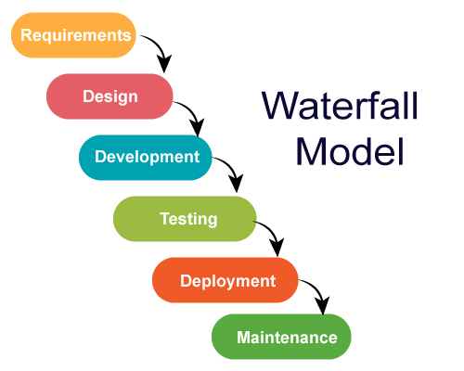
Figure 1: Waterfall Model

The development of the proposed system follows the Waterfall Model, a structured and sequential approach to software development. This model is appropriate for the project because the system requirements are clearly defined at the beginning, particularly in terms of document digitization, centralized storage, and role-based access control.
The Waterfall Model consists of the following phases:
- Requirements Analysis – Gathering and analyzing system requirements such as document scanning, storage, and access control.
- System Design – Designing the system architecture, database structure, and user interface.
- Implementation – Actual development and coding of the system using selected technologies.
- Testing – Verification of system functionality, including login, document access, and retrieval.
- Deployment – Installation and use of the system in a local environment.
- Maintenance – Continuous monitoring and updating of the system as needed.
This structured approach ensures that each phase is completed thoroughly before proceeding to the next, resulting in a stable and reliable system.
TECHNICAL BACKGROUND
Technologies to be Used

The Document Scanning and Access Control Management System is being developed with technologies that enable secure, efficient document management. This is because organizations are moving away from systems and towards digital ones, and they need solutions that ensure documents are accessible and secure.

The Document Scanning and Access Control Management System is a computer-based application that will be used within a network environment. It uses .NET MAUI and Blazor to create a user-friendly interface. These technologies make it possible to develop applications that can run on platforms without sacrificing performance and usability.

For storing and managing data, the Document Scanning and Access Control Management System uses Microsoft SQL Server, which is a robust relational database management system. This ensures that data is stored securely, queries are efficient, and large volumes of data, such as user accounts, document records, and access permissions, are handled reliably.

Security is a priority for the Document Scanning and Access Control Management System. It uses user authentication and role-based access control, which allows administrators to decide who can view or edit documents. This is in line with trends in system development, which emphasize the importance of protecting data, being accountable, and making sure systems are reliable.

Calendar of Activities
Brainstorming: The researchers got together to brainstorm ideas for a capstone project related to information systems. They came up with ideas and discussed them as a group. The team prepared possible titles for the project, focusing on digital solutions for data management and security. This process helped the researchers explore concepts and eventually decide on developing the Document Scanning and Access Control Management System.
Searching for Adviser: The researchers looked for an adviser who could guide them throughout the project. They reviewed advisers and prepared the requirements for approval. After submitting their request, the group got the guidance they needed for the study
Proposed Project Title: The researchers presented their proposed project titles to their adviser. Each title was discussed in detail to make sure it was feasible and aligned with the group’s skills and resources. After evaluating the options, the title "Document Scanning and Access Control Management System" was approved as the capstone project.
Adviser Approval: The assigned adviser accepted the request to guide the researchers throughout the capstone project. This marked an important milestone, as the group was able to proceed with clearer direction and proper supervision.
Searching for Client and Potential Meeting: the researchers identified a client or target environment for the Document Scanning and Access Control Management System. They studied organizations that handle volumes of documents and chose the Armed Forces of the Philippines as the project context. The team prepared for discussions and requirement gathering to understand document handling processes.
Starting Chapter: The researchers developed Chapter 1 of the study, which includes the project context and review of related literature. Various sources were gathered and analyzed to support the study and strengthen its foundation.
Starting the UI of the System: The front-end development of the Document Scanning and Access Control Management System was initiated. The user interface was designed to be simple organized and user-friendly to ensure navigation and accessibility.
Starting Chapter 2: The researchers worked on Chapter 2 of the study, focusing on the technical background, system design, and processes. This included describing how the system will function and how its components interact.
Starting the Backend of the System: Backend development was started, focusing on system logic, data processing, user authentication, document storage, and access control using Microsoft SQL Server.
Revising UI of the System: The user interface and system functionalities were revised and improved. Enhancements were made to improve usability, system performance, and overall user experience.
Finalization of Manuscript: The researchers will focus on completing and refining the chapters of the study. The group will. Organize all gathered information making sure that the discussion of the Document Scanning and Access Control Management System design, technical background and processes is clear and accurate. Necessary revisions will be made to improve the quality of the paper.
Testing and Debugging: The Document Scanning and Access Control Management System will undergo testing and debugging to identify errors in functionality, user interface and data processing. This will ensure that all features, such as login authentication, document upload, retrieval and access control will function properly and securely.
Deployment: The system will be deployed in a local network environment and installed on designated computers for authorized personnel. This will allow the system to be used in an actual working environment while ensuring secure and controlled access to documents.
Maintenance: The researchers will provide maintenance activities after deployment, including system monitoring, bug fixing, performance improvements, and updates. The system administrator will also manage user accounts and ensure continuous system security and reliability.
Gantt Chart of the Activities
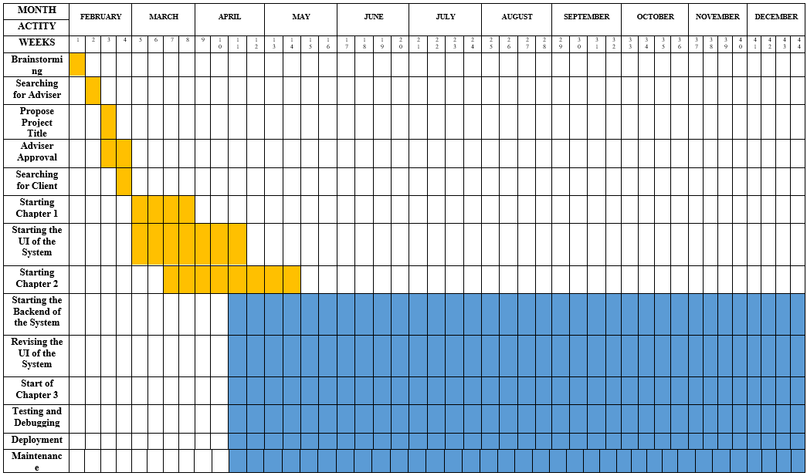

ONGOING
COMPLETE

Software Resources:

- .NET MAUI (Multi-platform App UI): This technology is used to develop system applications across multiple platforms while maintaining a consistent user interface and performance. .NET MAUI is selected because it allows efficient development of modern applications and supports integration with other technologies used in the system.
- Blazor Framework: This framework is used to build interactive user interfaces using C#. It enables the development of dynamic web-based components within the application, making the system more responsive and user-friendly.
- Microsoft SQL Server: This serves as the database management system of the project. It is used to store and manage user accounts, document records, and access permissions. SQL Server is chosen because of its reliability, security features, and ability to handle large volumes of data efficiently.
- Visual Studio IDE: This integrated development environment is used for coding, debugging, and testing the system. It provides tools and features that help streamline the development process and improve code quality.
- Windows Operating System: This serves as the primary operating system for development and system deployment. It provides compatibility with development tools such as Visual Studio and SQL Server.
- Microsoft Office Tools: These tools are used for documentation, including writing the research paper, preparing reports, and organizing project files.
- Figma: This design tool is used for creating wireframes and user interface prototypes of the system. It helps the researchers visualize the layout, structure, and user flow of the application before development. Figma allows easy collaboration and modification of designs, making it useful in improving the overall user experience.

Requirements Analysis

The researchers wanted to create a system that would work well for the Armed Forces of the Philippines. Researchers talked to the people who handle documents and observed how they do their jobs. The goal was to figure out what the Document Scanning and Access Control Management System needed to have. They broke it down into categories:

Who
- These are the people in charge of the whole system. They create user accounts decide who can do what and make sure everyone follows the rules. They also keep an eye on what's going on in the system.
- Authorized Personnel (Office Staff): Users who are allowed to access the system to upload, view, and retrieve documents. Their access level depends on their assigned role, such as view-only or edit permissions.
- Records Personnel: Staff who scan and upload documents into the Document Scanning and Access Control Management System. They make sure documents are properly categorized and stored in the database.
What
- The system will manage the digitization, storage, retrieval, and access control of important documents such as personnel records, reports, and other sensitive files.
- It will replace manual filing processes by providing a centralized digital repository for all documents.
- The Document Scanning and Access Control Management System will also make sure that authorized users can view or modify specific documents, based on their role.
Where
- The system will be deployed within a secure office environment of the organization.
- It will operate through a local network (LAN), limiting access to authorized users within the designated area.

When
- The system will be used during daily administrative operations, particularly when documents need to be stored, accessed, retrieved, or managed.
- It will also be used whenever new physical documents are scanned and added to the system.
How
- Currently, documents are managed through manual filing systems, where records are stored in physical folders and cabinets. Retrieval requires manual searching, which is time-consuming and inefficient.
- With the proposed system, documents will be scanned and converted into digital format, then stored in a centralized database using Microsoft SQL Server.
- Users will access the system through a secure login, and their actions will be controlled based on assigned roles, allowing faster, more secure, and more efficient document management.

Requirement Documentation

The Armed Forces of the Philippines needs a way to manage documents. Now they use a traditional manual system where they store important records like personnel files and reports in physical folders and filing cabinets. This can cause a lot of problems like documents getting lost, taking a long time to find, getting damaged, and people accessing confidential information who should not be able to. These problems affect how well the organization can manage its documents.
The researchers think they have a solution. They want to create a user- system called DASM-AFP: Computer-based Document Archiving and Security Management for the Armed Forces of the Philippines. This system will take the documents, turn them into digital files, store them in a central database, and only let authorized people access them. This will make it easier to handle documents, find them faster, keep them safer, and reduce the risk of losing them or someone accessing them who should not.
The DASM-AFP system has two parts: the User Management Module and the Administrator-Side, and the Document Archiving Module.

Administration and Security Module (Administrator/System-Side):
This part of the system lets the administrator control user accounts, give people roles, and decide who can access what. The administrator can create users, update their information, and deactivate them if needed. They can also control what level of access each user has to the system. This module also has security measures like user authentication and role-based access control to make sure only the right people can see documents. It also keeps track of what users are doing, so the administrator can see if someone is trying to access something they should not.

- Audit Trail (Sub-Feature):

The Audit Trail keeps a record of everything that happens in the system, like when someone logs in, uploads a document, or looks at a file. It also keeps track of when someone edits or deletes a document. This helps the administrator see what is going on and catch anyone who is trying to do something they should not be doing. It is also useful for looking at how the system is being used and investigating any security problems.

Document Archiving Module (User-Side):
This part of the system lets users upload digital documents, organize them, and store them in the database. Users can also search for. Find documents they need quickly. This replaces the manual filing system and makes it easier to find documents while keeping them organized.

The DASM-AFP system is a platform that helps the Armed Forces of the Philippines manage its documents in a better way. The DASM-AFP system makes sure that documents are stored safely, can be accessed securely, and are managed reliably. The DASM-AFP system is an improvement over the old manual system.

Key features of the DASM-AFP system include:
- The ability to upload and store documents in a central database
- The ability to search for and find documents quickly
- The ability to control who can access what documents
- The ability to keep track of what users are doing
- The ability to keep documents safe and secure

Design of Software, System, Product, and/or Processes

This section presents the overall design of DASM-AFP: Computer-based Document Archiving and Security Management for Armed Forces of the Philippines. It explains how the software, system components, and processes are structured to meet the requirements of secure and efficient document management. The system design focuses on providing centralized storage, user-friendly access, and strict security controls for sensitive documents. It also defines how users interact with the system, from document scanning and uploading to retrieval and management. Overall, the design ensures that the system is organized, efficient, and suitable for replacing the existing manual filing process.

FLOW CHART
DASM – AFP ADMIN APP
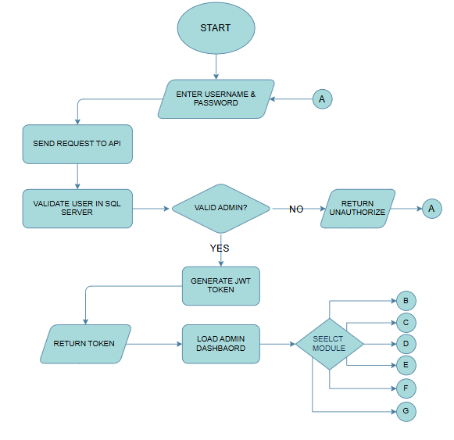
Figure 2: Admin Authentication Flow

The authentication process begins when the administrator enters a valid username and password. Upon submission, the credentials are transmitted to the Application Programming Interface (API) or server for validation against the records stored in the database. If the provided credentials are verified as valid and correspond to an administrative account, the system proceeds to generate a JSON Web Token (JWT). This token is then returned to the client and used to authorize access to the admin dashboard, where the administrator can navigate through various modules and perform subsequent actions. Conversely, if the credentials are invalid, the system returns an unauthorized access response.
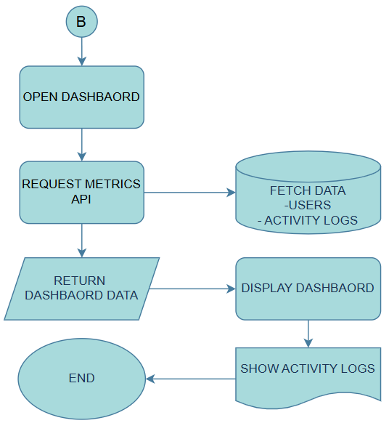
Figure 3: Admin Dashboard

Upon accessing the dashboard, the system initiates a request to the API to retrieve relevant metrics. These metrics include user data and activity logs, which are fetched from the database. The retrieved information is then displayed on the dashboard, providing the administrator with an overview of system activities and user interactions.

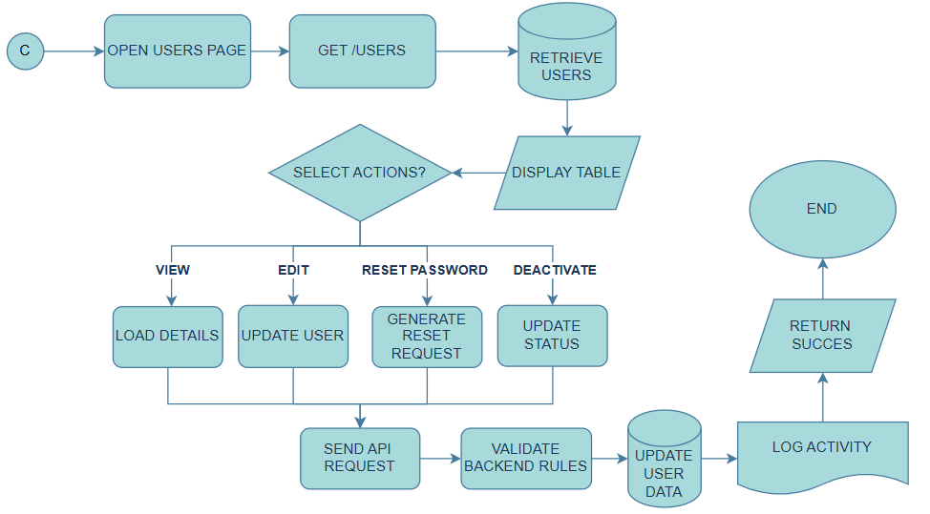
Figure 4: Admin User Management

When the Users Management module is accessed, a request is sent to the API to retrieve user records from the database. The retrieved data is displayed in a structured format on the interface. Administrators are provided with several action options, including viewing, editing, resetting passwords, and deactivating user accounts.
- The View function displays detailed information about a selected user.
- The Edit function allows modification of user information.
- The Reset Password function generates a password reset request.
- The Deactivate function updates the user’s account status.
Each action triggers an API request, which is validated by the backend system. Upon successful validation, the system updates the database accordingly and records the action in the activity logs as confirmation of completion.

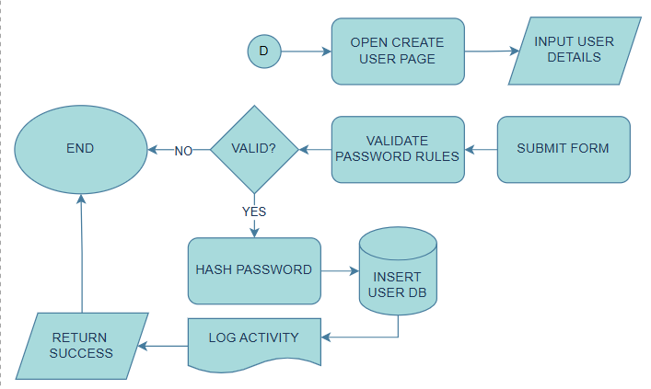
Figure 5: Admin Create User Account

In the Create User module, the administrator enters the required user information via a form. Upon submission, the system validates the entered password based on defined security requirements, including a minimum length of eight characters and the inclusion of uppercase letters, lowercase letters, and special characters.

If validation succeeds, the password is securely hashed before being stored. The user data is then inserted into the database, and the action is recorded in the activity logs as confirmation of successful user creation.

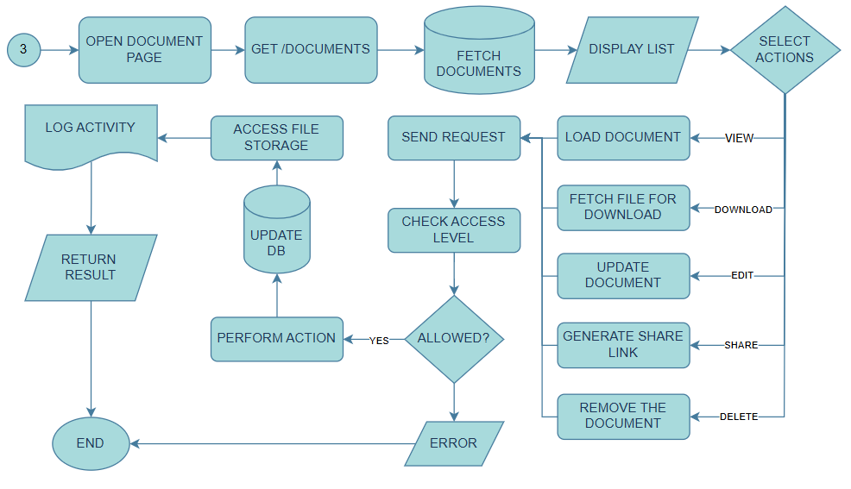
Figure 6: Admin Document Management

Within the document page, all available documents are retrieved from the database and displayed on the interface. Access to document actions is determined by the user’s assigned access level. Administrators are granted full access, all
owing them to view, edit, share, download, and delete documents.

When an action is selected, a request is sent to the API, where the system verifies the administrator’s access level. If authorized, the requested operation is executed, the database and file storage are updated accordingly, and the activity is recorded in the logs. A response is then returned to confirm the successful operation. If the action is not permitted, the system returns a 403 Forbidden error.

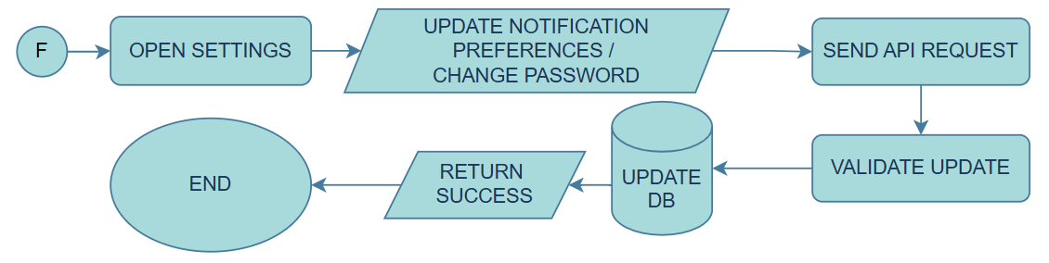
Figure 7: Admin Setting

The Settings module allows administrators to either update notification preferences or change their account password. Each action generates an API request, which is validated by the backend. Upon successful validation, the system updates the corresponding data in the database and returns a success response.

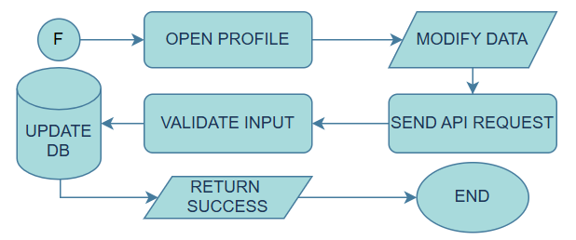
Figure 8: Admin Profile

When accessing the profile page, the system displays the administrator’s personal information. The administrator is permitted to modify specific fields, such as address and contact number. Upon submission of changes, an API request is sent for validation. If the input is valid, the database is updated and a success response is returned.

DASM – AFP USER SIDE
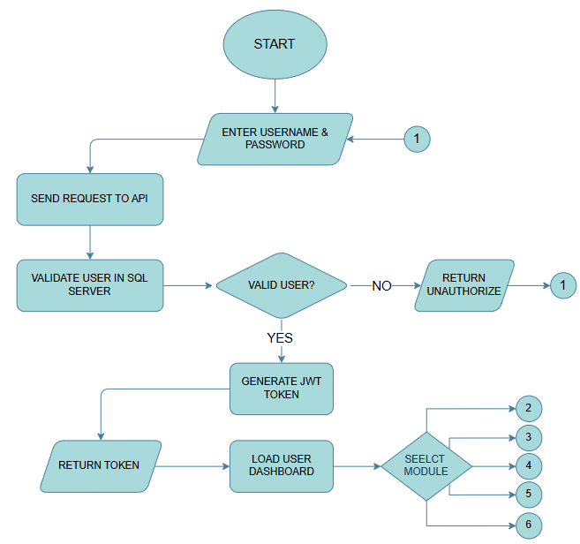
Figure 9: User’s Authentication Flow

The authentication process for users follows a similar procedure to that of administrators. Users enter their username and password, which are then transmitted to the API for validation against database records. If the credentials are valid and correspond to authorized users (e.g., civilian or military personnel), a JWT token is generated and returned. This token enables access to the user dashboard, where users can perform available actions. If the credentials are invalid, the system returns an unauthorized response.
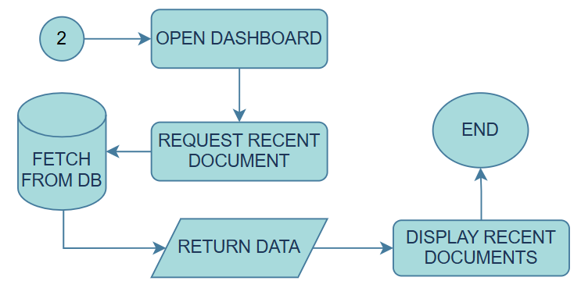
Figure 10: Users Dashboard

Upon accessing the user dashboard, the system sends a request to the API to retrieve recent document activities, including previously viewed or requested documents. These records are fetched from the database and returned to the interface, where they are displayed to provide users with a summary of their most recent interactions with the system.


Figure 11: Users' Document Management

In the document management module, documents are retrieved from the database and displayed to the user. Available actions depend on the access level assigned by the administrator. When a user selects an action, a request is sent to the server, which verifies whether the user has the necessary permissions.

If authorized, the system performs the requested action, updates the database and file storage, logs the activity, and returns a success response. Otherwise, an error message is displayed to indicate insufficient permissions.

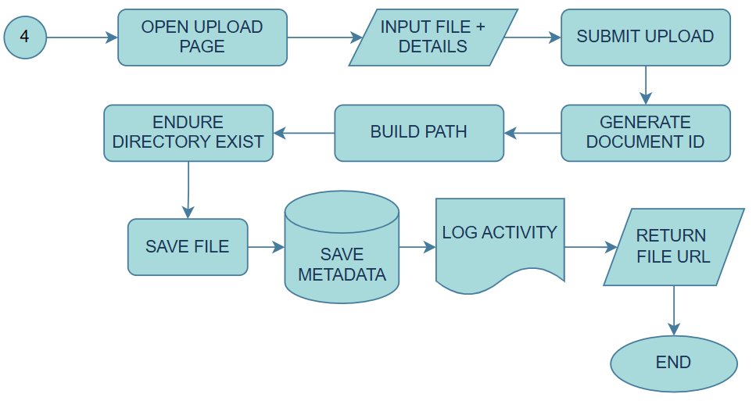
Figure 12: Users Upload Management

When a user uploads a file, the system generates a unique Document ID and constructs a file path based on the selected directory. The file is then stored accordingly. Upon successful upload, the system records the action in the activity logs and returns the file URL as confirmation.

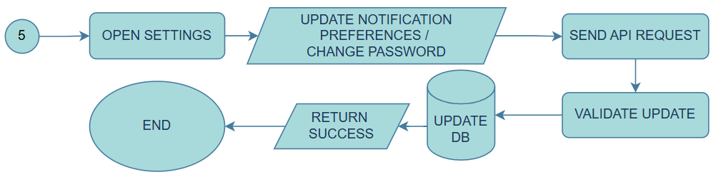
Figure 13: Users Setting

The User Settings module provides options for updating notification preferences or changing the account password. Each action triggers an API request, which is validated before any updates are applied. Once validated, the system updates the database and returns a success response.
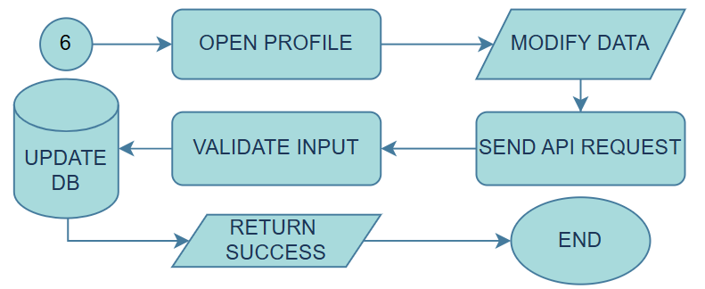
Figure 14: User Profile

The profile page displays the user’s personal information. Users are allowed to modify limited fields, such as address and contact number. After submitting changes, the system sends a request to the API for validation. If successful, the database is updated, and a confirmation response is returned.

DATA FLOW DIAGRAM
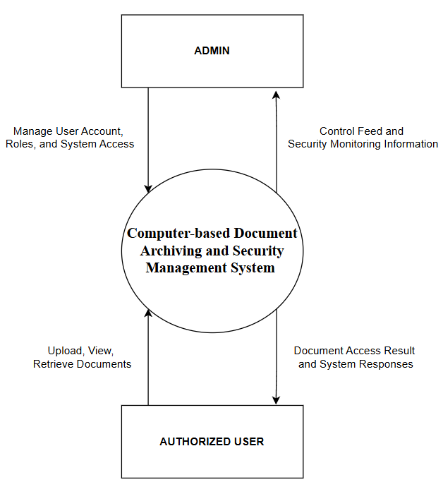
Figure 15: DFD Context Level

In Level 0 (Context Level) of the computer-based Document Archiving and Security Management System, a process is shown of how the system connects to its entities (Authorize User & Admin). The process flows through the computer-based Document Archiving and Security Management System, where admins manage User accounts, Roles, System access, and the system gives a security monitoring information and control feed to the admins. While the authorized user uploads, views, and retrieves documents to the system, the system will give document access results and responses to the authorized user's requests.

References
Directory of Open Access Journals. (2024). Document archiving research and technical standards for indexing. https://doaj.org/article/6c1eb6c59331475f9b6e53387b974b6c
Document Logistix. (2024). Document archiving management: Everything you need to know. https://document-logistix.com/document-archiving/
Gamba, R. J., et al. (2024). Web-based digital repository and encryption standards for Philippine academic institutions.
Local State College Study. (2025). Implementation of document tracking and archiving systems (DTAS) for ISO compliance.
MES Hybrid Document Systems. (2024, March 28). The impact of document archiving on data security: A comprehensive analysis. https://blog.mesltd.ca/the-impact-of-document-archiving-on-data-security-a-comprehensive-analysis
Microsoft. (n.d.). C# documentation. https://learn.microsoft.com/en-us/dotnet/csharp/
Microsoft. (n.d.). SQL Server Management Studio (SSMS). https://learn.microsoft.com/en-us/sql/ssms/download-sql-server-management-studio-ssms
Microsoft. (n.d.). Visual Studio 2022 documentation. https://learn.microsoft.com/en-us/visualstudio/ide/

APPENDICES

APPENDIX A: Prototype Design of The Document Archiving And Security Management for the Armed Forces of the Philippines

USER SIDE
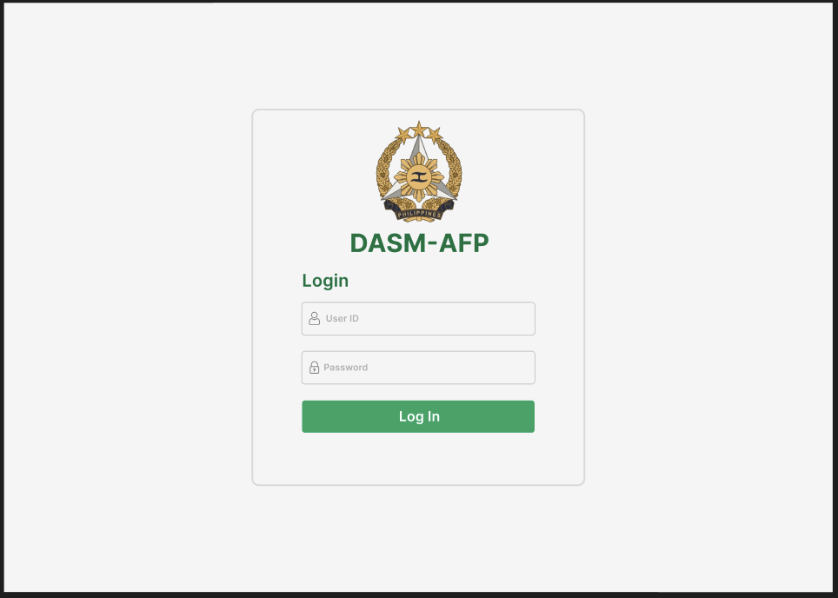
Figure 16: User Login Page

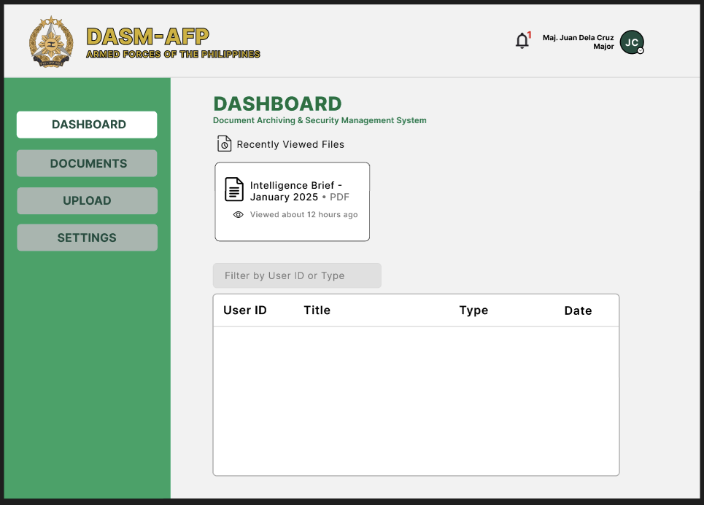
Figure 17: User Dashboard

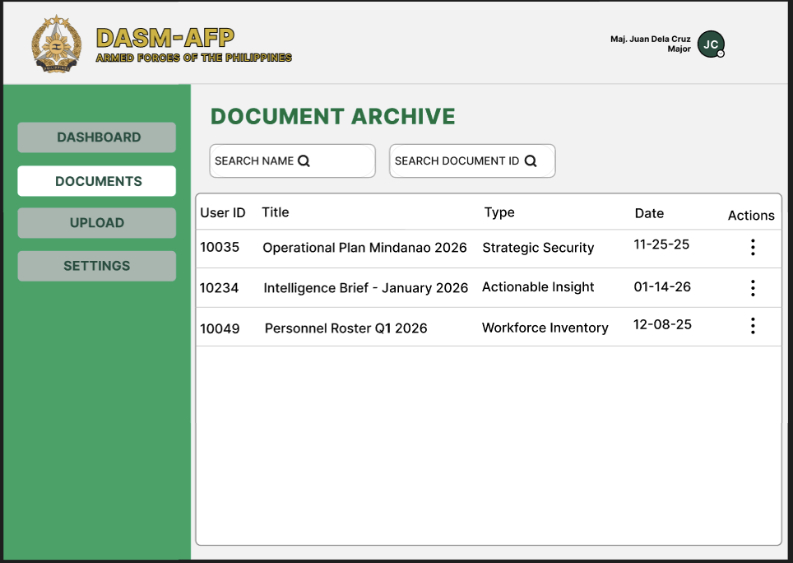
Figure 18: User Documents

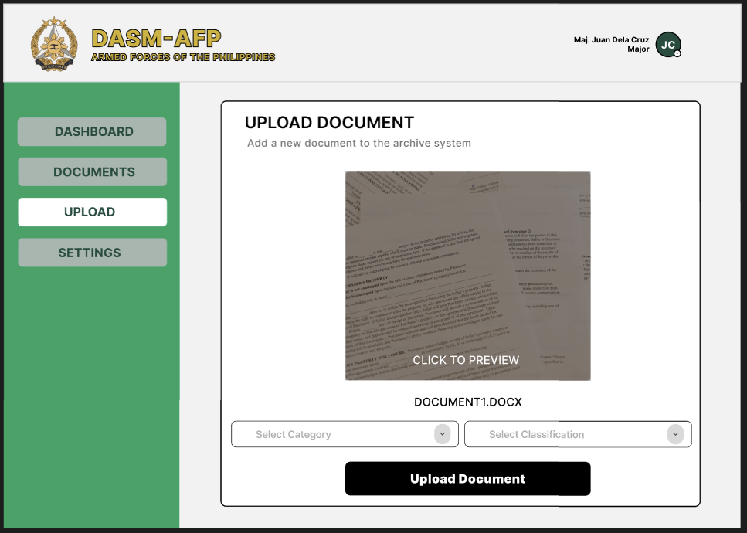
Figure 19: User Upload Documents

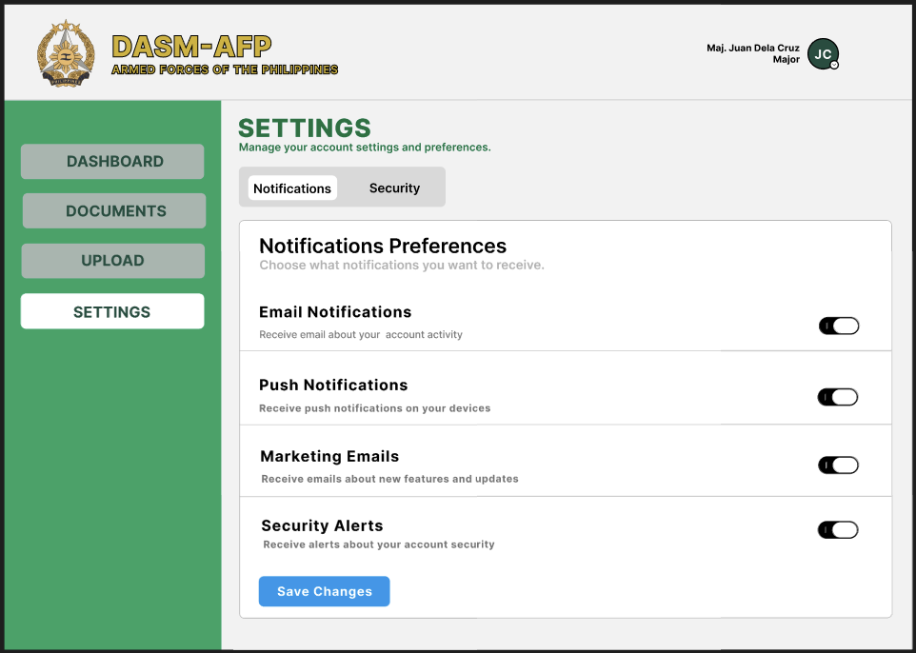
Figure 20: User Settings/Notification

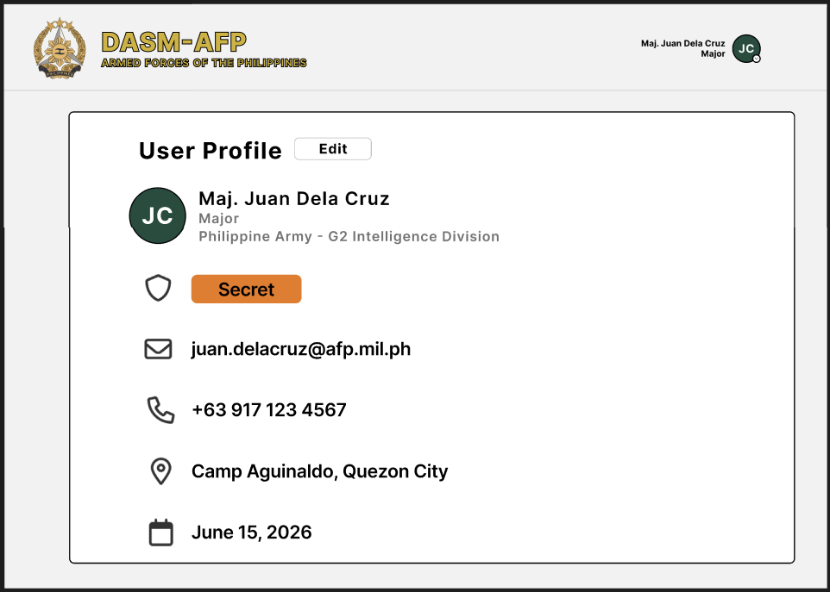
Figure 21: User Profile

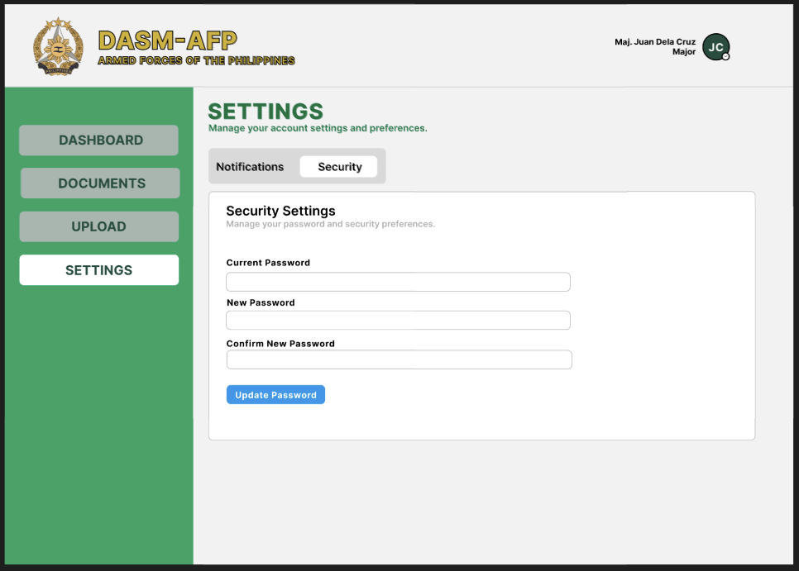
Figure 22: Users' Security Settings

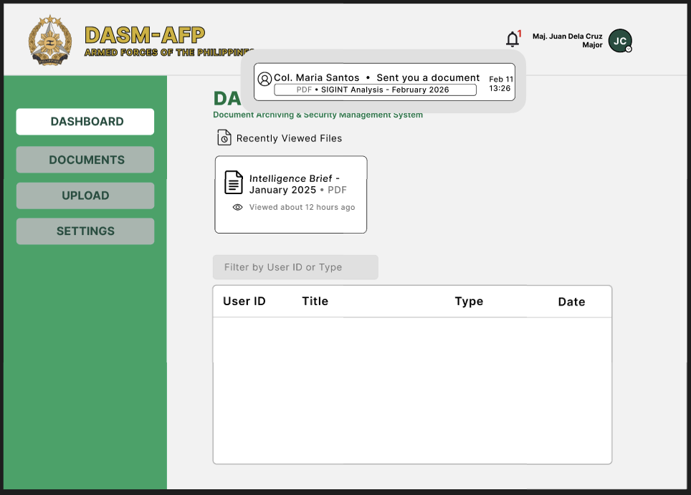
Figure 23: Users Dashboard Notification

ADMIN SIDE
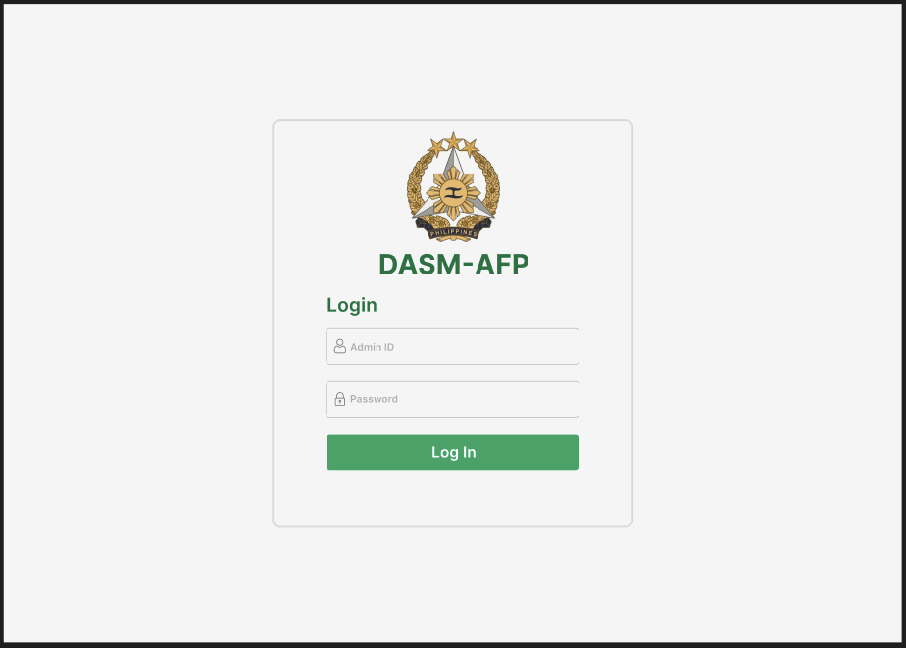
Figure 24: Admin Login Page

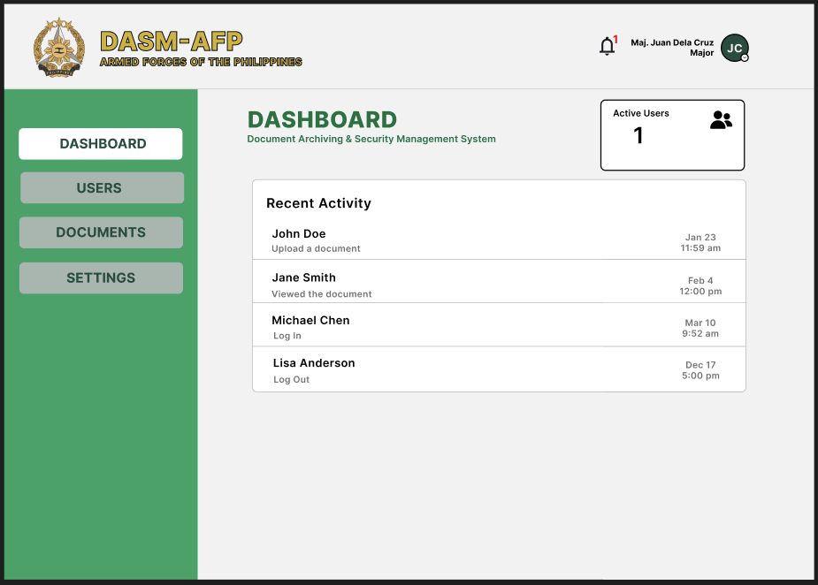
Figure 25: Admin Dashboard

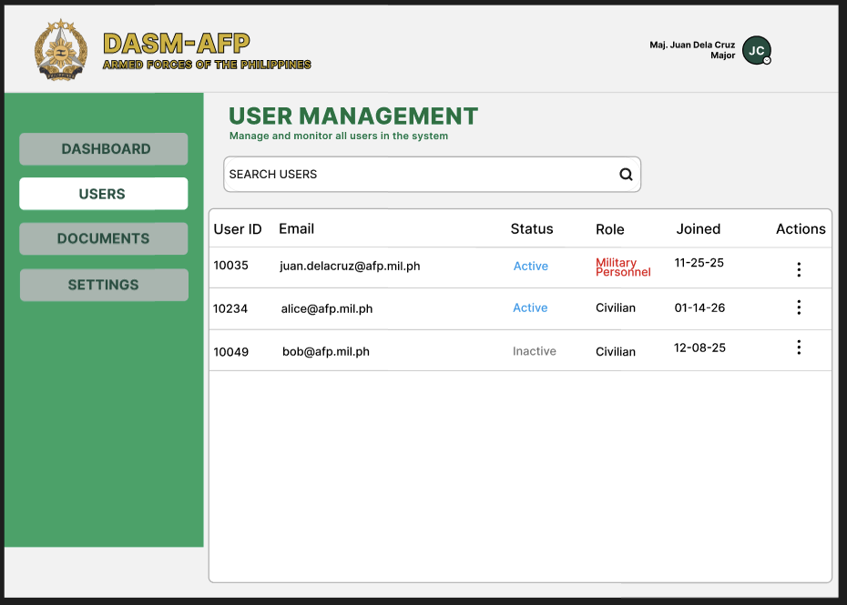
Figure 26: Admin Users Management

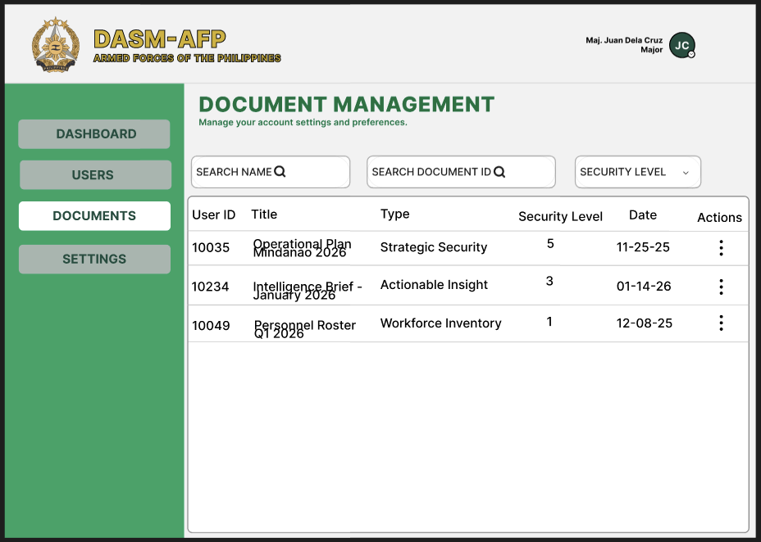
Figure 27: Admin Document Management

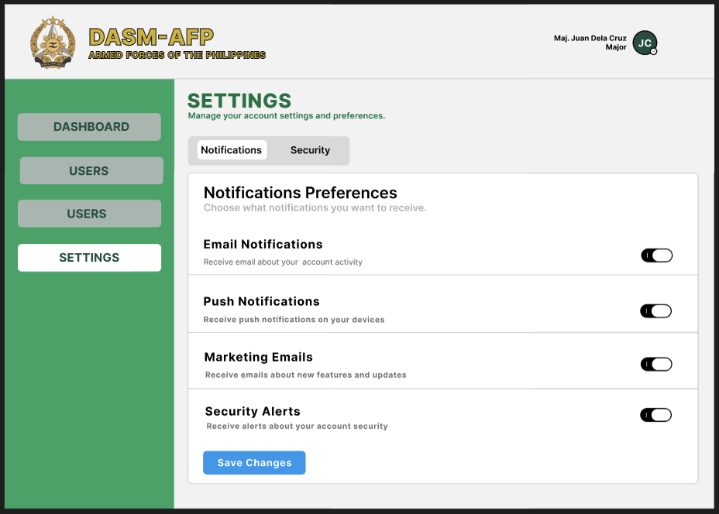
Figure 28: Admin Setting/Notification

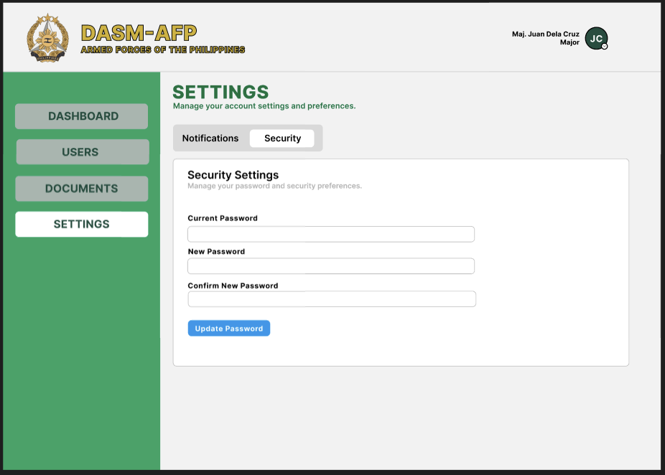
Figure 29: Admins Security

