DASM-AFP: Computer-based Document Archiving and Security Management for Armed Forces of the Philippines
A Capstone Project
Presented to the Faculty of the
Information and Communications Technology Program
STI College Cubao

In Partial Fulfilment
of the Requirements for the Degree
Bachelor of Science in Information Technology
Angelo Kyle S. Pinlac
Cherish Love A. Faeldin
Dominic Anthony M. Rabano
May Ann R. Villadar

October 19, 2025

ENDORSEMENT FORM FOR PROPOSAL DEFENSE

TITLE OF RESEARCH: DASM-AFP: Computer-based Document
Archiving and Security Management for Armed Forces of the Philippines

NAME OF PROPONENTS: Angelo Kyle S. Pinlac
Cherish Love A. Faeldin
Dominic Anthony M. Rabano
May Ann R. Villadar

In Partial Fulfilment of the Requirements
for the degree Bachelor of Science in Information Technology
has been examined and is recommended for Proposal Defense.

ENDORSED BY:

Mr. Michael Jericho Nemedez
Capstone Project Adviser

APPROVED FOR PROPOSAL DEFENSE:

Engr. John Ivan D. Bachiller
Capstone Project Coordinator

NOTED BY:

Mr. Brian Calata, LPT
Program Head

APPROVAL SHEET
This capstone project proposal titled DASM-AFP: Computer-based Document Archiving and Security Management for Armed Forces of the Philippines, prepared and submitted by Angelo Kyle S. Pinlac, Cherish Love A. Faeldin, Dominic Anthony M. Rabano, and May Ann R. Villadar, in partial fulfillment of the requirements for the degree of Bachelor of Science in Information Technology, has been examined and is recommended for acceptance and approval

Mr. Michael Jericho Nemedez
Capstone Project Adviser
Accepted and approved by the Capstone Project Review Panel
in partial fulfillment of the requirements for the degree of
Bachelor of Science in Information Technology

Panel Member | Panel Member

Lead Panelist
Noted:
Engr. John Ivan D. Bachiller | Mr. Brian Calata, LPT
Capstone Project Coordinator | Program Head

October 19, 2025

Table of Contents
 |  | Page
Title Page |  | i
Endorsement form for Proposal Defense |  | ii
Approval Sheet |  | iii
Table of Contents |  | vi
Introduction |  | 1
 | Project Context
 | Purpose and Description
 | Objectives
Scope and Limitations
Review of Related Literature/Studies/Systems
Methodology
 | Technical Background
 | Requirements Analysis
 | Requirements Documentation
 | Design of Software, System, Product, and/or Processes
References
Appendices
 | Resource Persons
 | Personal Technical Vitae

Introduction

Project Context
The Armed Forces of the Philippines (AFP) is a vast organization responsible for national security and defense, a mandate that necessitates the handling of a massive volume of sensitive paperwork on a daily basis. These records, which range from personnel files and medical histories to mission-critical operational documents, constitute the institutional memory of the organization. Currently, the majority of these documents are maintained through traditional manual filing methods, stored in physical folders and steel filing cabinets. While this system has been the standard for decades, it is increasingly inadequate for the demands of modern military administration.
The reliance on a physical filing infrastructure creates significant operational vulnerabilities. Paper-based records are inherently fragile and susceptible to various forms of physical degradation. Environmental factors such as humidity, heat, and potential water damage pose a constant threat to the integrity of the records. Furthermore, physical documents are prone to misplacement or loss during handling, creating gaps in critical information. This "old-fashioned" approach to record-keeping introduces a high level of risk, as the physical loss of a document is often permanent and irreversible.
Beyond physical risks, the current system is characterized by profound operational inefficiencies. When authorized personnel require access to a specific file, they must often engage in labor-intensive manual searches through voluminous stacks of paper. This process is not only time-consuming but also creates bottlenecks in the administrative workflow, slowing down office productivity, and hindering the organization’s ability to run smoothly. In a military context, where rapid access to information can be a factor in operational readiness, the delays caused by manual document retrieval represent a critical weakness.
Security remains the most pressing concern within the current framework. Physical filing cabinets, even when locked, are difficult to monitor and lack a robust mechanism for tracking access. There is a constant threat that sensitive or classified information may be viewed by individuals who do not possess the necessary clearance. Because physical systems cannot provide a real-time log of who accessed a file, and when, the organization lacks a transparent and accountable audit trail for its most important assets.
Recognizing these daily struggles, there is a clear and urgent need for a Document Scanning and Access Control Management System. The objective of the study is to provide a digital solution that converts physical papers into secure digital files, consolidated within a centralized and organized computer-based environment. By digitizing the AFP’s record-keeping, the system ensures that sensitive information is significantly more secure than a standard padlock on a cabinet.
The proposed system is designed to transform the AFP’s administrative landscape by making office work faster, safer, and more reliable. This transition to a digital framework is not merely a matter of convenience; it is a strategic shift toward modernization that meets the military’s growing demand for tighter information security and higher administrative standards in an increasingly digital world. All old files will be scan to convert it to digital, The study aimed to develop records archiving and document repository to overcome the barrier of server client method of deploying the documents from one place to another and easier data access to its stakeholders.
The transition to a digital framework is underpinned by a robust security architecture designed to surpass the limitations of physical filing. The system enhances information integrity by organizing documents into specific categories, which allows for a more systematic approach to data governance. Through this categorical organization, users can precisely select which personnel are authorized to access certain files based on their specific roles and departments. The system implements granular security settings by distinguishing between viewing and editing options, ensuring that document modifications are restricted to designated individuals while providing read-only access to others. This tiered access management creates a transparent and accountable digital trail, aligning with the military's requirement for rigorous information security.

Purpose and Description
The primary function of the system is to act as a secure digital bridge for the Armed Forces of the Philippines, moving away from the risks associated with traditional paper-based filing. Currently, the manual handling of documents leads to significant problems like physical damage, misplacement, and the constant threat of unauthorized people seeing sensitive information. The proposed system solves these issues by converting physical papers into a digital format that is kept in one central, organized location. Consequently, the system facilitates faster document retrieval, replacing hours of manual searching with a simple, efficient computer-based process that ensures long-term file safety.
The unique and innovative focus of the system is high-level security through integrated access control management. Unlike a physical filing cabinet that is difficult to monitor, the system allows the organization to strictly govern who can view or edit specific information, creating a transparent and accountable digital trail. This shift toward a paperless environment is highly relevant to the military's current needs, as it meets the growing demand for better operational efficiency and tighter information security. By streamlining administrative tasks and protecting vital records from damage or theft, the system provides a more professional way to manage the institution's most important assets in a rapidly changing digital world.

Objectives
The primary objective of the capstone project is to develop a system that modernizes document management through the following specific goals:
- To digitize physical documents using secure scanning methods.
- To provide centralized and organized document storage.
- To implement role-based access control for enhanced security.
- To enable quick and efficient document retrieval.
- To reduce paperwork and improve operational efficiency.
The implementation of the system offers a direct solution to existing problems of document loss and unauthorized access within the AFP. Transitioning to a digital framework allows authorized military personnel to operate within a more secure workspace where critical data is protected and easily accessible.
The general purpose of the study is to provide the Armed Forces of the Philippines with a secure, computer based solution for managing sensitive documents, transitioning away from inefficient manual filing systems. The scope of the system centers on the scanning, digital storage, and systematic organization of documents, alongside the implementation of user authentication and role based access control. The platform allows authorized military personnel the primary beneficiaries of the study to securely upload, view, and retrieve files within their respective offices.
While the system enhances document handling, several limitations exist that are beyond the control of the researcher. The system is strictly limited to internal use within the local network and does not support cloud-based storage, mobile access, or advanced automated data entry features. Furthermore, the effectiveness of the system depends entirely on the manual scanning of physical documents and the continuous availability of computer hardware and electricity. Because it is an offline-based solution for security reasons, it cannot be accessed remotely, and its functionality relies on the proper maintenance of user access privileges by the system administrator.

Review of Related Literature/Studies/Systems

Foreign Literature and Studies
The transition from traditional storage to modern document archiving is recognized as a strategic necessity for organizational resilience and regulatory compliance. As defined by Document Logistix (2024), effective document archiving is the systematic storage of inactive or less frequently accessed records in a secure, organized format for long-term retention. This process serves to preserve critical documentation for legal, historical, or reference purposes and is distinct from regular storage because it involves a deliberate methodology of categorizing and indexing files to ensure they are easily accessible when needed for litigation support or internal audits.
Data security serves as a primary driver for implementing advanced archiving systems. Research by MES Hybrid Document Systems (2024) indicates that secure digital archiving significantly reduces the risk of data breaches by utilizing encryption and role-based access controls to protect sensitive information. Their analysis highlights that inadequate data protection in various industries has led to high-profile breaches, where phishing attacks—often exacerbated by poor document management—account for over 80% of reported security incidents. Furthermore, archiving improves operational efficiency by reducing the time employees spend searching for information and lowering costs by moving inactive data to more affordable storage solutions.
While the literature consistently advocates for digital transformation, there are varying perspectives on how to handle the end-of-life cycle for data. According to the Directory of Open Access Journals (2024), one approach emphasizes the importance of automated retention periods and "document purging," which refers to the permanent deletion of records that have passed their mandated keep-by date. This practice eliminates the legal risks associated with storing unnecessary sensitive data. In contrast, other studies focus on the technical integrity of the archive itself, emphasizing features like virus protection, secure backup options, and compliance with specific international standards such as GDPR or HIPAA.
Local Literature and Studies
In the Philippine context, the management of records is strictly governed by Republic Act No. 9470, also known as the National Archives of the Philippines Act of 2007. Local research by Gamba et al. (2024) emphasizes that manual archiving in Philippine institutions often results in the physical degradation of documents due to environmental factors such as high humidity and thermal fluctuations. Their study advocates for a web-based digital repository that utilizes advanced encryption standards, such as 256-bit AES, to ensure that satellite campuses can access data securely through a virtual private network. This aligns with the global shift toward digital preservation but highlights a specific local need: protecting physical records from the tropical climate while ensuring remote accessibility across the archipelago.
Furthermore, the implementation of Document Tracking and Archiving Systems (DTAS) in local government and educational sectors has shown significant improvements in operational transparency. A study conducted in a local state college (2025) revealed that transitioning from vertical filing cabinets to automated tracking systems reduced document retrieval times and enhanced compliance with ISO standards. However, local literature also identifies a critical "awareness gap" regarding the Data Privacy Act of 2012 (RA 10173). Researchers noted that while digital tools improve efficiency, many local organizations still struggle with a lack of technical expertise and standardized procedures, which can lead to accidental data loss or non-compliance with national privacy mandates.
Synthesis and Rationale
The combination of foreign and local literature provides a strong justification for the proposed system. Foreign research establishes the technical standards for secure archiving and automated data management, while local studies highlight the urgent need to transition from manual, risk-prone filing to digital systems that comply with RA 9470 and the Data Privacy Act. By integrating global security features with a design tailored to the Philippine setting, this project aims to bridge the gap between international best practices and local implementation. This synthesis proves that the proposed system is a necessary infrastructure for ensuring data security and legal adherence in the local landscape

METHODOLOGY
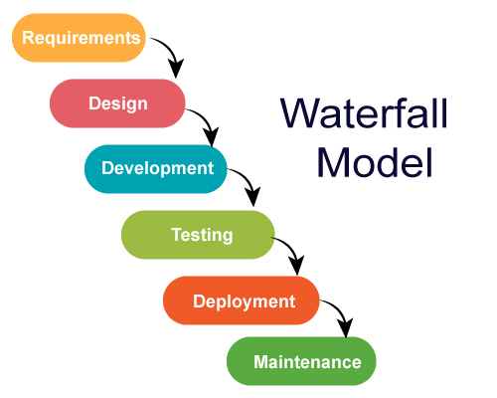
Figure 1: Waterfall Model

The development of the proposed system follows the Waterfall Model, a structured and sequential approach to software development. This model is appropriate for the project because the system requirements are clearly defined at the beginning, particularly in terms of document digitization, centralized storage, and role-based access control.
The Waterfall Model consists of the following phases:
- Requirements Analysis – Gathering and analyzing system requirements such as document scanning, storage, and access control.
- System Design – Designing the system architecture, database structure, and user interface.
- Implementation – Actual development and coding of the system using selected technologies.
- Testing – Verification of system functionality, including login, document access, and retrieval.
- Deployment – Installation and use of the system in a local environment.
- Maintenance – Continuous monitoring and updating of the system as needed.
This structured approach ensures that each phase is completed thoroughly before proceeding to the next, resulting in a stable and reliable system.

TECHNICAL BACKGROUND

Technologies to be Used
The development of the proposed Document Scanning and Access Control Management System is based on modern technologies that support secure and efficient document management. As organizations transition from manual to digital systems, there is a growing need for solutions that ensure both accessibility and data security.

The system is developed as a computer-based application deployed within a local network environment. It utilizes .NET MAUI and Blazor for building an interactive and user-friendly interface. These technologies enable efficient development of applications that can run on multiple platforms while maintaining performance and usability.

For data storage and management, the system uses Microsoft SQL Server, a robust relational database management system that ensures secure storage, efficient querying, and reliable handling of large volumes of data such as user accounts, document records, and access permissions.

Security is implemented through user authentication and role-based access control, allowing administrators to define which users can view or edit specific documents. This aligns with current trends in system development that emphasize data protection, accountability, and system reliability.

Calendar of Activities
Brainstorming: The researchers engaged in brainstorming activities to identify a suitable capstone project related to information systems. Several ideas were proposed and discussed among the group members. The team prepared multiple possible titles focusing on digital solutions for data management and security. This process allowed the researchers to explore different concepts and eventually decide on developing a Document Scanning and Access Control Management System.
Searching for Adviser: The researchers focused on finding a qualified adviser who could guide them throughout the development of the project. During this period, the team reviewed potential advisers and prepared the requirements for approval. After submission, the group secured proper guidance for the study.
Propose Project Title: The researchers presented their proposed project titles to their adviser. Each title was discussed in detail to ensure feasibility and alignment with the group’s skills and available resources. After evaluation, the title “Document Scanning and Access Control Management System” was approved as the official capstone project.
Adviser Approval: The assigned adviser accepted the request to guide the researchers throughout the capstone project. This marked an important milestone, as the group was able to proceed with clearer direction and proper supervision.
Searching for Client and Potential Meeting: The researchers identified a suitable client or target environment for the system. The team studied organizations that handle large volumes of documents and selected the Armed Forces of the Philippines (AFP) as the project context. Preparations for possible discussions and requirement gathering were conducted to understand document handling processes.
Starting Chapter: The researchers developed Chapter 1 of the study, which includes the project context and review of related literature. Various sources were gathered and analyzed to support the study and strengthen its foundation.
Wireframing: The researchers created wireframes for the system to visualize the layout and structure of key features such as login, dashboard, document upload, and document retrieval. This helped define the overall system flow and user interaction.
Starting the UI of the System: The front-end development of the system was initiated. The user interface was designed to be simple, organized, and user-friendly to ensure smooth navigation and accessibility.
Starting Chapter 2: The researchers worked on Chapter 2 of the study, focusing on the technical background, system design, and processes. This included describing how the system will function and how its components interact.
Starting the Backend of the System: Backend development was started, focusing on system logic, data processing, user authentication, document storage, and access control using Microsoft SQL Server.
Revising UI of the System: The user interface and system functionalities were revised and improved. Enhancements were made to improve usability, system performance, and overall user experience.
Finalization of Manuscript: The researchers will focus on completing and refining the chapters of the study. The group will review and organize all gathered information, ensuring that the discussion of the system design, technical background, and processes is clear and accurate. Necessary revisions will be made to improve the overall quality of the paper.
Testing and Debugging: The system will undergo testing and debugging to identify possible errors in functionality, user interface, and data processing. This will ensure that all features, such as login authentication, document upload, retrieval, and access control, will function properly and securely.
Deployment: The system will be deployed in a local network environment and installed on designated computers for authorized personnel. This will allow the system to be used in an actual working environment while ensuring secure and controlled access to documents.
Maintenance: The researchers will provide maintenance activities after deployment, including system monitoring, bug fixing, performance improvements, and updates. The system administrator will also manage user accounts and ensure continuous system security and reliability.

Gantt Chart of the Activities

MONTH | JANUARY |  |  |  | FEBRUARY |  |  |  | MARCH |  |  |  | APRIL |  |  |  | MAY
ACTITY
WEEKS | 1 | 2 | 3 | 4 | 5 | 6 | 7 | 8 | 9 | 10 | 11 | 12 | 13 | 14 | 15 | 16 | 17 | 18 | 19 | 20
Brainstorming
Searching for Adviser
Propose Project Title
Adviser Approval
Searching for Client
Starting Chapter 1
Wireframing
Starting the UI of the System
Starting Chapter 2
Starting the Backend of the System
Revising the UI of the System
Start of the Chapter 3
Testing and Debugging
Deployment
Maintenance

Resources Hardware

Resource | Minimum Specifications | Purpose
Development Laptop/PC | 12th Gen Intel(R) Core(TM) i5-1240P (1.70 GHz)  16.0 GB RAM/ 64-bit operating system, x64-based processor | To run Visual Studio and SQL Server concurrently without performance degradation.
Document Scanner | ADF (Automatic Document Feeder) enabled, 300 DPI minimum | To facilitate high-volume digitization of physical records.
Storage Media | 1TB External Drive or Cloud Storage | For secure backups of the source code and the document database.
Local Area Network | Wi-Fi 5 or Ethernet Connection | To test the database connectivity and multi-user access protocols.

Software Resources:
- .NET MAUI (Multi-platform App UI): This technology is used to develop system applications across multiple platforms while maintaining a consistent user interface and performance. .NET MAUI is selected because it allows efficient development of modern applications and supports integration with other technologies used in the system.
- Blazor Framework: This framework is used to build interactive user interfaces using C#. It enables the development of dynamic web-based components within the application, making the system more responsive and user-friendly.
- Microsoft SQL Server: This serves as the database management system of the project. It is used to store and manage user accounts, document records, and access permissions. SQL Server is chosen because of its reliability, security features, and ability to handle large volumes of data efficiently.
- Visual Studio IDE: This integrated development environment is used for coding, debugging, and testing the system. It provides tools and features that help streamline the development process and improve code quality.
- Windows Operating System: This serves as the primary operating system for development and system deployment. It provides compatibility with development tools such as Visual Studio and SQL Server.
- Microsoft Office Tools: These tools are used for documentation, including writing the research paper, preparing reports, and organizing project files.
- Figma: This design tool is used for creating wireframes and user interface prototypes of the system. It helps the researchers visualize the layout, structure, and user flow of the application before development. Figma allows easy collaboration and modification of designs, making it useful in improving the overall user experience.

Requirements Analysis
To ensure the development of a relevant and functional system, the researchers conducted interviews and observations with personnel involved in document handling within the Armed Forces of the Philippines (AFP). The goal was to identify key requirements for the Document Scanning and Access Control Management System, which were categorized as follows:
Who
- System Administrator: Individuals responsible for managing the overall system. They handle user account creation, assign roles and permissions, monitor system activities, and ensure that access to documents is properly controlled.
- Authorized Personnel (Office Staff): Users who are allowed to access the system to upload, view, and retrieve documents. Their access level depends on their assigned role, such as view-only or edit permissions.
- Records Personnel: Staff responsible for scanning and uploading physical documents into the system. They ensure that documents are properly categorized and stored in the database.
What
- The system will manage the digitization, storage, retrieval, and access control of important documents such as personnel records, reports, and other sensitive files.
- It will replace manual filing processes by providing a centralized digital repository for all documents.
- The system will also enforce role-based access control, ensuring that only authorized users can view or modify specific documents.
Where
- The system will be deployed within a secured office environment of the organization.
- It will operate through a local network (LAN), limiting access to authorized users within the designated area.
When
- The system will be used during daily administrative operations, particularly when documents need to be stored, accessed, retrieved, or managed.
- It will also be used whenever new physical documents are scanned and added to the system.
How
- Currently, documents are managed through manual filing systems, where records are stored in physical folders and cabinets. Retrieval requires manual searching, which is time-consuming and inefficient.
- With the proposed system, documents will be scanned and converted into digital format, then stored in a centralized database using Microsoft SQL Server.
- Users will access the system through a secure login, and their actions will be controlled based on assigned roles, allowing faster, more secure, and more efficient document management.
Requirement Documentation
According to the researchers’ interviews and observations, the Armed Forces of the Philippines (AFP) currently relies on a traditional manual document filing system. Important records such as personnel files, reports, and other sensitive documents are stored in physical folders and filing cabinets. This method often results in issues such as document misplacement, time-consuming retrieval, risk of physical damage, and lack of proper monitoring of access to confidential information. These challenges affect the efficiency, security, and reliability of document management within the organization.

To address these problems, the researchers proposed a user-friendly system entitled DASM-AFP: Computer-based Document Archiving and Security Management for Armed Forces of the Philippines. This digital solution aims to convert physical documents into a digital format, store them in a centralized database, and provide controlled access to authorized personnel. The system simplifies document handling, improves retrieval speed, enhances data security, and reduces the risk of document loss or unauthorized access.

The system is composed of two core components: the User Management Module and the Administrator-Side, and the Document Archiving Module (User-Side).

Administration and Security Module (Administrator/System-Side):
This component combines both administrative control and system security functionalities. It is responsible for managing user accounts, assigning roles, and defining access permissions. The administrator can create, update, and deactivate users while controlling their level of access to the system. In addition, this module enforces security measures such as user authentication and role-based access control, ensuring that only authorized personnel can access sensitive documents. It also supports monitoring of user activities to maintain accountability and prevent unauthorized access.

- Audit Trail (Sub-Feature):
The audit trail records all user activities within the system, such as login attempts, document uploads, file access, edits, and deletions. Each activity is logged with details including the user, action performed, date, and time. This feature provides transparency and accountability by allowing the administrator to track user actions and detect any unauthorized or suspicious behavior. It also serves as a reference for reviewing system usage and investigating potential security issues.

Document Archiving Module (User-Side):
This component handles the main functionality of the system, which is the digitization, storage, and retrieval of documents. Authorized users can upload scanned documents, categorize them, and store them in the centralized database. The module also provides search and retrieval features, allowing users to quickly locate needed files. This replaces the traditional manual filing system and improves efficiency by making documents easily accessible while maintaining proper organization.

Together, these components create an integrated platform that ensures efficient document storage, secure access, and reliable management of sensitive records within the organization.

Design of Software, System, Product, and/or Processes
This section presents the overall design of DASM-AFP: Computer-based Document Archiving and Security Management for Armed Forces of the Philippines. It explains how the software, system components, and processes are structured to meet the requirements of secure and efficient document management. The system design focuses on providing centralized storage, user-friendly access, and strict security controls for sensitive documents. It also defines how users interact with the system, from document scanning and uploading to retrieval and management. Overall, the design ensures that the system is organized, efficient, and suitable for replacing the existing manual filing process.
FLOW CHART
DASM – AFP ADMIN APP
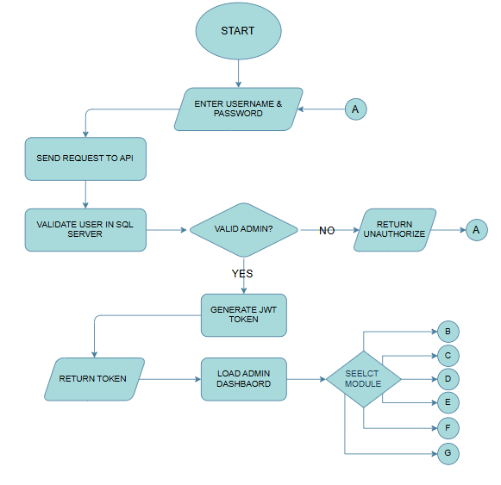
Figure 2: Admin Authentication Flow
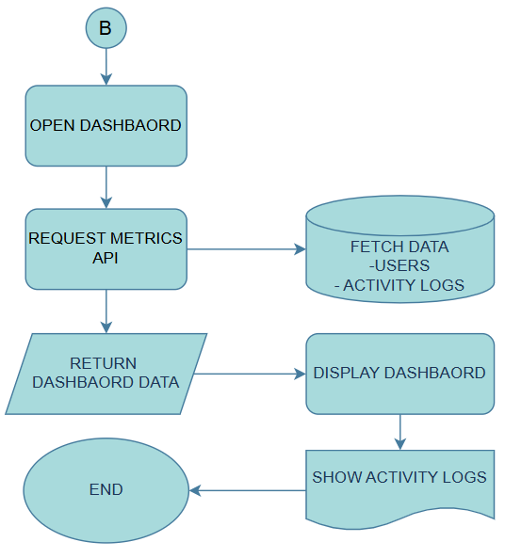
Figure 3: Admin Dashboard

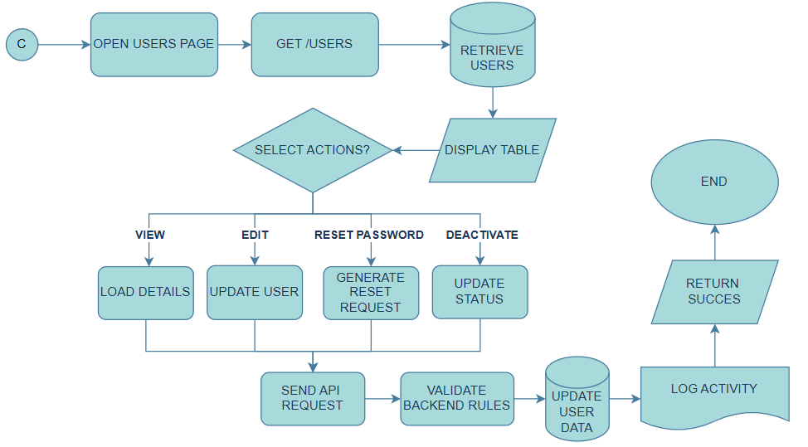
Figure 4: Admin User Management
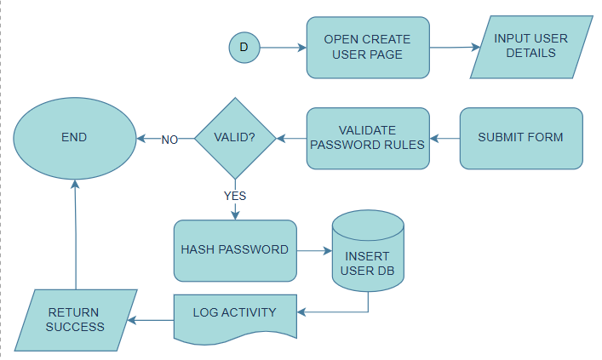
Figure 5: Admin Create User Account

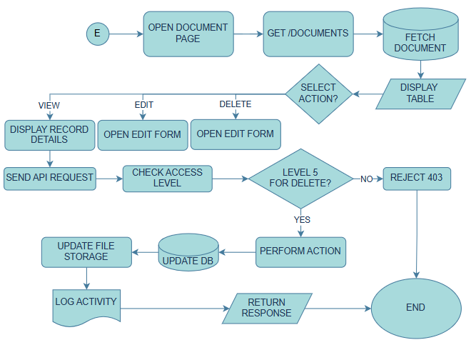
Figure 6: Admin Document Management

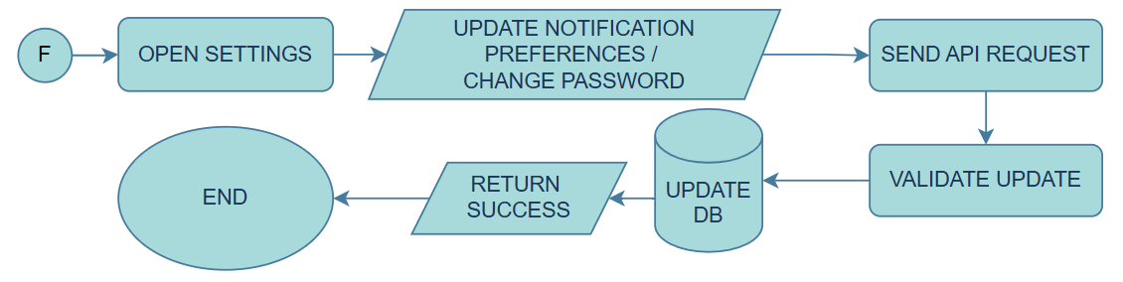
Figure 7: Admin Setting

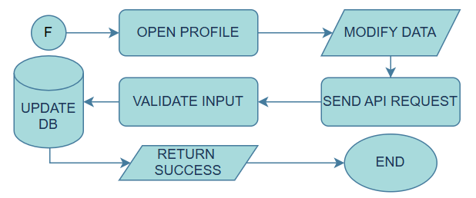
Figure 8: Admin Profile

DASM – AFP USER SIDE
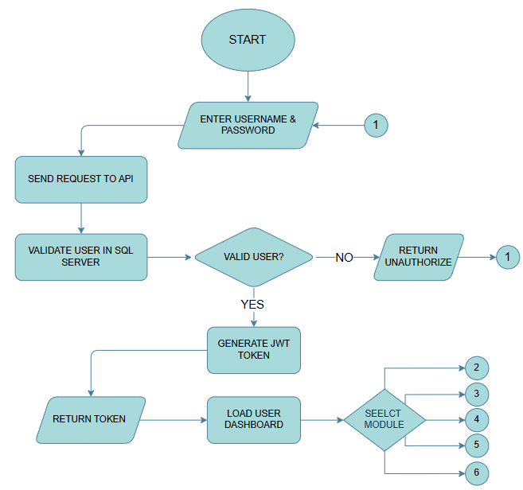
Figure 9: User’s Authentication Flow

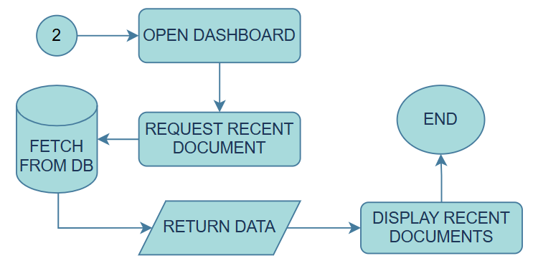
Figure 10: Users Dashboard

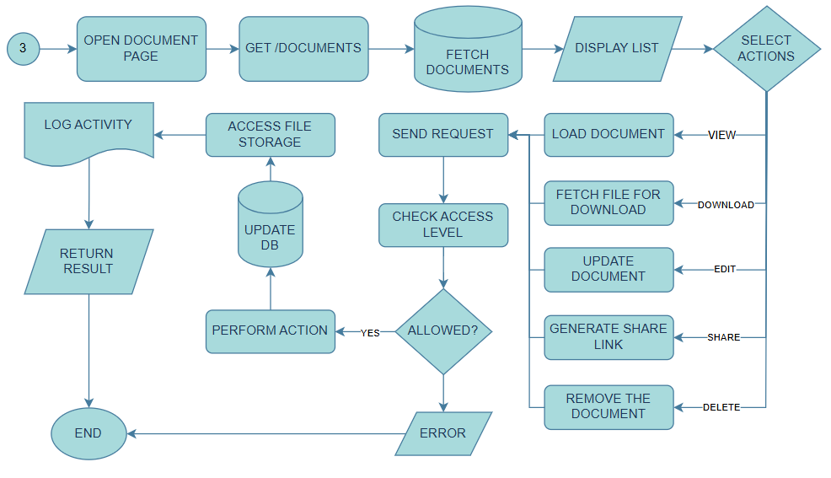
Figure 11: Users Document Management

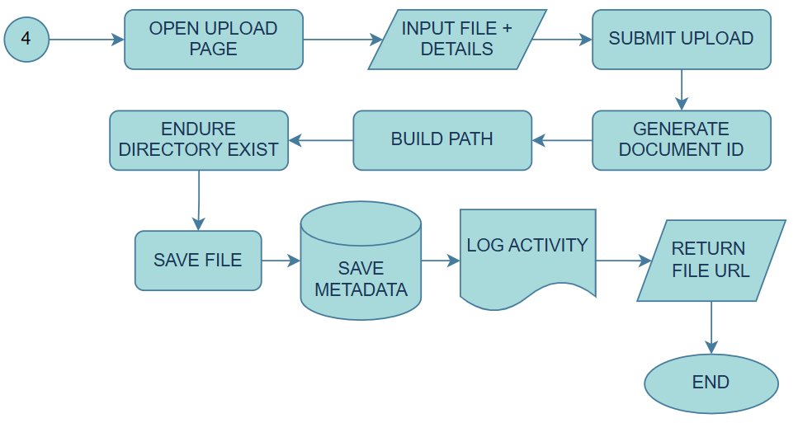
Figure 12: Users Upload Management

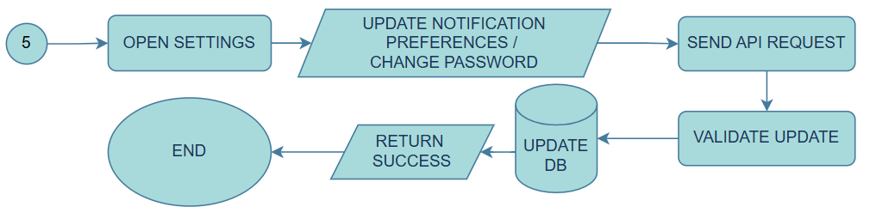
Figure 13: Users Setting

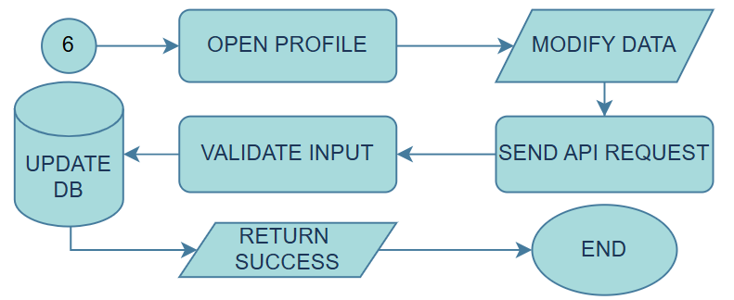
Figure 14: Users Profile

DATA FLOW DIAGRAM
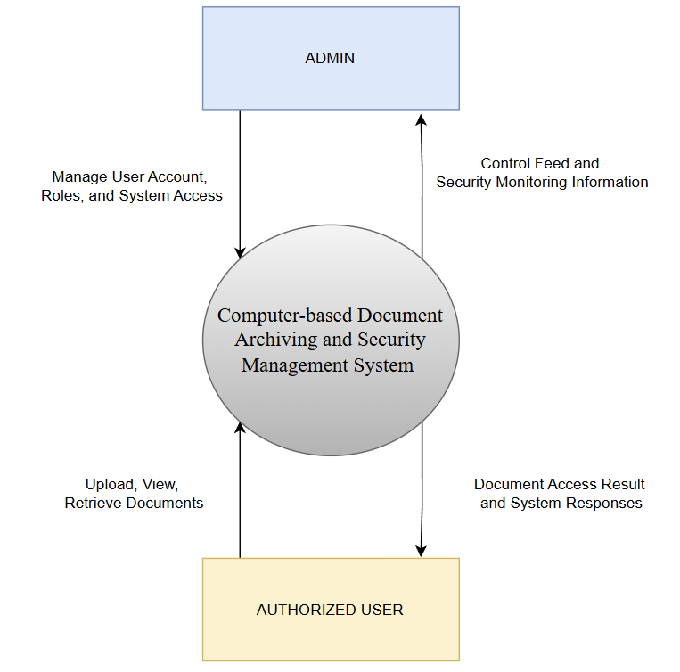
Figure 15: DFD Context Level

PROTOTYPE DESIGN OF THE DOCUMENT ARCHIVING AND SECURITY MANAGEMENT FOR ARMED FORCES OF THE PHILIPPINES

USER SIDE
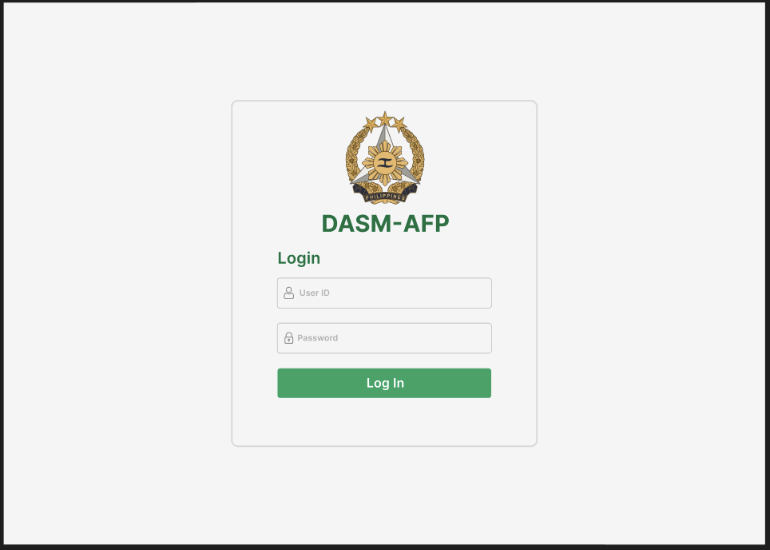
Figure 16: User Login Page

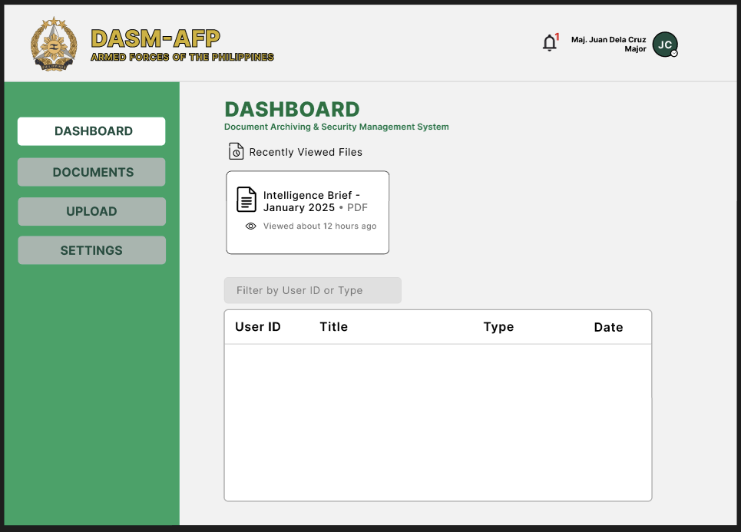
Figure 17: User Dashboard
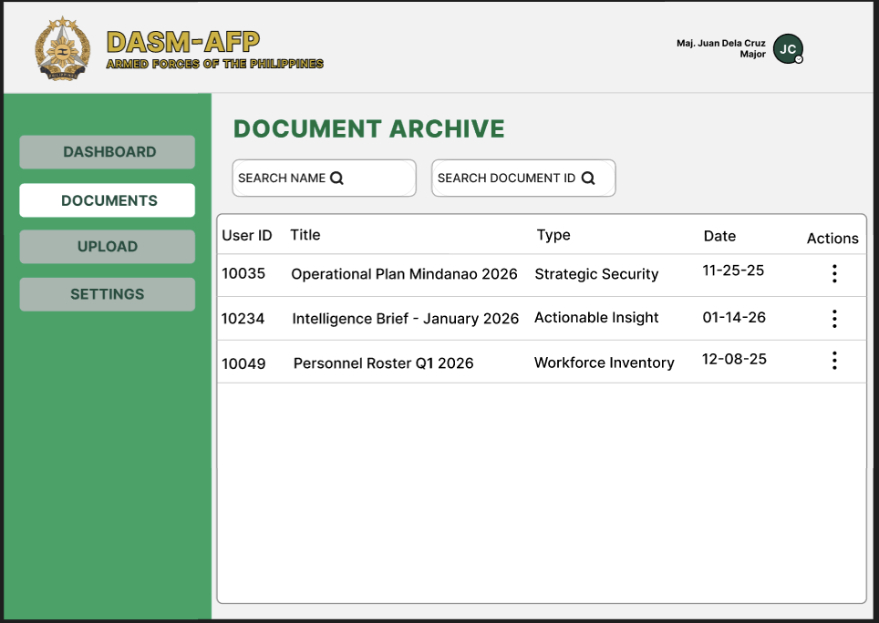
Figure 18: User Documents

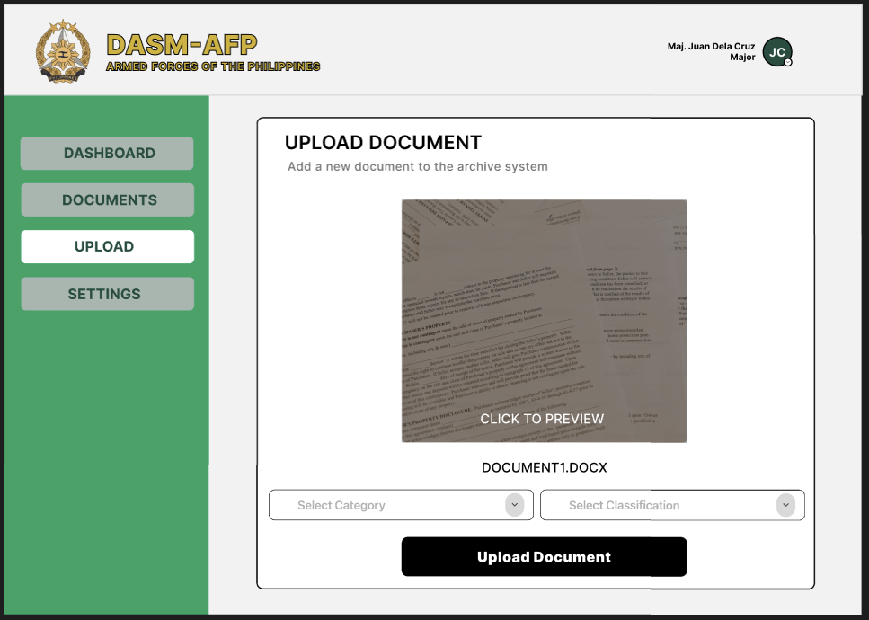
Figure 19: User Upload Documents
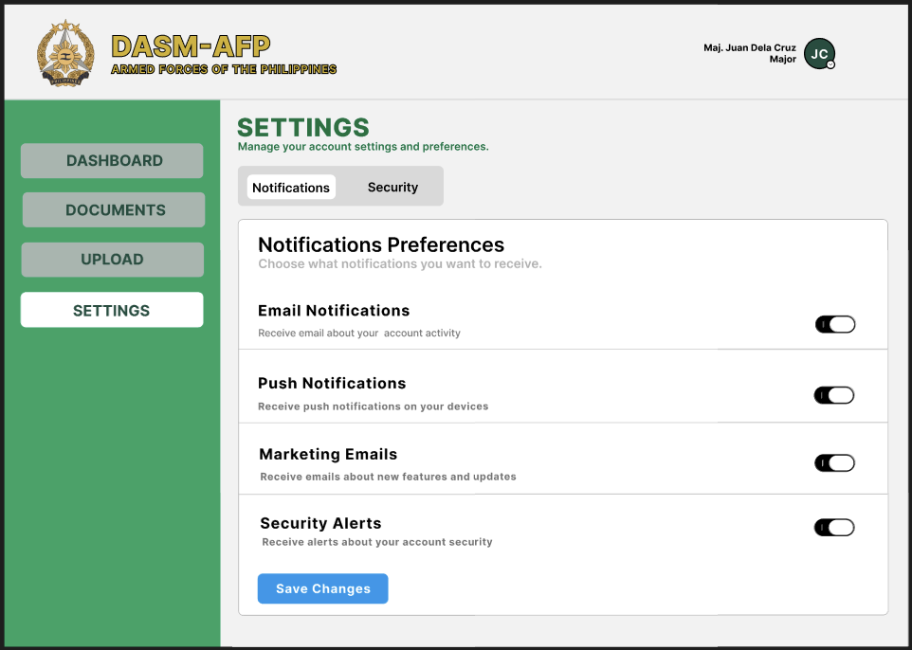
Figure 20: User Settings/Notification

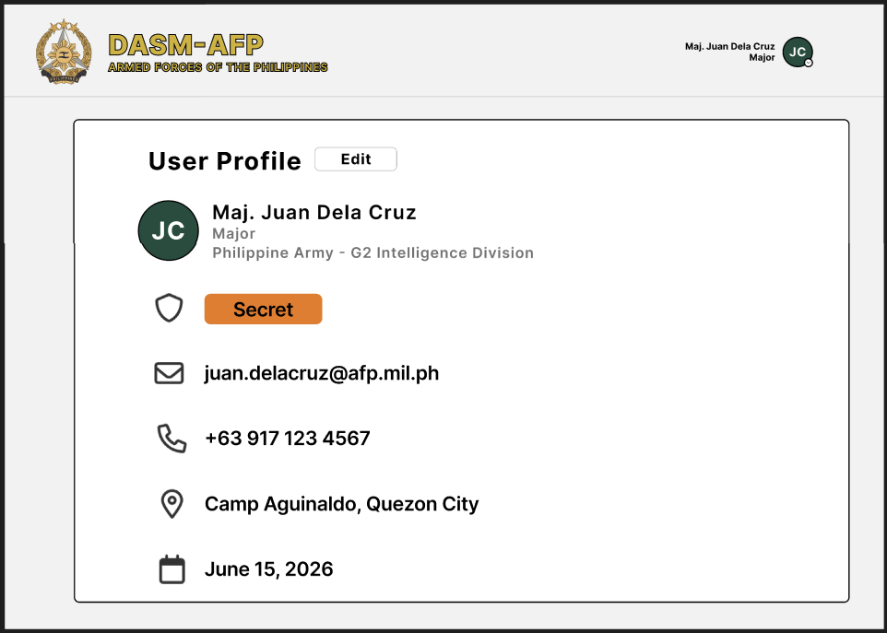
Figure 21: Users Profile
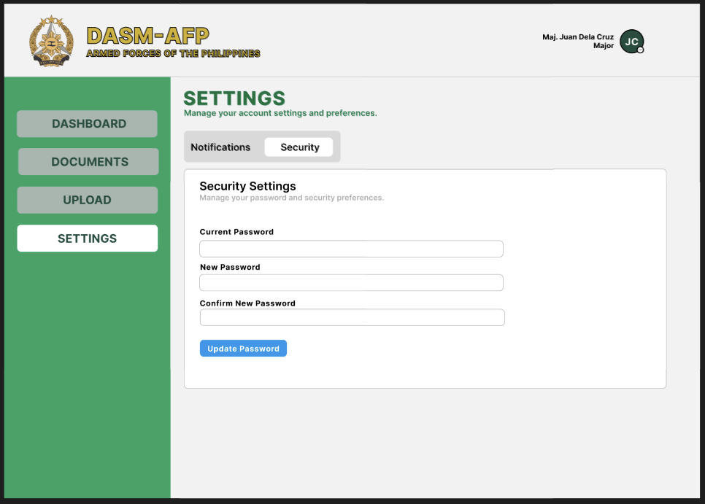
Figure 22: Users' Security Settings

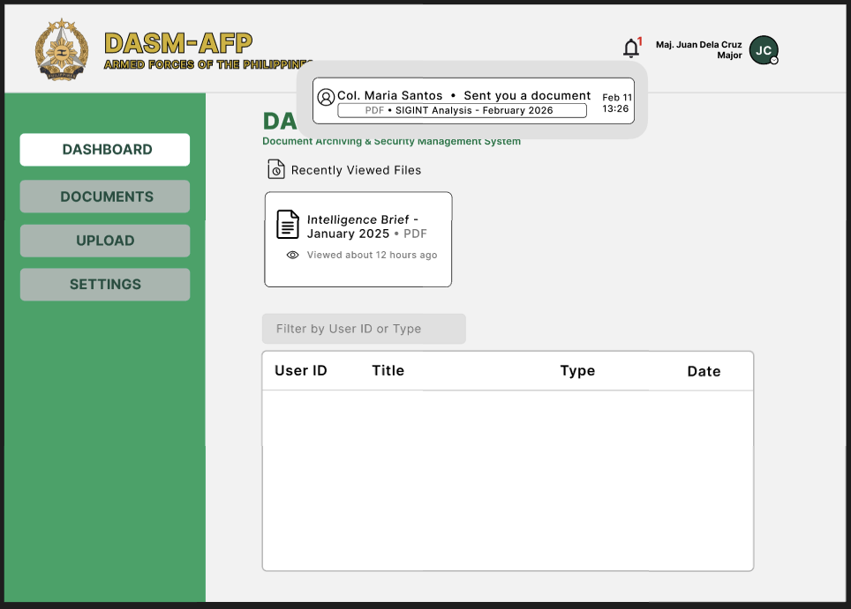
Figure 23: Users Dashboard Notification
ADMIN SIDE
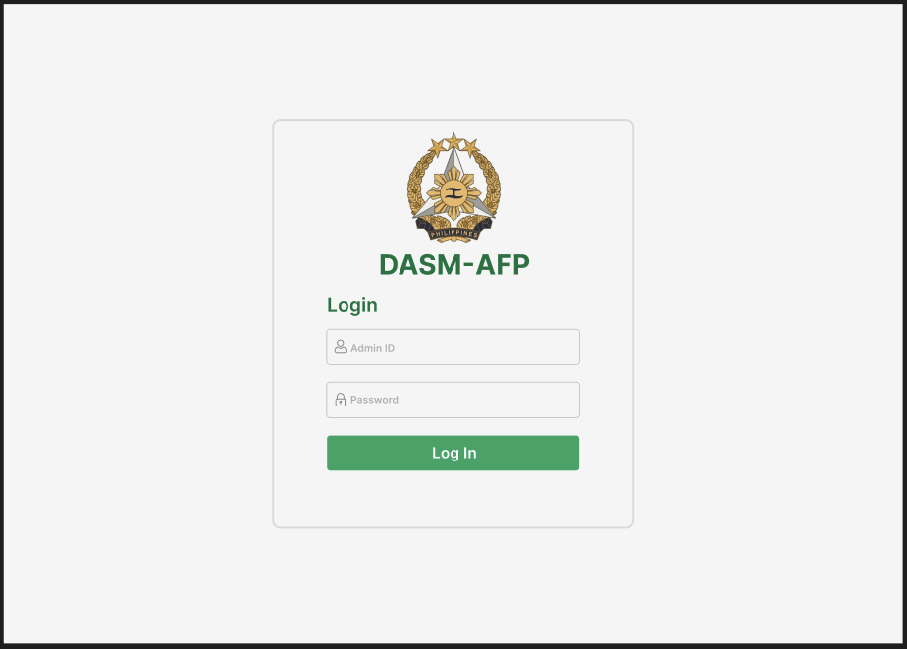
Figure 24: Admin Login Page

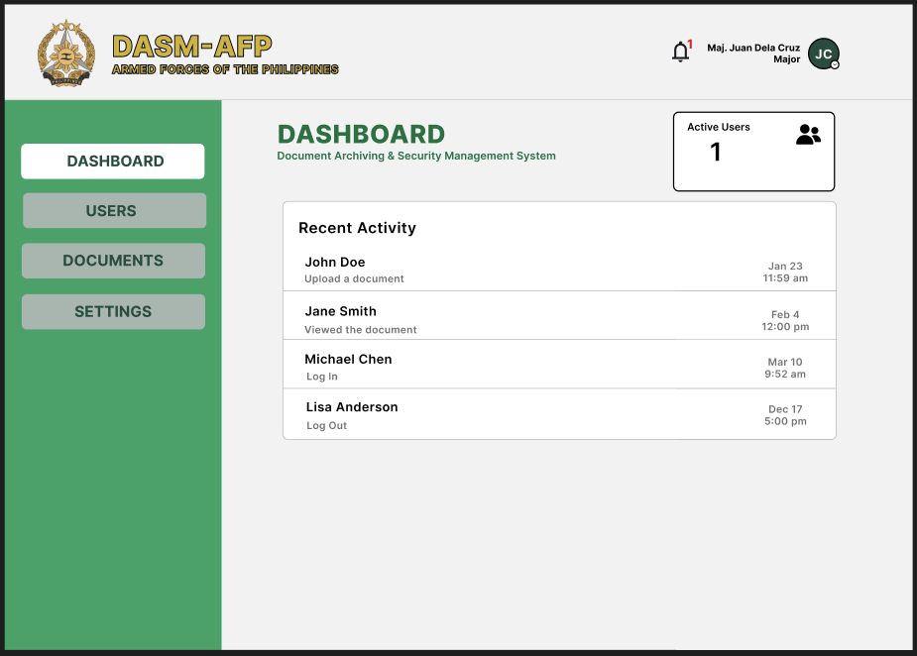
Figure 25: Admin Dashboard
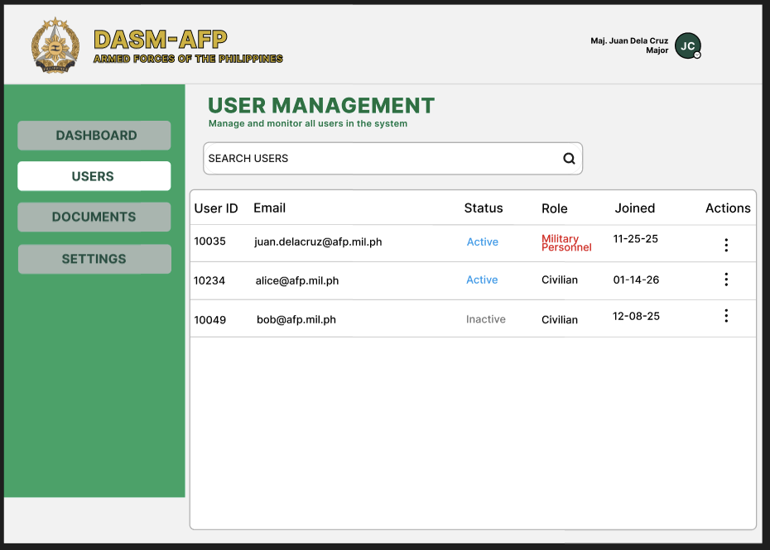
Figure 26: Admin Users Management

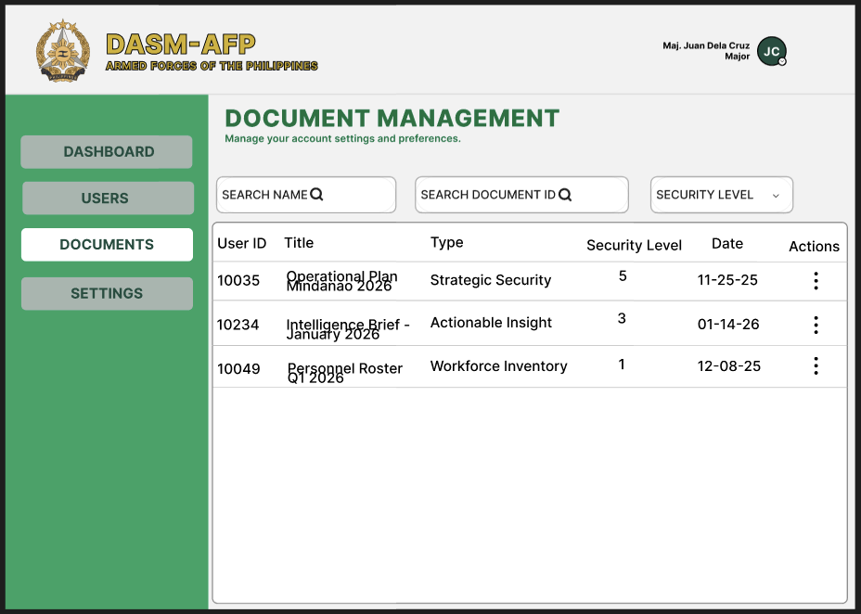
Figure 27: Admin Document Management
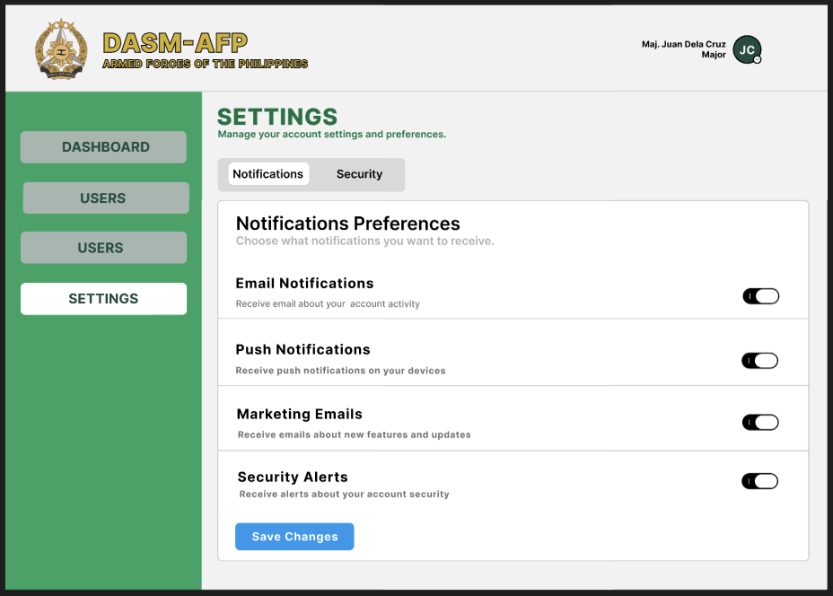
Figure 28: Admin Setting/Notification

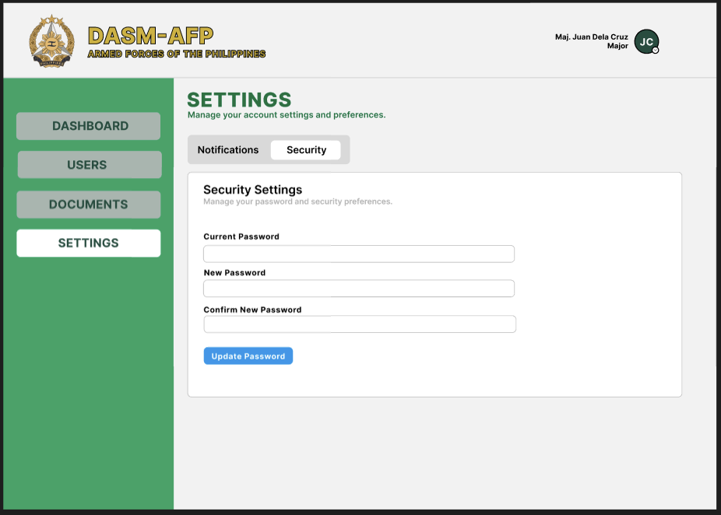Figure 29: Admins Security

