e-Serbisyong Tañong: Developing an Online Barangay Services System for Tañong, Marikina City
A Capstone Project
Presented to the Faculty of the
Information and Communications Technology Program
STI College Cubao

In Partial Fulfilment
of the Requirements for the Degree
Bachelor of Science in Information Technology
Raghnall Gent C. Caballero
Akeem L. Dela Torre
John Lloyd D. Rentura
Jemuel R. Tequillo

October 19, 2025

ENDORSEMENT FORM FOR FINAL DEFENSE

TITLE OF RESEARCH: e-Serbisyong Tañong: Developing an Online Barangay Services System for Tañong, Marikina

NAME OF PROPONENTS: Raghnall Gent C. Caballero
Akeem L. Dela Torre
John Lloyd D. Rentura
Jemuel R. Tequillo

In Partial Fulfilment of the Requirements
for the degree Bachelor of Science in Information Technology
has been examined and is recommended for Oral Defense.

ENDORSED BY:

Ms. Mheldred M. Halichic, LPT
Capstone Project Adviser

APPROVED FOR FINAL DEFENSE:

Engr. John Ivan D. Bachiller
Capstone Project Coordinator

NOTED BY:

Mr. Brian Calata, LPT
Program Head

APPROVAL SHEET
This capstone project titled e-Serbisyong Tañong: Developing an Online Barangay Services System for Tañong, Marikina, prepared and submitted by Raghnall Gent C. Caballero, Akeem L. Dela Torre, John Lloyd D. Rentura, and Jemuel R. Tequillo, in partial fulfillment of the requirements for the degree of Bachelor of Science in Information Technology , has been examined and is recommended for acceptance and approval.

Ms. Mheldred M. Halichic, LPT
Capstone Project Adviser
Accepted and approved by the Capstone Project Review Panel
in partial fulfillment of the requirements for the degree of
Bachelor of Science in Information Technology

Ms. Katherine Macatiag | Mr. Vincent David Alejandro Jr.
Panel Member | Panel Member

Mr. Aljames Besañes
Lead Panelist
Noted:
Engr. John Ivan D. Bachiller | Mr. Brian Calata, LPT
Capstone Project Coordinator | Program Head

October 19, 2025

Acknowledgements
The researchers would like to thank the following:
Capstone Project Coordinator, Engr. John Ivan Bachiller, for guiding us through the process and helping us meet all the requirements on time.
Capstone Project Adviser, Ms. Mheldred M. Halichic, for sharing your knowledge, giving helpful advice, and patiently guiding us from start to finish.
Capstone Project Review Panel, for your time, comments, and suggestions that helped us improve our work.
Parents and Guardians, for your love, support, and understanding throughout this journey.
Friends and Inspirations, for the encouragement, laughter, and motivation you gave us along the way.
Others, who have helped and supported us in any way, thank you for being part of our capstone project.

Abstract
Title of research: e-Serbisyong Tañong: Developing an Online Barangay Services System for Tañong, Marikina

Researchers: Raghnall Gent C. Caballero
Akeem L. Dela Torre
John Lloyd D. Rentura
Jemuel R. Tequillo

Degree: Bachelor of Science in Information Technology

Date of Completion: 2025

Keywords: Web Application, Online Services, Barangay System

The e-Serbisyong Tañong: Developing an Online Barangay Services System for Tañong, Marikina City is a web-based system designed to make barangay services faster and more convenient for residents. The system allows users to request documents, schedule appointments, and access barangay news and announcements online.
Key features include user registration, service and appointment requests, notifications, and admin management. The admin can view and manage requests, verify users, post announcements, and organize records. Although residents still need to visit the barangay for printed documents and payments, the system reduces manual work and shortens waiting times.
The project demonstrates a move toward digital transformation in local governance, making barangay services more efficient and accessible for the community. Testing and feedback from administrators and residents show a positive reception and willingness to adopt the system.

Table of Contents
 |  | Page
Title Page |  | i
Endorsement form for Final Defense |  | ii
Approval Sheet |  | iii
Ac |  | iv
Abstract |  | v
Table of Contents |  | vi
List of Figures |  | vii
List of Tables |  | viii
List of Notations |  | ix
Introduction |  | 1
 | Project Context
 | Purpose and Description
 | Objectives
Scope and Limitations
Review of Related Literature/Studies/Systems
Methodology
 | Technical Background
 | Requirements Analysis
 | Requirements Documentation
 | Design of Software, System, Product, and/or Processes
 | Development
Results and Discussion
 | Testing
 | Description of Prototype
 | Implementation Plan
 | Implementation Results
Conclusion
References
Appendices
 | Resource Persons
 | Relevant Source Code
 | Evaluation Tool/Test Documents
 | Sample Input/Output/Reports
 | User’s Guide
 | Personal Technical Vitae

Introduction

Project Context
In the Philippines, many barangays still use manual or paper-based ways to provide important services. These include issuing clearances, and certificates. Because of this outdated system, people often wait in long lines and deal with slow service. This not only frustrates residents who need these documents but also makes things harder for the barangay staff who are trying to help everyone.
The lack of a digital system became a serious problem during the COVID-19 pandemic. People were not allowed to go out easily, and yet they still needed documents and other services. Since everything was done on paper and in person, barangays could not serve their communities properly. What used to be a small problem became a big issue. The old manual system showed that it could no longer keep up, especially in times of crisis when people needed quick and safe service.
Even now that things are more normal, people still have a hard time getting basic barangay services. Simple requests like getting a barangay clearance, residency certificate, or other needed documents take a lot of time. Many must go to the barangay hall, line up, fill out forms, and sometimes come back on another day. For those who already have money problems, health issues, or no free time, these delays make life even harder. Sometimes, delays in getting these documents can even affect their chances of getting jobs, medical help, or government support. Barangay staff also face challenges. Using paper records takes a lot of time and effort. It’s easy to lose files, make mistakes, or miss requests. Staff members must go through piles of documents just to find one piece of information. It’s hard to keep everything organized, especially when many people come in every day asking for help.
To solve these problems, e-Serbisyong Tañong offers a digital platform that helps barangays modernize their services. With this system, people can request documents and services online, anytime and anywhere. They no longer need to physically visit the barangay hall just to submit a form or follow up on a request. Everything can be done with just a few clicks on a phone or computer.
For barangay workers, the system makes their work easier. They can use a simple dashboard to see all requests in one place, track progress, and update residents quickly. There’s no need to dig through stacks of paper or manually write down information. The system keeps everything neat, updated, and easy to manage.
e-Serbisyong Tañong also makes communication between the barangay and residents clearer. People can get updates about their request status or be notified about local programs and services. This saves time and avoids confusion. Residents don’t need to guess what to do or when to return.
In the long run, using a digital system like e-Serbisyong Tañong helps barangays provide better service. It makes things faster, easier, and more organized. It removes many of the problems caused by old, paper-based methods. By moving to digital tools, barangays can become more efficient and helpful to the people they serve.
As the world continues to grow and change, barangays must also improve the way they work. People expect faster, simpler, and more reliable services. e-Serbisyong Tañong helps barangays take that step forward, toward a modern system where services are easy to get and problems are solved quickly. With this kind of digital support, both residents and barangay staff can save time, avoid stress, and enjoy a smoother process for getting important services.

Purpose and Description
The primary purpose of e-Serbisyong Tañong is to offer a modern and convenient way for residents to access barangay services online. The system aims to make public service delivery faster, easier, and more organized through its web-based platform.
This project introduces a local digital platform that helps manage records and allows residents to request documents or check the status of their transactions anytime. It provides a simple and user- friendly interface that both barangay officials and residents can easily use. The inclusion of a news section on the homepage also keeps the community informed and connected. Overall, e- Serbisyong Tañong promotes efficiency, transparency, and stronger coordination within the barangay, making it an innovative and relevant solution for modern community service.

Objectives
General Problem
Barangay Tañong often faces significant challenges in ensuring the accessibility and efficiency of public services due to the lack of a centralized digital system. These challenges include limited access to real-time information, inefficient processing of service requests, and insufficient means for residents to access barangay services online. The absence of a dedicated digital platform hinders responsive governance and timely service delivery at the barangay level.
Specific Problem
- How can a centralized digital system improve the efficiency of processing barangay documents such as certificates and permits in Barangay Tañong?
- In what ways does the continued use of paper-based documentation affect the security, accuracy, and accessibility of resident records?
- How can an online platform enhance residents’ access to barangay services and streamline the process of requesting and tracking applications?
- What impact would a digital appointment and queueing system have on reducing wait times and improving service delivery at Barangay Tañong?
- How can the implementation of a digital communication channel improve the timeliness and reach of barangay announcements and service updates?

General Objectives
The proponents' main objective is to design and develop a centralized digital platform that aims to support barangay officials in managing and delivering public services more efficiently. The platform will provide online service applications to address challenges such as the lack of digital access to official documents, inefficient processing of service requests, and limited communication between barangay officials and residents.
Specific Objectives
- To design and implement a centralized digital platform that streamlines the processing of barangay documents such as certificates, clearances, and permits, reducing manual workload and turnaround time for both residents and barangay staff.
- To convert paper-based resident records and service requests into a secure, web-based system that ensures easier storage, retrieval, and management of barangay data.
- To develop an online service portal that allows residents to request, monitor, and receive updates on barangay services from the comfort of their homes.
- To develop a digital appointment and queuing system to reduce congestion and waiting time in the barangay hall during peak service hours, and will allow residents to schedule meetings or appointments with barangay officials.
- To integrate a digital announcement feature that delivers timely barangay updates and service notifications to residents through the platform.

Scope and Limitations
Scope
- Barangay Service Requests
- Allows residents of Barangay Tañong, Marikina to apply for barangay clearances and certificates online.
- Database for Resident Records
- Stores information of residents who registered, such as personal details.
- User Access
- The system will require users to create an account and log in before accessing any services.
- Notification and Updates
- The system will feature an integrated notification tab within the web platform where users can view real-time updates and status changes for their service requests, new announcements from the barangay, and other important alerts. This in-app notification system will keep residents informed without needing to rely on external channels like email or SMS.
- Accessibility and Connectivity
- To accommodate varying levels of internet availability, the system is optimized for performance on moderate connection speeds. The interface is also designed with simplicity in mind, ensuring accessibility for users with limited technical knowledge.

Limitations
- Limited Scalability
- The system is designed to cater specifically to Barangay Tañong and may face challenges when scaling up to accommodate larger areas or multiple barangays.
- Device Dependency
- The system requires users to have access to a device such as a smartphone or computer to submit service requests. Lack of device access may prevent some residents from fully benefiting from the system.
- Device Compatability
- The application may have compatibility issues with older devices or certain operating systems, including macOS, limiting its accessibility for all residents. Users with Mac computers or other non-Windows devices may experience compatibility issues.
- Internet Connectivity Issues
- The system requires a stable internet connection to process requests and provide real-time updates. Poor or intermittent connectivity may limit.

Review of Related Literature/Studies/Systems
This chapter presents a review of related literature and studies relevant to e-Serbisyong Tañong: Developing an Online Barangay Services System for Tañong, Marikina City. It seeks to compare and contrast existing systems, technologies, and methods that address online barangay services. This review highlights both the similarities and differences between previous approaches, providing a clear understanding of how this system can improve upon or resolve issues identified in past research. By evaluating the theories and findings of these studies, this section aims to support a more efficient and effective system of public service in barangays.

Foreign Literature

Is Paper Dead? Why Moving from Paper to Digital Documents is the Way Forward
Although progress has been made across the industry to reduce paper documents significantly, I think we can all agree that paper is not dead. With that said, paper digital transformation has become a requirement to survive in today’s technology-driven, mobile-enabled, and remote work environments. And it goes without saying that manual, paper-based processes are error-prone, inefficient, and labor-intensive (Kolodziej, 2023).

The observation that "paper is not dead" but paper digital transformation is now essential directly aligns with the reality faced by many barangays in the Philippines. Despite efforts to modernize, manual, paper-based systems remain widespread in local governance, especially in barangays, leading to delays, lost records, and staff burnout.

Just as the foreign blog emphasizes that paper processes are error-prone, inefficient, and labor- intensive, your project context highlights the frustration of residents who wait in long lines and the strain on barangay staff who must manually sift through records. These inefficiencies were amplified during the COVID-19 pandemic, when mobility restrictions further exposed the limitations of non-digital systems.

e-Serbisyong Tañong directly addresses this issue by offering a digital platform that reduces dependency on paper, automates document requests, and simplifies recordkeeping. This mirrors global trends where organizations recognize that digital transformation isn’t just an option, it’s a requirement in an increasingly connected and mobile-driven world.

Public Sector Shifts: Navigating Digital Transformation in Local Government
Canadian municipalities are facing growing pressures, not only to manage their money, operations, and fast-changing policies, but also to meet the increasing needs of a growing population with fewer resources. Now more than ever, it's important for municipal governments to be innovative and plan ahead. That begins with digital transformation, an initiative often led by IT teams that requires buy- in across the entire organization.

Municipalities across the globe are embracing digital transformation to make a positive impact on public services, enhance operational efficiency, and foster greater citizen engagement. In this post, we’ll dive into strategies local governments are using to navigate change, showcasing real-life examples of governments driving tangible results (Setsikas, 2025).

The challenges faced by Canadian municipalities, as described by Setsikas (2025), closely mirror the issues encountered by barangays in the Philippines, both are local government units grappling with rising service demands, limited resources, and the need for modernization. Just as Canadian municipalities are under pressure to improve efficiency, manage operations, and respond to growing citizen needs, barangays are also struggling with outdated manual systems that result in long queues, document delays, and service inefficiencies.

In both contexts, digital transformation emerges as a crucial solution. The Canadian experience highlights that successful digital change requires not just technology, but also organization-wide buy- in and strategic planning, a principle that also applies to the implementation of e-Serbisyong Tañong. The barangay system, much like its Canadian counterpart, must involve all levels of staff in embracing and adapting to new tools to deliver better, faster, and more reliable services.

Moreover, just as municipalities worldwide are using digital tools to boost public service delivery and citizen engagement, the e-Serbisyong Tañong platform aims to streamline barangay services, reduce manual errors, and provide residents with convenient access to essential documents. Both settings emphasize the role of digital innovation in fostering inclusive, accessible, and efficient governance.

7 Benefits of Digital Forms
Digitizing processes offers numerous advantages, particularly in terms of efficiency and environmental sustainability. One of the primary benefits is the ability to streamline operations, digital forms enable faster and more accurate data capture, reducing the need for manual entry and minimizing errors. Additionally, information collected through digital means is instantly accessible, allowing for real-time analysis and more informed decision-making. This accessibility also enhances the ability to manage and monitor activities as they happen. From an environmental perspective, reducing paper usage significantly lowers the carbon footprint, contributing to more sustainable practices. Organizing and storing data becomes much simpler with digital systems, which improve searchability and retrieval, ultimately boosting productivity and collaboration among team members. Furthermore, digital forms can be equipped with encryption and other security measures to protect sensitive information and ensure data privacy. Their mobile accessibility means forms can be filled out and submitted from virtually anywhere, offering flexibility for both employees and customers. Lastly, by enhancing the speed and accuracy of data collection, digital processes help deliver better service, improving customer satisfaction and fostering loyalty (MoreApp, n.d.). In contrast to this study where the researchers aim to reduce the paperworks, by digitizing forms. The researchers also found the same convenience brought by digitizing the forms, leading them to integrate this into the study’s system.

Local Literature

E-Governance Practices and Quality of Service Delivery through G2C in the Philippines
According to Pancho (2022), the use of ICT in delivering services to the public improves the quality of it. The result of the study shows the great contribution of ICT on delivering services to the public as it offers efficiency and effectiveness to the citizens. Through adaptation of ICT-based solutions to the quality of service for the citizens, it improves the government-to-citizen interactions allowing provisions of fluency on the services. This enables on promoting good governance for distribution of standard public services which gives a great impact to the relationship between citizen and the government. Through collaboration of ICT-based solutions on service provision from the government, it enables the beneficiaries to easily acquire these privileges.

What A Paperless Philippines Could Look Like
According to (UNAWA, 2022), The idea of becoming paperless calls for doing away with all paper in the workplace, at home, and in schools. This is accomplished through digitization, which involves transforming documents and other objects into digital form. Going "paperless," according to proponents, can save costs, increase output, free up storage space, facilitate information sharing and documentation, maintain the security of personal data, and benefit the environment. The idea can also be used for communications outside of the workplace. Even though paper usage has declined, it is still widely used, and few businesses are paperless.

The Future of the Filipino Office: Will We Still Need Paper and Pens?
We see more and more businesses in the Philippines using computers, smartphones, and the internet. Tasks like writing letters, sending documents, and keeping records are often done digitally now. This move towards a digital workplace has many benefits. It can make work faster, easier to organize, and better for the environment by saving trees.

Think about how we communicate today. Email has largely replaced physical letters. Important documents are shared through online platforms instead of being printed and hand-delivered. Meetings can happen online with people in different locations. All these changes point towards a future where less paper is used in offices.

Foreign Studies

Adoption of e-government services at different maturity levels: A qualitative study in India
India has improved its online government services through programs like Digital India. These services grow in steps, starting from giving information to letting people do full transactions online. This growth is called e-government maturity (Mishra et al., 2021).

Even with more services online, many people still use only the basic ones. Studies show that lack of internet access, low digital skills, and low trust in online systems are common problems, especially in rural areas (Sarkar et al., 2020; Raj & Verma, 2023). During the COVID-19 pandemic, more people started using online services, but many still had trouble using them well (Chaudhary & Ranjan, 2021).

Other problems include websites not being in local languages and services not meeting people’s real needs (Patel & Rao, 2023; Narayan & Das, 2022). This study will look closely at how people in India use e-government services at different stages and what helps or stops them from using them.

E-Services: Implementation of Digital-Based Public Services in the 4.0 Era
The rapid growth of information and communication technology (ICT) has transformed how governments provide services. This digital shift, known as e-government, helps improve transparency, efficiency, and public access to services (World Bank, 2021).

In Indonesia, the development of e-government has faced challenges such as uneven infrastructure, low digital literacy, and a lack of standardization. Although the government has promoted ICT use since Presidential Instruction No. 3 of 2003, progress has been slow compared to neighboring countries like Malaysia and Singapore.

A specific example of successful e-service implementation can be seen in Sriharjo Village. The local government developed a letter disposition system to improve administrative services. This innovation made processes faster, more transparent, and easier for citizens to access. The system also helps village officials delegate tasks and manage community events more efficiently.

The e-government implementation in Indonesia is closely related to the challenges and goals outlined in the project context of e-Serbisyong Tañong. Just like many barangays in the Philippines, several local governments in Indonesia struggle with outdated manual systems, poor infrastructure, and limited digital literacy, which create delays and inefficiencies in public service delivery. The digital divide highlighted between Java and other Indonesian regions mirrors the situation in the Philippines, where urban areas often have better access to technology than rural barangays. The Sriharjo Village's success in using a digital letter disposition system shows that even small communities can benefit from tailored digital solutions, much like how e-Serbisyong Tañong aims to streamline document processing in Barangay Tañong. These studies reinforce the importance of digital transformation at the grassroots level and support e-Serbisyong Tañong’s vision of improving local governance through practical and accessible technology.

The Application of E-Government in the Development of Village Government Democracy in Gowa Regency Indonesia
A recent study by Anas et al. (2024) looked at how e-government helps improve services in small villages in Gowa Regency, Indonesia. The study focused on three important goals of good governance: transparency, participation, and accountability. These are key in making sure that governments are open, fair, and responsive to the needs of the people.

The research was done in three villages: Pakatto, Jenetallasa, and Bontolempangan. The villages used a digital system called Digides to provide better services to residents. For example, in Pakatto, people could now check the village budget online. This helped make the government’s actions more open to the public. Youth groups and local leaders helped explain the new system to the people so they could understand how to use it.

The study also found that using e-government made it faster and easier for villagers to get things done. People no longer needed to go to the village office for every request, they could now apply for documents online, saving time and effort. However, not all villages had the same success. In remote areas like Bontolempangan, the internet connection was weak, so residents still had to go to the office in person. This showed the need for better internet service.

Another challenge was digital literacy. Younger people learned how to use the system quickly, but older people found it harder. This means that just giving technology is not enough. People need help and training to use it properly, especially those who are not used to smartphones or the internet.

The researchers said that e-government can help improve local governments a lot—but only if there is strong internet, support from leaders, and effort to include everyone in the process. The study showed that small communities can move from slow, paper-based systems to faster digital ones, where citizens play an active role.

This study is helpful for other countries like the Philippines. Many barangays face the same problems with paper-based services and slow processes. The experience in Indonesia shows that with the right tools and support, digital systems can make public service better, faster, and more transparent for everyone.

Local Studies

One Barangay: A Mobile and Web Barangay Management System
Research was conducted last December 2022, titled as One Barangay: A Mobile and Web Barangay Management System. This research tackles the difficulties and challenges in organizing data information. According to One Barangay: A Mobile and Web Barangay Management System (2022), managing the files of their community members mostly relies on processing them using MS Word or Excel manually without using a database to keep them secure, centralized, and shared within its organization. This highlights the difficulties of using habitual applications.

WeBarangay: A Local E-Government Services Web Application for N.S. Amoranto in Quezon City, Philippines
During the pandemic, the "new normal" was introduced to us, forcing us to discover and learn technology. As stated by Rey and Aumentado (2024), the primary goal of their research is to offer an alternative means of interaction between barangay officials and residents in the Philippines. This initiative aims to bridge the digital divide by leveraging modern technologies to create more efficient communication channels. With the ongoing shift toward digital platforms, the research emphasizes the importance of providing a user-friendly, accessible system that allows barangay officials to connect with their constituents, even in remote areas where face-to-face interaction may be limited.

Towards Digitization through e-Barangay “A Web-based Barangay Information System”
In the Philippines, a barangay is the country's smallest administrative entity. It is here that
community projects and endeavors are planned, initiated, and implemented [1]. Also, the barangay processes requests of documents such as Cedula, Indigency Form, Business Permit, and other related documents needed by its residents. Moreover, it manages the filing of complaints and monitoring of local statistics. However, due to manual processing of transactions, the quality of services declines as manual handling of transactions takes more time, is prone to human error, and is less secure in terms of keeping records. For these reasons, boosting government transactions and public service delivery through digitization is critical, as contemporary technology brings up new options for barangays to better serve their residents Pancho, A. R. (2022).

Synthesis of Review of Related Literature
The growing need for digital transformation in local government services, particularly in the Philippine barangays, is reflected across both foreign and local literature. The shift from paper- based to digital systems is essential for improving the efficiency, accessibility, and transparency of services, as highlighted by various studies.

In the foreign literature, Kolodziej (2023) underscores the inefficiencies of manual, paper-based systems, highlighting their propensity for errors and delays. This observation resonates with the challenges faced by barangays in the Philippines, where residents often experience long wait times and administrative delays due to manual processes. The COVID-19 pandemic further exposed these vulnerabilities, reinforcing the urgent need for digital systems. As e-Serbisyong Tañong seeks to address, moving towards a digital platform can reduce the dependency on paper, automate document requests, and streamline record-keeping, mirroring global trends where digital transformation is no longer optional, but a necessity to maintain service quality in a technology- driven world.

Public sector digital transformation is another key theme explored in the literature. Setsikas (2025) discusses how municipalities worldwide, including in Canada, have embraced digital tools to enhance service delivery, operational efficiency, and citizen engagement. This mirrors the Filipino context, where barangays face similar challenges in managing rising demands for services, with limited resources. Both systems benefit from comprehensive planning, involving all stakeholders in the transition to ensure smooth implementation. The e-Serbisyong Tañong platform is an example of this kind of strategic approach, offering an inclusive and accessible solution to streamline barangay services, much like the digital initiatives implemented by municipalities in Canada.

The advantages of digital forms in streamlining operations and improving data accessibility are well-documented in the literature. MoreApp (n.d.) emphasizes how digital forms can reduce manual errors, boost productivity, and improve customer satisfaction, which directly relates to the goals of e-Serbisyong Tañong. By digitizing requests and records, the system not only enhances the speed and accuracy of service delivery but also contributes to more sustainable practices by reducing paper usage. This aligns with the global shift towards paperless systems, which, as UNAWA (2022) argues, offer environmental benefits, cost savings, and organizational efficiencies.

Local literature further supports the importance of digitization in local government operations. Pancho (2022) highlights how ICT-based solutions enhance the quality of government-to-citizen interactions, improving the overall service delivery experience. In the context of barangays, this translates into a need for streamlined, automated systems that can support faster, more effective delivery of services. The findings from One Barangay (2022) point to the difficulties of managing data manually, which further reinforces the need for centralized digital systems, a goal that e-Serbisyong Tañong aims to achieve by moving away from traditional paper-based processes.

Additionally, WeBarangay (2024) highlights how digital platforms bridge the communication gap between barangay officials and residents, even in remote areas, by creating more accessible and efficient communication channels. The e-Serbisyong Tañong platform, similarly, seeks to provide a user-friendly interface for both barangay staff and residents, ensuring easier access to important documents and real-time updates on request statuses.

Finally, Towards Digitization through e-Barangay (2024) points out the issues faced by barangays due to the reliance on manual processes, such as human error, inefficiency, and security concerns. This is precisely what the e-Serbisyong Tañong platform addresses, aiming to modernize the barangay's service provision by digitalizing document requests and improving record security.
In conclusion, both foreign and local studies underscore the growing importance of digital transformation in improving the quality, efficiency, and accessibility of local government services. e-Serbisyong Tañong stands at the intersection of these global and local trends, providing a solution that addresses the inefficiencies of paper-based systems while contributing to the broader push for digitization in the public sector. The insights from these studies offer a solid foundation for the continued development and implementation of digital platforms like e-Serbisyong Tañong in Filipino barangays, enhancing governance and service delivery in a rapidly evolving digital landscape.

METHODOLOGY

Technical Background
Overview of Current Technologies to be Used in the System
Online services have become a practical solution for delivering essential goods and services, especially barangay level. To support this approach, e-Serbisyong Tañong was developed as a web-based application that helps residents of Tañong, Marikina City, access barangay services, such as requesting forms and receive timely updates from the barangay. The system is designed with basic features and simple functionality to ensure accessibility for users with limited technical experience.
This is a web-based project, Visual Studio was used as the development environment. The system was built using HTML, CSS, Tailwind CSS, JavaScript, and Node.js. HTML (Hypertext Markup Language) forms the structure of the web pages, providing a clean and user-friendly layout. CSS (Cascading Style Sheets) and Tailwind CSS were used to style the application, ensuring it is visually appealing, modern, and responsive across various screen sizes. JavaScript adds interactivity to the system by handling form inputs, displaying real-time alerts, and updating content dynamically without refreshing the page. Node.js serves as the runtime environment for executing JavaScript on the server side, enabling faster processing, efficient data handling, and integration with backend services such as Firebase.
To manage and store data efficiently, the system integrates Firebase Realtime Database, a cloud- hosted NoSQL database that allows data to be stored and synced in real time across all connected clients. This enables instant service requests and other user interactions, ensuring that both barangay officials and residents have immediate access to the latest information.
The website connects to the Firebase Realtime Database using Firebase SDKs (Software Development Kits) integrated into the JavaScript code. By initializing Firebase with the project’s configuration credentials (such as API key, database URL, and project ID), the website can perform CRUD (Create, Read, Update, Delete) operations. This allows the application to send data to the database when users submit forms and retrieve data to display updates dynamically on the page without needing to reload.
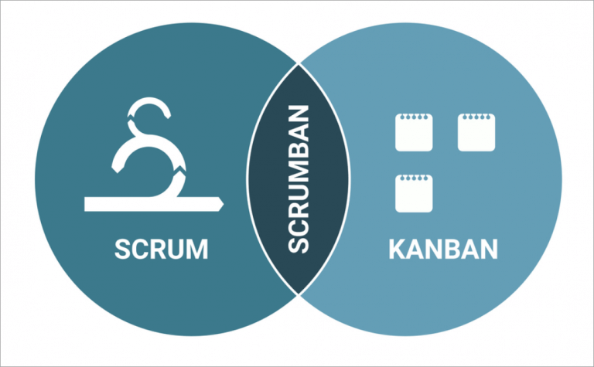
Figure 1. Scrumban
For the development of e-Serbisyong Tañong, the proponents used the Scrumban method. It is a mix of Scrum and Kanban. The proponents chose this method because it helps in working step by step while staying flexible when changes happen. It also fits a small team that needs to plan, work, and check progress easily.
In the Scrum part, the work was divided into short parts called sprints. Each sprint lasted around two weeks. Every sprint had four stages. These were planning, development, testing, and review. During planning, the proponents listed what features to do, like making the login page or connecting the system to Firebase. The development and testing stages were for coding and checking if each feature works. After that, the proponents met with the adviser and client to review and improve the system before the next sprint.

In the Kanban part, the proponents used a board to track tasks. The board had four columns called To Do, In Progress, Testing, and Done.
- To Do - tasks that are not yet started.
- In Progress - tasks that are being worked on.
- Testing - tasks that are done but still need checking.
- Done - tasks that are finished and approved.
Using the Scrumban method helped the proponents stay organized and finish tasks on time. It made it easier to see what needs to be done, share updates, and make the system better step by step.
Calendar of Activities
Chart below shows the list of tasks and the time when each task was done. It presents the summary of activities and the time given to finish each part of the project. The color blue shows the tasks that are still ongoing, while the color yellow shows the tasks that are already completed.
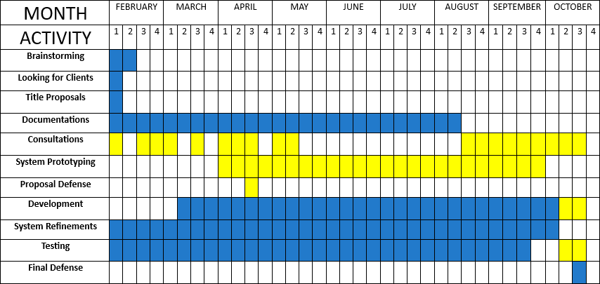

Brainstorming - The proponents engage in discussions to come up with initial concepts for a community-focused system and drafts possible thesis titles for approval by the capstone coordinator and program head.
Looking for Client - The proponents seek a suitable client whose needs match the goals of the proposed system.
Title Proposals - The proponents submit multiple suggested thesis titles related to community- based systems for evaluation and approval by academic authorities.
Documentation - The proponents create detailed write-ups based on the approved proposal, aiming to generate new knowledge or expand on existing ideas about the planned system.
Consultations - The proponents meet with their assigned adviser to review and revise drafts of their documents based on expert and client feedback.
System Prototyping - The proponents build an early model of the system that showcases its main features and design.
Proposal Defense - The proponents deliver a formal defense of their proposed system in front of a panel to justify its relevance and feasibility.
System Refinement - The proponents enhance and improves the system according to the adviser’s comments and suggestions.
Testing - The proponents conduct trials of the system to detect and fix any errors or bugs before final deployment.
Development - The proponents continue to develop the proposed system.
Final Defense - The proponents present the completed system and full documentation to a panel of evaluators. They demonstrate the system’s features, discuss its development process and results, and respond to questions to justify that the project meets academic and technical standards for completion.
Resources

Table 1. Dela Torre’s Hardware and Software Specifications


Table 2. Rentura’s Hardware and Specifications

Table 3. Tequillo’s Hardware and Specifications
Specification Requirements
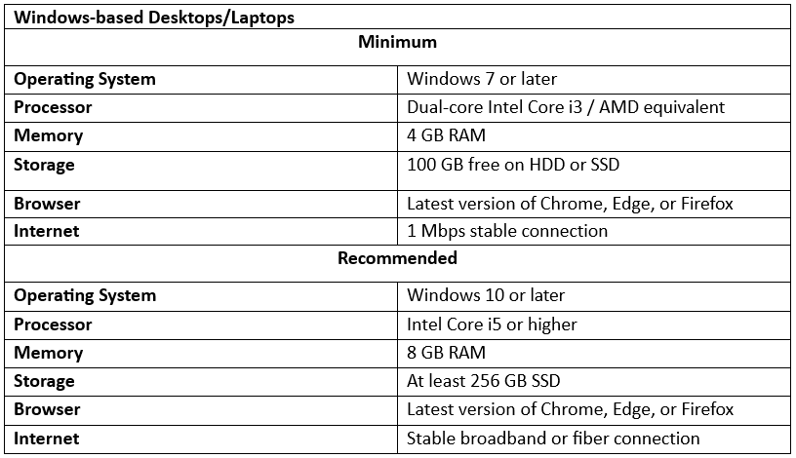
Table 4.

Requirements Analysis
The development of e-Serbisyong Tañong aims to address the challenges faced by Barangay Tañong, Marikina City in managing document requests. By leveraging digital tools, the system is designed to improve service accessibility for residents while optimizing the workflow of barangay officials.
Who
- Barangay Residents
Individuals who use the system to request and track official barangay documents (e.g., barangay clearance, certificate of indigency) through an online platform, enhancing convenience and accessibility.
- Barangay Officials/Admins
Authorized personnel who manage system operations, such as reviewing, approving, and processing document requests, handling online payments, and updating request statuses.
What
- Processing/Requesting Documents
Residents can submit requests for official barangay documents online, replacing the traditional paper-based approach. Barangay staff can then process these requests.
- Online Payment Integration
The system provides a GCash payment option, giving users a cashless and convenient way to pay for document fees.

- Document Request Status Tracking
Users can track the status of their document requests in real-time (e.g., pending, under review, approved), ensuring transparency and better communication between the barangay and residents.
- User Registration and Login
The system includes a secure user registration and login module, allowing users to create personal accounts. Account access ensures personalized services and secure access to request histories and updates.
When
- Document Requests
Available on a daily basis during barangay office hours or as determined by the system's online availability.
How
- The system will be developed as a web-based platform called e-Serbisyong Tañong. It will allow residents to:
  - Submit and monitor document requests
  - Pay online for services
  - Receive updates on request status
- For barangay personnel, the system simplifies administrative workflows by:
  - Organizing requests
  - Automating status updates
  - Reducing reliance on manual paper processing

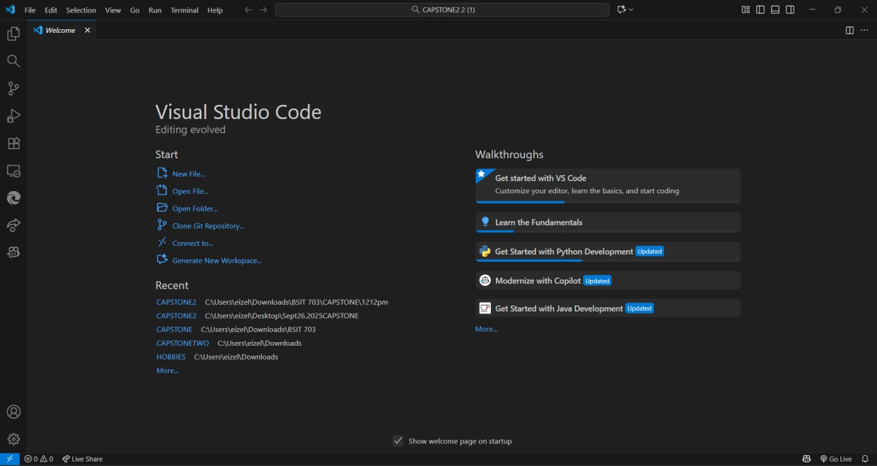
Requirements Documentation
Figure 1. Visual Studio Code

This shows the development environment used by the proponents for coding the e-Serbisyong Tañong web system.
Figure 2. Firebase
This presents the cloud database used for storing and retrieving resident records and service requests in real time.

Design of Software, System, Product, and/or Processes
In this part, the developers shall describe in detail how they designed the system in accordance with standards.

Development
In this part, the developers shall describe in detail how they developed the system in accordance with standards.

RESULTS AND DISCUSSION

Testing
In this part, the proponents shall discuss and test the software development standards.

Description of Prototype
This part includes the system requirements, the preliminary design, and how the system is being evaluated and tested.

Implementation Plan
The Implementation Plan describes how the information system will be deployed, installed, and transitioned into an operational system. The plan contains an overview of the system, a brief description of the major tasks involved in the implementation, the overall resources needed to support the implementation effort (such as hardware, software, facilities, materials, and personnel), and any site-specific implementation requirements.

Implementation Results
This part consists of the outputs during the implementation phase. These may include the generated outcomes as the ground for improving the project/system. This part is optional.

Conclusion
The first part of this section is your summary, followed by the conclusion/s, and the last part is/are your recommendation/s.
This section summarizes the results based on the results and discussion chapter. There should be no presentation of tables or figures. A good summary should be comprehensive. A summary must be concise. Your summary should be considerably shorter than the source. Avoid repetitive details. A summary must be coherent and independent. You are expected to maintain your own voice throughout the summary. Don’t simply quote other researcher’s works; instead use your own words to express your understanding of what you have read. After all, your summary is based on your interpretation of the findings, points, or ideas. However, you should be careful not to create any misinterpretation or distortion by introducing comments or criticisms of your own.
Conclusions should unite with the findings and accomplishments of the study. If there are three summaries, there should also be three conclusions. Conclusions are arranged as they appear in the findings. Moreover, rejection and acceptance of the hypotheses, if applicable, are explained under conclusion. Only conclusions which are based definitely on the findings or results should be made. Mere opinions which have no basis in facts and findings have no place in the conclusions of the study.
Recommendations are based on the conclusions. It may include further research of the study and/ or enhancement of the developed system.
In the succeeding paragraphs, there should be no indentations, paragraphs are justified with left alignment. Delete this highlighted section and replace it with your content.

References
The reference list provides the information necessary for a reader to locate and retrieve any sources cited in the body of the paper. Each source you cite in the paper must appear in your reference list; likewise, each entry in the reference list must be cited in your text. Your references should begin on a new page separate from the text of the manuscript; label this page REFERENCES centered at the top of the page (bold, but do not underline or use quotation marks). All text should be double-spaced, just like the rest of the text.
Basic Rules
•All lines after the first line of each entry in your reference list should be indented one-half inch from the left margin. This is called hanging indentation.
• Authors’ names are inverted (last name first); give the last name and initials for all authors of a particular work unless the work has more than six authors. If the work has more than six authors, list the first six authors and then use et al. after the sixth author’s name to indicate the rest of the authors.
•Reference list entries should be alphabetized by the last name of the first author of each work.
•If you have more than one article by the same author, single-author references or multiple-author references with the exact same authors in the exact same order are listed in order by the year of publication, starting with the earliest.
•When referring to any work that is NOT a journal, such as a book, article, or Web page, capitalize only the first letter of the first word of a title and subtitle, the first word after a colon or a dash in the title, and proper nouns. Do not capitalize the first letter of the second word in a hyphenated compound word.
•Capitalize all major words in journal titles.
•Italicize titles of longer works such as books and journals.
•Do not italicize, underline, or put quotes around the titles of shorter works such as journal articles or essays in edited collections.
The following rules for handling works by a single author or multiple authors apply to all references in your reference list, regardless of the type of work (book, article, electronic resource, etc.)
Single Author: Last name first, followed by author initials.
Example:
Berndt, T. J. (2002). Friendship quality and social development. Current Directions in Psychological Science, 11, 7-10
Two Authors: List by their last names and initials. Use the ampersand (&) instead of “and.”
Example:
Wegener, D. T., & Petty, R. E. (1994). Mood management across affective states: The hedonic contingency hypothesis. Journal of Personality & Social Psychology, 66, 1034-1048.
Three to Six Authors: List by last names and initials; commas separate author names, while the last author name is preceded again by ampersand.
Example:
Kernis, M. H., Cornell, D. P., Sun, C. R., Berry, A., & Harlow, T. (1993). There’s more to self-esteem than whether it is high or low: The importance of stability of self-esteem. Journal of Personality and Social Psychology, 65, 1190-1204.
More Than Six Authors: If there are more than six authors, list the first six as above and then “et al.,” which stands for “and others.” Remember not to place a period after “et” in “et al.”
Example:
Harris, M., Karper, E., Stacks, G., Hoffman, D., DeNiro, R., Cruz, P., et al. (2001). Writing labs and the Hollywood connection. Journal of Film and Writing, 44(3), 213-245. Organization as Author: Name of Organization. (year)
Example:
American Psychological Association. (2003).
Unknown Author:
Example:
Merriam-Webster’s collegiate dictionary (10th ed.).(1993). Springfield, MA: Merriam-Webster.
NOTE: When your essay includes parenthetical citations of sources with no author named, use a shortened version of the source’s title instead of an author’s name. Use quotation marks and italics as appropriate. For example, parenthetical citations of the two sources above would appear as follows: (Merriam-Webster’s, 1993) and (“New Drug,” 1993).
Two or More Works by the Same Author: Use the author’s name for all entries and list the entries by the year (earliest comes first).
Example:
Berndt, T.J. (1981).; Berndt, T.J. (1999).
When an author appears both as a sole author and, in another citation, as the first author of a group, list the one-author entries first.
Example:
Berndt, T. J. (1999). Friends’ influence on students’ adjustment to school. Educational Psychologist, 34, 15-28. Berndt, T. J., & Keefe, K. (1995). Friends’ influence on adolescents’ adjustment to school. Child Development, 66, 1312-1329.
References that have the same first author and different second and/or third authors are arranged alphabetically by the last name of the second author, or the last name of the third if the first and second authors are the same.
Example:
Wegener, D. T., Kerr, N. L., Fleming, M. A., & Petty, R. E. (2000). Flexible corrections of juror judgments: Implications for jury instructions. Psychology, Public Policy, & Law, 6, 629-654.
Wegener, D. T., Petty, R. E., & Klein, D. J. (1994). Effects of mood on high elaboration attitude change: The mediating role of likelihood judgments. European Journal of Social Psychology, 24, 25-43.
Two or More Works by the Same Author in the Same Year: If you are using more than one reference by the same author (or the same group of authors listed in the same order) published in the same year, organize them in the reference list alphabetically by the title of the article or chapter. Then assign letter suffixes to the year. Refer to these sources in your essay as they appear in your reference list, e.g.: “Berdnt (1981a) makes similar claims...”
Example:
Berndt, T. J. (1981a). Age changes and changes over time in prosocial intentions and behavior between friends. Developmental Psychology, 17, 408-416.
Berndt, T. J. (1981b). Effects of friendship on prosocial intentions and behavior. Child Development, 52, 636-643.
Article in Journal Paginated by Volume: Journals that are paginated by volume begin with page one in issue one, and continue numbering issue two where issue one ended, etc.
Example:
Harlow, H. F. (1983). Fundamentals for preparing psychology journal articles. Journal of Comparative and Physiological Psychology, 55, 893-896.
Article in Journal Paginated by Issue: Journals paginated by issue begin with page one every issue; therefore, the issue number gets indicated in parentheses after the volume. The parentheses and issue number are not italicized or underlined.
Example:
Scruton, R. (1996). The eclipse of listening. The New Criterion, 15(30), 5-13.
Article in a Magazine
Example:
Henry, W. A., III. (1990, April 9). Making the grade in today’s schools. Time, 135, 28-31.
Article in a Newspaper: Unlike other periodicals, p. or pp. precedes page numbers for a newspaper reference in APA style. Single pages take p., e.g., p. B2; multiple pages take pp., e.g., pp. B2, B4 or pp. C1, C3-C4.
Example:
Schultz, S. (2005, December 28). Calls made to strengthen state energy policies. The Country Today, pp. 1A, 2A.
Note: Because of issues with HTML coding, the listings below using brackets contain spaces that are not to be used with your listings. Use a space as normal before the brackets, but do not include a space following the bracket.
A Translation
Example:
Laplace, P. S. (1951). A philosophical essay on probabilities. (F. W. Truscott & F. L. Emory, Trans.). New York: Dover. (Original work published 1814).
Note: When you cite a republished work, like the one above, work in your text, it should appear with both dates: Laplace (1814/1951).
Edition Other Than the First
Example:
Helfer, M. E., Keme, R. S., & Drugman, R. D. (1997). The battered child (5th ed.). Chicago: University of Chicago Press.
Article or Chapter in an Edited Book: When you list the pages of the chapter or essay in parentheses after the book title, use “pp.” before the numbers: (pp. 1-21). This abbreviation, however, does not appear before the page numbers in periodical references, except for newspapers.
Example:
O’Neil, J. M., & Egan, J. (1992). Men’s and women’s gender role journeys: Metaphor for healing, transition, and transformation. In B. R. Wainrib (Ed.), Gender issues across the life cycle (pp. 107-123). New York: Springer.
Government Document
Example:
National Institute of Mental Health. (1990). Clinical training in serious mental illness (DHHS Publication No. ADM 90-1679). Washington, DC: U.S. Government Printing Office.
Report From a Private Organization
Example:
American Psychiatric Association. (2000). Practice guidelines for the treatment of patients with eating disorders (2nd ed.). Washington, D.C.: Author.
Conference Proceedings
Example:
Schnase, J.L., & Cunnius, E.L. (Eds.). (1995). Proceedings from CSCL ’95: The First International Conference on Computer Support for Collaborative Learning. Mahwah, NJ: Erlbaum.
Electronic Sources- Article From an Online Periodical: Online articles follow the same guidelines for printed articles. Include all information the online host makes available, including an issue number in parentheses.
Example:
Bernstein, M. (2002). 10 tips on writing the living Web. A List Apart: For People Who Make Websites, 149. Retrieved from http://www.alistapart.com/articles/writeliving
Newspaper Article
Example:
Parker-Pope, T. (2008, May 6). Psychiatry handbook linked to drug industry. The New York Times. Retrieved from http://www.nytimes.com
Online Lecture Notes and Presentation Slides: When citing online lecture notes, be sure to provide the file format in brackets after the lecture title (e.g. PowerPoint slides, Word document).
Example:
Roberts, K. F. (1998). Federal regulations of chemicals in the environment [PowerPoint slides]. Retrieved from http://siri.uvm.edu/ppt/40hrenv/index.html

Appendices

Appendix A. reSOURCE PERSONS

Appendix B. relevant source code

APPENDIX C. EVALUATION TOOL/TEST DOCUMENTS

APPENDIX D. SAMPLE INPUT/OUTPUT/REPORTS

APPENDIX E. USER’S GUIDE

APPENDIX F. PERSONAL TECHNICAL VITAE
Curriculum Vitae of
Mark Gabriel B. Rotulo
227 Kalantiaw EXT. Project 4 Quezon City
Markgabriel.sti@gmail.com
09813757558

EDUCATIONAL BACKGROUND
Level | Inclusive Dates | Name of school/ Institution
Tertiary | 9/2022 | STI College Cubao
Vocational/Technical | 2020 | Juan Sumolong High School
High School | 2016 | Jose P. Laurel High School
Elementary | 2009-2016 | Caloocan North/Kalantiaw Elementary School

PROFESSIONAL OR VOLUNTEER EXPERIENCE
Inclusive Dates | Nature of Experience/  Job Title | Name and Address of Company or Organization
month year
month year
month year
month year
Listed in reverse chronological order (most recent first).

AFFILIATIONS
Inclusive Dates | Name of Organization | Position
month year
month year
month year
month year
Listed in reverse chronological order (most recent first).

SKILLS
SKILLS | Level of Competency | Date Acquired
 |  | month year
 |  | month year
 |  | month year

TRAININGS, SEMINARS, OR WORKSHOPS ATTENDED
Inclusive Dates | Title of Training, Seminar, or Workshop
month year
month year
Curriculum Vitae of
Mark Gabriel B. Rotulo
227 Kalantiaw EXT. Project 4 Quezon City
Markgabriel.sti@gmail.com
09813757558

EDUCATIONAL BACKGROUND
Level | Inclusive Dates | Name of school/ Institution
Tertiary | 9/2022 | STI College Cubao
Vocational/Technical | 2020 | Juan Sumolong High School
High School | 2016 | Jose P. Laurel High School
Elementary | 2009-2016 | Caloocan North/Kalantiaw Elementary School

PROFESSIONAL OR VOLUNTEER EXPERIENCE
Inclusive Dates | Nature of Experience/  Job Title | Name and Address of Company or Organization
month year
month year
month year
month year
Listed in reverse chronological order (most recent first).

AFFILIATIONS
Inclusive Dates | Name of Organization | Position
month year
month year
month year
month year
Listed in reverse chronological order (most recent first).

SKILLS
SKILLS | Level of Competency | Date Acquired
 |  | month year
 |  | month year
 |  | month year

TRAININGS, SEMINARS, OR WORKSHOPS ATTENDED
Inclusive Dates | Title of Training, Seminar, or Workshop
month year

