Carina Liu
Lab 8 Documentation
Database name: websyslab8
1. Creating the students table
CREATE TABLE students (
rin INT(9) PRIMARY KEY,
rcsID CHAR(7),
first_name VARCHAR(100) NOT NULL,
last_name VARCHAR(100) NOT NULL,
alias VARCHAR(100) NOT NULL,
phone INT(10),
street VARCHAR(255),
city VARCHAR(100),
state VARCHAR(50),
zip VARCHAR(10)
) COLLATE=utf8_unicode_ci;

2. Create the courses table
CREATE TABLE courses (
crn INT PRIMARY KEY,
prefix VARCHAR(10),
number INT,
title VARCHAR(255)
) COLLATE=utf8_unicode_ci;

3. Alter the courses table (adding section & year)
ALTER TABLE courses
ADD section VARCHAR(10),
ADD year INT(4);

4. Create the grades table
CREATE TABLE grades (
id INT PRIMARY KEY AUTO_INCREMENT,
crn INT,
rin INT,
grade INT(3) NOT NULL,
FOREIGN KEY (crn) REFERENCES courses(crn),
FOREIGN KEY (rin) REFERENCES students(rin)
);

5. Insert data into courses
INSERT INTO courses (crn, prefix, number, title, section, year) VALUES
(10001, 'ITWS', 2110, 'Web Systems Development', '01', 2025),
(10002, 'CSCI', 1200, 'Data Structures', '04', 2025),
(10003, 'MGMT', 1260, 'Business Ethics and Law', '01', 2025),
(10004, 'CSCI', 2300, 'Intro to Algorithms', '03', 2025);
Figure 1- Final courses table

6. Insert data into students
INSERT INTO students (rin, rcsID, first_name, last_name, alias, phone, street, city, state, zip) VALUES
(660000001, 'smithj', 'Johnathan', 'Smith', 'John', 5185551111, '1 8th St', 'Troy', 'NY', '12180'),
(660000002, 'doej2', 'Jane', 'Doe', 'JD', 5185552222, '2 8th St', 'Troy', 'NY', '12180'),
(660000003, 'liuc17', 'Carina', 'Liu', 'Cari', 5185553333, '3 8th St', 'Troy', 'NY', '12180'),
(660000004, 'kimd4', 'David', 'Chen', 'Dc', 5185554444, '4 8th St', 'Troy', 'NY', '12180');
Figure 2- Final students table

7. Insert data into grades
INSERT INTO grades (crn, rin, grade) VALUES
(10001, 660000001, 95),
(10001, 660000002, 88),
(10001, 660000003, 92),
(10002, 660000001, 85),
(10002, 660000004, 91),
(10003, 660000002, 99),
(10003, 660000003, 73),
(10004, 660000001, 90),
(10004, 660000003, 96),
(10004, 660000004, 89);

8. Student sorting queries
a) order by RIN
SELECT *
FROM students
ORDER BY rin;

b) order by Last Name
SELECT *
FROM students
ORDER BY last_name, first_name;

c) order by RCSID
SELECT *
FROM students
ORDER BY rcsID;

d) order by First Name
SELECT *
FROM students
ORDER BY first_name, last_name;

9. Students with grade > 90
SELECT DISTINCT
s.rin,
s.first_name,
s.last_name,
s.street,
s.city,
s.state,
s.zip
FROM students AS s
JOIN grades AS g
ON s.rin = g.rin
WHERE g.grade > 90;

10. Average grade per course
SELECT
c.crn,
c.prefix,
c.number,
c.title,
AVG(g.grade) AS avg_grade
FROM courses AS c
JOIN grades AS g
ON c.crn = g.crn
GROUP BY
c.crn, c.prefix, c.number, c.title;

11. Number of students in each course
SELECT
c.crn,
c.prefix,
c.number,
c.title,
COUNT(DISTINCT g.rin) AS num_students
FROM courses AS c
JOIN grades AS g
ON c.crn = g.crn
GROUP BY
c.crn, c.prefix, c.number, c.title;

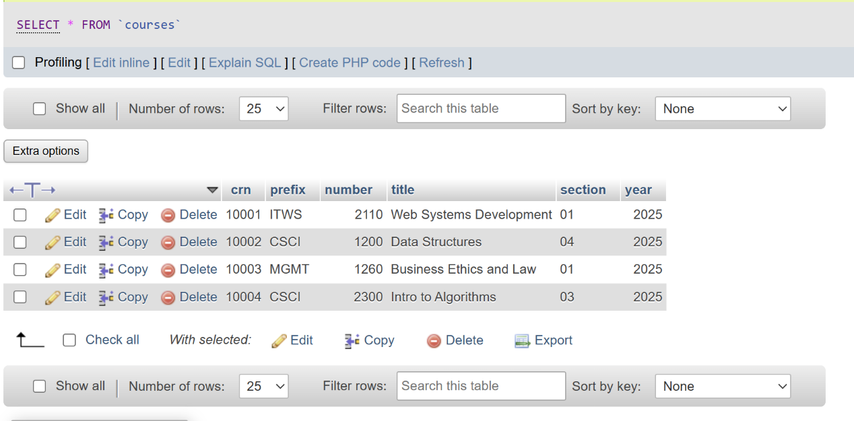
Final Courses table

Final students table
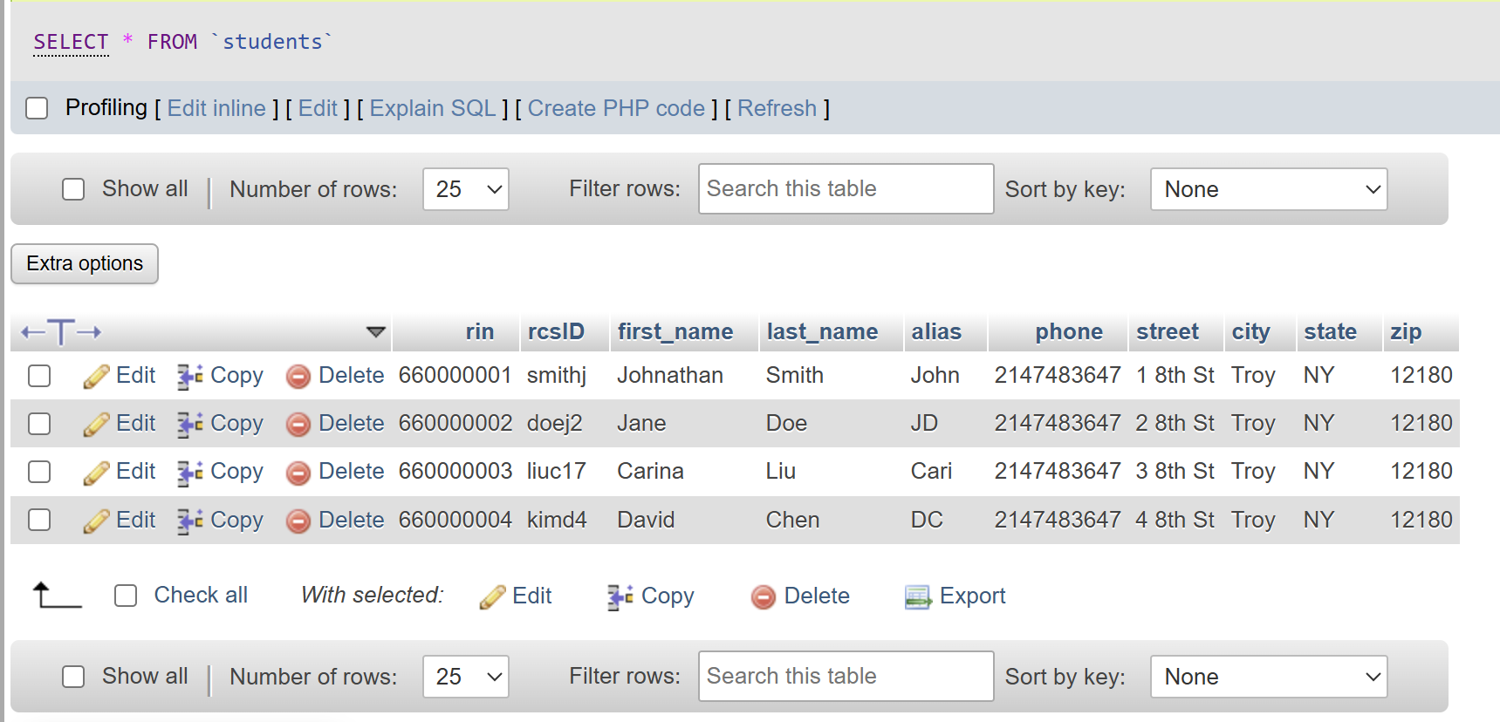

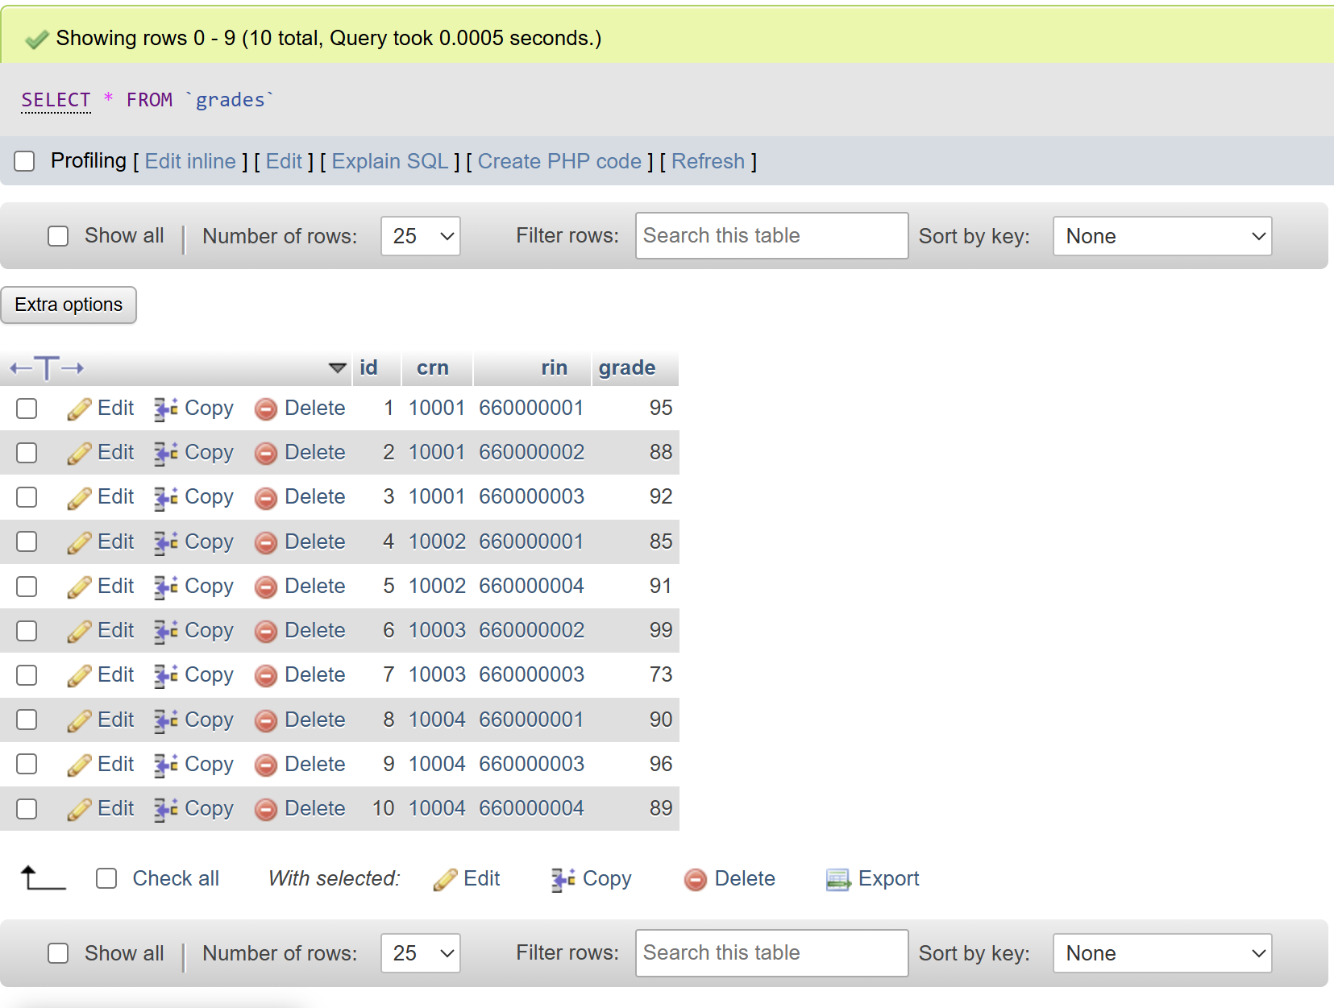
Final Grades table

