Assignment 2
Java RMI

Name: Camara Carina
Group: 30241

Requirements

Functional requirements:
Users introduce the information of their cars using a simple form:
- int year – fabrication year
- int engineSize – engine size
- double price – purchasing price

The application uses RPC to send the car information to the distributed object from the server that computes the following information depending on the client request:
- Tax for a car
- Selling price for a car

The result of the invoked operation, tax, respectively selling price, is displayed on the client GUI.

Conceptual architecture of the distributed system
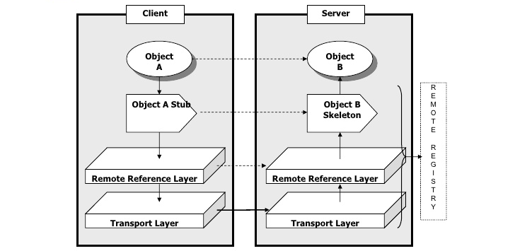

UML Deployment diagram

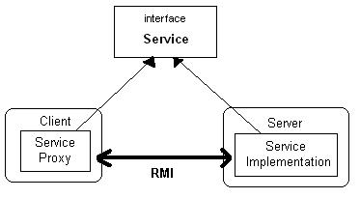

Readme file

How to run the application:
1.
javac src/com/mkyong/rmiinterface/RMIInterface.java src/com/mkyong/rmiserver/ServerOperation.java src/com/mkyong/rmiclient/ClientOperation.java src/com/mkyong/common/Car.java

2.
cd src
rmiregistry &

java com.mkyong.rmiserver.ServerOperation
3.
cd src
java com.mkyong.rmiclient.ClientOperation

