Assignment 3
Java Message Service

Name: Camara Carina
Group: 30241

Requirements

Functional requirements:
Users introduce the information of their DVDs using a simple form:
- String title – DVD’s title
- int year - year
- double price – purchasing price

The application uses RabbitMQ Server to send the DVD information to the distributed object from the server that computes the following information:

- Each time new information about a DVD is introduced in the system, the application must send automatically notification e-mails to all the subscriber customers to notify them about the new item.
- Each time new information about a DVD is introduced in the system the application must create automatically a text file and write the information about the DVD in it.

Conceptual architecture of the distributed system

The basic building blocks of a JMS application consist of:
- Administered objects: connection factories and destinations
- Connections
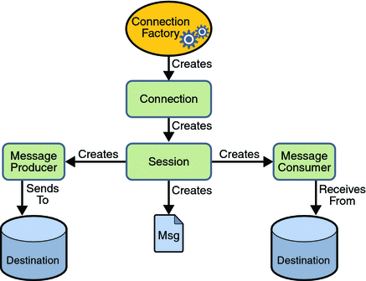
- Sessions
- Message producers
- Message consumers
- Messages

The basic architecture of a message queue is simple, there are client applications called producers that create messages and deliver them to the broker (the message queue). Other applications, called consumers, connects to the queue and subscribes to the messages to be processed. A software can be a producer, or consumer, or both a consumer and a producer of messages. Messages placed onto the queue are stored until the consumer retrieves them.
