Hospital

ReadMe File

Student: Camara Carina
Group: 30235
Date: 2017-05-17
Table of Contents
1. Tools 3
2. Using the application 4
1. Login 4
1.1. Invalid login 4
1.2 Login as Admin 5
1.3 Login as Secretary 6
1.4 Login as Doctor 6
2. Choose an operation 7
2.2 As Admin 7
2.2.1 Create Secretary 7
2.2.2 Update Secretary 7
2.2.3 Delete Secretary 8
2.2.4 Create Doctor 8
2.2.5 Update Doctor 9
2.2.6 Delete Doctor 10
2.3 As Secretary 11
2.3.1 Create Patient 11
2.3.2 Update Patient 12
2.3.3 Create Consultation 12
2.3.4 Update Consultation 13
2.3.5 Check in Patient 13
2.4 As Doctor 14
2.4.1 See Consultation 14
2.4.2 See Past Consultations 14
3. Logout 16

1. Tools
The project uses the following tools:
Spring Tool Suite – how to install
https://spring.io/tools/sts/all
MySQl WorkBench – how to install
https://dev.mysql.com/doc/workbench/en/wb-installing-linux.html
Tomcat v8.0 – how to install
https://tomcat.apache.org/download-80.cgi

2. Using the application

1. Login
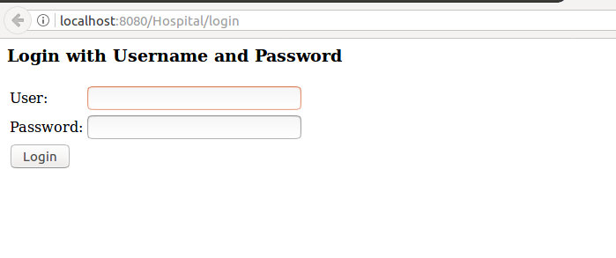

1.1. Invalid login

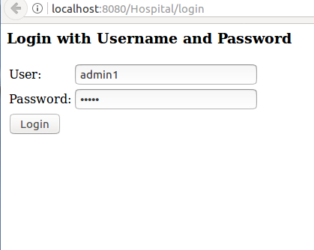
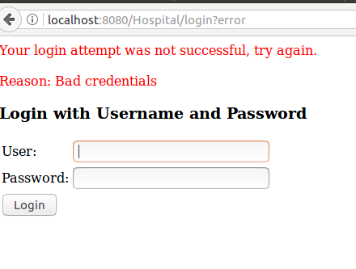

We try to login wih the username admin1 and the password admin.
In the database admin’s username is admin, so the attempt will not be successful.

1.2 Login as Admin

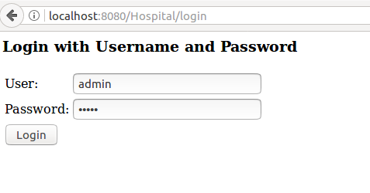

Using the username admin and the password admin, we will be able to access the main page where we can choose were to go.

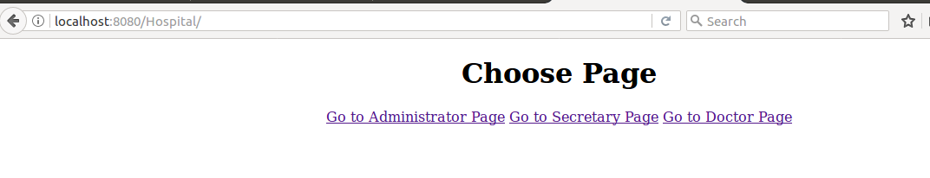
Since we are logged as an Admin, we can not access secretary’s page or doctor’s page.
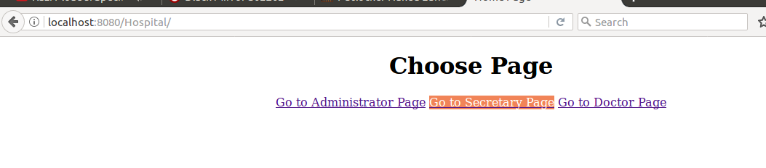

If we try to access the Secretary’s Page we will be redirected to the 403 Page (Access Denied)
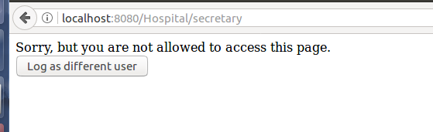

1.3 Login as Secretary
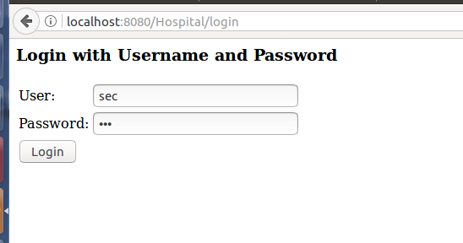

Using the username sec and the password sec, we will be able to access the main page where we can choose were to go.
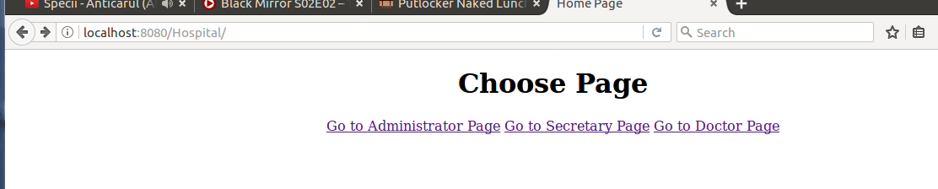

1.4 Login as Doctor
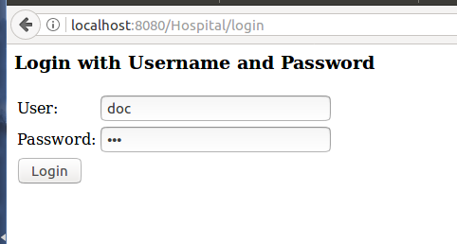

Using the username doc and the password doc, we will be able to access the main page where we can choose were to go.

2. Choose an operation

2.2 As Admin

2.2.1 Create Secretary
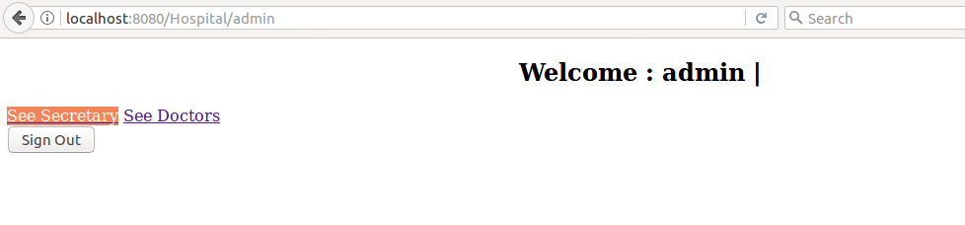

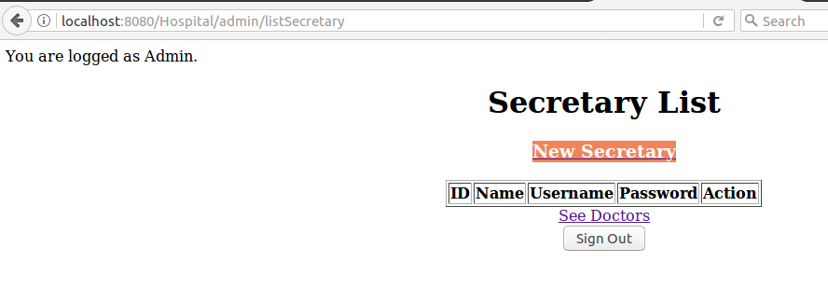

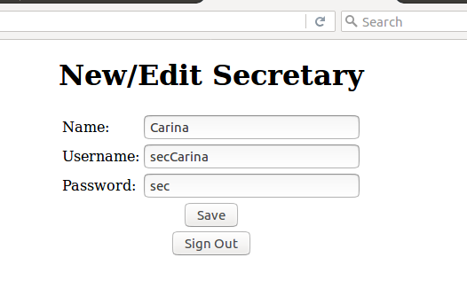
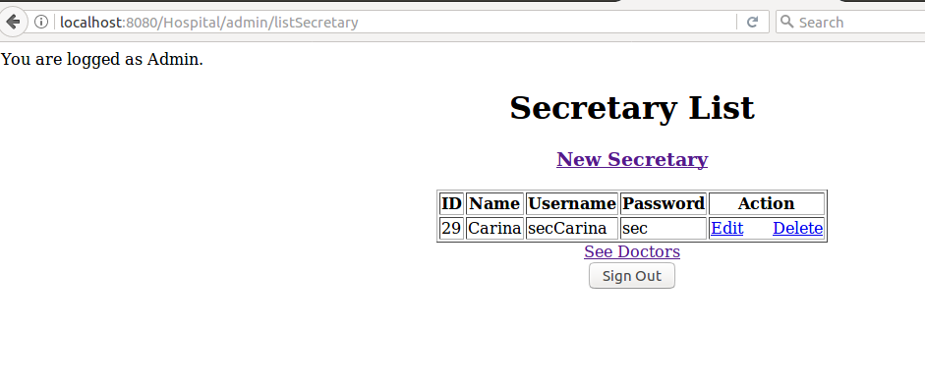

2.2.2 Update Secretary
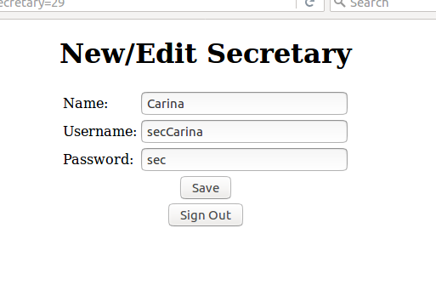

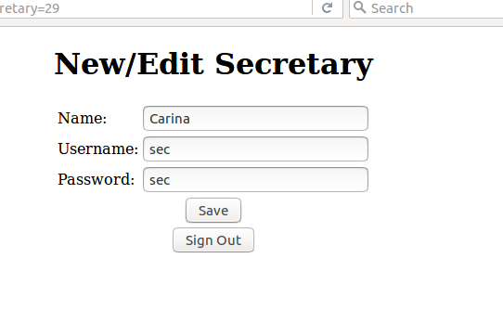
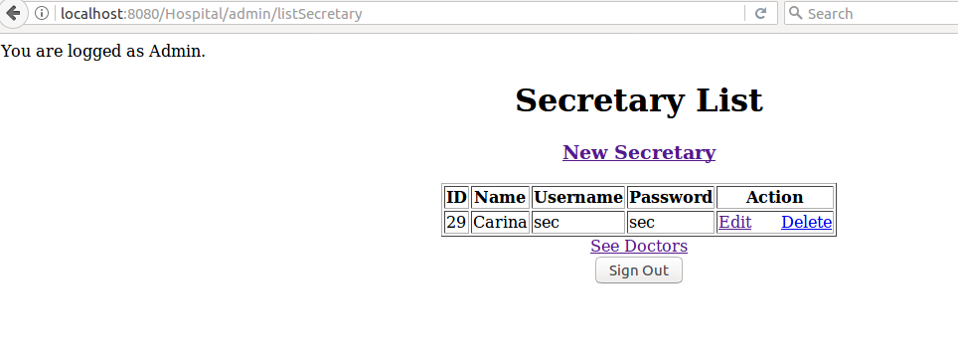

2.2.3 Delete Secretary
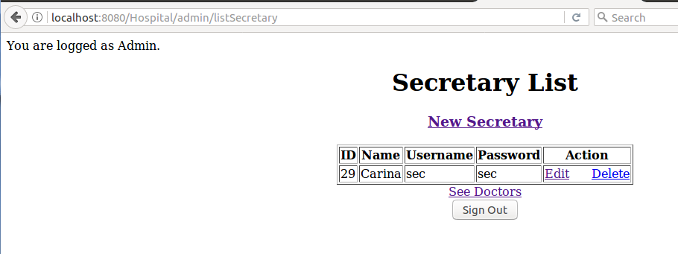

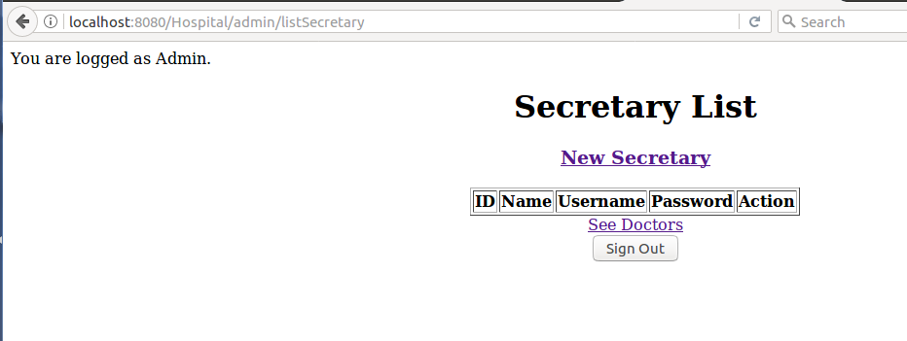

2.2.4 Create Doctor
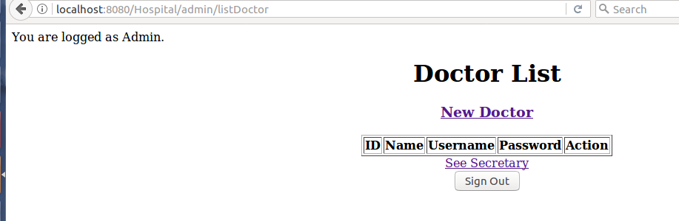

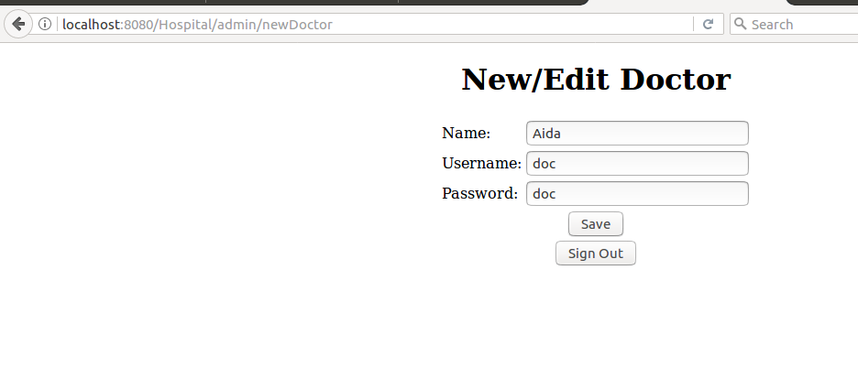

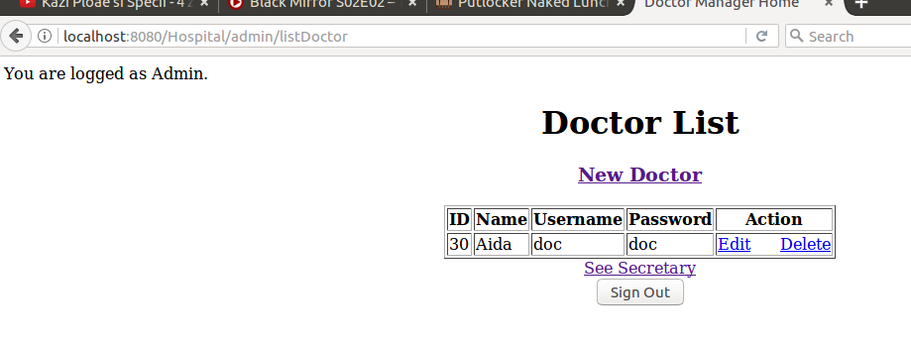

2.2.5 Update Doctor
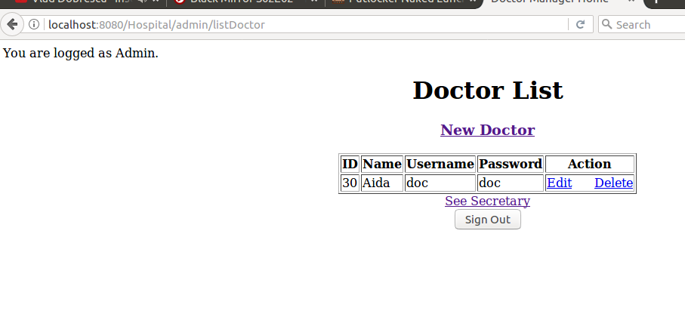

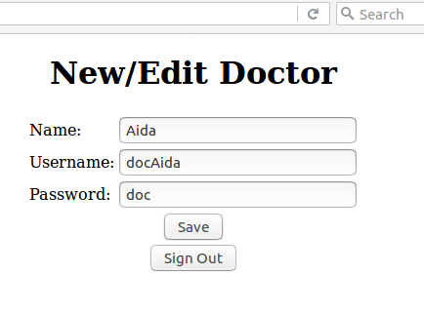

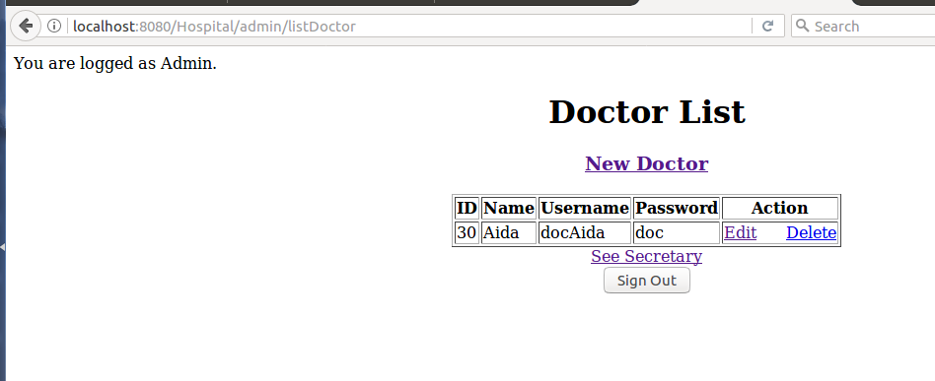

2.2.6 Delete Doctor

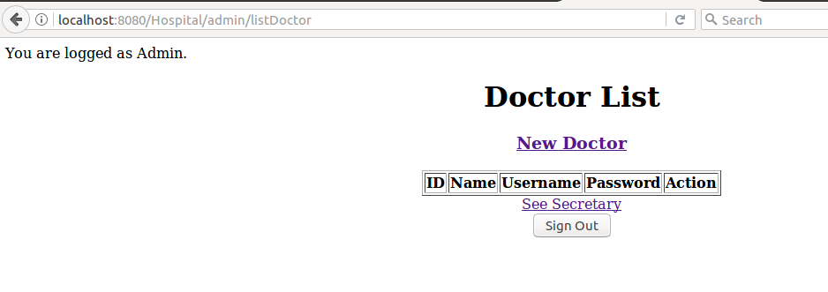

2.3 As Secretary
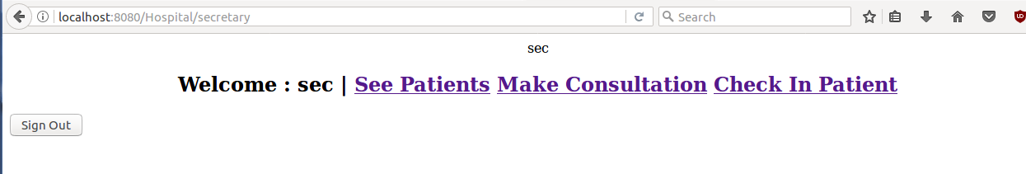

2.3.1 Create Patient
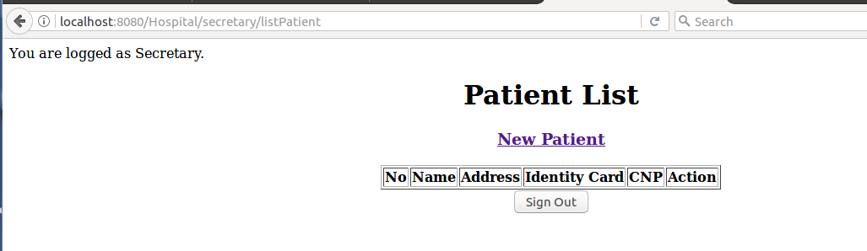

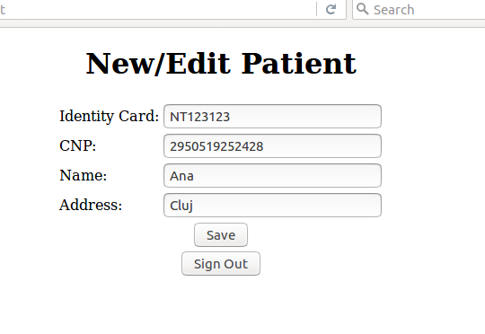

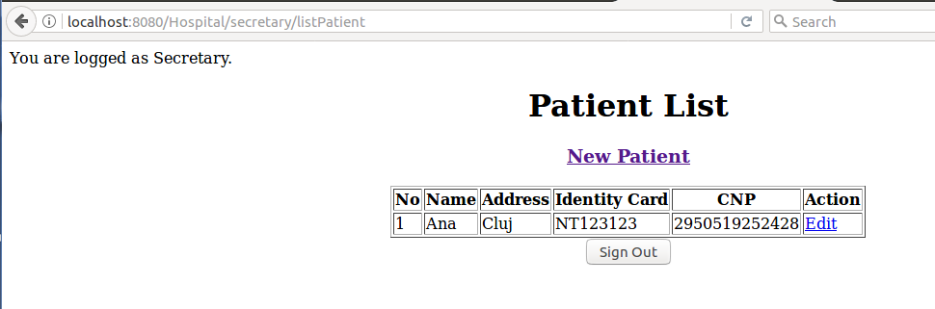

2.3.2 Update Patient
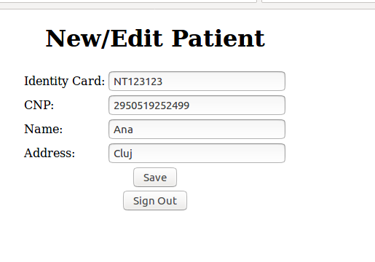

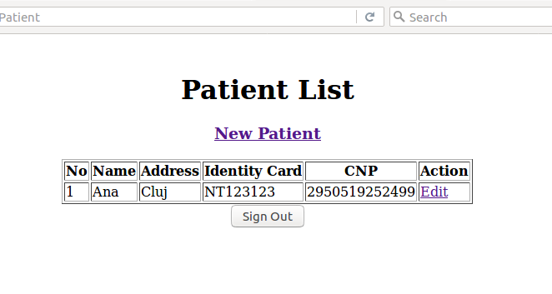

2.3.3 Create Consultation
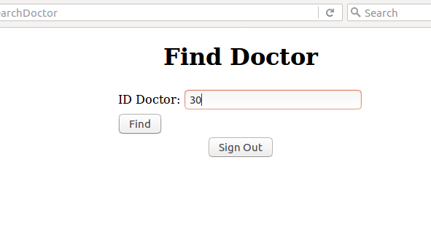
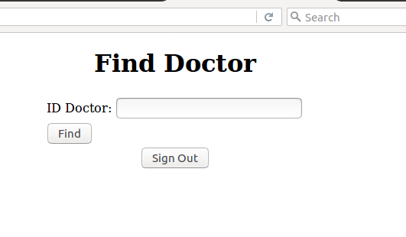

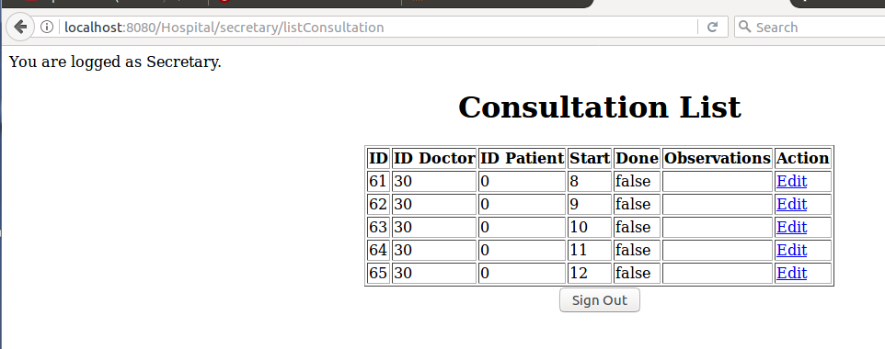

2.3.4 Update Consultation

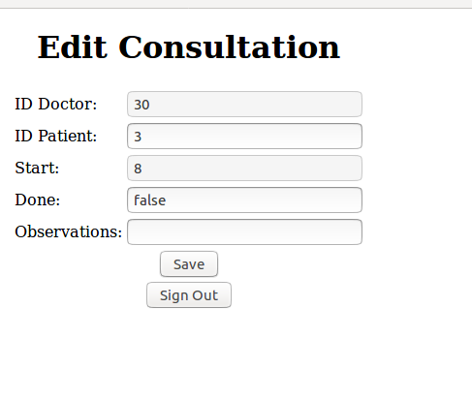

2.3.5 Check in Patient
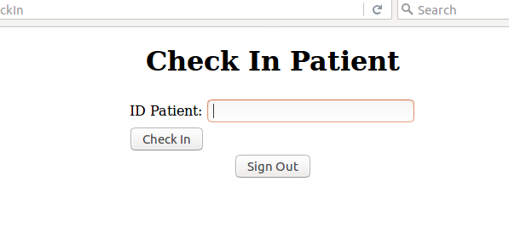
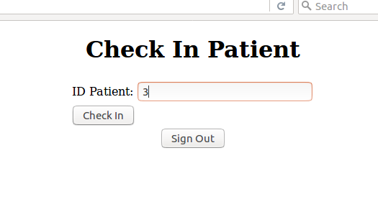

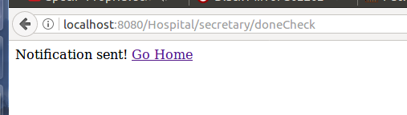

2.4 As Doctor

2.4.1 See Consultation
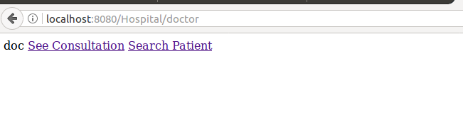

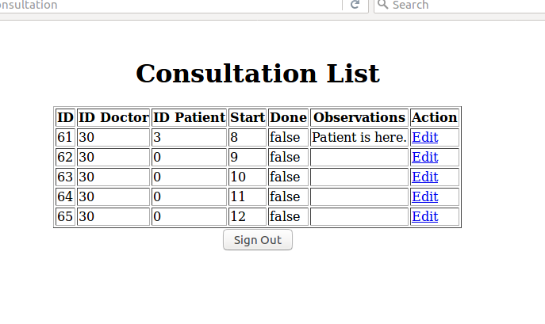
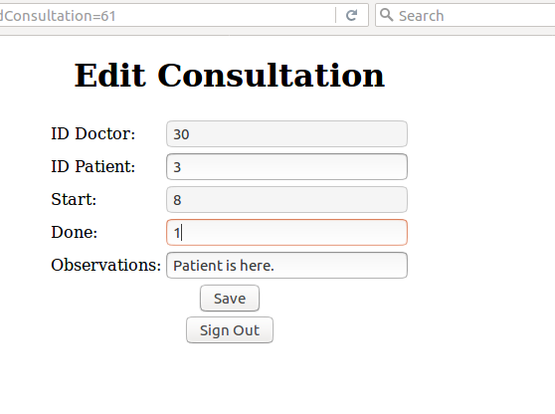

The Consultation list lists only the logged in doctor’s consultations.

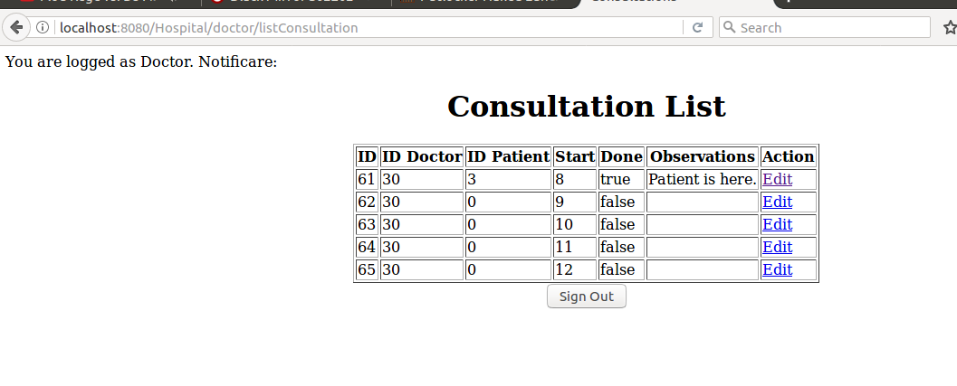

2.4.2 See Past Consultations

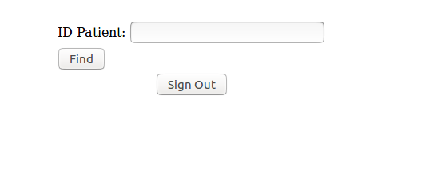
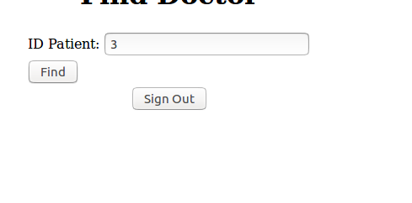

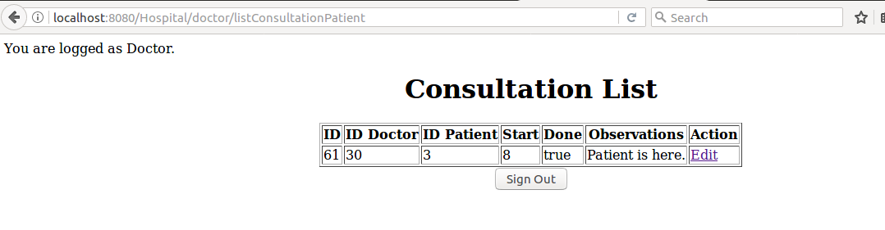

3. Logout



