ONLINE MENTAL HEALTH SELF ASSESSMENT SYSTEM
CASE STUDY IN TANZANIA

BY

CAREEN GODSON BIRDI

BCS/30861/2301/DT

A RESEARCH REPORT SUBMITTED TO THE FACULTY OF COMPUTING
MANAGEMENT AND SOCIAL SCIENCE IN PARTIAL FULFILLMENT OF THE
REQUIREMENT FOR THE AWARD OF BACHELOR DEGREE OF COMPUTER
SCIENCE AT KAMPALA INTERNATIONAL
UNIVERSITY IN TANZANIA

MARCH 2026

DECLARATION

I, Careen Godson Birdi, declare that this research report entitled "Online Mental Health Self Assessment System" is my own original work and that it has not been presented or will not be presented by any other academic institution for similar or any other degree awards.

Student Name: ……………………………………..

Sign………………………………… Date…………………………

I confirm that the work reported in this project was carried out by the candidate under my supervision.

Name: ……………………………………

Sign……………………… Date…………………………

DEDICATION

This project is dedicated to my beloved parents and family for their endless support, encouragement, and motivation throughout my academic journey.

ACKNOWLEDGEMENT

I would like to express my sincere gratitude to Almighty God for granting me the strength, knowledge, and determination to complete this research project successfully. I would also like to extend my heartfelt appreciation to my project supervisor for the valuable guidance, constructive suggestions, and continuous support provided throughout the research process.

My sincere appreciation also goes to the lecturers of the Department of Computing and Information Technology at Kampala International University in Tanzania for the knowledge and skills they have imparted to me during my academic studies. Furthermore, I would like to thank the mental health professionals, ICT experts, and university students who participated in this study by providing useful information and insights that helped in the development of this research.

Finally, I am grateful to my family and friends for their encouragement, patience, and moral support throughout this research journey. May God bless everyone who contributed directly or indirectly to the successful completion of this project.

TABLE OF CONTENTS

LIST OF FIGURES

Figure 2.1: Screenshot of the BetterHelp Online Therapy Platform Interface ................. 11
Figure 2.2: Screenshot of the Wysa AI Mental Health Chatbot Interface ........................ 12
Figure 2.3: Screenshot of the MindDoc Mental Health Self-Assessment Application ........ 13
Figure 2.4: Screenshot of the 7 Cups Online Emotional Support Platform ..................... 14
Figure 2.5: Screenshot of the Headspace Mental Wellness and Mindfulness Platform ...... 15
Figure 3.1: Use Case Diagram for the Online Mental Health Assessment System ............. 25
Figure 3.2: Activity Diagram for "Take Assessment" Process ......................................... 26
Figure 3.3: Sequence Diagram for "View Results" Interaction ....................................... 27
Figure 3.4: Class Diagram for the System ....................................................................... 28
Figure 3.5: Deployment Diagram Showing System Architecture ...................................... 29
Figure 3.6: Entity Relationship Diagram (ERD) for the Database .................................. 30

LIST OF ABBREVIATIONS

CSS – Cascading Style Sheets
DBMS – Database Management System
DSR – Design Science Research
ERD – Entity Relationship Diagram
GAD-7 – Generalized Anxiety Disorder Scale (7-item)
HTML – HyperText Markup Language
HTTP – HyperText Transfer Protocol
ICT – Information and Communication Technology
JMIR – Journal of Medical Internet Research
MIS – Management Information System
PHQ-9 – Patient Health Questionnaire (9-item)
PHP – Hypertext Preprocessor
RDBMS – Relational Database Management System
TAM – Technology Acceptance Model
UI – User Interface
UML – Unified Modeling Language
URT – United Republic of Tanzania
WHO – World Health Organization

ABSTRACT

Mental health disorders are among the leading causes of disability globally, yet access to timely mental health assessment and professional support remains severely limited, particularly in developing countries such as Tanzania. Traditional mental health assessment methods are constrained by geographical barriers, high costs, stigma, and a shortage of qualified mental health professionals. These barriers prevent many individuals from receiving early diagnosis and appropriate treatment, leading to worsening mental health outcomes.

This study presents the design, development, and implementation of an Online Mental Health Assessment System — a web-based platform that enables users to conduct standardized mental health self-assessments, receive automated feedback, and access professional referral recommendations. The system is guided by the Technology Acceptance Model (TAM) and developed using the Design Science Research (DSR) methodology, which involves iterative cycles of problem identification, design, development, demonstration, and evaluation.

The system incorporates validated screening tools including the Patient Health Questionnaire (PHQ-9) for depression assessment and the Generalized Anxiety Disorder Scale (GAD-7) for anxiety screening. Key features of the system include user registration and authentication, profile management, standardized assessment modules, automated result generation, assessment history tracking, and an administrator panel for system management.

The system design was documented using Unified Modeling Language (UML) diagrams including Use Case, Activity, Sequence, Class, and Deployment diagrams, as well as an Entity Relationship Diagram (ERD) for the database architecture. The platform was developed using HTML5, CSS3, JavaScript, Python/Django, and MySQL as the backend database.

The proposed system addresses critical gaps identified in existing literature, including the absence of locally tailored, integrated, and accessible online mental health assessment platforms in Tanzania. By improving accessibility, reducing stigma through anonymity, providing immediate automated feedback, and supporting healthcare providers with preliminary screening data, this system contributes significantly to improving mental healthcare delivery through digital technology.

Keywords: Online Mental Health Assessment, Digital Health, Web-based System, Mental Health Screening, Technology Acceptance Model, Design Science Research.

CHAPTER ONE

INTRODUCTION

1.1 Introduction
This chapter presents the background of the study, statement of the problem, objectives of the study, research questions, significance of the study, limitations of the study, scope of the study, and organization of the study. It provides a foundation for understanding the development of an Online Mental Health Assessment System and its role in improving access to mental health screening, early detection, and intervention services among users.

1.2 Background of the Study
Mental health is an essential component of overall well-being and significantly contributes to individuals’ productivity, social relationships, and quality of life. According to the World Health Organization (WHO, 2022), mental health disorders such as depression, anxiety, and stress-related conditions are among the leading causes of disability worldwide. These conditions affect millions of people globally and contribute to significant social and economic burdens, including reduced productivity, increased healthcare costs, and poor quality of life.

Despite the increasing prevalence of mental health challenges, access to mental health services remains limited, particularly in developing countries. Studies indicate that there is a significant shortage of mental health professionals, limited mental health facilities, and widespread stigma associated with mental illness (WHO, 2021). In many communities, individuals experiencing mental health problems hesitate to seek professional help due to fear of discrimination and lack of awareness about available services.

Recent advancements in information and communication technologies (ICT) have transformed healthcare delivery through digital health solutions such as telemedicine, mobile health applications, and web-based assessment tools. According to the World Bank (2020), digital health technologies improve access to healthcare services, enhance early disease detection, and support remote monitoring of patients. Online mental health assessment systems enable individuals to complete psychological screenings, receive preliminary evaluations, and access professional support remotely, thereby improving accessibility and reducing barriers to care (Torous et al., 2020).

In the Tanzanian context, mental health services are still developing, and many individuals face barriers such as limited healthcare infrastructure, shortage of mental health professionals, and low awareness of mental health conditions (URT, 2022). Although internet usage and smartphone adoption have increased in recent years, the availability of reliable web-based mental health assessment platforms remains limited. This situation creates a need for a digital platform that allows users to assess their mental health status, receive feedback, and obtain appropriate recommendations for further support.

Therefore, the development of an Online Mental Health Assessment System is important to enhance mental health awareness, promote early detection of mental health conditions, and improve access to mental health services through digital technology.

1.3 Statement of the Problem
Mental health disorders continue to affect a large number of individuals worldwide, yet many people lack access to timely mental health assessment and professional support. According to WHO (2022), a significant proportion of individuals with mental health conditions do not receive appropriate treatment due to limited resources, stigma, and lack of accessible services.

Traditional mental health assessment methods often require physical visits to healthcare facilities, which may be costly, time-consuming, and inaccessible to individuals living in remote areas. Additionally, social stigma associated with mental health conditions prevents many individuals from seeking help, leading to delayed diagnosis and worsening health conditions (WHO, 2021).

Despite advancements in digital technologies, there is limited availability of accessible and reliable web-based platforms that provide mental health screening and assessment services in many developing countries, including Tanzania (URT, 2022). The absence of such systems limits early detection and intervention, which may result in increased severity of mental health problems and reduced quality of life. Therefore, there is a need to design and implement an Online Mental Health Assessment System that enables users to perform self-assessments, receive immediate feedback, and access appropriate mental health guidance.

1.4 Objective of Study

1.4.1 General Objective
To design and implement an Online Mental Health Assessment System to support early detection and monitoring of mental health conditions.

1.4.2 Specific Objectives

- To analyze user requirements and existing mental health assessment practices.
- To design the system architecture, database structure, and user interfaces for the Online Mental Health Assessment System.
- To develop a web-based system that allows users to perform mental health assessments and receive feedback.
- To implement the system by integrating assessment tools, user management, and reporting modules.
- To test and evaluate the performance, accuracy, and usability of the developed system.

1.5 Research Questions

- What are the current challenges in accessing mental health assessment services?
- How can a web-based system improve accessibility and efficiency of mental health assessment?
- What features are necessary for an effective Online Mental Health Assessment System?
- How effective is the developed Online Mental Health Assessment System in supporting early detection of mental health conditions?
- What are the potential future improvements for the Online Mental Health Assessment System?

1.6 Significance of the Study
The following describes the significance of the study.

1.6.1 To Users
The study provides users with a convenient, confidential, and accessible platform for assessing their mental health status. The system enables early detection of mental health conditions by allowing users to complete self-assessment questionnaires and receive immediate feedback. This promotes self-awareness, encourages timely help-seeking behavior, and reduces the impact of mental health problems on individuals’ daily lives. Furthermore, the system helps reduce stigma by providing a private environment where users can assess their mental health without fear of discrimination.

1.6.2 To Healthcare Providers
Healthcare providers benefit from the system as a decision-support tool that assists in monitoring patients’ mental health status. The system helps professionals collect preliminary data, improve diagnosis processes, and enhance service delivery efficiency. It also reduces workload by providing automated screening and enables healthcare professionals to focus on treatment and intervention.

1.6.3 To the Government
The study supports government initiatives aimed at improving healthcare services through digital transformation. The system contributes to national health strategies by promoting mental health awareness, improving access to healthcare services, and supporting early intervention programs. It also provides valuable data that policymakers can use to improve mental health planning and resource allocation.

1.6.4 To Scholars and Researchers
The study contributes to the existing body of knowledge on digital health technologies and mental health assessment systems. It provides a reference for future research in system development, mental health technology adoption, and healthcare innovation. The findings may also guide further studies on improving digital health services.

1.7 Limitations of the Study
Every research study faces certain limitations that may affect the scope, methodology, or generalizability of its findings. In the context of this study on an Online Mental Health Assessment System, several limitations were encountered during the research and development process.

1.7.1 Limited User Awareness
Some users may lack awareness or understanding of how to use online mental health systems or interpret assessment results. This limitation was mitigated by incorporating clear user guidelines, tutorials, and instructions within the system to enhance usability and ensure proper interpretation of results.

1.7.2 Internet Connectivity Challenges
Limited or unstable internet connectivity may restrict access to the system, especially in rural areas. This was addressed by optimizing the system for low-bandwidth usage and efficient data processing to improve accessibility across varying network conditions.

1.7.3 Accuracy of Self-Reported Data
The system relies on users’ self-reported responses, which may be influenced by personal bias or inaccurate information. This limitation was mitigated by incorporating validated psychological assessment questionnaires (PHQ-9 and GAD-7) to improve reliability and accuracy of results.

1.7.4 Privacy and Security Concerns
Users may have concerns about confidentiality and security of personal health information. This was addressed by implementing data encryption, secure authentication mechanisms, and privacy protection measures to ensure data security throughout the system.

1.8 Scope of the Study
The following describes the scope of the study.

1.8.1 Content Scope
The study focuses on the design, development, and implementation of an Online Mental Health Assessment System. It covers system requirements analysis, system design, development of assessment tools, implementation, and testing of system functionality. The system is specifically designed to support mental health self-assessment among individuals aged 18 years and above, targeting university students, employees, and community members who may be experiencing mental health challenges.

The system incorporates standardized assessment tools, namely the Patient Health Questionnaire (PHQ-9) for depression screening and the Generalized Anxiety Disorder Scale (GAD-7) for anxiety assessment. The content scope also covers user account management, assessment history tracking, result visualization, automated feedback generation, and administrative system management. The system does not include real-time counseling, professional therapy, or clinical diagnosis, as it is designed to complement and not replace professional mental healthcare services.

1.8.2 Theoretical Scope
The study is guided by the Technology Acceptance Model (TAM), originally proposed by Davis (1989), to evaluate user acceptance of the online mental health assessment system based on the key constructs of perceived usefulness and perceived ease of use. TAM provides a theoretical lens for understanding how users’ attitudes toward digital health technology influence their intention to adopt and consistently use the system. Additionally, the Design Science Research (DSR) methodology informs the theoretical orientation of the development process by providing a structured framework for designing, developing, and evaluating the system as an innovative IT artifact.

1.8.3 Time Scope
The study was conducted within the academic year 2024/2025. The research activities, including system requirements analysis, design, development, testing, and evaluation, were carried out within the allocated academic project timeframe. The system development period spans approximately six months, covering the phases from initial planning and requirements gathering through system implementation and final evaluation. Data collection for requirements analysis was conducted during the first quarter of the study period, while system design and development were completed in the second and third quarters. System testing and final evaluation were conducted in the final quarter of the project timeframe.

1.9 Organization of the Study

Chapter One: Introduction – Presents the background of the study, statement of the problem, objectives, research questions, significance, limitations, and scope.
Chapter Two: Literature Review – Reviews relevant literature on online mental health assessment systems, covering theoretical frameworks, empirical studies, and research gaps.
Chapter Three: Research Methodology – Presents the research methodology and system design, including research design, target population, data collection tools, system development methodology, and UML diagrams.
Chapter Four: Research Findings and Discussion – Discusses system implementation and findings, presenting the developed system features, test results, and evaluation outcomes.
Chapter Five: Summary, Conclusions, and Recommendations – Provides conclusions and recommendations for future work.

CHAPTER TWO

LITERATURE REVIEW

2.1 Introduction
This chapter presents a comprehensive review of literature related to online mental health assessment systems. It examines the concept of mental health assessment, evolution of digital mental health technologies, online mental health screening tools, benefits and challenges of online mental health systems, theoretical frameworks, empirical studies, critical review, and research gaps. The purpose of this chapter is to establish a theoretical and empirical foundation for the development of an online mental health assessment system.

2.2 Theoretical Literature Review

2.2.1 The Technology Acceptance Model (TAM)
This study is guided by the Technology Acceptance Model (TAM), which explains how users adopt and use new technologies. According to Davis (1989), two key factors influence technology adoption:

- Perceived Usefulness (PU): Users are more likely to adopt a system if they believe it will enhance their performance.
- Perceived Ease of Use (PEOU): Users adopt systems that are easy to use and require minimal effort.

Perceived usefulness refers to the degree to which a user believes that using a system enhances performance, while perceived ease of use refers to the degree to which a system is free from effort. TAM is relevant to online mental health assessment systems as it explains factors influencing users’ acceptance of digital health technologies and allows assessment of attitudes toward adoption and potential resistance factors.

2.2.2 Design Science Research (DSR) Framework
The Design Science Research (DSR) methodology, established by Hevner et al. (2004), provides a complementary theoretical framework that guides the development of the system as an IT artifact. DSR promotes iterative design and evaluation cycles, aligning with the complexity of designing a mental health system that balances clinical validity, user experience, security, and technical performance requirements.

2.3 Concept of Mental Health Assessment
Mental health assessment refers to a systematic process of evaluating an individual’s psychological, emotional, and behavioral functioning using standardized tools and procedures. It involves identifying symptoms, diagnosing mental health conditions, determining treatment needs, and monitoring progress over time (American Psychiatric Association, 2013). Traditional mental health assessment methods include clinical interviews, psychological testing, behavioral observations, and self-report questionnaires conducted by trained professionals.

Mental health assessment plays a critical role in early detection and intervention of mental disorders. Early identification of mental health problems helps prevent severe complications and improves treatment outcomes (Kazdin, 2000). However, traditional face-to-face assessment methods are often limited by accessibility barriers, high costs, shortage of professionals, and social stigma associated with seeking mental health services.

The advancement of information and communication technology has transformed mental health assessment practices by introducing digital and online assessment approaches. These approaches enable individuals to complete mental health screening tests remotely through web-based platforms, improving accessibility and convenience (Andersson & Titov, 2014).

2.4 Online Mental Health Assessment Systems
Online mental health assessment systems are web-based applications designed to evaluate users’ mental health status using structured questionnaires and automated feedback mechanisms. These systems typically use validated screening tools such as the Patient Health Questionnaire (PHQ-9) for depression and Generalized Anxiety Disorder Scale (GAD-7) for anxiety assessment (Kroenke et al., 2001; Spitzer et al., 2006).

Online assessment platforms provide real-time analysis of user responses, immediate feedback, and recommendations for further evaluation or treatment. These systems may also include features such as user authentication, data storage, progress tracking, and referral services. Research indicates that online mental health assessment systems significantly improve access to mental health services, particularly in rural and underserved areas where professional services are limited (Richards & Richardson, 2012). Additionally, these systems reduce waiting time, enhance efficiency in service delivery, and support early detection of mental health conditions.

2.5 Digital Mental Health Technologies
Digital mental health technologies refer to the use of information and communication technologies to support mental health assessment, monitoring, and intervention. These technologies include mobile health applications, web-based platforms, telepsychiatry services, wearable devices, and artificial intelligence-based systems (Torous et al., 2020).

The integration of digital technologies in mental healthcare has improved service accessibility and efficiency. Digital platforms enable remote monitoring of mental health conditions, personalized interventions, and continuous communication between patients and healthcare providers (Naslund et al., 2017). Furthermore, digital technologies help reduce stigma associated with mental health treatment by providing anonymous and confidential services. Mobile health applications and web-based assessment tools have been widely adopted in mental healthcare due to their ability to provide cost-effective and scalable solutions.

2.6 Benefits of Online Mental Health Assessment Systems
Online mental health assessment systems provide numerous advantages over traditional assessment methods. One major benefit is accessibility. Individuals can access online assessment services anytime and from any location, which reduces geographical barriers to mental healthcare (Barak et al., 2008).

Another benefit is convenience and cost-effectiveness. Online systems reduce transportation costs, consultation fees, and waiting time associated with traditional services. They also allow automated data collection and analysis, which improves efficiency and reduces administrative workload. Online assessment systems also promote user anonymity and confidentiality, which reduces stigma and encourages individuals to seek help for mental health problems. Research shows that anonymity increases users’ willingness to disclose sensitive information related to their mental health (Joinson, 2001). Furthermore, online systems provide immediate feedback and recommendations, enabling early detection and timely intervention of mental health conditions.

2.7 Challenges of Online Mental Health Assessment Systems
Despite their benefits, online mental health assessment systems face several challenges. One major concern is data privacy and security. Protecting sensitive mental health information from unauthorized access and cyber threats is essential in digital health systems (Bennett & Glasgow, 2009).

Another challenge is the limited diagnostic accuracy of online assessments. Automated systems may not capture complex psychological symptoms that require professional clinical judgment. Therefore, online assessments should complement rather than replace traditional clinical evaluations. Digital literacy barriers also affect the effectiveness of online mental health systems. Some individuals may lack the skills or resources required to use digital platforms effectively. Additionally, internet connectivity issues may limit accessibility in some regions.

2.8 Empirical Review
Several empirical studies have examined the effectiveness of online mental health assessment systems. Andersson and Titov (2014) found that internet-based mental health interventions effectively identify and manage mental health conditions. Similarly, Richards and Richardson (2012) reported that online psychological interventions significantly improve mental health outcomes.

Torous et al. (2020) highlighted the growing role of digital mental health technologies in improving healthcare accessibility and monitoring mental health conditions. Naslund et al. (2017) also found that digital mental health interventions enhance patient engagement and treatment adherence. These studies demonstrate the potential of online mental health assessment systems in improving access to mental healthcare and supporting early intervention.

2.9 Similar Systems
This section reviews five existing online mental health assessment and support platforms that are related to the proposed system. Each platform is examined for its overview, key strengths, and weaknesses in order to identify gaps that the proposed Online Mental Health Assessment System aims to address.

1. BetterHelp

Overview:
BetterHelp is one of the world’s largest online therapy and counseling platforms, connecting users with licensed mental health professionals through a fully digital environment. The platform offers multiple communication channels including text messaging, live chat, phone, and video sessions. BetterHelp incorporates standardized mental health screening tools during onboarding to match users with appropriate therapists based on their self-reported symptoms and preferences (BetterHelp, 2023).

Strengths:
- Large Network of Therapists: Access to over 30,000 licensed therapists across diverse specializations including depression, anxiety, trauma, and relationship issues.
- Multi-modal Communication: Users can interact with therapists via messaging, live chat, phone, or video, increasing flexibility and accessibility.
- Integrated Screening: Onboarding assessments using validated tools help route users to appropriate professional support.
- Mobile and Web Accessible: The platform is available on both web browsers and mobile applications, improving reach.

Weaknesses:
- High Cost: Subscription fees ranging from $60–$100 per week make it inaccessible for users in low-income settings such as Tanzania.
- No Local Language Support: The platform is designed primarily for English-speaking users and lacks Swahili or other local language interfaces.
- Relies on High Connectivity: Consistent high-speed internet is required for video and audio sessions, limiting usability in rural areas.

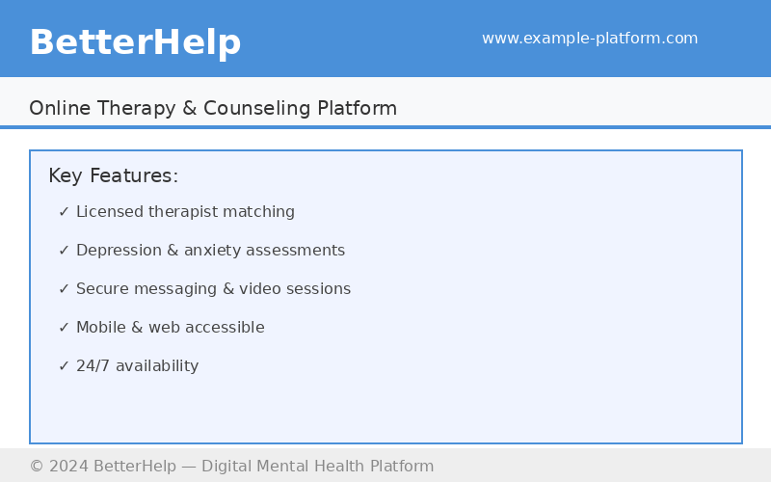
Figure 2.1: Screenshot of the BetterHelp Online Therapy Platform Interface

2. Wysa

Overview:
Wysa is an AI-powered mental health chatbot designed to provide emotional support and conduct evidence-based mental health screenings. The platform uses artificial intelligence to engage users in structured conversations, guiding them through Cognitive Behavioral Therapy (CBT) techniques and validated assessment instruments including the PHQ-9 and GAD-7 scales. Wysa has been deployed in several countries and is designed to function effectively in low-resource digital environments (Wysa, 2023).

Strengths:
- PHQ-9 and GAD-7 Integration: Uses the same validated screening tools as the proposed system, ensuring clinical relevance and accuracy.
- AI-Driven Interaction: Conversational AI provides immediate, non-judgmental responses, reducing user hesitation in disclosing mental health symptoms.
- Low-Bandwidth Optimized: The text-based chatbot interface is designed to function effectively even under limited internet connectivity conditions.
- Anonymous Usage: Users can engage without disclosing personal identifying information, supporting stigma reduction.

Weaknesses:
- Limited Clinical Depth: AI-driven responses cannot replace professional clinical judgment in complex or crisis mental health situations.
- No Administrator Module: Wysa lacks institutional-level reporting and administrative oversight features needed by healthcare providers.
- Language Barrier: The platform does not support Swahili, limiting its cultural appropriateness for Tanzanian users.

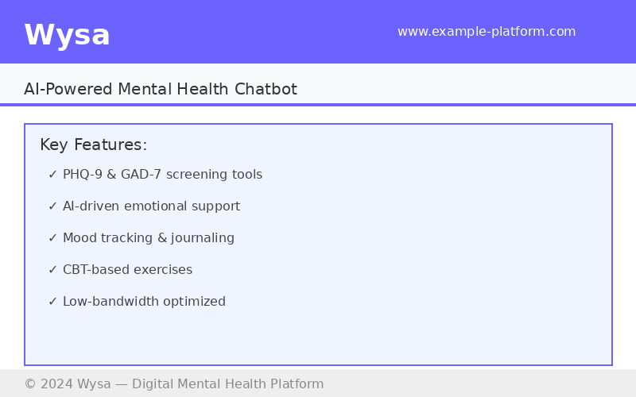
Figure 2.2: Screenshot of the Wysa AI Mental Health Chatbot Interface

3. MindDoc

Overview:
MindDoc is a clinically validated digital mental health application developed by psychologists and psychiatrists to support mental health self-monitoring and early symptom detection. The platform allows users to complete daily mood assessments, track emotional patterns over time, and complete standardized clinical questionnaires. MindDoc provides users with personalized insights, graphical progress reports, and therapist referral recommendations based on their assessment outcomes (MindDoc, 2023).

Strengths:
- Clinically Developed: Designed in collaboration with mental health professionals, ensuring evidence-based assessment frameworks and reliable screening outcomes.
- Comprehensive Symptom Tracking: Continuous daily tracking enables trend identification and longitudinal monitoring of users’ mental health status.
- Progress Visualization: Graphical dashboards presenting assessment history and symptom trends improve user engagement and self-awareness.
- Therapist Referral Integration: Automatically recommends professional support when assessment results indicate elevated risk levels.

Weaknesses:
- Primarily App-Based: MindDoc is predominantly available as a mobile application, limiting access for users without smartphones or using desktop-only environments.
- Limited Free Features: Core clinical assessment features are locked behind a premium subscription, reducing accessibility for low-income users.
- Not Tailored for Africa: The platform lacks localization for Sub-Saharan African contexts in terms of language, cultural norms, and infrastructure constraints.

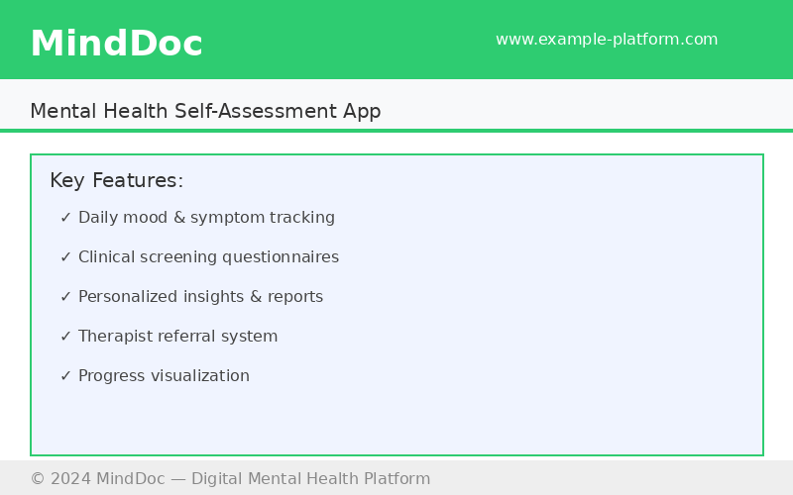
Figure 2.3: Screenshot of the MindDoc Mental Health Self-Assessment Application

4. 7 Cups

Overview:
7 Cups is a web-based emotional support and online therapy platform that connects users with trained volunteer listeners and licensed therapists for mental health support. The platform provides anonymous peer-to-peer chat services, self-help guides, mental health assessments, and community support forums. 7 Cups is accessible via both web browsers and mobile applications, and offers a free basic service tier alongside premium therapy options (7 Cups, 2023).

Strengths:
- Anonymous Peer Support: Users can access emotional support anonymously through trained volunteer listeners, significantly reducing stigma-related barriers.
- Free Basic Access: Core features including peer chat and self-help resources are available at no cost, improving accessibility for low-income users.
- Mental Health Assessments: Includes screening tools for depression, anxiety, and other conditions, providing preliminary evaluation prior to professional referral.
- Community Support Forums: Peer-moderated forums create a sense of community and shared experience, supporting users between professional sessions.

Weaknesses:
- Variable Volunteer Quality: The quality and consistency of peer support provided by volunteer listeners varies significantly, potentially delivering unreliable responses.
- No Institutional Reporting: The platform lacks administrator-level dashboards for healthcare providers to monitor aggregated assessment data and trends.
- Limited Cultural Localization: Content and communication styles are not adapted for East African cultural norms or available in Swahili.

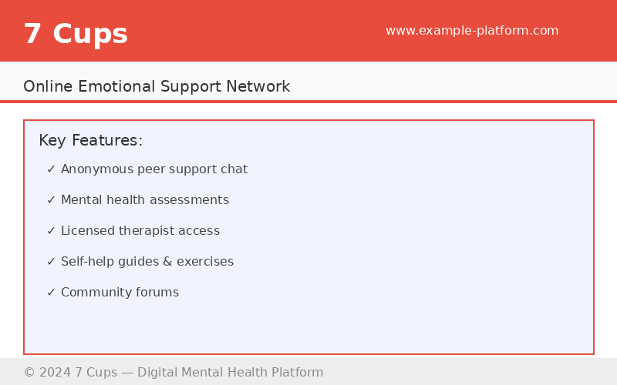
Figure 2.4: Screenshot of the 7 Cups Online Emotional Support Platform

5. Headspace

Overview:
Headspace is a globally recognized digital mental wellness platform specializing in mindfulness-based interventions, guided meditation, and stress management programs. The platform incorporates scientifically validated mental health content developed in collaboration with clinical researchers. Headspace provides structured programs for anxiety reduction, sleep improvement, and emotional regulation, supported by progress tracking dashboards and personalized recommendations (Headspace, 2023).

Strengths:
- Evidence-Based Content: Mindfulness and meditation programs are developed with clinical researchers and validated through peer-reviewed studies, ensuring scientific credibility.
- Structured Wellness Programs: Tailored programs for stress, anxiety, sleep, and focus provide systematic mental health support beyond simple screening.
- Progress Tracking: User dashboards track engagement and progress through wellness programs, supporting habit formation and sustained use.
- High Usability: Intuitive interface design and guided onboarding ensure ease of use for individuals of varying digital literacy levels.

Weaknesses:
- No Clinical Assessment Tools: Headspace does not incorporate standardized clinical screening instruments such as PHQ-9 or GAD-7 for formal mental health evaluation.
- Subscription Cost: Premium features require a paid subscription, limiting access for users in low-income settings.
- Wellness Rather Than Assessment Focus: The platform prioritizes preventive wellness rather than clinical assessment and professional referral, reducing its utility as a diagnostic screening tool.

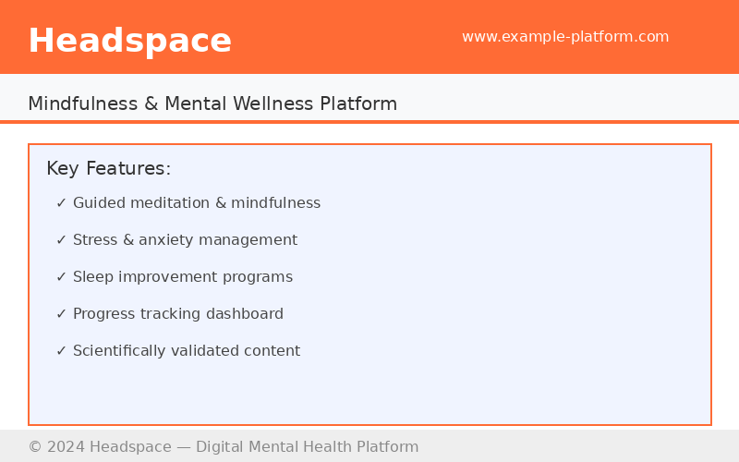
Figure 2.5: Screenshot of the Headspace Mental Wellness and Mindfulness Platform

2.10 Critical Review and Research Gap
A critical examination of existing literature reveals several significant limitations in current digital mental health assessment systems that this study seeks to address. While numerous studies (Andersson & Titov, 2014; Richards & Richardson, 2012; Torous et al., 2020) demonstrate the potential of online mental health platforms, the majority of these systems were developed for high-income, Western contexts and lack adaptability to the social, cultural, and infrastructural realities of Sub-Saharan African countries such as Tanzania.

Furthermore, most existing systems operate as standalone tools without integration of multiple mental health assessment instruments, user history tracking, and administrator-level reporting within a single cohesive platform. This fragmentation limits their utility for comprehensive mental health monitoring and institutional use. The research gap, therefore, lies in the absence of locally tailored, integrated, and accessible web-based mental health assessment platforms designed specifically for institutional and organizational settings in developing countries.

2.10.1 How the Proposed System Fills the Gap
The proposed Online Mental Health Assessment System directly addresses the identified research gaps through targeted solutions across multiple dimensions:

i. Accessibility Gap – Solution:
The system is built as a lightweight, low-bandwidth web application accessible on any standard browser without requiring specialist software or high-end hardware. This directly bridges the digital divide in resource-constrained settings such as Tanzania, where internet speeds are variable and device ownership is limited.

ii. Integration Gap – Solution:
Unlike fragmented tools that offer only a single screening instrument, the proposed system integrates multiple validated tools (PHQ-9 and GAD-7) within a unified platform complete with user management, assessment history, automated feedback, and an administrative reporting dashboard, providing a comprehensive one-stop mental health assessment solution.

iii. Stigma Reduction Gap – Solution:
The system provides a fully anonymous and confidential self-assessment environment that allows users to evaluate their mental health without social exposure. This directly reduces the stigma barrier that prevents many individuals in Tanzania and other developing countries from seeking mental health support.

iv. Healthcare Provider Support Gap – Solution:
The administrator module enables healthcare providers and institutional managers to view aggregated, anonymized assessment data, monitor mental health trends, and generate reports. This supports data-driven decision-making for mental health resource allocation and intervention planning at the institutional level.

v. Localization Gap – Solution:
The system is specifically designed and tested for the Tanzanian user context, taking into account local infrastructure limitations, language clarity, and cultural appropriateness in assessment communication and feedback messaging, unlike globally generic platforms that do not account for local needs.

2.11 Summary of Literature Review
This chapter reviewed literature related to online mental health assessment systems. The chapter discussed the concept of mental health assessment, digital mental health technologies, benefits and challenges of online assessment systems, theoretical framework, empirical review, and identified research gaps through a critical analysis. The review establishes that while digital mental health platforms have significant demonstrated potential, locally tailored, integrated solutions are urgently needed in developing country contexts like Tanzania. The proposed system addresses these gaps by providing an accessible, integrated, stigma-reducing, and institutionally responsive online mental health assessment platform. This review provides a strong theoretical and empirical foundation for the system developed and described in the subsequent chapters.

CHAPTER THREE

RESEARCH METHODOLOGY

3.1 Introduction
This chapter presents the research methodology, system analysis, and design processes employed in the development of the Online Mental Health Assessment System. It begins with an overview of the research design adopted, followed by a description of the target population and sample size considered for requirements gathering. The chapter further explains the tools used for data collection, detailing each tool’s purpose and justification. The system development methodology is then described in depth, including its features and the rationale for its selection. Finally, the chapter presents the comprehensive system design documented through Unified Modeling Language (UML) diagrams, database design, and development tools.

3.2 Research Design
The study adopts a descriptive and developmental research design. The development of this system follows a Design Science Research (DSR) methodology. DSR is focused on creating and evaluating innovative artifacts — in this case, the Online Mental Health Assessment System — to solve identified problems. This approach is suitable as it involves iterative cycles of design, development, and evaluation to ensure the final product is both functional and meets user needs. The process typically includes stages such as problem identification, definition of objectives, design and development, demonstration, and evaluation.

The research adopts a mixed approach that combines both qualitative and quantitative methods. Qualitative approaches were used for requirements gathering through interviews and document analysis, while quantitative methods were applied in system performance testing and usability evaluation. This combination ensures comprehensive coverage of both technical system requirements and user experience considerations.

3.2.1 Target Population
The target population for this study comprises individuals who are potential users and stakeholders of the Online Mental Health Assessment System. This includes university students, academic and administrative staff, and mental health professionals at the University of Dar es Salaam and affiliated health facilities in Dar es Salaam, Tanzania. University students represent a key demographic group highly susceptible to mental health challenges including depression, anxiety, and stress-related disorders due to academic pressure, financial strain, and social adjustment demands.

The study also targets healthcare providers, specifically clinical psychologists, counselors, and psychiatrists, who provide insight into existing assessment practices, system requirements, and the clinical utility of automated screening tools. System administrators and ICT professionals constitute an additional population segment consulted on technical infrastructure requirements and system integration considerations.

3.2.2 Sample Size
A purposive sampling technique was applied to select participants with relevant knowledge and experience in mental health services and digital health systems. A sample of 30 university students was selected to provide feedback on system usability and user experience. Ten healthcare professionals were engaged to validate the clinical relevance and accuracy of the assessment tools incorporated in the system. Five ICT experts and system administrators were consulted on technical design and security requirements. This total sample of 45 participants was deemed sufficient to provide diverse, representative, and informative input for the system requirements analysis and usability evaluation phases of the research.

3.2.3 Data Collection Tools
Data collection is a fundamental phase in the development of any information system, as it informs the identification of user requirements, system functionalities, and design specifications. For this study, multiple complementary data collection tools were employed to ensure comprehensive and reliable information gathering from diverse stakeholder groups.

1. Interviews
Structured and semi-structured interviews were conducted with mental health professionals, system administrators, and selected university students to gather in-depth information about existing mental health assessment practices, challenges experienced with current systems, and expectations for the proposed digital solution. Interview sessions were conducted face-to-face and via video conferencing platforms, lasting approximately 30 to 45 minutes each. Interview data provided qualitative insights that cannot be captured through closed-ended questionnaires alone.

2. Questionnaires
Self-administered questionnaires were distributed to university students to collect quantitative data on their mental health assessment needs, technology usage patterns, and preferences for system features. The questionnaire was designed using a combination of closed-ended questions with Likert-scale response options and selected open-ended questions to capture additional qualitative insights. The questionnaire was distributed electronically via Google Forms to maximize reach and minimize data collection costs.

3. Document Review
A systematic review of existing documents, publications, and reports was conducted to complement primary data collection. Documents reviewed included academic journals, conference papers, technical reports on digital mental health systems, WHO mental health guidelines, national health sector reports from the United Republic of Tanzania, and documentation from similar existing online mental health platforms. The review of existing mental health assessment instruments, specifically the PHQ-9 and GAD-7 scales, informed the selection and integration of validated screening tools into the system.

4. Observation
Direct observation of existing mental health assessment processes at selected health facilities and counseling centers at the University of Dar es Salaam was conducted to gain firsthand understanding of workflow challenges, data recording inefficiencies, and opportunities for digital system intervention. Observational data provided contextual insights that supplemented interview and questionnaire findings.

3.3 System Development Methodology
The system was developed using the Design Science Research (DSR) methodology, a well-established research framework in information systems development that focuses on the creation, design, and evaluation of innovative IT artifacts as solutions to identified real-world problems.

3.3.1 Design Science Research (DSR) Methodology
DSR was selected as the primary development methodology for this study because it aligns directly with the research objective of designing and implementing a functional web-based system that addresses specific organizational and social problems in mental healthcare delivery.

3.3.2 Why DSR Methodology was Chosen
The Design Science Research methodology was chosen over alternative methodologies such as Agile, Waterfall, and prototyping-only approaches for several compelling reasons:

- DSR is inherently problem-driven, making it highly suitable for studies that aim to solve a clearly defined real-world problem — in this case, the limited accessibility of mental health assessment services in Tanzania. The methodology mandates that the developed artifact must demonstrably address the identified problem, ensuring research relevance and practical impact.
- DSR promotes iterative design and evaluation cycles, allowing for continuous refinement of the system based on feedback from stakeholders at each stage of development.
- DSR is recognized as a rigorous scientific approach in information systems research (Hevner et al., 2004), providing academic credibility and a structured framework that supports both technical development and scholarly contribution.
- Unlike purely quantitative or qualitative research approaches, DSR integrates both design and evaluation components within a single unified framework, enabling the researcher to build the system and assess its effectiveness within the same methodological structure.

3.3.3 Features of the DSR Methodology
The Design Science Research methodology incorporates several distinctive features that make it particularly well-suited for information system development projects:

- Problem Identification and Motivation: The methodology begins with a clear identification and articulation of the research problem. In this study, the problem of limited access to mental health assessment services in Tanzania was systematically documented, providing the foundation for system development.
- Definition of Objectives for a Solution: DSR requires the explicit specification of what the developed artifact must achieve. The system objectives defined in Section 1.4 directly correspond to this DSR component.
- Design and Development: This phase involves the actual creation of the IT artifact through design decisions informed by requirements analysis, theoretical frameworks, and established design principles. The system was designed using UML modeling techniques and implemented using selected web technologies.
- Demonstration: The DSR methodology requires that the developed artifact be demonstrated in a relevant environment. System demonstration was conducted through usability testing with selected participants from the target population.
- Evaluation: A systematic evaluation of the artifact against the defined objectives and performance criteria is a mandatory component of DSR. System evaluation included functional testing, performance testing, and usability testing.
- Communication: DSR culminates in the communication of the research process, artifact design, and evaluation findings to relevant audiences. This dissertation serves as the primary communication vehicle.

3.4 System Requirements Analysis
System requirements analysis involves identifying the necessary functional and non-functional requirements that must be fulfilled for the successful design and implementation of the Online Mental Health Assessment System. This process ensures that the system meets the needs of its users — general users seeking assessment and administrators managing the system — while remaining efficient, secure, and user-friendly.

3.4.1 Functional Requirements (What the system should do)

1. User Registration and Authentication
The system shall allow freight clients and truck owners to create and manage accounts.
- The system shall allow users to register using email and contact information.
- The system shall allow users to log in and log out securely.
- The system shall allow users to view and update their profile information.
- The system shall verify user credentials during login.

2. Take Assessment
- Users shall be able to select and complete standardized mental health assessments (PHQ-9, GAD-7).
- The system shall present questions sequentially and record user responses.

3. View Results and Feedback
- Upon completing an assessment, users shall receive immediate, automated feedback and a summary of their results.
- The system shall provide recommendations for next steps based on assessment outcomes.

4. Assessment History
- Users shall be able to view a log of their past assessments and results.

5. Administrator Management
- Admin Login: An administrator shall have a secure login portal.
- User Management: The administrator shall be able to view, add, deactivate, or delete user accounts.
- Assessment Management: The administrator shall be able to add new assessment questionnaires, update existing ones, or remove outdated ones.
- View System Data: The administrator shall be able to view aggregated, anonymized data for reporting purposes.

3.4.2 Non-Functional Requirements (How the system should behave)

1. Security
All user data, especially mental health information, must be encrypted in transit and at rest. Authentication mechanisms must be robust, and the system shall restrict access based on user roles.

2. Usability
The system should have a simple, intuitive, and empathetic user interface that is easy to navigate for users of all technical skill levels. Users shall be able to complete key tasks with minimal effort.

3. Reliability
The system should be available and accessible with minimal downtime. Assessment scoring and feedback must be accurate and the system shall maintain correct user records.

4. Performance
The system should load quickly and process assessments and generate results in near real-time, within 3–5 seconds under normal network conditions.

5. Scalability
The system architecture should be able to handle a growing number of users and assessments without significant performance degradation.

6. Privacy
The system must comply with data protection principles, ensuring user anonymity and confidentiality of sensitive mental health data.

3.5 Modelling Language
This project used UML (Unified Modeling Language) to design the system before development. UML helps show how the system works and how users interact with it. It makes communication easier between developers and stakeholders, and reduces errors early in the process.

UML includes both structural diagrams — for example, the Class Diagram — which describe how the system is built, and behavioural diagrams — for example, the Use Case Diagram — which describe how the system behaves at runtime. The following UML models were used in this study: Use Case Diagram, Activity Diagram, Sequence Diagram, Class Diagram, Deployment Diagram, and Entity Relationship Diagram (ERD).

3.6 System Design

3.6.1 Use Case Diagram
The Use Case Diagram provides a high-level view of the system’s functionality from a user’s perspective. It shows the actors interacting with the system and the various use cases (functions) they perform.

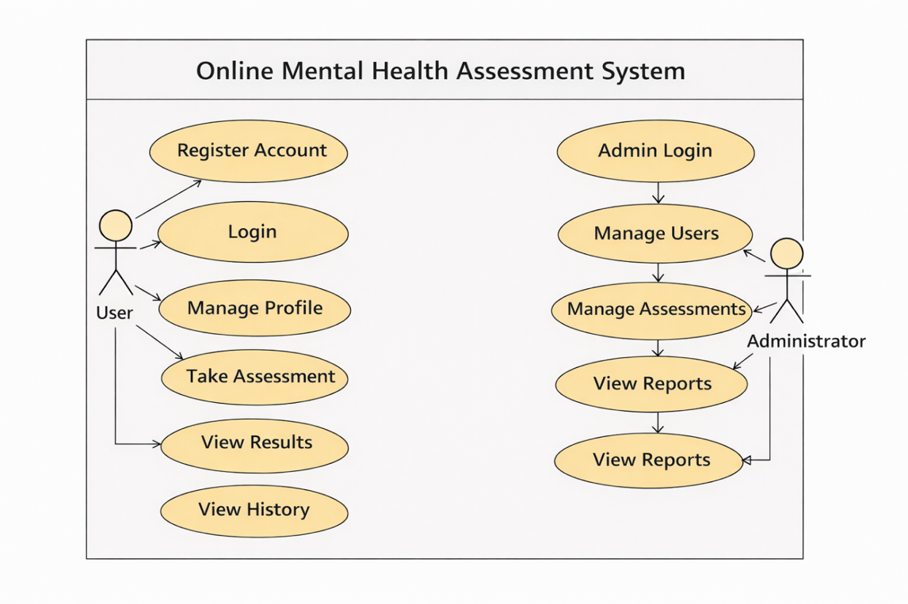
Figure 3.1: Use Case Diagram for the Online Mental Health Assessment System

The diagram features two main actors: User and Administrator. The User actor can perform the following use cases: Register Account, Login, Manage Profile, Take Assessment, View Results, and View Assessment History. The Administrator actor can perform the following use cases: Admin Login, Manage Users, Manage Assessments, and View Reports/System Data.

3.6.2 Activity Diagram
Activity diagrams illustrate the flow of control from one activity to another. They are useful for modeling the dynamic aspects of the system, particularly for complex processes.

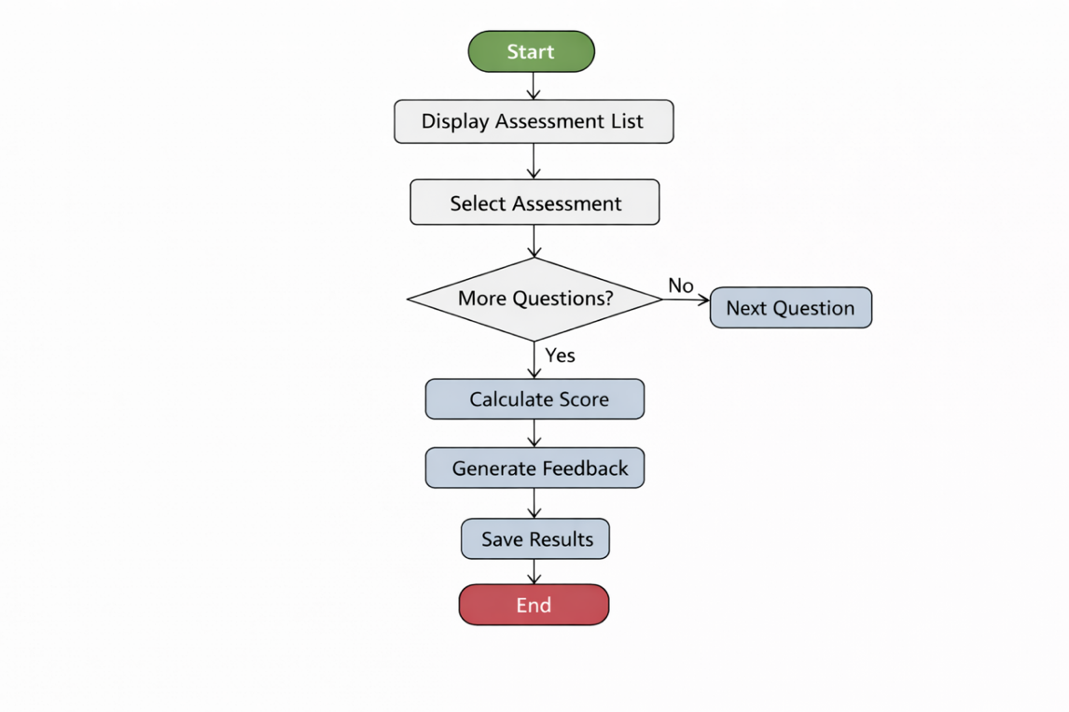
Figure 3.2: Activity Diagram for "Take Assessment" Process

The diagram describes the "Take Assessment" flow starting from the user selecting "Take Assessment", through system display of available assessments, user selection, question display, answer selection, decision node for more questions, score calculation, feedback generation, result saving, and final display to the user.

3.6.3 Sequence Diagram
A sequence diagram shows how objects interact in a given scenario, detailing the sequence of messages exchanged over time.

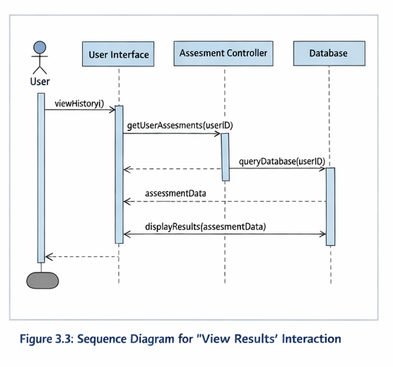
Figure 3.3: Sequence Diagram for "View Results" Interaction

This diagram features vertical lifelines for the User, User Interface (UI), Assessment Controller, and the Database, illustrating the message exchange sequence for viewing assessment results and history.

3.6.4 Class Diagram
The class diagram is the main building block of object-oriented design. It shows the system’s classes, their attributes, methods, and the relationships between them.

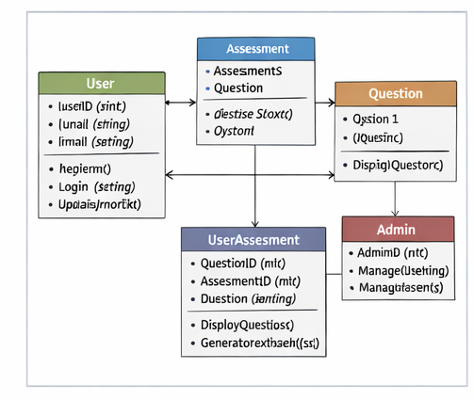
Figure 3.4: Class Diagram for the System

The main classes in the system are: User, Assessment, Question, UserAssessment, and Admin, with defined attributes, methods, and One-to-Many relationships between them.

3.6.5 Deployment Diagram
A deployment diagram shows the physical architecture of the system — the hardware and software nodes and how they are connected.

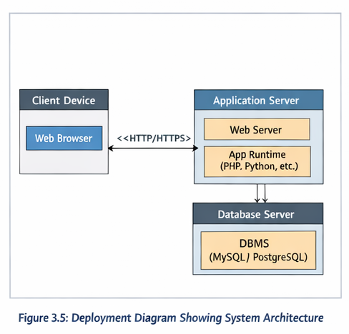
Figure 3.5: Deployment Diagram Showing System Architecture

The diagram shows two main nodes: the Client Device node (Web Browser) and the Application Server node (Web Server, Application Runtime, and Database Management System), connected via HTTP/HTTPS protocol.

3.6.6 Entity Relationship Diagram (ERD)
The Entity Relationship Diagram (ERD) is a data modeling tool that describes the data and the relationships between them within a database. It is similar to the class diagram but focuses purely on data structure for database implementation.

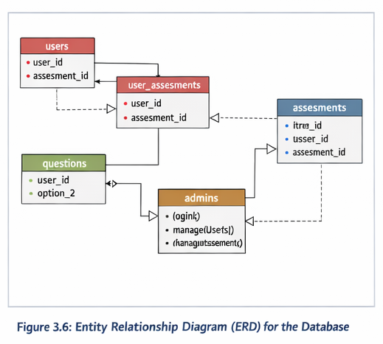
Figure 3.6: Entity Relationship Diagram (ERD) for the Database

The ERD illustrates the five core database tables: users, assessments, questions, user_assessments, and admins, with their respective primary keys, foreign key relationships, and attribute definitions using crow’s foot notation.

3.7 Database Design
Based on the relational diagram above, the database is designed to ensure data integrity, security, and efficient retrieval. The database will be implemented using a relational database management system (RDBMS) such as MySQL or PostgreSQL. The database was normalized to ensure efficient storage and retrieval while minimizing redundancy and promoting data integrity.

The following tables form the complete relational database schema for the Online Mental Health Assessment System.

Table 1: Users Table
Field | Data Type | Key | Description
user_id | INT | PK | Unique identifier – auto-incremented primary key
full_name | VARCHAR(100) |  | Full name of the user
email | VARCHAR(100) | UNIQUE | Login email address – must be unique
password_hash | VARCHAR(255) |  | Hashed password stored securely
created_at | TIMESTAMP |  | Timestamp of account creation

Table 2: Assessments Table
Field | Data Type | Key | Description
assessment_id | INT | PK | Unique assessment identifier
title | VARCHAR(100) |  | Title of the assessment (e.g., PHQ-9)
description | TEXT |  | Description of the assessment purpose

Table 3: Questions Table
Field | Data Type | Key | Description
question_id | INT | PK | Unique question identifier
assessment_id | INT | FK | References assessments.assessment_id
question_text | TEXT |  | The question text presented to the user
option_1 to option_4 | VARCHAR(255) |  | Answer options for the question

Table 4: User Assessments Table
Field | Data Type | Key | Description
user_assessment_id | INT | PK | Unique identifier – auto-incremented
user_id | INT | FK | References users.user_id
assessment_id | INT | FK | References assessments.assessment_id
date_taken | TIMESTAMP |  | Date and time assessment was completed
total_score | INT |  | Calculated total score
risk_level | VARCHAR(50) |  | Risk level: Minimal, Mild, Moderate, Severe
feedback | TEXT |  | Automated feedback message generated by system

Table 5: Admins Table
Field | Data Type | Key | Description
admin_id | INT | PK | Unique admin identifier – auto-incremented
username | VARCHAR(100) | UNIQUE | Unique administrator login username
password_hash | VARCHAR(255) |  | Hashed admin password using secure encryption

3.8 Development Tools and Technologies
The following tools and technologies will be used to implement the designed system:

- Frontend: HTML5, CSS3, JavaScript (with a framework like React or Vue.js for a dynamic user interface).
- Backend: Python with Django or Flask framework, or PHP with Laravel.
- Database: MySQL or PostgreSQL.
- Server: Apache or Nginx.
- Design Tools: Lucidchart or draw.io for creating the UML diagrams.

3.9 Testing Design
Testing was an essential phase in the system development lifecycle of the Online Mental Health Assessment System. To ensure quality assurance, multiple forms of testing were adopted.

3.9.1 Unit Testing
Unit testing involved testing individual modules or components of the system in isolation to confirm that each performs as intended before integration. The following system units were tested independently:

- Login and registration page – input validation, session creation, and role assignment.
- Assessment module – question display, response recording, and score calculation.
- Result and feedback generation – automated scoring and appropriate feedback messaging.
- Assessment history – accurate retrieval and display of past assessments.
- Admin management panel – user management and assessment configuration functionality.

3.9.2 User Acceptance Testing (UAT)
After unit testing, a group of end-users — including university students, healthcare professionals, and system administrators — were invited to test the complete system. Their feedback helped identify usability issues, ensure that all requirements were met, and guided final improvements before deployment.

Testing Type | Scope | Method | Expected Outcome
Unit Testing | Individual modules | Developer tests each component independently | Each module performs correctly
Integration Testing | Modules tested together | Test data passed across interconnected modules | Data flows correctly between components
UAT | Full system by end-users | Users perform real tasks and provide feedback | Usability confirmed; requirements met
Security Testing | Authentication and access control | Attempt to access restricted pages without credentials | Unauthorized access blocked
Performance Testing | Page load and response times | Monitor response times during normal usage load | Pages load within 3–5 seconds

3.10 Chapter Summary
This chapter presented a detailed analysis and design of the proposed Online Mental Health Assessment System. It began by outlining the system requirements — both functional and non-functional — which define what the system must do and how it should perform. The requirements were tailored to address the needs of the two primary user groups: general users seeking mental health assessment and system Administrators.

The chapter introduced UML as the system design modelling language and explained its role in visually representing both the structure and behaviour of the system. Six design diagrams were developed and presented: the Use Case Diagram, Activity Diagram, Sequence Diagram, Class Diagram, Deployment Diagram, and Entity Relationship Diagram.

The database design section presented the complete relational schema for the system. Five database tables were described in full: users, assessments, questions, user_assessments, and admins. Each table was documented with its fields, data types, primary and foreign key constraints, and field-level descriptions. The chapter concluded with the testing design covering Unit Testing, Integration Testing, User Acceptance Testing, Security Testing, and Performance Testing. Together, these design artefacts provide a thorough, well-documented, and implementable technical foundation for the development phase of the Online Mental Health Assessment System.

REFERENCES

All references are formatted in accordance with the American Psychological Association (APA) 7th Edition citation style.

American Psychiatric Association. (2013). Diagnostic and Statistical Manual of Mental Disorders (5th ed.). American Psychiatric Publishing.

Andersson, G., & Titov, N. (2014). Advantages and limitations of Internet-based interventions for common mental disorders. World Psychiatry, 13(1), 4–11.

Barak, A., Hen, L., Boniel-Nissim, M., & Shapira, N. (2008). A comprehensive review and a meta-analysis of the effectiveness of internet-based psychotherapeutic interventions. Journal of Technology in Human Services, 26(2–4), 109–160.

Bennett, G. G., & Glasgow, R. E. (2009). The delivery of public health interventions via the Internet: actualizing their potential. Annual Review of Public Health, 30, 273–292.

Davis, F. D. (1989). Perceived usefulness, perceived ease of use, and user acceptance of information technology. MIS Quarterly, 13(3), 319–340. https://doi.org/10.2307/249008

Hevner, A. R., March, S. T., Park, J., & Ram, S. (2004). Design science in information systems research. MIS Quarterly, 28(1), 75–105.

Joinson, A. N. (2001). Self-disclosure in computer-mediated communication: The role of self-awareness and visual anonymity. European Journal of Social Psychology, 31(2), 177–192.

Kazdin, A. E. (2000). Psychotherapy for children and adolescents: Directions for research and practice. Oxford University Press.

Kroenke, K., Spitzer, R. L., & Williams, J. B. (2001). The PHQ-9: validity of a brief depression severity measure. Journal of General Internal Medicine, 16(9), 606–613.

Naslund, J. A., Aschbrenner, K. A., Araya, R., Marsch, L. A., Unützer, J., Patel, V., & Bartels, S. J. (2017). Digital technology for treating and preventing mental disorders in low-income and middle-income countries: a narrative review. The Lancet Psychiatry, 4(6), 486–500.

Richards, D., & Richardson, T. (2012). Computer-based psychological treatments for depression: a systematic review and meta-analysis. Clinical Psychology Review, 32(4), 329–342.

Spitzer, R. L., Kroenke, K., Williams, J. B., & Löwe, B. (2006). A brief measure for assessing generalized anxiety disorder: the GAD-7. Archives of Internal Medicine, 166(10), 1092–1097.

Torous, J., Jän Myrick, K., Rauseo-Ricupero, N., & Firth, J. (2020). Digital mental health and COVID-19: Using technology today to accelerate the curve on access and quality tomorrow. JMIR Mental Health, 7(3), e18848.

United Republic of Tanzania (URT). (2022). Health Sector Report Tanzania. Ministry of Health.

World Bank. (2020). Digital Development Overview. World Bank Group.

World Health Organization. (2021). Mental Health Atlas 2020. World Health Organization.

World Health Organization. (2022). World Mental Health Report: Transforming mental health for all. World Health Organization.

