ANA 515 Assignment 2

Anita Blege

2022-09-17

The raw survey file is comma delimited and about 2.16mb in size. This is a one-time data set collated through a survey which was administered by two FiveThirtyEight reporters using Survey Monkey. The data contains the responses of 1,615 survey respondents on characteristics of masculinity and what they think it means to be a man. The purpose of this survey was to attempt to measure how men view existing gender norms,patriarchal social systems, gender disparities, and general roles of masculinity in the society.

#Use read.csv from the utils package (which is installed by default) to read in the data and assign it to a dataframe object to be used later.

masculinity_survey <- read.csv('https://github.com/fivethirtyeight/data/blob/master/masculinity-survey/raw-responses.csv?raw=true')

#rename some columns using dplyr to make the df more readable

masculinity_survey<- masculinity_survey%>%   
rename (how_masculine_do_you_feel = q0001, importance_of_being_seen_As_masculine = q0002, unhealthy_societal_pressure = q0005, employment_status = q0009,marital_status = q0024, sexual_orientation = q0026, race = q0028, education_level = q0029)

We have data about 1615 survey responses and 98 columns.

#select certain columns and view their first 5 outputs

masculinity_survey<- masculinity_survey%>%  
   
select (how_masculine_do_you_feel, importance_of_being_seen_As_masculine, unhealthy_societal_pressure, employment_status, marital_status, sexual_orientation, race, education_level)

m1<- masculinity_survey%>% count(how_masculine_do_you_feel, sort = TRUE)  
  
m2<- masculinity_survey%>% count(importance_of_being_seen_As_masculine, sort = TRUE)  
  
m3<- masculinity_survey%>%count(unhealthy_societal_pressure, sort = TRUE)  
  
m4<- masculinity_survey%>%count(employment_status, sort = TRUE)  
  
m5<- masculinity_survey%>%count(marital_status, sort = TRUE)  
  
m6<- masculinity_survey%>%count(sexual_orientation, sort = TRUE)  
  
m7<- masculinity_survey%>%count(race, sort = TRUE)  
  
m8<- masculinity_survey%>%count(education_level, sort = TRUE)

kable(m1, caption = "In General How Masculine or Manly Do You Feel")

In General How Masculine or Manly Do You Feel

| how_masculine_do_you_feel | n |
| --- | --- |
| Somewhat masculine | 826 |
| Very masculine | 612 |
| Not very masculine | 131 |
| Not at all masculine | 32 |
| No answer | 14 |

kable(m2, caption = "Do You Think That Society Puts Pressure On Men A Way That Is Bad Or Unhealthy For Them?")

Do You Think That Society Puts Pressure On Men A Way That Is Bad Or Unhealthy For Them?

| importance_of_being_seen_As_masculine | n |
| --- | --- |
| Somewhat important | 628 |
| Not too important | 541 |
| Not at all important | 240 |
| Very important | 197 |
| No answer | 9 |

kable(m3, caption = "“How Important Is It To You That Others See You As Manly")

“How Important Is It To You That Others See You As Manly

| unhealthy_societal_pressure | n |
| --- | --- |
| Yes | 955 |
| No | 647 |
| No answer | 13 |

kable(m4, caption = "Which Of These Categories Best Describes Your Employment Status")

Which Of These Categories Best Describes Your Employment Status

| employment_status | n |
| --- | --- |
| Employed, working full-time | 737 |
| Not employed-retired | 524 |
| Employed, working part-time | 143 |
| Not employed, NOT looking for work | 110 |
| Not employed, looking for work | 68 |
| Not employed, student | 30 |
| No answer | 3 |

kable(m5, caption = "What Is Your Marital Status")

What Is Your Marital Status

| marital_status | n |
| --- | --- |
| Married | 996 |
| Never married | 286 |
| Divorced | 218 |
| Widowed | 82 |
| Separated | 25 |
| No answer | 8 |

kable(m6, caption = "What Is Your Sexual Orientation")

What Is Your Sexual Orientation

| sexual_orientation | n |
| --- | --- |
| Straight | 1408 |
| Gay | 111 |
| Bisexual | 52 |
| Other | 31 |
| No answer | 13 |

kable(m7, caption = "What Is Your Race")

What Is Your Race

| race | n |
| --- | --- |
| White | 1351 |
| Other | 85 |
| Black | 72 |
| Hispanic | 71 |
| Asian | 36 |

kable(m8, caption = "What Is The Last Grade Of School You Completed")

What Is The Last Grade Of School You Completed

| education_level | n |
| --- | --- |
| College graduate | 515 |
| Post graduate degree | 482 |
| Some college | 292 |
| High school or G.E.D. | 157 |
| Associate’s degree | 148 |
| Did not complete high school | 21 |

Below are charts of the dataset for certain variables of interest:

Masculinity

masculinity_survey %>%  
ggplot(aes(fct_infreq(how_masculine_do_you_feel)%>%fct_rev())) + geom_bar() + coord_flip() + labs(x="Masculinity")

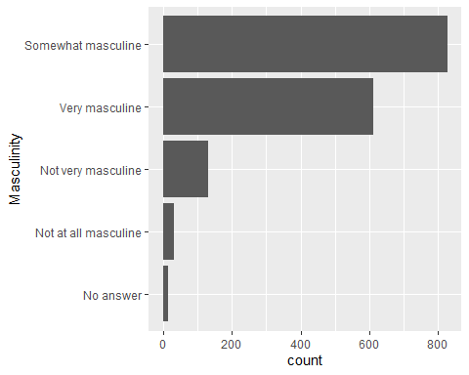

Employment Status

masculinity_survey %>%  
ggplot(aes(fct_infreq(employment_status)%>%fct_rev())) + geom_bar() + coord_flip() + labs(x="Employment Status")

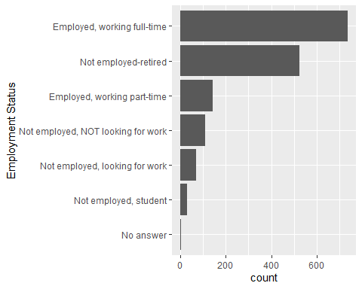

Education Level

masculinity_survey %>%  
ggplot(aes(fct_infreq(employment_status)%>%fct_rev())) + geom_bar() + coord_flip() + labs(x="Education Level")

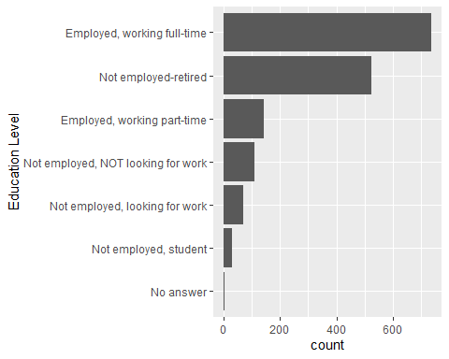

masculinity_survey_sub<- select (masculinity_survey, how_masculine_do_you_feel, unhealthy_societal_pressure, employment_status, marital_status, sexual_orientation, race, education_level)

Summarytable<-data.frame(masculinity_survey)  
sum_table <- summary(Summarytable)  
#creates the summary  
sum_table #prints the summary in your output

## how_masculine_do_you_feel importance_of_being_seen_As_masculine  
## Length:1615 Length:1615   
## Class :character Class :character   
## Mode :character Mode :character   
## unhealthy_societal_pressure employment_status marital_status   
## Length:1615 Length:1615 Length:1615   
## Class :character Class :character Class :character   
## Mode :character Mode :character Mode :character   
## sexual_orientation race education_level   
## Length:1615 Length:1615 Length:1615   
## Class :character Class :character Class :character   
## Mode :character Mode :character Mode :character

#summary(masculinity_survey_sub, title = "SUmmary")  
  
#kable(sum_table, caption = "Summarized Value of Sub DataSet")