ANA515 Assignment 1

Anita Blege

2022-09-02

We have data about 100798 individuals killed by guns. Only 15687 are older than 65. The distribution of the remainder is shown below:

Gun deaths by age

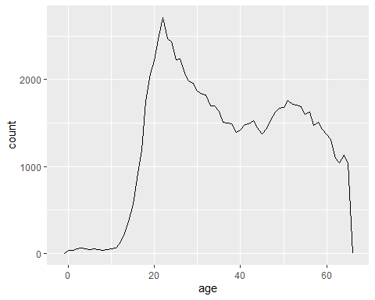

Gun deaths by race

