Anita Blege - Week 5 (Visualizations Activity)

Anita Blege

2022-09-24

masculinity_survey <- read.csv('https://github.com/fivethirtyeight/data/blob/master/masculinity-survey/raw-responses.csv?raw=true')

The visualizations below help us with basic exploration of the masculinity survey data.

#rename some columns using dplyr to make the df more readable

masculinity_survey_sub<- select (masculinity_survey, how_masculine_do_you_feel, unhealthy_societal_pressure, employment_status, marital_status, sexual_orientation, race, education_level)

Masculinity

masculinity_survey %>%  
ggplot(aes(fct_infreq(how_masculine_do_you_feel)%>%fct_rev())) + geom_bar(color = 'green') + coord_flip() + labs(x="Masculinity")

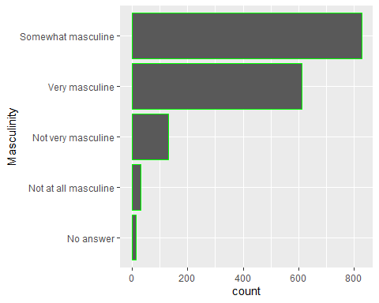

Unhealthy Societal Pressure

masculinity_survey %>%  
ggplot(aes(fct_infreq(unhealthy_societal_pressure)%>%fct_rev())) + geom_bar(color = 'pink') + labs(x="Unhealthy Societal Pressure ")

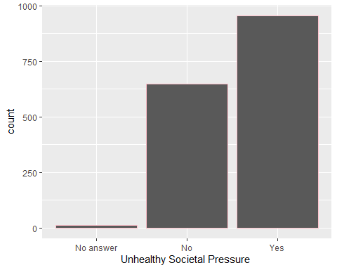

Employment Status

masculinity_survey %>%  
ggplot(aes(fct_infreq(employment_status)%>%fct_rev())) + geom_bar(color = 'blue') + coord_flip() + labs(x="Employment Status")

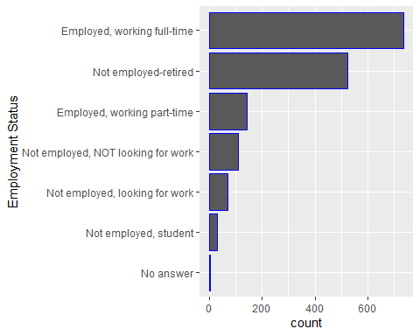

Education Level

masculinity_survey %>%  
ggplot(aes(fct_infreq(education_level)%>%fct_rev())) + geom_bar(color = 'yellow')+ coord_flip() + labs(x="Education Level")

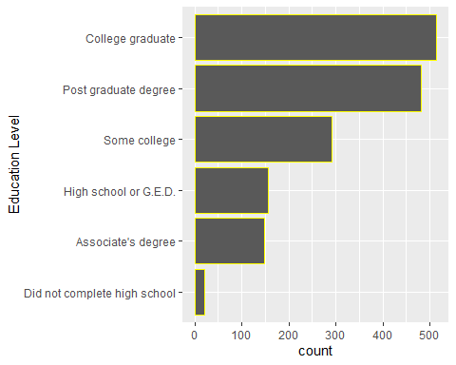

Marital Status

masculinity_survey %>%  
ggplot(aes(fct_infreq(marital_status)%>%fct_rev())) + geom_bar(color = 'red') + labs(x="Marital Status")

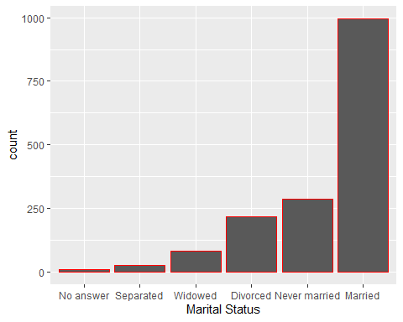

Sexual Orientation

masculinity_survey %>%  
ggplot(aes(fct_infreq(sexual_orientation)%>%fct_rev())) + geom_bar(color = 'brown') + labs(x= "Sexual Orientation")

