CARI-IPTV Operator and Admin Manual
Platform version 1.0.0
Prepared for <OPERATOR>
September 2026
Contents
About this manual 4
1. Overview and architecture 4
1.1 What CARI-IPTV is 4
1.2 Components 5
1.3 How subscribers see it 5
2. Requirements 6
2.1 Servers 6
2.2 Operating system 6
2.3 Network and ports 6
2.4 Domains and TLS 7
2.5 Accounts and keys to have ready 7
3. Installation 7
3.1 Main server: admin panel, player, database 7
3.2 Database and migrations 8
3.3 First sign-in tasks 8
3.4 VOD server 9
3.5 Connect the VOD server to the admin panel 9
3.6 Headend and live sources 10
3.7 HTTPS on the main server 10
3.8 HTTPS on the VOD server 11
3.9 Web player 11
3.10 Go-live checklist 12
4. Configuration 12
4.1 Settings in the admin panel 12
4.2 Files on the main server 14
4.3 VOD server configuration file 15
5. Content 15
5.1 Channels 15
5.2 Categories 18
5.3 EPG (programme guide) 18
5.4 Movies 20
5.5 Uploading and packaging VOD 22
5.6 TV Shows 24
5.7 Packages, content groups and entitlements 25
5.8 Advertising 27
5.9 Layouts and server-driven UI 29
6. Subscribers 33
6.1 How a subscriber registers 33
6.2 Verification problems 33
6.3 Sign-in 34
6.4 Password reset (support procedure) 34
6.5 Device limits 34
6.6 Managing a subscriber 34
6.7 Parental controls and adult content 35
6.8 Cancelling and deleting accounts 35
6.9 Subscriber self-service in the player 35
6.10 Support quick reference 36
7. Mobile app 36
7.1 What subscribers use on a phone 36
7.2 Branding per brand 37
7.3 Layout for phones 37
7.4 Native apps, signing and store submission 37
8. Operations 37
8.1 Updating the main server 37
8.2 Updating the VOD server 38
8.3 Backups 38
8.4 Logs 38
8.5 Monitoring 38
8.6 Common faults 38
8.7 Scheduled jobs 39
9. Security notes 39
9.1 What is protected 39
9.2 What is not protected, and what to do about it 39
9.3 Recommended hardening 40
Appendix A. API reference summary 40
Appendix B. Configuration reference 41
B.1 Admin settings keys 41
B.2 .env on the main server 42
B.3 vod-server.conf sections 42
B.4 Installer options 42
Appendix C. Glossary 42
Appendix D. Where the documentation and the code disagree 43
Appendix E. Current limitations at a glance 43

About this manual
This manual is for the operator who installs and runs CARI-IPTV under their own brand, and for the admin staff who manage channels, programme guides, movies, packages and subscribers day to day.
It is written from the platform as it exists in the code today. Where a feature looks available on screen but does not work as you would expect, this manual says so. Those points are collected in Appendix E.
Placeholders used throughout:
Placeholder | Meaning
<OPERATOR> | Your company or brand name
<ADMIN_DOMAIN> | The domain name of the main server, for example tv.example.com. The admin panel, the subscriber web player and the API all live on this domain
<VOD_DOMAIN> | The domain name of the VOD server, for example vod.example.com
<SERVER_IP> | The IP address of a server before a domain is set up
<BRANCH> | The Git branch of the install scripts you were told to use. The scripts are pinned to a specific branch; ask your supplier which one
<ADMIN_PASSWORD>, <DB_PASSWORD>, <VOD_API_KEY> | Secrets generated at install time. Never write them in this document
Screens in this manual were captured from the admin panel and the web player of this version. Your colours and logo will differ once you brand the platform.

1. Overview and architecture

1.1 What CARI-IPTV is
CARI-IPTV is a television middleware platform. It gives you:
- An admin panel where staff manage live channels, programme guides (EPG), movies, TV shows, subscription packages, subscribers, advertising and the look of the app.
- A web player that subscribers open in a browser on a computer, phone, tablet or smart TV to watch live TV and on-demand video.
- A VOD server that takes your video files and converts them into streaming formats that play smoothly on any device.
- Scheduled jobs that keep the programme guide fresh and build personalised recommendations.
CARI-IPTV does not receive, encode or relay live television. Live channels are supplied by your headend or a stream provider as stream URLs, and the platform simply points subscribers at them.

1.2 Components
Subscribers (browser on PC, phone, tablet, smart TV)
|
v
+-----------------------------------------------------------------------+
| Main server <ADMIN_DOMAIN> |
| /admin Admin panel (staff) |
| / Web player (subscribers) |
| /api/v1 API used by the player |
| MySQL database |
| Scheduled jobs: EPG fetch every 5 min, recommendations nightly |
+------+----------------------+-----------------------+----------------+
| | |
v v v
VOD server <VOD_DOMAIN> Live stream URLs Internet services
(transcodes and serves from your headend TMDB, Fanart.tv, YouTube,
movies and episodes) or provider OpenSubtitles, IPTV-org,
optional OpenAI/Anthropic,
your SMTP mail server
Component | Role | Who uses it
Admin panel | Everything staff do: content, packages, subscribers, settings | Operator staff
Web player | Watching TV and video, managing own account | Subscribers
VOD server | Converts uploaded video into adaptive streams (HLS/DASH). Has its own small web page for technical settings | Content staff, technical staff
Database (MySQL 8) | Stores all data. Installed on the main server automatically | Nobody directly
EPG fetch job | Downloads programme guides on a schedule | Runs automatically
Recommendation job | Builds “Recommended for you” rows overnight | Runs automatically
Local AI (Ollama) | Optional. Writes channel descriptions and ad text, produces analytics reports. Installed automatically; can be replaced by OpenAI or Anthropic | Staff, through the admin panel

1.3 How subscribers see it
A subscriber goes to https://<ADMIN_DOMAIN>/, signs in, and sees a home screen you design in App Layout. From there they browse Movies, TV Shows, Live TV with a programme guide, Search and My List, and manage their account on the Profile page.

2. Requirements

2.1 Servers
You need at least two machines, or two virtual machines:
Server | Purpose | Notes
Main server | Admin panel, web player, API, database, scheduled jobs | The installer also downloads about 9 GB of local AI models. Allow for that disk space, or plan to use a cloud AI provider and remove the models
VOD server | Video transcoding and streaming | Transcoding is CPU heavy. More cores mean faster processing. Storage must hold your whole video library. A fast disk for the temporary folder helps
You can run both on one machine for testing. For production keep them separate so transcoding does not slow the admin panel and player.

2.2 Operating system
The install scripts support Ubuntu, Debian, CentOS, RHEL, Rocky Linux and AlmaLinux (install.sh, vod-server/scripts/install.sh). Ubuntu 22.04 or 24.04 is the simplest choice because the optional TSDuck package used for satellite EPG capture is available for those versions.
The database must be MySQL 8. MariaDB is not supported: the admin login uses MySQL-only syntax and fails on MariaDB. The installer installs MySQL 8 for you.

2.3 Network and ports
Port | Server | Used for | Open to
80 | Main | Admin, player and API over HTTP. Also needed for the Let’s Encrypt certificate check | Internet
443 | Main | HTTPS, once you install a certificate (section 3.7) | Internet
8090 | VOD | VOD server API and streaming. Also its own web page | Main server and subscribers. See section 9 for why you should put it behind HTTPS
80 / 443 | VOD | Only if you enable HTTPS on the VOD server itself | Internet
3306 | Main | MySQL | Nobody. Local only
11434 | Main | Local AI (Ollama) | Nobody. Local only
The installer does not configure a firewall. Open and close ports yourself using your hosting provider’s firewall or ufw.
Both servers need outbound internet access during installation, and the main server needs it during normal use to reach TMDB, Fanart.tv, YouTube, OpenSubtitles, IPTV-org and the two content delivery networks the player loads its video engine and fonts from.

2.4 Domains and TLS
- Choose a domain for the main server, <ADMIN_DOMAIN>. Staff and subscribers both use it.
- Choose a domain for the VOD server, <VOD_DOMAIN>.
- Point both domains at the servers before you install, so certificates can be issued straight after.
- The main installer sets up HTTP only. You add HTTPS yourself in section 3.7. Do not open the service to the public without HTTPS: passwords and session tokens would travel in clear text.

2.5 Accounts and keys to have ready
Item | Why
An SMTP mail account (host, port, username, password) | Subscribers cannot complete sign-up without verification emails. Admin password reset emails also need it
TMDB API key | Movie and TV show metadata, artwork, cast. Free at themoviedb.org
Fanart.tv API key | Channel logos and high quality artwork. Free
YouTube Data API key | Trailer search and free-content import. Free with a daily quota
OpenSubtitles API key plus username and password | Subtitle search and download. Free tier is limited to 20 downloads per day
Optional: OpenAI or Anthropic API key | Only if you prefer cloud AI over the local model

3. Installation
Install in this order. Each step ends with a check. Do not move on until the check passes.

3.1 Main server: admin panel, player, database
All of this is done by one script, install.sh. It installs Nginx, PHP 8.2, MySQL 8, the local AI runtime, the optional TSDuck tool, creates the database, loads the schema and all migrations, creates the first admin account, and installs the scheduled jobs.
- Log in to the main server as a user with sudo rights.
- Run the installer. Replace <BRANCH> with the branch you were given.
- curl -sSL "https://raw.githubusercontent.com/caritechsolutions/cari-iptv/<BRANCH>/install.sh?$(date +%s)" | sudo bash
- The script asks no questions. It generates a database password and an admin password for you.
- To choose your own passwords and admin email instead, pass options after -- (from the usage text in install.sh):
- curl -sSL "https://raw.githubusercontent.com/caritechsolutions/cari-iptv/<BRANCH>/install.sh?$(date +%s)" | sudo bash -s -- --admin-pass=<ADMIN_PASSWORD> --admin-email=admin@<ADMIN_DOMAIN>
- Other options: --db-pass=, --install-dir= (default /var/www/cari-iptv), --port= (default 80).
- Wait. The AI model download is the slow part and can take a long time on a slow connection. It is not fatal if it fails.
- At the end the script prints the admin URL, the username admin and the admin password. It also saves them to /var/www/cari-iptv/INSTALL_CREDENTIALS.txt.
Check: open http://<SERVER_IP>/admin/login in a browser. You should see the login page. Sign in as admin with the printed password. The Dashboard appears.
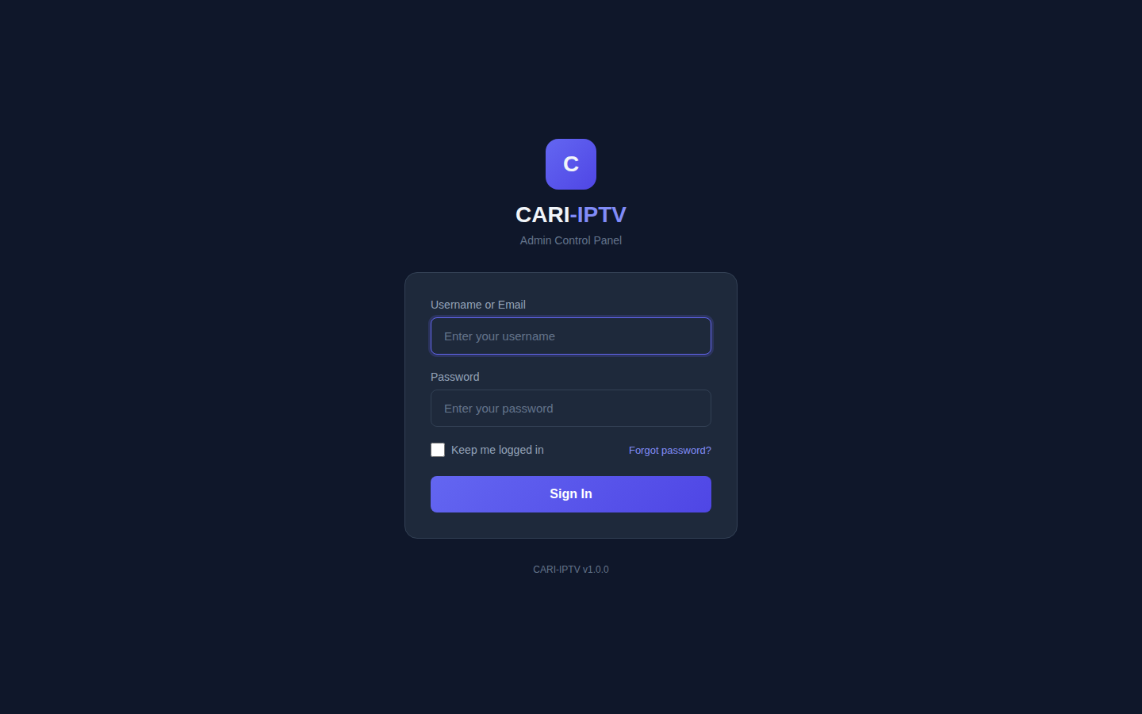
Admin login page

3.2 Database and migrations
The installer creates the database and runs every migration, so there is nothing to do on a fresh install. Later updates run any new migrations automatically (update.sh). Applied migrations are recorded in a _migrations table so they never run twice.
Check: in the admin panel, open Channels. The page loads and shows the demo channels the installer created. If the database was not set up you would see an error page instead.

3.3 First sign-in tasks
Do these before anything else.
- Open the user menu (top right) and choose My Profile. Change the admin password.
- Delete the credentials file on the server:
- sudo rm /var/www/cari-iptv/INSTALL_CREDENTIALS.txt
- Go to Settings > General. Set Site Name to your brand and Site URL to https://<ADMIN_DOMAIN>. Save. Site URL is used inside verification emails and in stream links, so set it before subscribers sign up.
- Go to Settings > Email and fill in your SMTP details. Tick Enable SMTP. Save. Use Send Test Email and confirm it arrives.
- Remove the demo data: the installer adds demo channels, four demo packages named Basic, Standard, Premium and Annual Premium, and a demo movie. Delete the ones you do not want from Channels, Packages and Movies.
Check: the test email arrives, and the sidebar shows your Site Name.

3.4 VOD server
The VOD server has its own installer, vod-server/scripts/install.sh. It builds FFmpeg from source, so allow 20 to 60 minutes depending on the CPU.
- Log in to the VOD server with sudo rights.
- Run:
- curl -sSL "https://raw.githubusercontent.com/caritechsolutions/cari-iptv/<BRANCH>/vod-server/scripts/install.sh?$(date +%s)" | sudo bash
- Near the end the script prints a box headed SAVE YOUR API KEY. Copy the key somewhere safe. This is <VOD_API_KEY>. If you lose it, read it back from the config file:
- sudo grep api_key /etc/vod-server/vod-server.conf
- The script also prints the address of the VOD server’s own web page: http://<SERVER_IP>:8090.
Check: run this on the VOD server. It must answer with JSON that includes "status":
curl http://localhost:8090/api/status
Then open http://<SERVER_IP>:8090 in a browser and confirm the VOD server dashboard loads.

3.5 Connect the VOD server to the admin panel
- In the admin panel go to Settings > Integrations.
- In the VOD Servers card click Add Server.
- Fill in:
  - Server Name: for example VOD 1.
  - Server URL: http://<SERVER_IP>:8090 (the address the main server uses to reach it, usually a private address).
  - API Key: <VOD_API_KEY>.
  - Tick Default server and Active.
- Click Test Connection. You should see the server version, uptime and content count.
- Click Save Server.
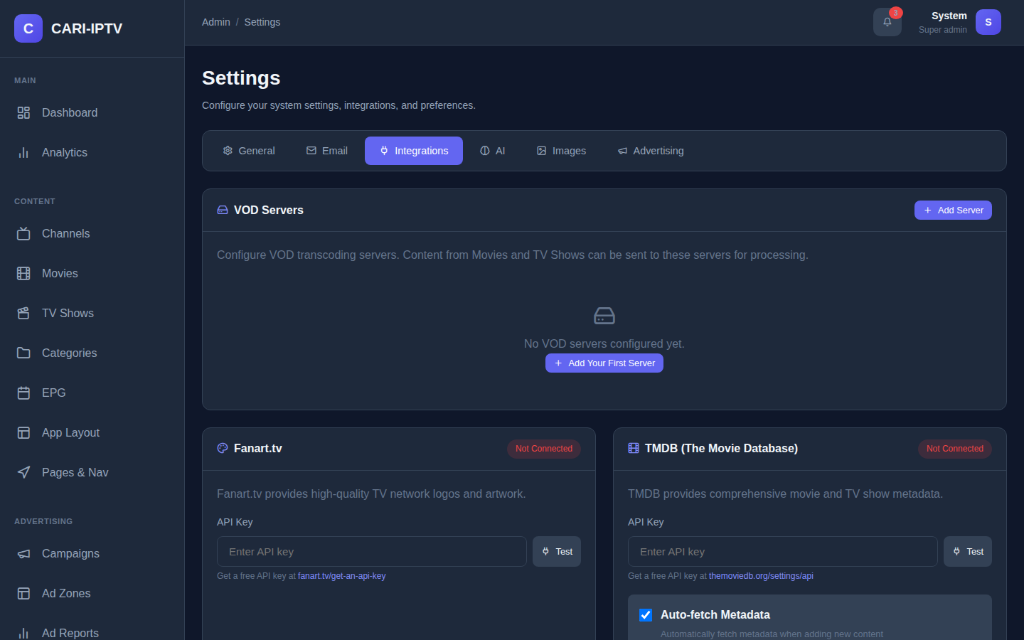
Settings, Integrations tab with the VOD Servers card
Important: the stream links given to subscribers are built from the Server URL, because the Public URL field is not available on this screen in this version (see Appendix E). Therefore the Server URL you enter here must be one that subscribers’ browsers can also reach, for example https://<VOD_DOMAIN> once HTTPS is set up on the VOD server (section 3.8). If you enter a private address, movies will play for staff on the office network and fail for everyone else.
Check: Test Connection reports success and the card shows a green dot next to the server.

3.6 Headend and live sources
Live channels are external in this version. Your headend, encoder or stream provider gives you one HLS URL per channel (ending in .m3u8). You enter those URLs when you add channels (section 5.1). There is nothing to install for live TV on these servers.
Check: open one of your stream URLs in VLC or a browser that supports HLS. If it does not play there, it will not play in CARI-IPTV either.

3.7 HTTPS on the main server
The installer configures HTTP only. Add a certificate with Certbot, a standard tool that is not part of this repository.
- Make sure <ADMIN_DOMAIN> already points at the main server.
- Install Certbot and request a certificate. On Ubuntu:
- sudo apt install certbot python3-certbot-nginx
sudo certbot --nginx -d <ADMIN_DOMAIN>
- Choose the option to redirect HTTP to HTTPS when asked.
Check: open https://<ADMIN_DOMAIN>/admin/login. The browser shows a padlock and the login page.

3.8 HTTPS on the VOD server
The VOD installer includes Certbot and prints the procedure at the end of the install. In short (from vod-server/scripts/install.sh):
- Edit /etc/vod-server/vod-server.conf. Under [ssl] set enabled = true. Under [acme] set enabled = true and domain = <VOD_DOMAIN>.
- Restart: sudo systemctl restart vod-server.
- Request the certificate:
- sudo certbot certonly --webroot -w /var/lib/vod-server/acme -d <VOD_DOMAIN>
- Copy the certificate files into place and fix ownership:
- sudo cp /etc/letsencrypt/live/<VOD_DOMAIN>/fullchain.pem /etc/vod-server/ssl/cert.pem
sudo cp /etc/letsencrypt/live/<VOD_DOMAIN>/privkey.pem /etc/vod-server/ssl/key.pem
sudo chown vod-server:vod-server /etc/vod-server/ssl/*.pem
sudo systemctl restart vod-server
- Renewals are automatic. The installer added a renewal hook that copies new certificates and reloads the service.
- Back in the admin panel, edit the VOD server and change its Server URL to https://<VOD_DOMAIN>.
Check: https://<VOD_DOMAIN>/api/status answers in a browser with a padlock.

3.9 Web player
The web player is part of the main server. There is nothing separate to install.
Check: open https://<ADMIN_DOMAIN>/. You are redirected to the subscriber login page.
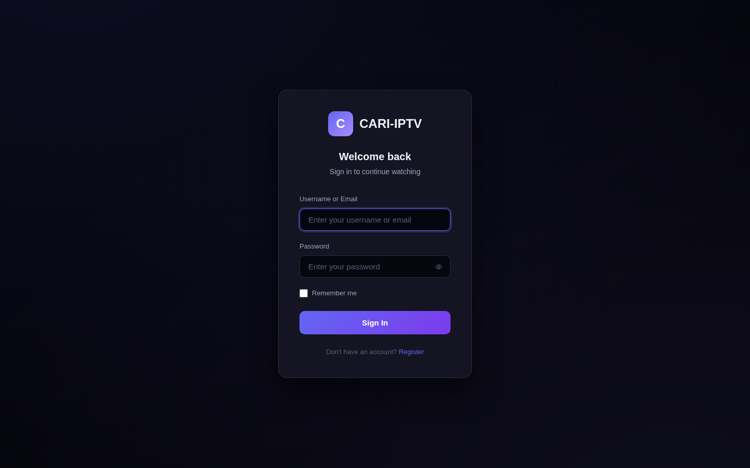
Subscriber login page

3.10 Go-live checklist
- Admin password changed and credentials file deleted.
- Site Name and Site URL set.
- SMTP working (test email received).
- TMDB, Fanart.tv, YouTube and OpenSubtitles keys entered and tested in Settings > Integrations.
- HTTPS on both servers.
- Demo channels, packages and movie removed.
- At least one package created and linked to content groups (section 5.7). Until a package exists, every item in the player shows a padlock.
- A published layout for the Web platform (section 5.9).
- Firewall closed except ports 80 and 443 on the main server and 443 (or 8090) on the VOD server.

4. Configuration

4.1 Settings in the admin panel
Open Settings from the user menu (top right). There are six tabs.

General
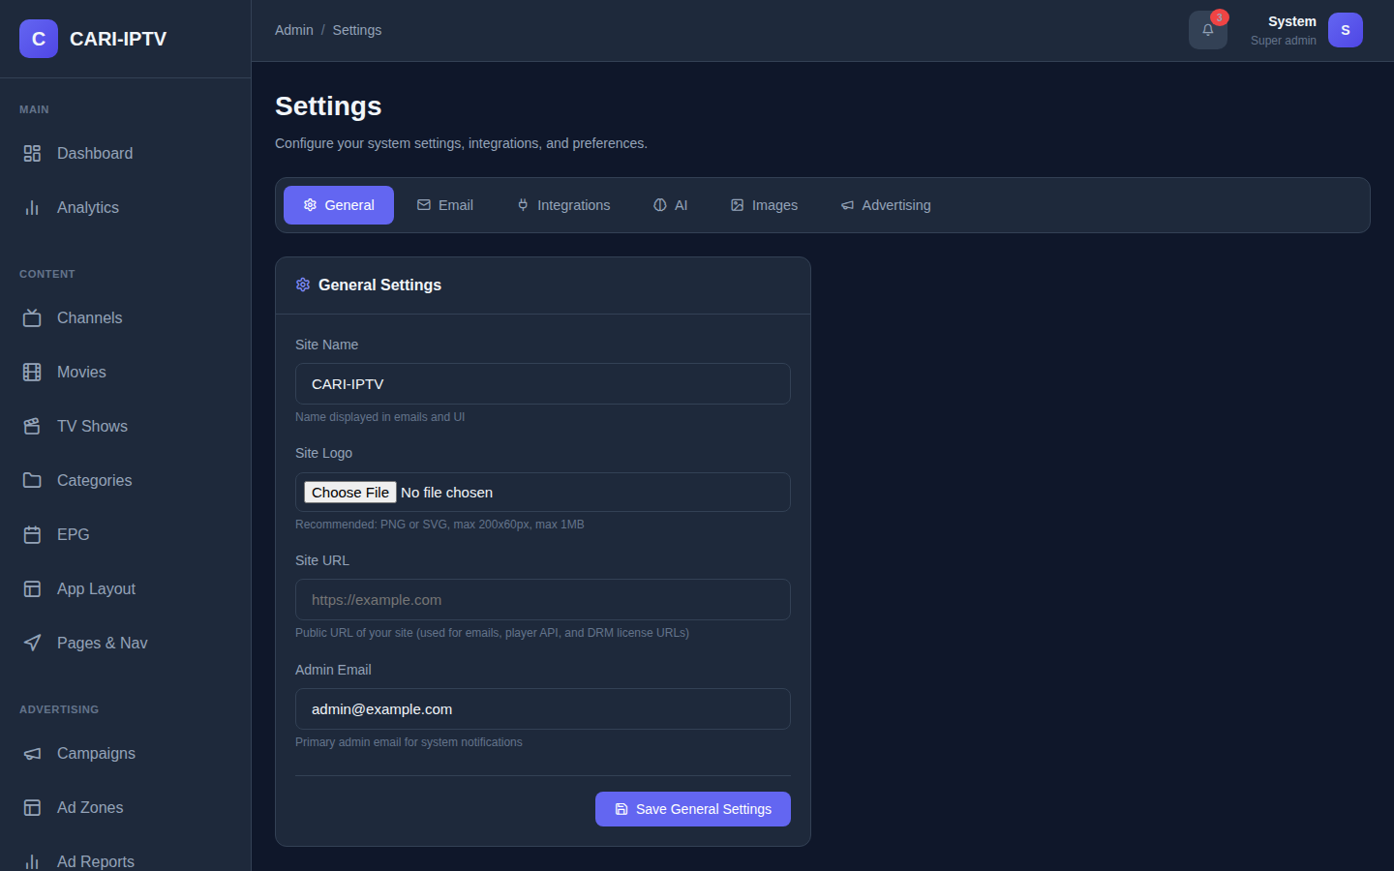
Settings, General tab
Setting | Default | What it does | Recommended
Site Name | CARI-IPTV | Brand name in the player sidebar, browser tab and emails | Your brand
Site Logo | none | Image in the player and admin sidebar. PNG, SVG, JPEG, GIF or WebP up to 1 MB, about 200 by 60 pixels. Until set, a square tile with the first letter of the Site Name is shown | Your logo, light on dark
Site URL | empty | Used in verification email links, player links and DRM licence links | https://<ADMIN_DOMAIN>
Admin Email | admin@example.com | Address for system notifications | A monitored mailbox
These are the only branding controls. Colours are fixed in this version.

Email
Setting | Default | Notes
Enable SMTP | off | Must be on for any email to be sent
SMTP Host, Port, Encryption | empty, 587, TLS | From your mail provider. TLS on 587 is the usual choice
Username, Password | empty | Mail account credentials. The password field shows blank after saving; leave it blank to keep it
From Email, From Name | empty, CARI-IPTV | What subscribers see as the sender
Use the Test Email card after saving. If SMTP is not enabled and configured, registration appears to work but no verification email is ever sent, and the new subscriber can never sign in.

Integrations
- VOD Servers: see section 3.5.
- Fanart.tv and TMDB: paste each API key and click Test. Both are saved by the single Save Metadata Settings button under the TMDB card. Leave Auto-fetch Metadata ticked.
- YouTube Data API: key plus Save YouTube Settings. The free quota allows roughly 100 searches per day.
- OpenSubtitles: API key, username and password, preferred languages as comma-separated two-letter codes (for example en,es,fr), and Auto-fetch Subtitles to search automatically when importing from TMDB. The username and password are required for downloads.

AI
Setting | Default | Notes
Enable AI Features | off | Turns on AI buttons across the panel
AI Provider | Ollama (Local) | Local is free and private. OpenAI and Anthropic need an API key and send text to their cloud
Ollama Server URL and Model | http://localhost:11434, llama3.2:1b | Click the refresh icon to list installed models. Larger models give better text but need more memory
OpenAI / Anthropic key and model | empty | Only for cloud providers
Click Test AI Connection before saving.

Images
Keep Auto-optimize Images on and WebP Quality at 85. This converts every uploaded logo and poster to a small WebP file, which makes the player load faster.

Advertising
Controls when overlay ads appear during playback. Defaults: first banner after 30 seconds, shown for 15 seconds, repeated every 300 seconds; first text scroller after 15 seconds, repeated every 300 seconds. Set a repeat interval to 0 to show an ad only once per playback. Untick the enable boxes to switch overlays off entirely.

4.2 Files on the main server
You rarely need to touch these.
File | Purpose
/var/www/cari-iptv/.env | Database connection, APP_URL, APP_DEBUG. Written by the installer. Keep APP_DEBUG=false in production so error details are not shown to visitors
/etc/cron.d/cari-iptv | The scheduled jobs. Rewritten by every update, so do not edit it
/etc/nginx/sites-available/cari-iptv | Web server configuration
/var/www/cari-iptv/storage/logs/ | Application logs (section 8.3)

4.3 VOD server configuration file
/etc/vod-server/vod-server.conf on the VOD server. Restart the service after any change: sudo systemctl restart vod-server. The settings you are most likely to change:
Section and key | Default | Meaning
[server] port | 8090 | Port for the API, streaming and the web page
[server] api_key | generated at install | The key the admin panel uses. Treat as a password
[storage] library_path | /var/lib/vod-server/library | Where finished videos live. Put your large disk here
[storage] temp_path | /var/lib/vod-server/tmp | Working space during transcoding. Fast disk recommended
[storage] min_free_space_gb | 10 | Refuse new jobs below this much free space
[transcoding] max_concurrent_jobs | 2 | How many videos convert at once. Roughly half your CPU cores
[transcoding] default_profile | standard | Default quality ladder
[transcoding] hwaccel | none | nvenc for NVIDIA cards, vaapi or qsv for Intel. Read section 5.5.3 before enabling
[ssl], [acme] | off | HTTPS, see section 3.8
[drm] enabled | false | Encrypts stored video. See section 9 before relying on it
If you move the library to another disk, the service also needs permission to write there. The installer explains this at the end of the install: add a ReadWritePaths= line for the new path to /etc/systemd/system/vod-server.service and run sudo systemctl daemon-reload.
Transcode profiles (quality ladders) are edited on the VOD server’s own web page under Profiles, not in the admin panel.

5. Content

5.1 Channels
Channels in the sidebar lists your live TV channels.
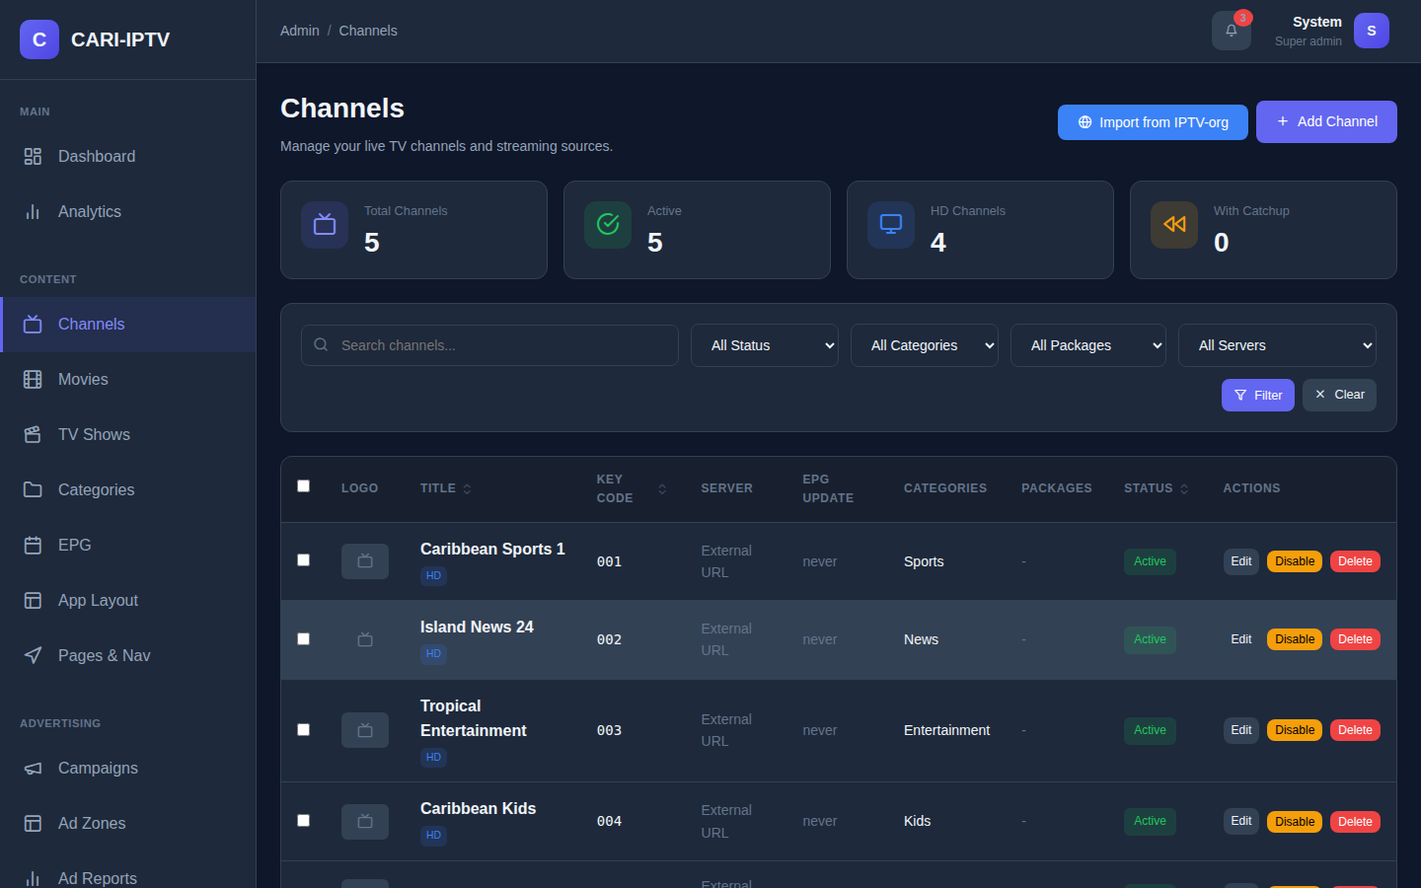
Channels list

Add a channel
- Click Add Channel.
- On the Metadata tab enter the Title. Everything else is optional.
- In Stream Settings paste the Stream URL from your headend. HLS links ending in .m3u8 are the format the player is built for. Tick HD or 4K if you want the badge shown.
- Optionally set a Channel Number and Sort Order. The player orders channels by Sort Order, then by name.
- Under Categories tick one or more live categories and choose the Primary Category.
- Add a Logo: upload a square image (about 400 by 400), or click Search Logos to find one on Fanart.tv and click Apply to Logo. A Landscape Logo (500 by 296) is optional.
- Make sure Active is ticked. Click Create Channel.
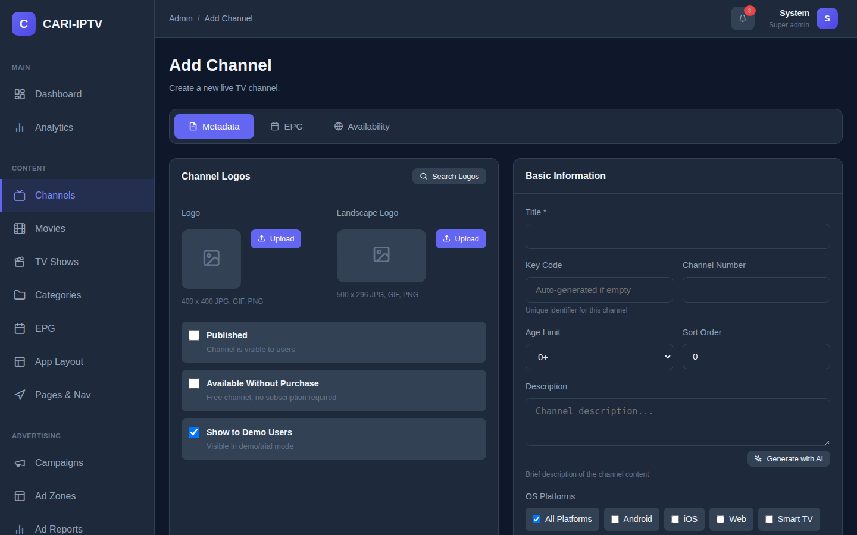
Add Channel form
The Key Code is filled in automatically if you leave it blank. It is a short unique number staff can use to find the channel.

Which settings actually affect subscribers
Only two things on this form change what subscribers see:
- Active (in Stream Settings). An inactive channel disappears from the player immediately. Use the Disable button in the list, or the bulk Deactivate action, to take a channel off air quickly.
- Categories, which drive the Categories page and category rows in layouts.
The following are recorded but not used by the player in this version, so treat them as notes for staff: Published, Available Without Purchase, Show to Demo Users, Age Limit, OS Platforms, Backup Stream URL, Streaming Server, Content Owner, Catchup, and the Include in Packages checkboxes. To control who can watch a channel, use Content Groups (section 5.7), not the Packages box on this form.

Import channels from IPTV-org
IPTV-org is a public directory of free-to-air streams. It is the only bulk import in this version; there is no M3U playlist import.
- On the Channels list click Import from IPTV-org.
- Pick a Country and optionally a category, or use the quick buttons for Caribbean countries, then Search.
- Use Preview to test a stream.
- Tick the channels you want and click Import.
Imported channels arrive Active, with logo, country and language filled in. Channels whose name or stream URL already exists are skipped. The importer matches IPTV-org category names to your live categories by name; unmatched ones are left without a category.

Edit, disable, delete
- Edit opens the same form. The EPG tab on an existing channel shows which guide sources it is mapped to and the next programmes. Mapping itself is done on the EPG page (section 5.3).
- Tick several rows to use the bulk bar: Activate, Deactivate, Delete.
- Deleting a channel is immediate and cannot be undone.

5.2 Categories
Categories are the genres subscribers browse by. Each category has a type: Live TV, Movies or TV Shows. A channel can only use live categories, a movie only movie categories, and so on.
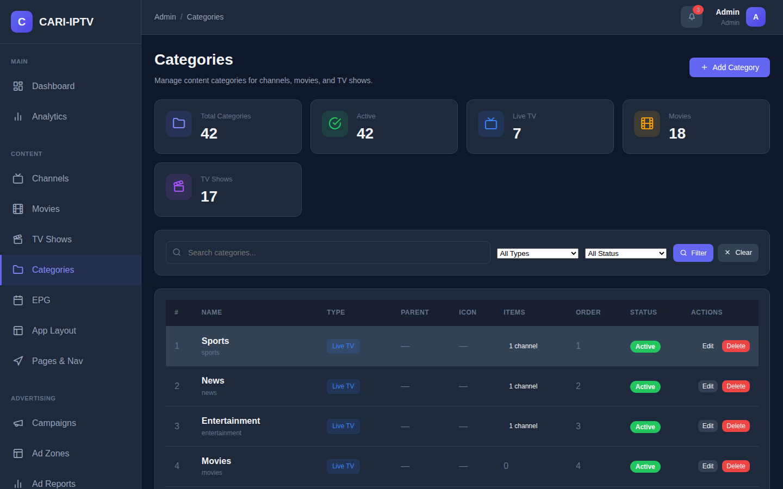
Categories page
- Click Add Category.
- Enter a Name and choose the Type. The type cannot be changed later; delete and recreate instead.
- Optionally pick a Parent Category (one level of nesting) and an Icon Class such as lucide-film.
- Save.
Drag rows to reorder. A category cannot be deleted while any channel, movie or show uses it, or while it has sub-categories.
When you import a movie or show from TMDB, its genres are created as categories automatically if they do not exist yet.

5.3 EPG (programme guide)
EPG in the sidebar manages guide sources and links guide channels to your channels.
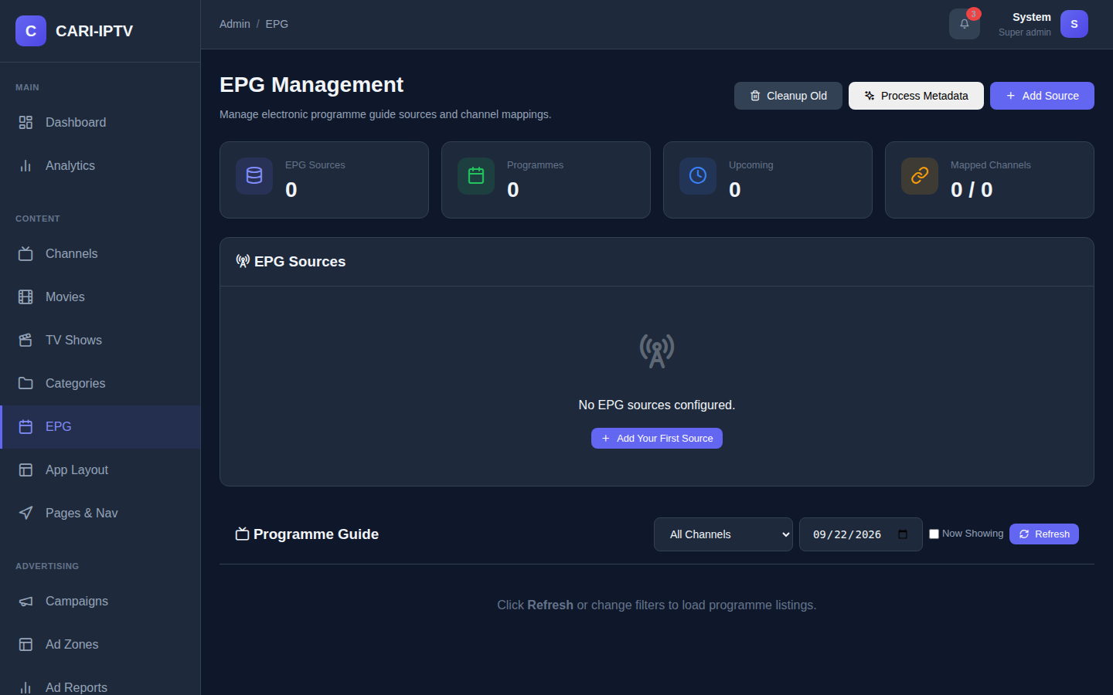
EPG Management page

Source types
Type | What you enter | When to use
XMLTV URL | A web address of an XMLTV file (.xml or .xml.gz) | Your EPG provider gives you a link. Refreshes automatically
XMLTV File Upload | Nothing at first; you upload the file afterwards with the Upload button | You receive files by email or download. Must be uploaded by hand each time
EIT / DVB (MPTS Stream) | Multicast address, port, EIT PID (usually 0x12) and a capture timeout | Your headend carries the guide inside the satellite transport stream. Requires the TSDuck tool, which the installer tries to add

Add a source
- Click Add Source.
- Enter a Name and choose the Type, then the fields for that type.
- Tick Active. Tick Auto Refresh and choose a Refresh Interval (every hour is a sensible default).
- Set Source Timezone to the timezone the guide times are written in. Leave at UTC for DVB sources. For XMLTV, times that already carry an offset are converted correctly whatever you choose here.
- Save.

Map channels
Guide data is only stored for channels that are mapped. A new source imports nothing until you map it.
- On the source row click Channel mappings.
- Click Auto-Map. It matches guide channels to your channels by name.
- Review the list. Auto-map uses a partial name match as a fallback, so similar names such as “Sports 1” and “Sports 10” can be mismatched. Correct any wrong rows with the Map To Channel dropdown, and map the ones it missed.
- Close the dialog and click Fetch now on the source.
Check: the Programmes count on the source row is no longer zero, and the Programme Guide panel at the bottom of the page lists programmes for a mapped channel.

How refreshing works
A job runs every five minutes and fetches any URL or DVB source whose refresh interval has passed (/etc/cron.d/cari-iptv, installed by install.sh). File-upload sources are never refreshed automatically. Old programmes are deleted every night at 02:00.
Note that re-fetching an XMLTV source replaces all of that source’s programmes, including past ones. DVB sources keep the past seven days.

Programme artwork (TMDB metadata)
After each import, programme titles are looked up on TMDB so the player can show posters, synopses and cast for what is on. This needs the TMDB key from Settings. The Programme Metadata card shows how many titles are pending, enriched or not found. Click Process Metadata to run the lookup by hand.

5.4 Movies
Movies in the sidebar is your on-demand film library.
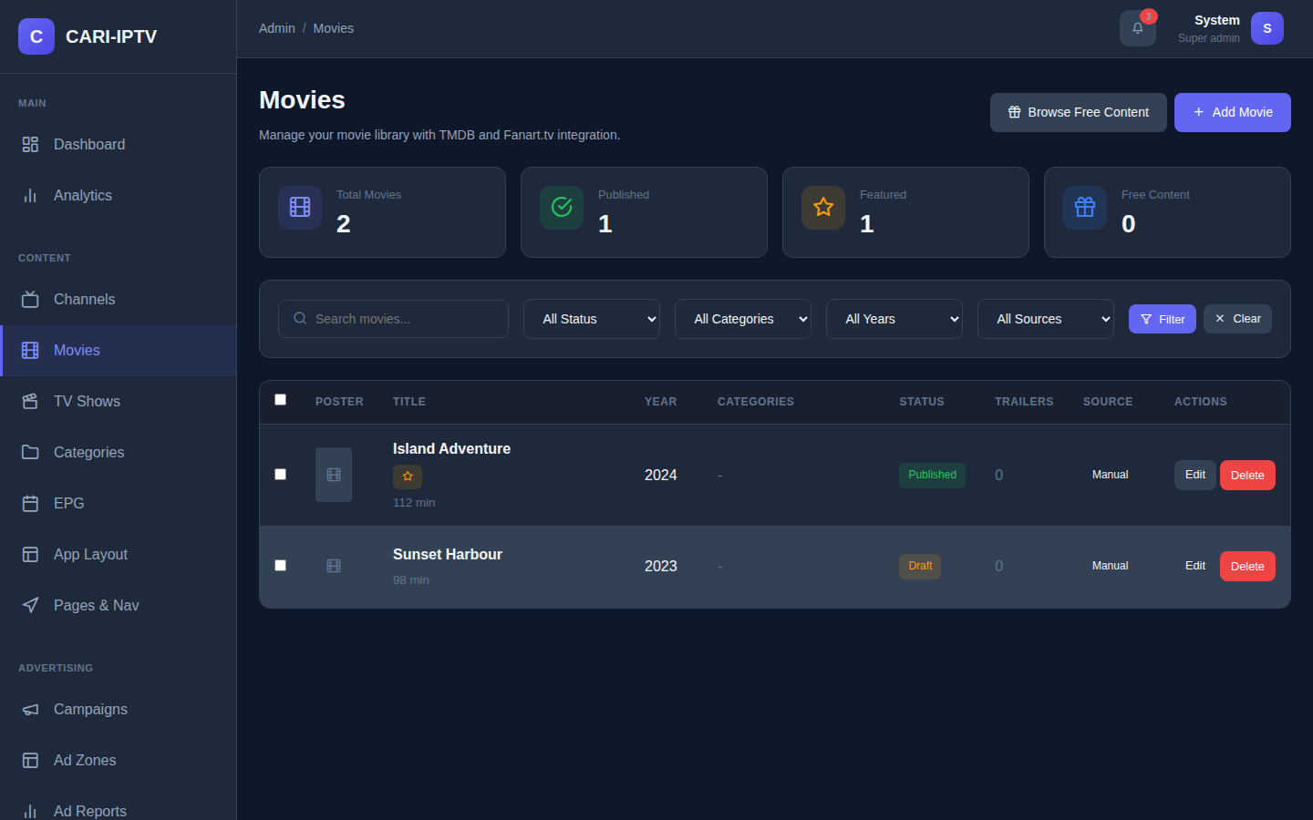
Movies list

Add a movie from TMDB (recommended)
- Click Add Movie.
- In Search TMDB type the title and click Search.
- Click the correct result. The form fills with title, year, synopsis, runtime, director, genres, poster and backdrop. Cast, trailers and genre categories are imported too.
- Set Status to Published if you want it visible now, or leave it as Draft while you add the video.
- Click Create Movie.
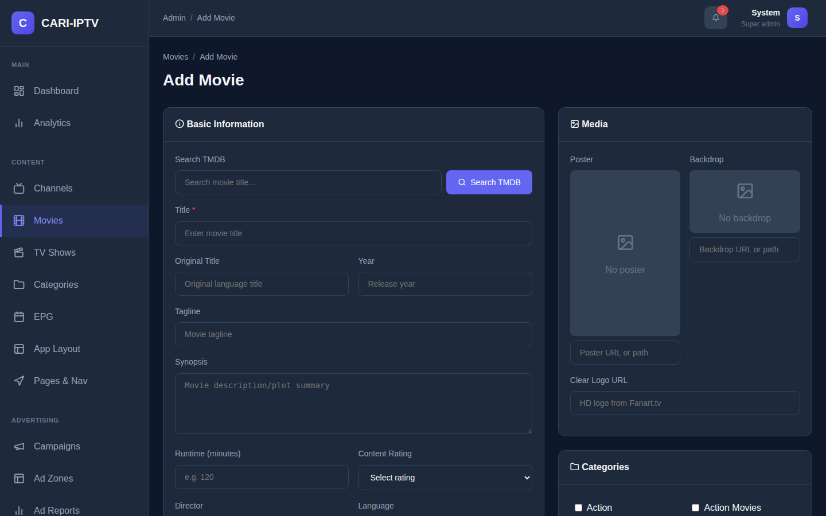
Add Movie form

Add a movie by hand
Only Title is required. Fill in what you have, upload or paste a Poster and Backdrop in the Media card, and save.

Give the movie a video
There are two ways. Both put the playable link into the Primary Stream URL field.
- You already have a stream URL (for example from another streaming server): paste it into Primary Stream URL and save.
- You have a video file: use the VOD server. Save the movie first, then follow section 5.5.

Publish
A movie only appears in the player when Status is Published. Use the bulk Publish and Draft actions on the list to change several at once. Archived hides a movie without deleting it.
Tick Featured Movie to make it eligible for hero and featured rows in layouts.

Artwork, trailers, subtitles, markers
On the edit page of a saved movie:
- Browse Fanart.tv (Media card) offers posters, backdrops and clear logos when the movie has a TMDB id.
- Search Trailers finds YouTube trailers. Imports from TMDB already include trailers.
- Subtitles card: Search OpenSubtitles, Extract subtitle tracks that are embedded in the video file, or Upload an .srt, .vtt or .ass file (5 MB maximum) with its language. One subtitle per language. Click the star to make one the default.
- Content Markers card (shown once the movie has a stream): play the preview, pause at the right moment and click Intro Start, Intro End, Credits Start or Ad Cue Point. The player uses these for Skip Intro, Next Episode and mid-roll ads.
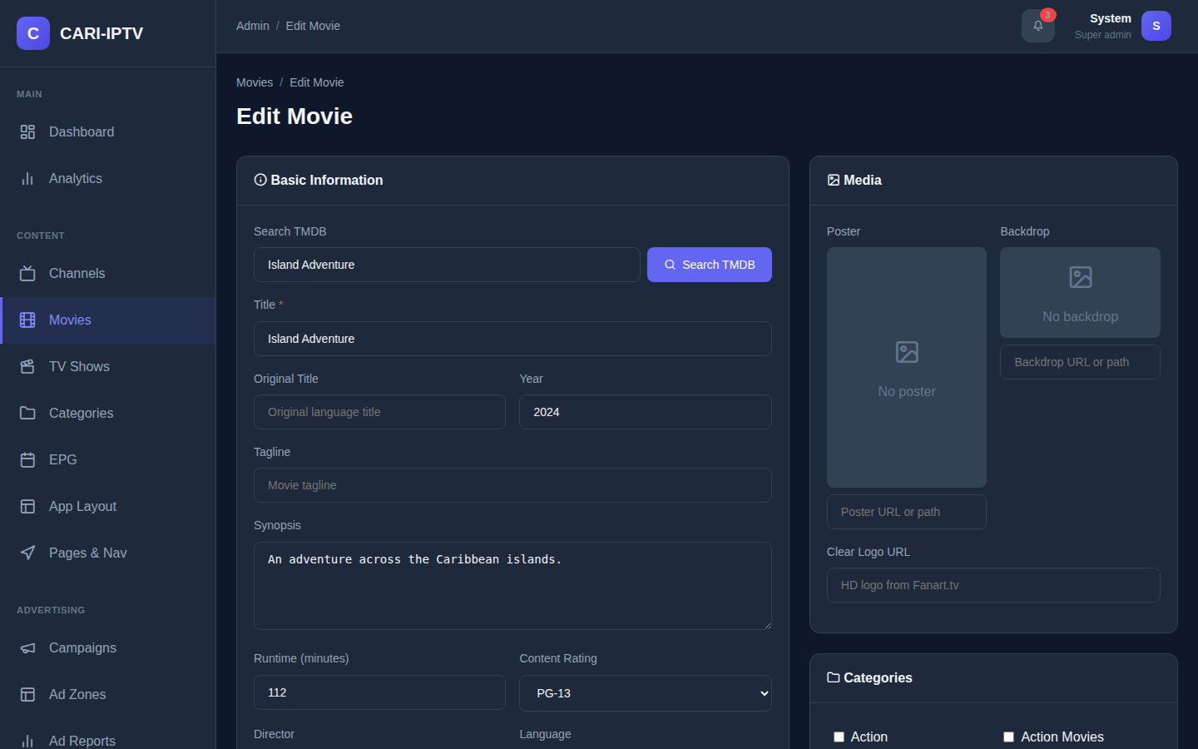
Edit Movie page

Free content
Browse Free Content searches the Internet Archive and YouTube Creative Commons for films you can add at no cost. Check the licence terms of each item yourself before publishing it.

5.5 Uploading and packaging VOD
The VOD server converts one source file into a set of quality levels (a “ladder”) and packages them so the player can switch quality as the connection changes. This is done from the movie or episode page.

5.5.1 Prepare the file
Read this before uploading. The player must work on phones, tablets, smart TVs and desktop browsers, and phones are the strictest.
Target format: 8-bit H.264, High profile, 4:2:0 colour (yuv420p), stereo AAC audio. This is what every phone, tablet, smart TV and browser decodes in hardware.
Why 10-bit files fail on phones. Some source files, especially HEVC rips, animation and HDR masters, use 10-bit colour (called High 10 or Hi10P in H.264, Main 10 in HEVC). Phone chips only decode 8-bit H.264 in hardware. Given a 10-bit stream, a phone either refuses to play it, plays audio with a black picture, or falls back to software decoding which stutters and drains the battery. The VOD server’s normal (software) encoding path converts everything to 8-bit 4:2:0 automatically, so 10-bit sources are fine as long as hardware acceleration is off (the default). If you turn on hwaccel on the VOD server, no colour conversion is forced and a 10-bit source can come out as a 10-bit stream that phones cannot play. Keep hardware acceleration off unless you convert sources to 8-bit first.
HDR is not converted. The VOD server does not tone-map HDR (PQ or HLG, BT.2020) sources to standard range. An HDR master will come out washed out and dark. Convert HDR sources to SDR before uploading.
Aspect ratio is not preserved. Each quality level is scaled to a fixed 16:9 size (for example 1280 by 720). A 4:3 or cinema 2.39:1 source will be stretched. Pad non-16:9 sources to 16:9 before uploading.
No upscale guard. The ladder always produces every level in the profile, so a 480p source uploaded with the standard profile also produces a 1080p file that is no sharper but costs bandwidth. Use the Low Bandwidth profile for low resolution sources.
If you have a source that breaks any of these rules, run it through FFmpeg first. This is a standard tool, not part of the platform. A safe conversion that produces 8-bit H.264 High profile, converts HDR to SDR and pads to 16:9 is:
ffmpeg -i source.mkv \
-vf "zscale=t=linear:npl=100,format=gbrpf32le,zscale=p=bt709,tonemap=tonemap=hable:desat=0,zscale=t=bt709:m=bt709:r=tv,format=yuv420p,scale=1920:1080:force_original_aspect_ratio=decrease,pad=1920:1080:(ow-iw)/2:(oh-ih)/2" \
-c:v libx264 -profile:v high -pix_fmt yuv420p -preset slow -crf 18 \
-c:a aac -b:a 192k -ac 2 \
prepared.mp4
For a plain SDR 16:9 source that is merely 10-bit, the shorter form is enough:
ffmpeg -i source.mkv -c:v libx264 -profile:v high -pix_fmt yuv420p -preset slow -crf 18 -c:a aac -b:a 192k -ac 2 prepared.mp4
Accepted upload formats: any video file, including .mp4, .mkv, .avi, .ts and .m2ts. The main server accepts uploads up to 12 GB.

5.5.2 Choose a profile
Profile | Output | Use for
Standard (H.264 ABR) | 360p, 480p, 720p, 1080p in H.264 | Default. Use this for anything subscribers watch on phones or in browsers
Low Bandwidth (H.264) | 360p, 480p, 720p at lower bitrates | Low resolution sources, or markets with slow connections
High (HEVC) | 480p to 1080p in HEVC | Smaller files, but HEVC does not play in every browser (Firefox and older Chrome do not support it). Only if you control the devices
HEVC 4K | up to 2160p in HEVC | 4K masters for smart TVs. Same browser caveat
AV1 (Web/Mobile) | 480p to 1080p in AV1 | Newest devices only

5.5.3 Upload and transcode a movie
- Open the movie’s edit page. The VOD Transcode card is shown once at least one VOD server exists.
- Choose the VOD Server and the Transcode Profile.
- Click Source File and pick the prepared video.
- Click Upload & Transcode. The upload progress bar runs first, then the job is queued.
- If a video for this movie already exists on the server, you are asked whether to overwrite it.
- The badge shows Processing with the current step (Downloading source, Transcoding, Packaging for streaming) and a percentage. You can leave the page; the status updates when you return, and the Movies list shows the percentage in the Status column.
- When it finishes the badge shows Ready and the message “Transcode complete. Stream URL has been set.” The Primary Stream URL now points at the VOD server. Anything that was in that field before is replaced.
- Set Status to Published and save.
Check: sign in to the player as a test subscriber with a package that includes the movie, open it and confirm it plays and that the quality switches when you change the network.
If the badge shows Failed, hover or read the error text. The most common causes are a corrupt source file, not enough free disk space on the VOD server (below min_free_space_gb), or the VOD server being unreachable. Fix the cause and click Upload & Transcode again.
Remove VOD deletes the converted video from the VOD server and clears the stream link.

5.5.4 Episodes
The same card is available per episode in the VOD & Markers dialog on the Episodes page (section 5.6).

5.5.5 The VOD server’s own web page
http://<VOD_DOMAIN>:8090 (or https://<VOD_DOMAIN> after section 3.8) shows Dashboard, Content, Jobs, Uploads, Cluster, Profiles, DRM and Settings. Content staff mostly use Jobs to watch the queue and Content to see what is stored. Technical staff use Profiles to add or change quality ladders and Settings to change the options from section 4.3 without editing the file.

5.6 TV Shows
TV Shows works like Movies, with seasons and episodes underneath.
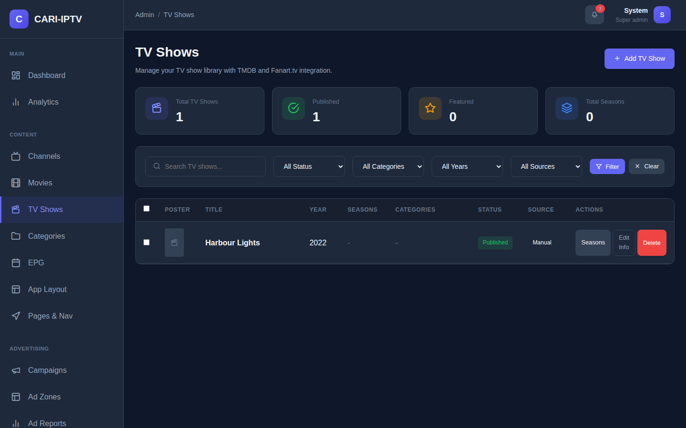
TV Shows list
- Click Add TV Show, search TMDB, pick the result, save.
- Click Manage Seasons (or the Seasons button in the list).
- Click Import Seasons from TMDB to create all seasons, or Add Season by hand.
- On a season card click TMDB to pull that season’s episode names, synopses, air dates and stills.
- Click Episodes on the season.
- For each episode either paste a Stream URL (Primary) in the episode’s Edit dialog, or open VOD & Markers and upload a file exactly as for a movie.
- Set the show’s Status to Published.
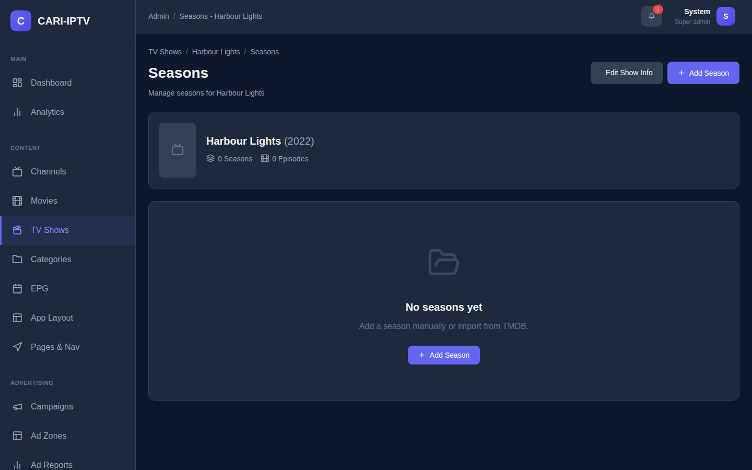
Seasons page
Each episode row also has Subtitles (search OpenSubtitles or upload) and the VOD & Markers dialog, where you set Intro Start, Intro End and Credits Start so the player can offer Skip Intro and Next Episode.

5.7 Packages, content groups and entitlements
Subscribers only see content as available when they hold a package that grants it. Two objects work together:
- A Content Group is a bundle of channels, movies, shows or whole categories.
- A Package is what a subscriber subscribes to. It has a price and grants one or more content groups.
Both are managed on the Packages page, which has a Content Groups tab and a Packages tab.
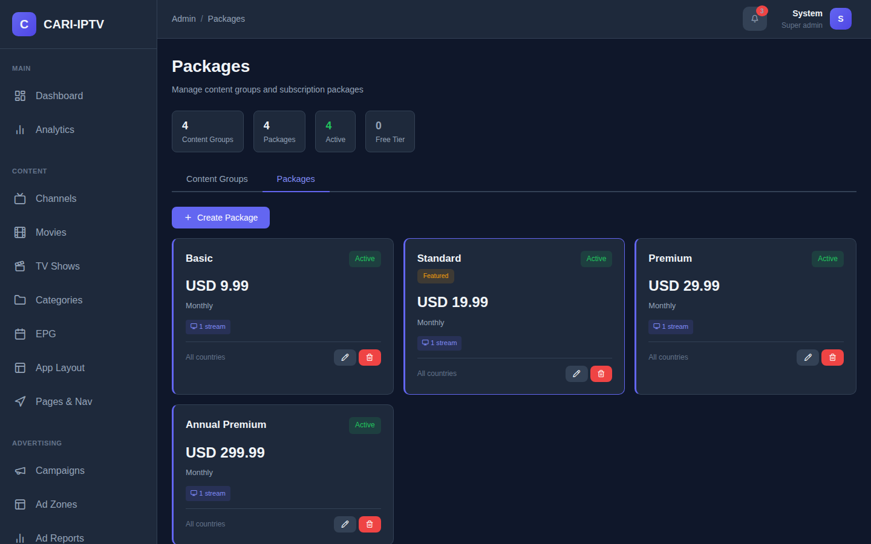
Packages tab

Create a content group
- Open Content Groups (sidebar link, or the tab).
- Click Create Content Group. Enter a name such as “Basic Channels” and a colour. Save.
- Click Manage Content on the group card.
- Choose a type (Channels, Movies, Series, Categories), search, and click items to add them. Adding a category adds everything in it.
- Click Done.
The installer seeds four empty groups: Basic Channels, Premium Channels, Movies Library, TV Shows Library. Rename or delete them as you like.

Create a package
- On the Packages tab click Create Package.
- Enter the Package Name and a Description customers will see.
- Pricing: tick Free Package for a free tier, or enter Price, Currency, Billing Period, tax settings and Trial Days.
- Features and limits: Simultaneous Streams, Video Quality, Catch-up TV, Cloud DVR, Ad-Free. These are shown to customers as feature tags.
- Assign Content Groups: select the groups this package grants. Hold Ctrl or Cmd to select several.
- Leave Active ticked. Tick Featured to highlight it on the Subscribe page. Save.

What is enforced, in plain terms
- A subscriber with no package at all sees a padlock on everything.
- Content that is in at least one content group is locked unless one of the subscriber’s packages grants a group containing it.
- Content that is in no content group is open to every signed-in subscriber. New channels and movies start this way, so add new content to a group if it should be paid-only.
- The padlock is applied by the player app. The server itself does not withhold stream links from a subscriber who lacks the package (see section 9). Treat packages as the way you present and sell tiers, and keep this limitation in mind.
- Simultaneous Streams, Video Quality, Catch-up, DVR, Platforms and Countries on a package are descriptive only in this version. The stream limit that is actually applied is the per-subscriber Max Concurrent Connections (section 6.5).

Free tiers and trials
- A free package is activated instantly when a subscriber chooses it on the Subscribe page.
- A paid package with Trial Days greater than zero starts a trial the first time a subscriber chooses it. When the trial ends the package is no longer counted.
- A paid package without a trial, or after the trial, shows “Payment is required”. There is no payment gateway in this version. Staff activate paid packages by editing the subscriber (section 6.6).

5.8 Advertising
Campaigns is where ads are managed. The basic flow is: create a campaign, add one or more ads to it, then place each ad in a zone.
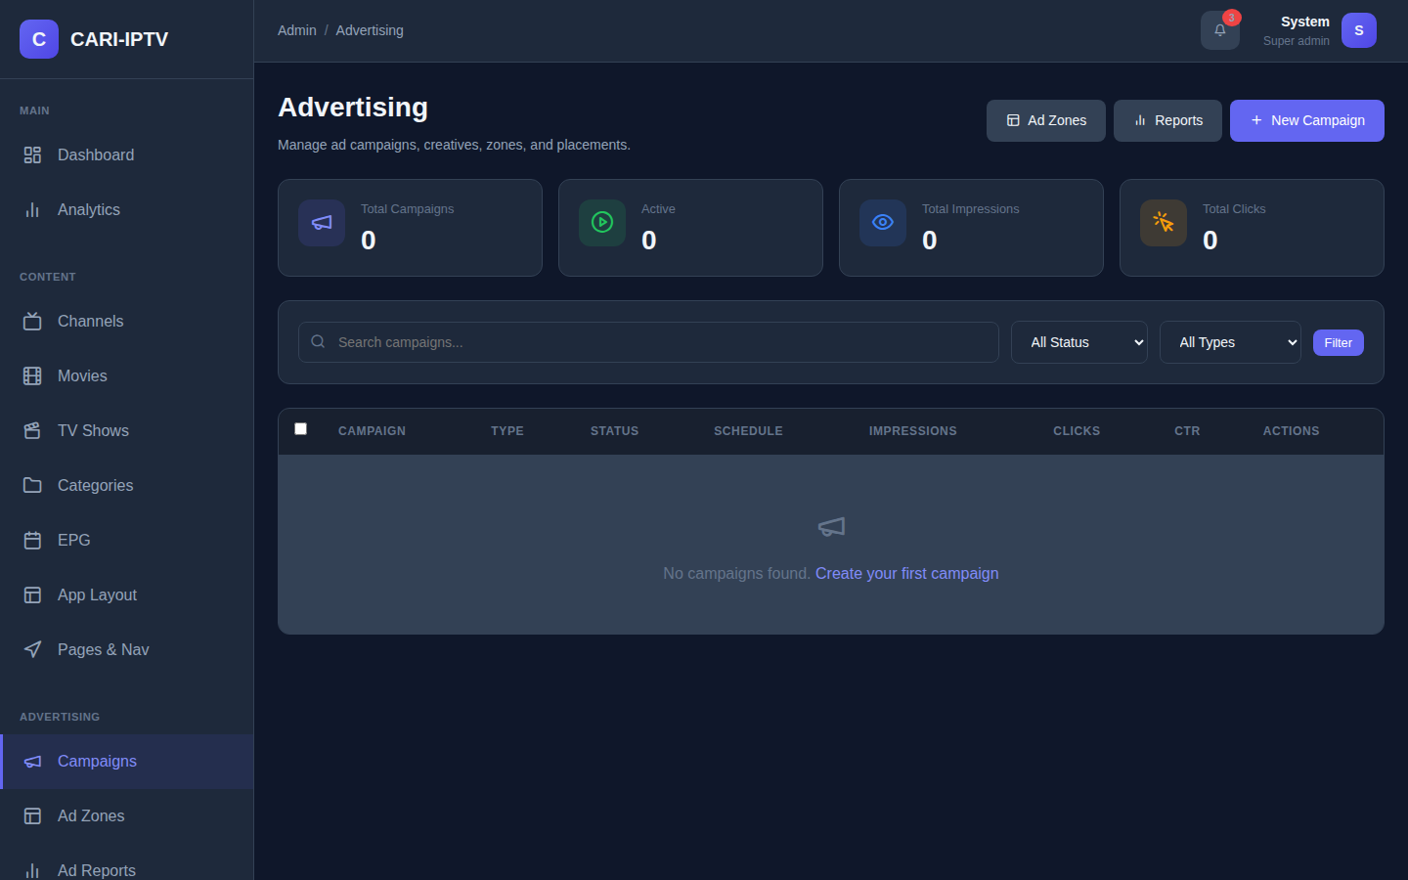
Campaigns list

Ad types
Type | Where it shows | What you supply
Text Scroller | A ticker over the video | Text, speed, font size, colours. Generate with AI writes copy for you
Banner Image | An image over the video, top or bottom | Upload an image, paste a URL, or generate one with AI. Optional click URL
Pre-Roll Video | Before the content starts | Upload a video, paste a video URL, or a VAST tag URL. Duration and skip-after seconds
Mid-Roll Video | During the content | Same as pre-roll, plus where to insert: a percentage, a number of seconds, or the Ad Cue markers set on the movie

Create a campaign
- Click Create Campaign.
- Enter Campaign Name and Advertiser. Set Status to Active when ready (Draft campaigns do not serve).
- Optionally set Start Date and End Date, daily and total budgets, a Frequency Cap (max times per user per day) and impression caps.
- Click Create Campaign. The page reopens with two more tabs.
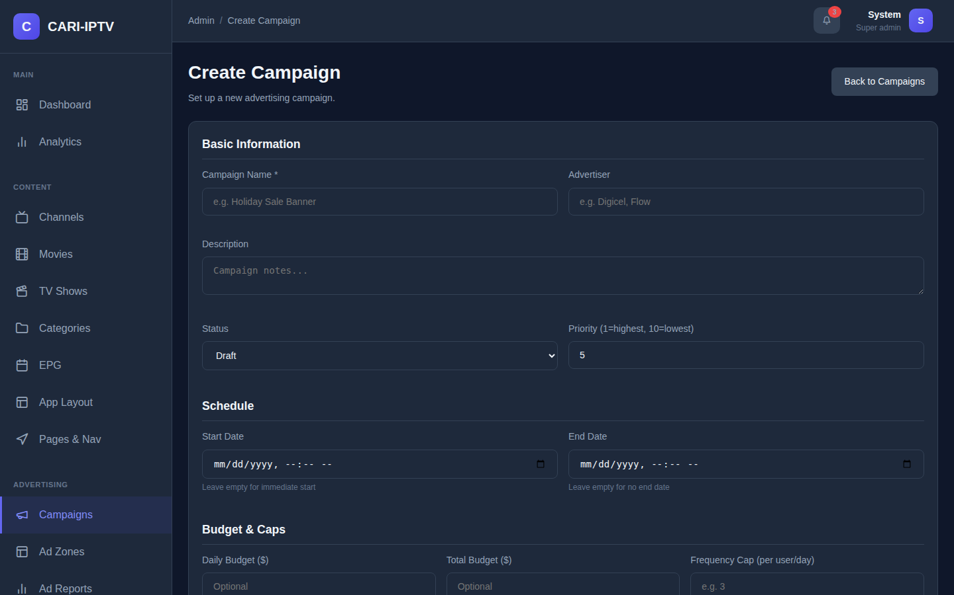
Campaign form

Add an ad
- On the Ads tab click Add Ad.
- Enter a Name, choose the Type, and fill the settings for that type. Set Status to Active.
- Weight controls rotation when a campaign has several ads of the same type.
- Save.

Place the ad
- On the Placements tab click Add Placement.
- Choose the Ad and the Zone (for example preroll-vod for movies, preroll-live for channels, live-banner, vod-text-scroller).
- Add Targeting Rules if the ad should only show for some viewers: by Package (for example only free-tier subscribers), Channel, Category, Content Type, Platform, or a time Schedule such as 06:00-12:00. Each rule can Include or Exclude.
- Save.

Zones, reports and the rest
- Ad Zones lists the ten built-in zones and lets you add your own. You rarely need to change them.
- Ad Reports shows impressions, clicks, click-through rate and spend per campaign, with a date filter.
- Ad Pods groups several ads into one commercial break. Waterfall defines fallback chains when a zone has no direct ad. Forecast predicts revenue with AI. A/B Tests lists tests but cannot create them in this version. These are advanced options; the basic flow above is enough for most operators.
- Overlay timing (when banners and scrollers appear) is set in Settings > Advertising (section 4.1).

5.9 Layouts and server-driven UI
The player’s home screen and menu are not fixed. You design them in App Layout and Pages & Nav, separately for each platform: Web, Mobile, Smart TV and Set-Top Box. The web player always uses the Web layout and Web navigation, on desktop and on phones alike; it reshapes the same rows for the small screen. The Mobile, Smart TV and Set-Top Box platforms are ready for future native apps and are not used by anything in this version.
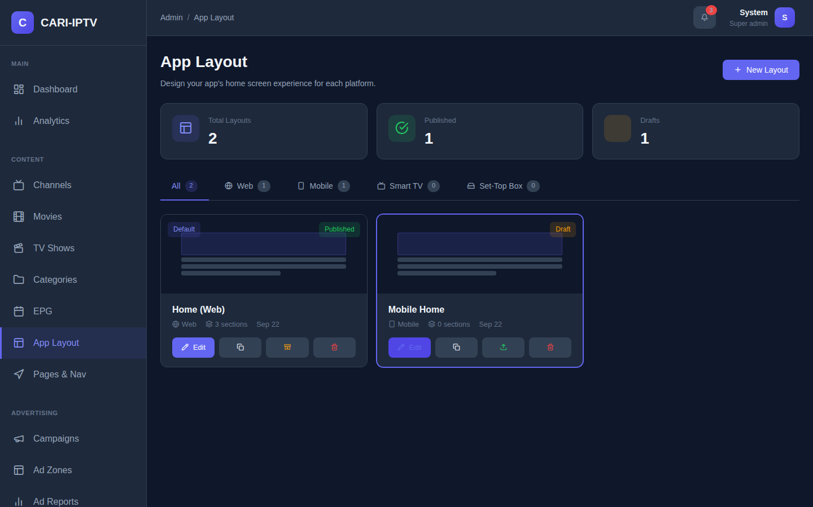
App Layout page

Build a layout
- Click Create Layout. Enter a name and pick the platform. The builder opens.
- Click Add Section and choose a component. Useful ones:
  - Hero Slideshow: big rotating billboard at the top. One per layout.
  - Content Row: a horizontal rail of posters. Source can be Curated (you pick), Latest, Popular, Top Rated, Featured or a Category.
  - Live Now and TV Guide: driven by the EPG.
  - Channel Grid: featured channels.
  - Continue Watching, Recommended For You, Because You Watched, Trending Now: personalised rows, filled automatically.
  - Packages List: shows your packages with prices.
  - Promo Banner: an image with a link.
- Click the arrow on a section to expand it. Set the Section Title subscribers see and any settings. For a curated section click Add Content to search your library, import from TMDB, or upload an image with a link.
- Drag sections by the handle to reorder. Click the eye icon to hide a section without deleting it.
- Click Save Changes on each section you edited.
- Back on the App Layout page click Publish on the layout card.
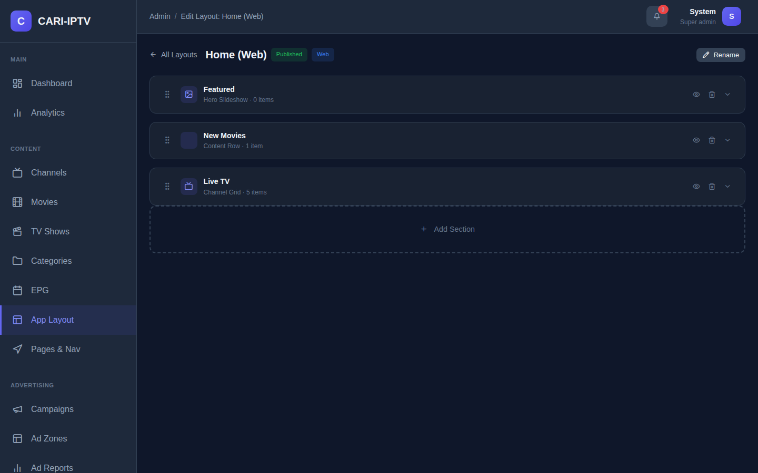
Layout builder
Only one layout per platform is the default at a time. Publishing makes the layout the default for its platform. Use duplicate to make a copy to experiment with, and Set to Draft to take a layout out of use.
Subscribers see layout changes within about 30 seconds, or on their next page change, without clearing anything.

Pages and navigation
Pages & Nav controls which screens exist and what the menu shows, per platform.
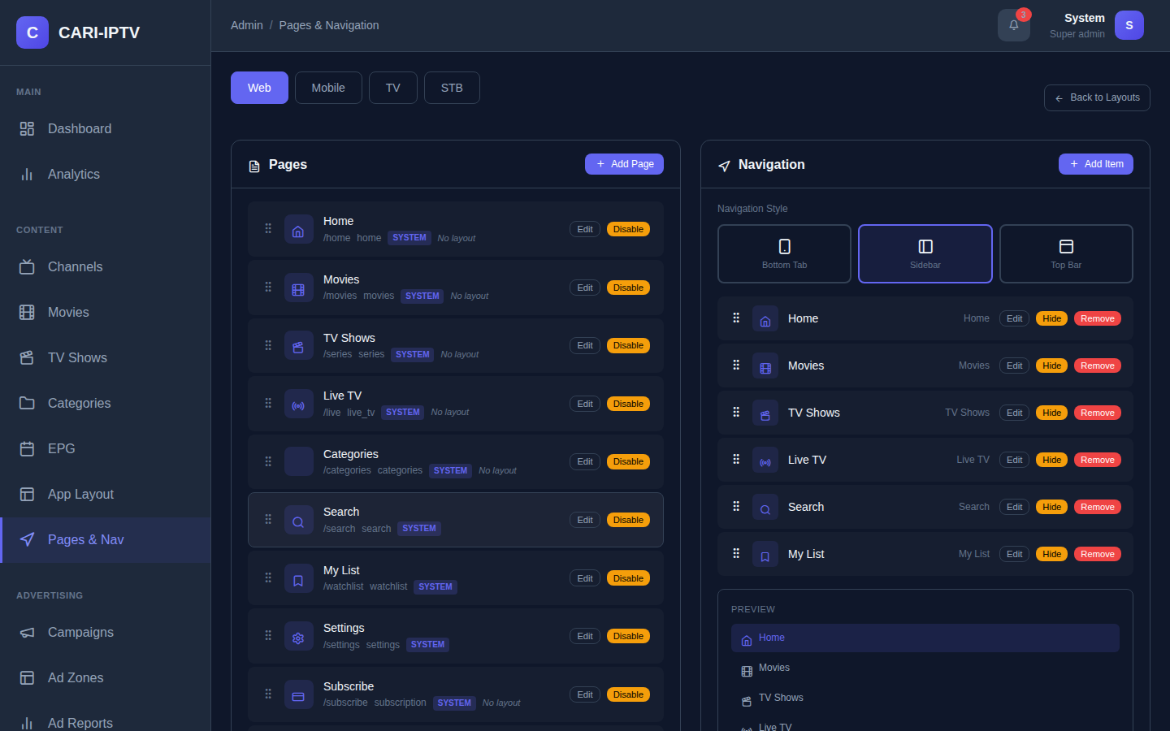
Pages & Navigation page
- The Pages panel lists the screens. Built-in ones are marked System and cannot be deleted. Add Page creates a custom page: give it a name, a URL slug, a Page Type and optionally a Layout to render. The Home, Movies, TV Shows, Live TV, Categories and Custom page types can carry a layout.
- The Navigation panel is the menu. Drag to reorder, Edit to change the label or icon, Hide to remove an item from the menu without deleting the page. Add items that link to a page, an external URL, or a deep link.
- On a phone the Web navigation is shown as a bottom tab bar, so keep the Web menu to five items or fewer.

Publish a layout that works on phones
Because phones use the Web layout, design the Web layout with phones in mind:
- In App Layout stay on the Web tab and open your layout in the builder.
- Keep the hero small and put the most-used rows first, because phone screens show fewer rows at once. Wide rows become swipeable rails on a phone automatically.
- Publish it.
- In Pages & Nav, on the Web tab, check the navigation has at most five items.
Check: open https://<ADMIN_DOMAIN>/ on a phone, sign in, and confirm the home screen shows your rows with the bottom tab bar.
If you also create and publish a Mobile layout, it is stored and served by the API for a future native app, but the web player will not show it.
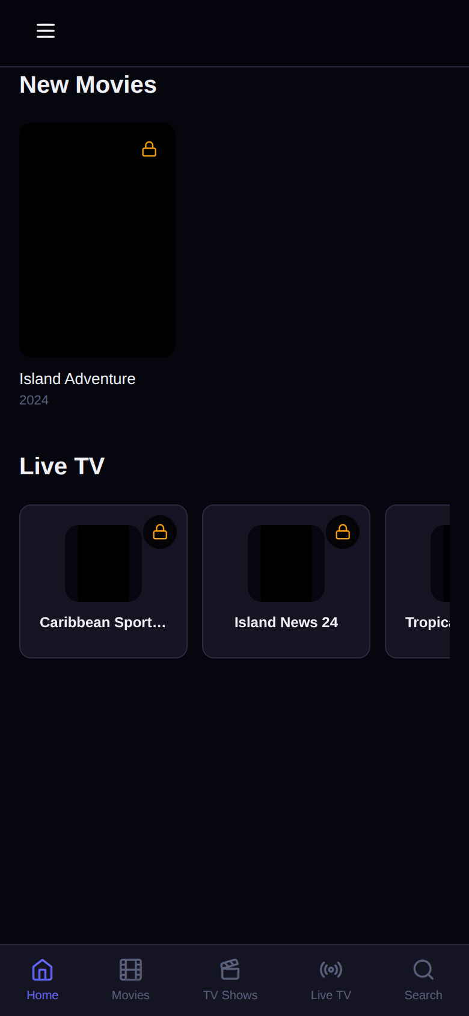
Player home screen on a phone

6. Subscribers

6.1 How a subscriber registers
- The subscriber opens https://<ADMIN_DOMAIN>/register.
- They enter First Name, Last Name, Email, Password (8 characters minimum) and Confirm Password. Phone, Date of Birth and Country are optional.
- The platform emails a verification link. The link never expires.
- They click the link, see a confirmation page, and can sign in.
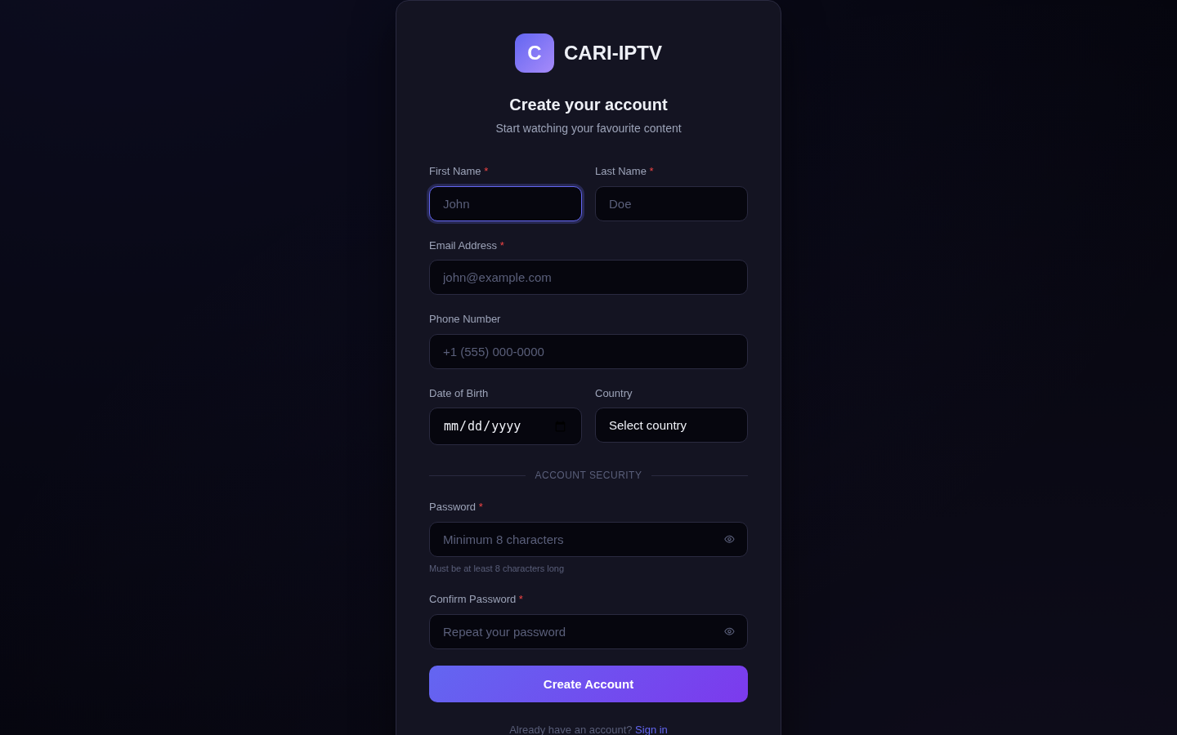
Registration page
A username is created automatically from the part of the email before the @. The subscriber can sign in with either the username or the email.
New accounts hold no package. They can pick a free package or start a trial on the Subscribe page in the player, or staff assign one.
Registration cannot be switched off from the admin panel in this version.

6.2 Verification problems
If a subscriber says they never received the email:
- Check Settings > Email is enabled and the test email works.
- Ask the subscriber to try signing in. The login page then shows a Resend verification email button; they click it.
- If that still fails, verify them yourself: there is no resend button in the admin panel, so open the subscriber in Subscribers, tick Email Verified and save. They can sign in straight away.

6.3 Sign-in
Subscribers sign in at https://<ADMIN_DOMAIN>/login with username or email and password. They stay signed in for up to 30 days of inactivity on that device. Sign-in is refused if the account status is not Active, if it is marked Disabled, or if the email is not verified.

6.4 Password reset (support procedure)
There is no self-service password reset for subscribers in this version. The login page has no “Forgot password” link. Use this procedure:
- Verify the caller’s identity against the details on their account (name, email, phone, address).
- Open Subscribers, find the account, click Edit.
- Type a new temporary password in the Password field. Save.
- Give the password to the subscriber by a channel you trust, and ask them to change it. Note that the player has no change-password screen either, so if they want a different one they will call again.
The platform does not email the subscriber about the change.

6.5 Device limits
- Each subscriber has Max Concurrent Connections (default 1) on their record. This is the limit that is applied. The Simultaneous Streams value on the package is a label only, so when you sell a two-screen package, set the subscriber’s Max Concurrent Connections to 2 by hand.
- When a subscriber signs in on one more device than allowed, the oldest device is silently signed out. Nobody sees an error.
- There is no list of devices and no “sign out everywhere” button in this version. To force every device off, set the subscriber’s status to Inactive, save, then set it back to Active. Anyone already watching may continue for up to one hour before their session ends.

6.6 Managing a subscriber
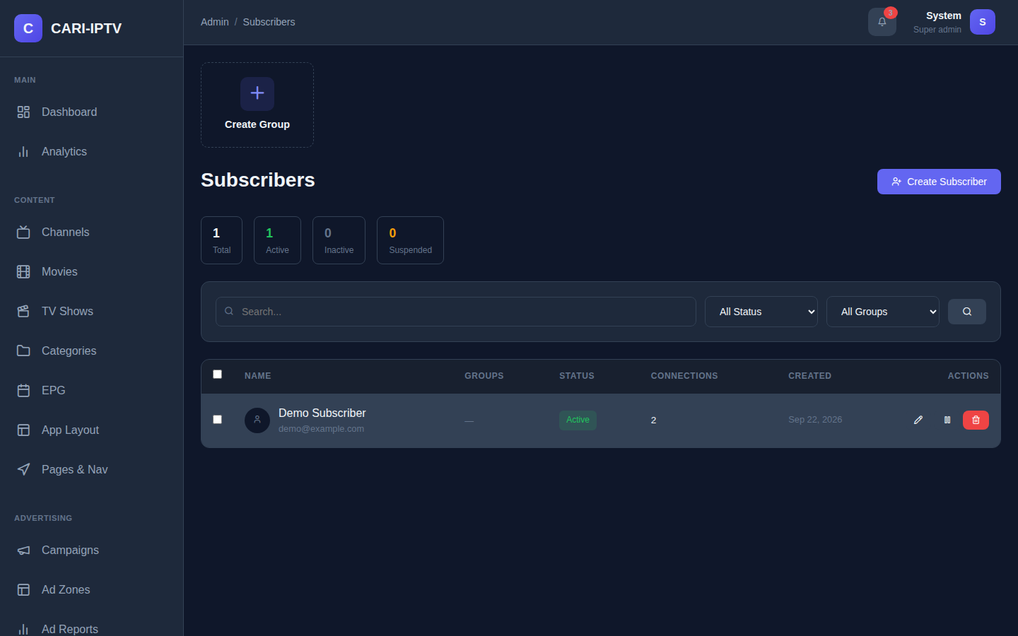
Subscribers page
Open Subscribers. Search by name, username, email or phone. Filter by status or group. Tick rows for bulk Activate, Deactivate, Suspend or Delete.
Create Subscriber or Edit opens one dialog with these sections:
- Top checkboxes: Disabled, Email Verified, Phone Verified.
- General: names, username, email, phone, password, Status (Active, Inactive, Suspended, Expired).
- Settings: NPVR limit, Max Concurrent Connections, birthday, Parental Pin, Enable Adult Content.
- Location: country, city, address, ZIP.
- Packages & Groups: tick the Packages the subscriber has paid for. This is how paid subscriptions are activated. Removing a package cancels it. Groups are labels for your own reporting (for example DTH, Trial, Staff) and do not affect access.
- Additional: External ID (your billing system’s reference) and internal Notes.
Status meanings are for your bookkeeping only; Inactive, Suspended, Expired and Disabled all block sign-in in the same way. Agree a convention, for example Suspended for non-payment and Expired for a lapsed contract.
The quick toggle button in the list switches between Active and Inactive.

6.7 Parental controls and adult content
- Every subscriber has a four-digit Parental PIN (default 0000). They change it on the Profile page in the player, and staff can read or reset it in the Edit dialog. It is stored unencrypted, so treat it as low-security convenience, not a secret.
- Channels, movies, shows and packages can be flagged as adult in the database, but there is no adult checkbox on the content forms in this version, so this flag cannot be set from the admin panel. The subscriber-side toggle exists but has nothing to filter until that is added.

6.8 Cancelling and deleting accounts
- To stop service, set the status to Inactive or Suspended. This is reversible.
- Delete removes the account and everything attached to it: subscriptions, watch history, watchlist, ratings and devices. It cannot be undone. Subscribers cannot delete their own accounts; a written request to support is the process.

6.9 Subscriber self-service in the player
On the Profile page a subscriber can see their details, see and Cancel subscriptions, turn adult content on or off, set the PIN, and sign out. On the Subscribe page they can pick free packages and start trials.
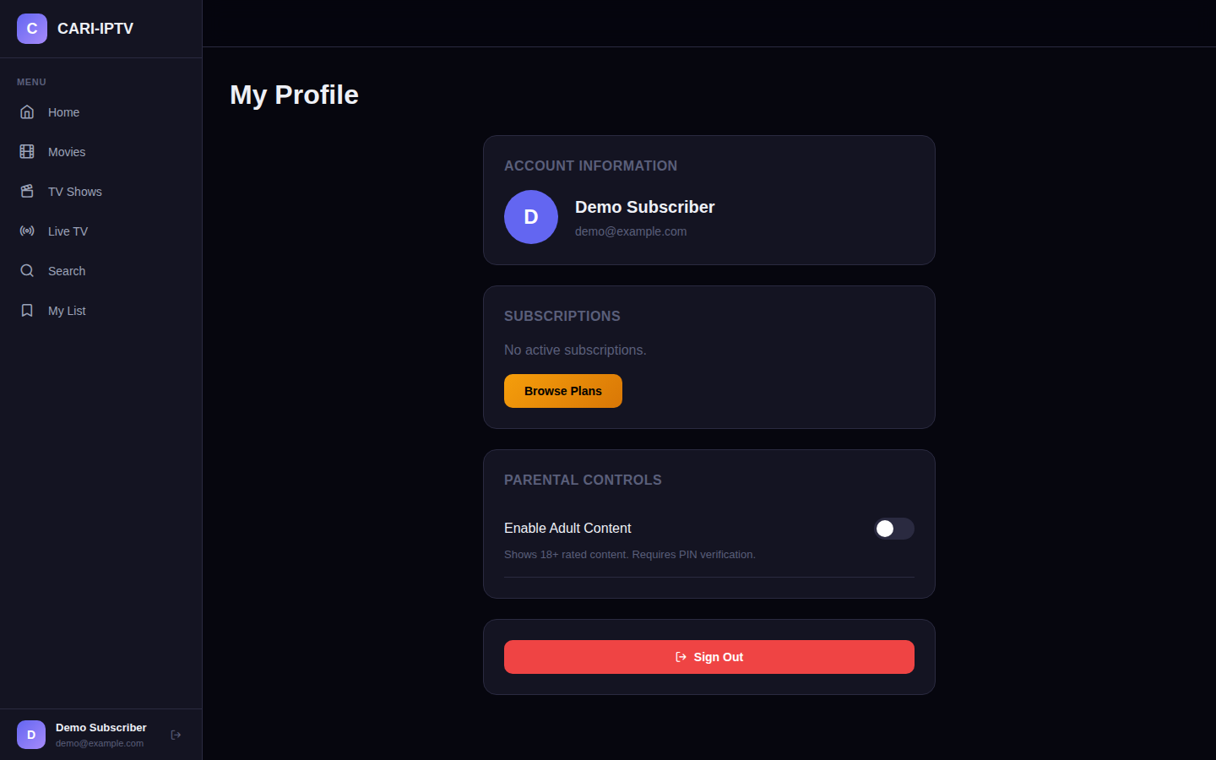
Subscriber profile page

6.10 Support quick reference
Subscriber says | Likely cause | What to do
“I registered but cannot sign in” | Email not verified, or SMTP not configured | Tick Email Verified on the account. Fix SMTP
“Wrong password” | Forgotten password | Section 6.4
“Everything has a padlock” | No package on the account, or content not in a granted group | Assign a package. Check the content is in a group that package grants
“It plays on my laptop but not my phone” | 10-bit or HEVC video, or a browser without HEVC support | Re-encode with the Standard profile (section 5.5.1)
“Movie will not play at all” | VOD Server URL is a private address, or HTTPS mismatch (player on HTTPS, VOD on HTTP) | Set the VOD server URL to its public HTTPS address (section 3.5, 3.8)
“I keep getting signed out” | Another device signed in and the connection limit was reached | Raise Max Concurrent Connections
“I was suspended but can still watch” | Active sessions last up to one hour | Wait, or it will stop within the hour
“No programme guide” | Channel not mapped, or source not fetched | Section 5.3

7. Mobile app

7.1 What subscribers use on a phone
In this version there is no separate downloadable app. Subscribers use the same web player in the phone’s browser. It adapts to the small screen: the sidebar becomes a bottom tab bar, rows become swipe rails, and the video player goes full screen in landscape.
To make it feel like an app, tell subscribers to add it to the home screen:
- iPhone (Safari): open https://<ADMIN_DOMAIN>/, tap the Share button, then Add to Home Screen.
- Android (Chrome): open the address, tap the three-dot menu, then Add to Home screen or Install app.
The icon and title come from your Site Logo and Site Name.

7.2 Branding per brand
Everything a subscriber sees as “the brand” comes from Settings > General: Site Name and Site Logo. If you run more than one brand, each brand needs its own installation of the platform on its own domain; there is no multi-brand switch inside one installation.

7.3 Layout for phones
Design the Web layout with phones in mind as described in section 5.9. Keep the Web navigation to five items. The separate Mobile platform in App Layout is not used by the web player.

7.4 Native apps, signing and store submission
Not applicable to this version. The platform’s API already accepts mobile, tv and stb as platforms and serves them their own layouts and navigation, so a native app can be added later without changes to the admin workflow. When that app exists, this chapter should be extended with its build, signing and store checklist.

8. Operations

8.1 Updating the main server
Always update with a backup. Rollback is only possible when --backup was used (update.sh).
- Choose a quiet time. The update takes a few minutes and subscribers may see errors while files are being replaced.
- Run:
- curl -sSL "https://raw.githubusercontent.com/caritechsolutions/cari-iptv/<BRANCH>/update.sh?$(date +%s)" | sudo bash -s -- --backup
- The script backs up files and the database to /var/backups/cari-iptv/backup_<date>/, downloads the new version, replaces the application files, runs new migrations, resets permissions and restarts services. It keeps the five most recent backups.
- The last lines show the previous and new version numbers.
Check: sign in to the admin panel, open Channels and Movies, then open the player and play one channel.
If the update fails part way, the script restores the backup automatically. To go back later by hand, restore the folder and database from /var/backups/cari-iptv/ (standard rsync and mysql commands) or ask your supplier.
Updates overwrite the application folders. Any hand edits to files under public/, src/ or templates/ are lost. Your .env, uploads and database are kept.

8.2 Updating the VOD server
curl -sSL "https://raw.githubusercontent.com/caritechsolutions/cari-iptv/<BRANCH>/vod-server/scripts/update.sh?$(date +%s)" | sudo bash
The script pauses running jobs, keeps a copy of the old program as /usr/local/bin/vod-server.bak, rebuilds, restarts and checks health. If the new version fails to start it puts the old one back automatically. Your configuration and video library are not touched. Manual rollback, printed by the script:
sudo cp /usr/local/bin/vod-server.bak /usr/local/bin/vod-server && sudo systemctl restart vod-server
Check: curl http://localhost:8090/api/status answers, and a paused job resumes in the Jobs list.

8.3 Backups
The updater’s --backup is a good ad-hoc backup, but also schedule your own:
What | Where | How
Database | Main server | mysqldump cari_iptv > backup.sql nightly (standard tool). Credentials are in /var/www/cari-iptv/.env
Uploads (logos, posters, subtitles) | /var/www/cari-iptv/public/uploads/ | Copy to another machine
.env | /var/www/cari-iptv/.env | Copy once and after any change
VOD configuration | /etc/vod-server/vod-server.conf | Copy. It contains the API key
VOD library | /var/lib/vod-server/library/ and /var/lib/vod-server/vod-server.db | Large. Copy or snapshot the disk

8.4 Logs
Log | Location
Application errors | /var/www/cari-iptv/storage/logs/php-error.log
EPG fetch | /var/www/cari-iptv/storage/logs/epg.log
Recommendations | /var/www/cari-iptv/storage/logs/recommendations.log
Web server | /var/log/nginx/cari-iptv-error.log and -access.log
VOD server | /var/log/vod-server/vod-server.log, or journalctl -u vod-server -f
These logs are not rotated automatically. Check their size monthly and clear or rotate them.

8.5 Monitoring
- Dashboard in the admin panel: add the Disk Space and Memory Usage panels.
- Analytics: viewers now, buffering and error trends, top content, churn risk.
- VOD server dashboard (port 8090): CPU, memory, disk, active jobs.
- systemctl status nginx php8.2-fpm mysql on the main server and systemctl status vod-server on the VOD server.

8.6 Common faults
Symptom | Cause | Fix
Admin panel shows a blank or error page | Database down or wrong credentials in .env | sudo systemctl status mysql; compare .env with the database user
Player loads but no video ever starts | Browser cannot reach the CDN that hosts the video engine, or the server has no internet | Allow outbound access; the video engine is loaded from jsdelivr.net
Live channel does not play | Stream URL wrong, offline, or HTTP stream on an HTTPS site | Test the URL in VLC. Serve streams over HTTPS
Movie shows Processing forever | VOD server stopped, or job failed while the panel was closed | Check the Jobs page on the VOD server; restart it; re-submit
Transcode fails immediately | Disk below min_free_space_gb, or unreadable file | Free space; re-encode the source with FFmpeg
Guide is empty | Source not fetched or channels unmapped | Fetch now; check mappings; read epg.log
Guide times are wrong by hours | Source Timezone set wrongly | Edit the source’s timezone and fetch again
Verification emails not arriving | SMTP disabled or wrong; provider blocking | Send Test Email; check spam; check port 587 outbound
Uploads fail on large files | Size above the 12 GB limit or a proxy in front with a smaller limit | Split or shrink the file; raise the proxy limit
Recommendations never appear | Nightly job has not run yet, or AI not configured | Wait for the 03:00 run; check recommendations.log

8.7 Scheduled jobs
Installed to /etc/cron.d/cari-iptv by the installer and rewritten by every update. Do not edit the file; changes are lost.
When | Job
Every 5 minutes | Fetch EPG sources that are due
02:00 daily | Delete programmes older than two days
03:00 daily | Build AI taste profiles and recommendations for up to 100 subscribers, and prune analytics older than 90 days

9. Security notes
This section is deliberately frank so you can make informed decisions.

9.1 What is protected
- Admin sign-in locks an account for 15 minutes after five failed attempts. Admin sessions expire after two hours of inactivity unless “Keep me logged in” was ticked.
- Passwords for staff and subscribers are stored hashed.
- All player and API requests require a signed-in subscriber. Stream links are not listed to anonymous visitors.
- Every form in the admin panel is protected against cross-site request forgery.
- Uploaded images are re-encoded, which strips embedded content.
- The VOD server requires its API key for every management call.

9.2 What is not protected, and what to do about it
Gap | Effect | Recommendation
No HTTPS from the installer | Passwords and tokens in clear text | Section 3.7 and 3.8 before go-live
No firewall from the installer | Database and AI ports are local-only, but 8090 on the VOD server is open to the world | Restrict 8090 to the main server, and expose the VOD server to subscribers only through HTTPS on 443
Entitlements are applied by the player, not the server | A technically capable subscriber can request any stream link with their own login, regardless of package | Treat packages as presentation. Plan for server-side enforcement in a future version. Keep a paper trail of subscriptions for disputes
Adult filtering is applied by the player only | Same as above | Same
The DRM key endpoint on both servers answers without a login | Content encryption protects files on disk and in transit, but is not access control. Anyone who knows a content id can fetch its key | Do not describe the service as DRM-protected to rights holders. Restrict who can reach the VOD server
Ad tracking endpoints are public | Impression and click counts could be inflated | Treat ad reports as indicative; reconcile with the advertiser’s own numbers
Admin roles are not enforced | Every admin account can do everything, including managing other admins and settings | Create as few admin accounts as possible. Use strong unique passwords. Review Admin Users monthly
A suspended subscriber keeps a valid session for up to one hour | Delayed cut-off | Accept, or ask your supplier for immediate revocation
Parental PIN stored unencrypted | Staff can read it | Tell subscribers not to reuse a banking PIN
The player loads its video engine and fonts from public CDNs | If those CDNs are unreachable the player breaks | Consider hosting them locally with your supplier
Local customisations are overwritten by updates | Silent loss of branding edits | Only brand through Settings

9.3 Recommended hardening
- HTTPS on both servers, with HTTP redirected.
- Firewall: main server 80 and 443 only; VOD server 443 only (or 8090 only from the main server’s address).
- Change the admin password on day one and delete INSTALL_CREDENTIALS.txt.
- One admin account per person, no shared logins.
- Set APP_DEBUG=false in .env (the installer does this).
- Back up nightly and test a restore quarterly.
- Keep the VOD server’s API key out of tickets and chat.

Appendix A. API reference summary
The API is what the player uses. Base address https://<ADMIN_DOMAIN>/api/v1. Responses are JSON. Sign-in returns an access token valid for one hour and a refresh token valid for 30 days; the access token is sent as Authorization: Bearer <token>.
Group | Endpoints | Login required
Account | POST auth/register, auth/login, auth/refresh, auth/logout, auth/resend-verification; GET auth/verify-email/{token} | No
Account | GET auth/me, auth/entitlements, auth/continue-watching, auth/watchlist, auth/rating; POST auth/watch-progress, auth/watchlist/toggle, auth/subscribe, auth/unsubscribe, auth/update-profile, auth/rate | Yes
Content | GET channels, channels/{id}, movies, movies/featured, movies/{id}, series, series/{id}, episodes/{id}, categories, person/{id}, search, manifest | Yes
Guide | GET epg, epg/{channelId}, epg/programme-info | Yes
App | GET app/config/{platform}, app/layout/{platform}, app/navigation/{platform}, app/pages/{platform} | Yes
Ads | GET ads/serve, ads/breaks, ads/overlay-settings; POST ads/impression, ads/event | No
DRM | GET/POST drm/license (login), GET drm/key/{contentId} (no login) | Mixed
Analytics | POST analytics/event, analytics/batch, analytics/qoe, analytics/impressions, analytics/share; GET recommendations, recommendations/profile | Yes
VOD server API (base http://<VOD_DOMAIN>:8090/api, header X-API-Key): status, config, profiles, jobs, content, upload, browse. status and the DRM key endpoints do not require the key.

Appendix B. Configuration reference

B.1 Admin settings keys
Group | Keys
general | site_name, site_logo, site_url, admin_email
smtp | enabled, host, port, encryption, username, password, from_email, from_name
metadata | tmdb_api_key, fanart_tv_api_key, youtube_api_key, auto_fetch_metadata
subtitles | opensubtitles_api_key, opensubtitles_username, opensubtitles_password, preferred_languages, auto_fetch_subtitles
ai | ai_enabled, provider, ollama_url, ollama_model, openai_api_key, openai_model, anthropic_api_key, anthropic_model
image | auto_optimize, keep_originals, webp_quality
ads | banner_enabled, banner_initial_delay, banner_display_duration, banner_repeat_interval, scroller_enabled, scroller_initial_delay, scroller_repeat_interval

B.2 .env on the main server
APP_ENV=production
APP_DEBUG=false
APP_URL=https://<ADMIN_DOMAIN>
DB_HOST=localhost
DB_PORT=3306
DB_DATABASE=cari_iptv
DB_USERNAME=cari_iptv
DB_PASSWORD=<DB_PASSWORD>

B.3 vod-server.conf sections
[server] port, bind_address, api_key, log_file, log_level, www_root. [ssl] enabled, cert_file, key_file, auto_self_signed. [acme] enabled, http_port, webroot, domain, https_port. [storage] library_path, temp_path, min_free_space_gb, database_path. [transcoding] max_concurrent_jobs, ffmpeg_path, ffprobe_path, mp4box_path, default_profile, segment_duration, gop_size, poll_interval, hwaccel, gpu_device. [thumbnails] enabled, interval, width, height, columns, quality. [subtitles] enabled, auto_extract. [cluster] node_name, health_check_interval, offline_threshold, max_concurrent_migrations. [drm] enabled, scheme, key_server_url, auto_generate. [profile:name] codec, preset, crf, renditions, audio_codec, audio_bitrate.

B.4 Installer options
install.sh: --db-pass=, --admin-pass=, --admin-email=, --install-dir=, --port=. update.sh: --backup, --backup-dir=, --branch=, --install-dir=.

Appendix C. Glossary
Term | Meaning
ABR | Adaptive bitrate. The player switches between quality levels as the connection changes
Content group | A bundle of channels, movies, shows or categories that a package grants
DVB, EIT | Satellite and cable broadcast standard; EIT is the programme guide table carried inside it
EPG | Electronic programme guide. What is on, now and next
HLS | HTTP Live Streaming. The .m3u8 stream format the player uses
Layout | The arrangement of rows and sections on a player screen, designed in App Layout
Package | A subscription plan with a price that grants content groups
Profile (transcode) | A quality ladder used by the VOD server, such as Standard or Low Bandwidth
Rendition | One quality level within a ladder, for example 720p
SDR, HDR | Standard and high dynamic range. HDR must be converted before upload
TMDB | The Movie Database, source of metadata and artwork
VOD | Video on demand: movies and episodes, as opposed to live TV
XMLTV | A file format for programme guides
yuv420p | The 8-bit 4:2:0 colour format every device decodes

Appendix D. Where the documentation and the code disagree
Found while writing this manual. The manual follows the code.
Existing documentation says | The code does
README: install from the main branch | The scripts are pinned to a feature branch. Use the branch your supplier names
CLAUDE.md: the install script’s branch line is near line 1357 | It is line 1377
CLAUDE.md: /admin/vod-server is the VOD Server page with profile management | It redirects to Settings > Integrations. Profiles are managed on the VOD server’s own page
CLAUDE.md: 10 layout section types | 17 section types
CLAUDE.md: ads are served from /admin/ads/api/... | The player uses the public /api/v1/ads/... endpoints
CLAUDE.md: roles control access | Roles and permissions are never checked
README and CLAUDE.md: packages control access | Access is decided by the player only
Migration 024 comment: seeds VOD server settings | Creates the table only
Migration 004 seeds metadata.fanart_api_key and image.generate_sizes | The panel uses metadata.fanart_tv_api_key and image.auto_optimize; the seeded keys are unused
Migration 019 name: seeds default packages | Seeds four empty content groups. The demo packages come from the installer
Sidebar: Activity Log | No such page; the link gives a 404
Channel form: “Published: channel is visible to users” | The player ignores Published; only Active matters
Channel form: Include in Packages | Not read by entitlement checks
Player: “Invalid or expired verification link” | Links never expire; only invalid or already used
App Layout: separate Mobile, Smart TV and Set-Top Box layouts | The web player always requests the Web layout, including on phones

Appendix E. Current limitations at a glance
- No subscriber password reset or change-password screen.
- No device list or sign-out-everywhere for subscribers.
- Packages are not enforced by the server; the player shows padlocks only.
- Package limits (streams, quality, platforms, countries, tax) are descriptive.
- No payment gateway; paid packages are activated by staff.
- Subscriptions do not expire automatically except by ignoring past expiry dates in entitlement checks.
- Adult flag cannot be set on content from the admin panel.
- VOD server Public URL cannot be set from the admin panel; the Server URL must be publicly reachable.
- No M3U playlist import; IPTV-org is the only bulk channel import.
- Channel Published, Backup Stream URL, Age Limit, OS Platforms and similar fields are stored but unused.
- Admin roles and page permissions are not enforced.
- The Activity Log menu item is a dead link.
- A/B tests cannot be created from the admin panel.
- Registration cannot be turned off from the admin panel.
- Colours of the player are not configurable.
- Mobile, Smart TV and Set-Top Box layouts are stored but not used by any client yet.
- No HTTPS or firewall from the main installer.
- Update “maintenance mode” does not actually block visitors.
- Log files are not rotated.
- Transcoder does not tone-map HDR, preserve aspect ratio, or skip upscaling.
- DRM key endpoint is public by design.

