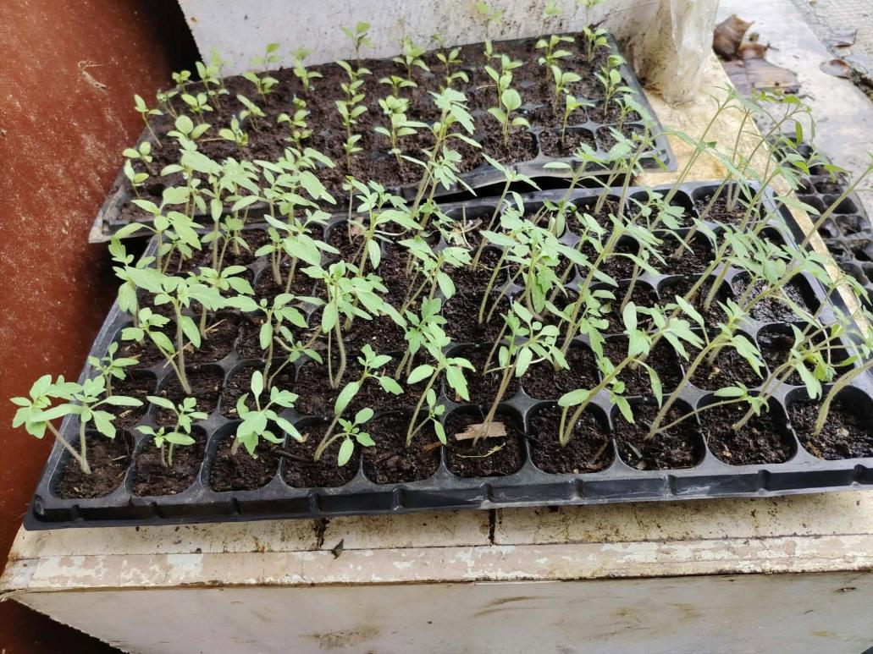

Plant Name: Tomato
Local Name: Kamatis
Scientific Name: Solanum lycopersicum
Family: Solanaceace
Category: Vegetable Plant
Location Found: Farm Land, Dapa Siargao
Origin: South America.
Habitat: Gardens, farms, and places with sunlight.
Uses: Used in cooking, salads, sauces, and other foods.
Description: A tomato (kamatis) is a small, round fruit that is usually red when ripe. It has a juicy texture, soft inside, and a slightly sweet and sour taste. It is commonly used in salads, sauces, and different Filipino dishes.

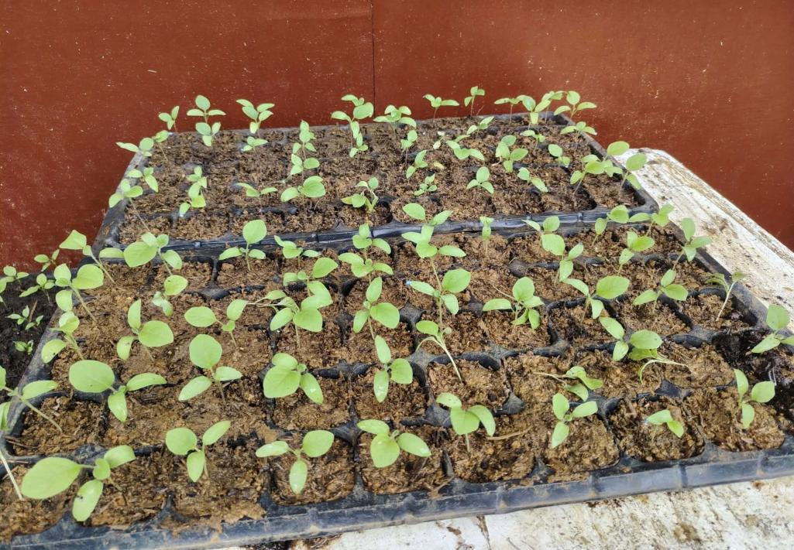

Plant Name: Egg Plant
Local Name: Talong
Scientific Name: Solanum melongena
Family: Solanaceace
Category: Vegetable Plant
Location Found: Farm Land, Dapa Siargao
Origin: Southest Asia.
Habitat: Gardens and farms with warm weather and well- drained soil.

Uses: Commonly cooked as food, especially in Filipino Dish.

Description: Eggplant (talong) is a purple, elongated vegetable with soft flesh and
small seeds inside. It has a mild taste and is commonly used in Filipino dishes like
tortang talong and pinakbet.

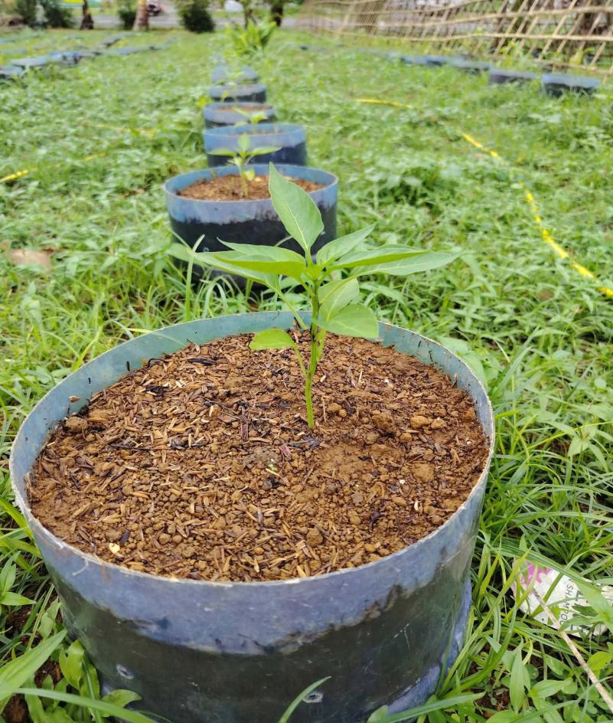

Plant Name: Water Spinanch
Local Name: Tangkong
Scientific Name: Ipomoea aquatica
Family: Convolvulaceae
Category: Vegetable Plant
Location Found: San Roque, Pilar Sdn
Origin: Tropical & subtropical Asia
Habitat: Wet soil, ponds, riversides, and canals.

Uses: It young leaves and steams are cooked as vegetables.

Description: Water spinach (Tangkong) is a green leafy vegetable with long,
hollow stems and soft leaves. It has a mild taste and is commonly used in Filipino
dishes like adobong kangkong.

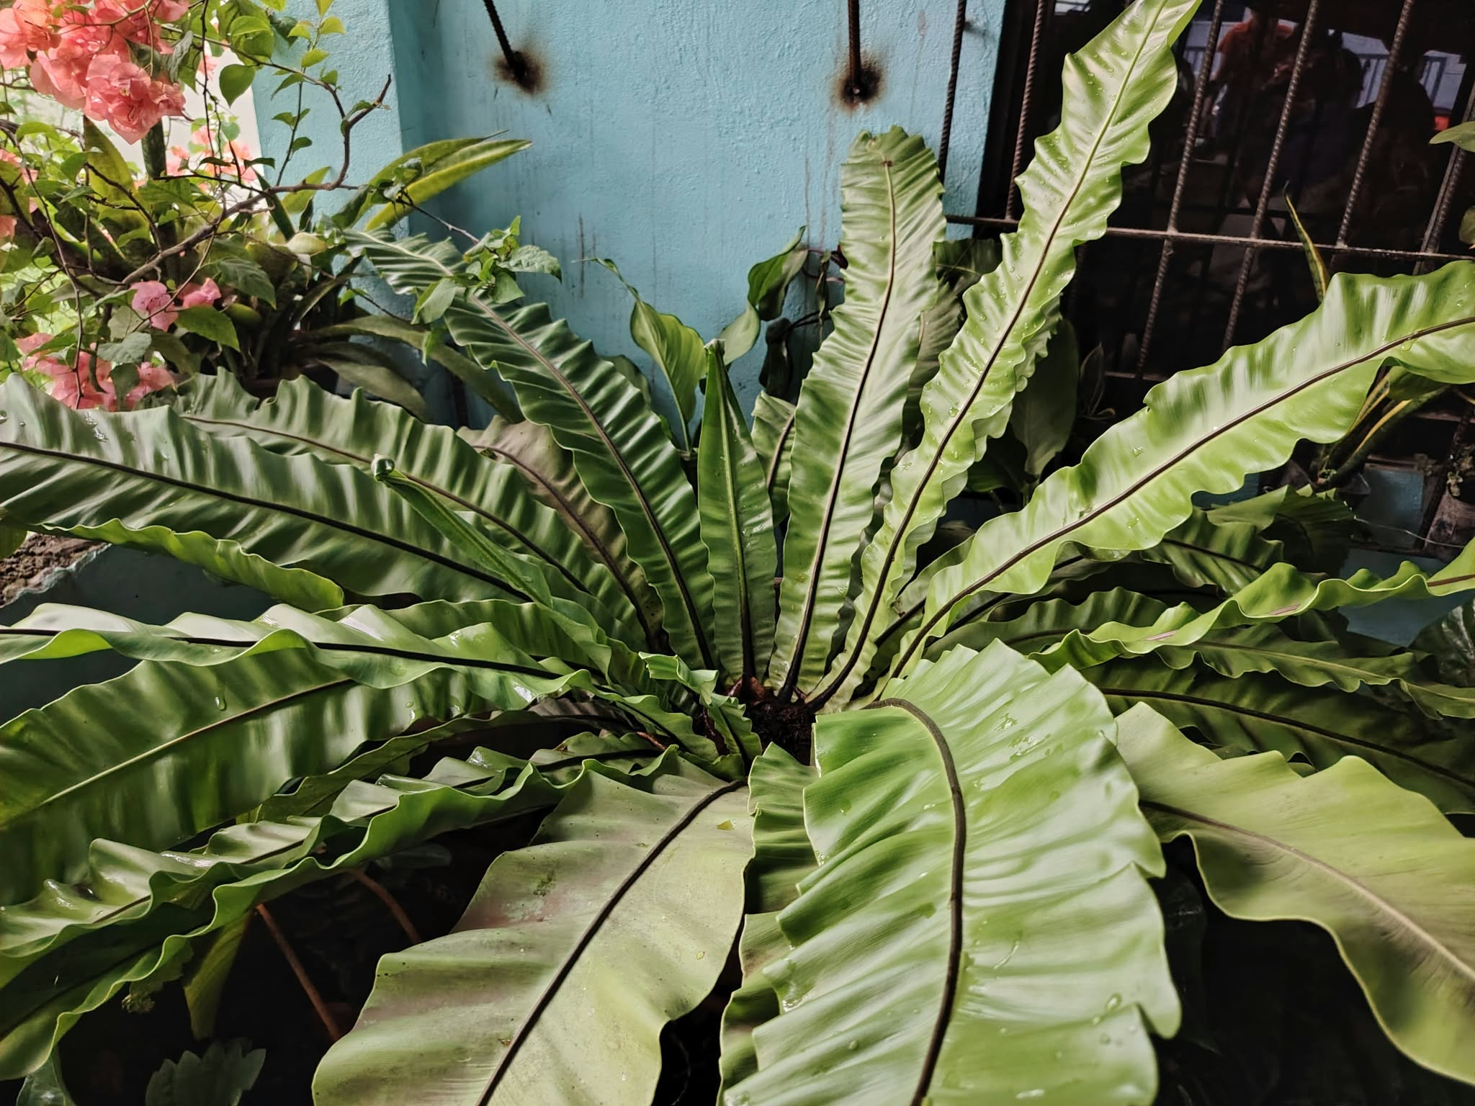

Plant Name: Bird’s Nest Fern
Local Name: Pako
Scientific Name: Aspelenuim nidus

Family: Aspleniaceae

Category: Ornamental Plant

Location Found: General Luna, Siargao

Origin: Tropical Asia

Habitat: Shady forests, tree trunks, and moist gardens.

Uses: Used as an ormental plant for gardens and home decoration.

Description: Bird’s Nest Fern (Pako) is a green leafy plant with long, wide leaves
that grow in a circular shape. It usually grows in shady and moist places and is
commonly found on trees or rock

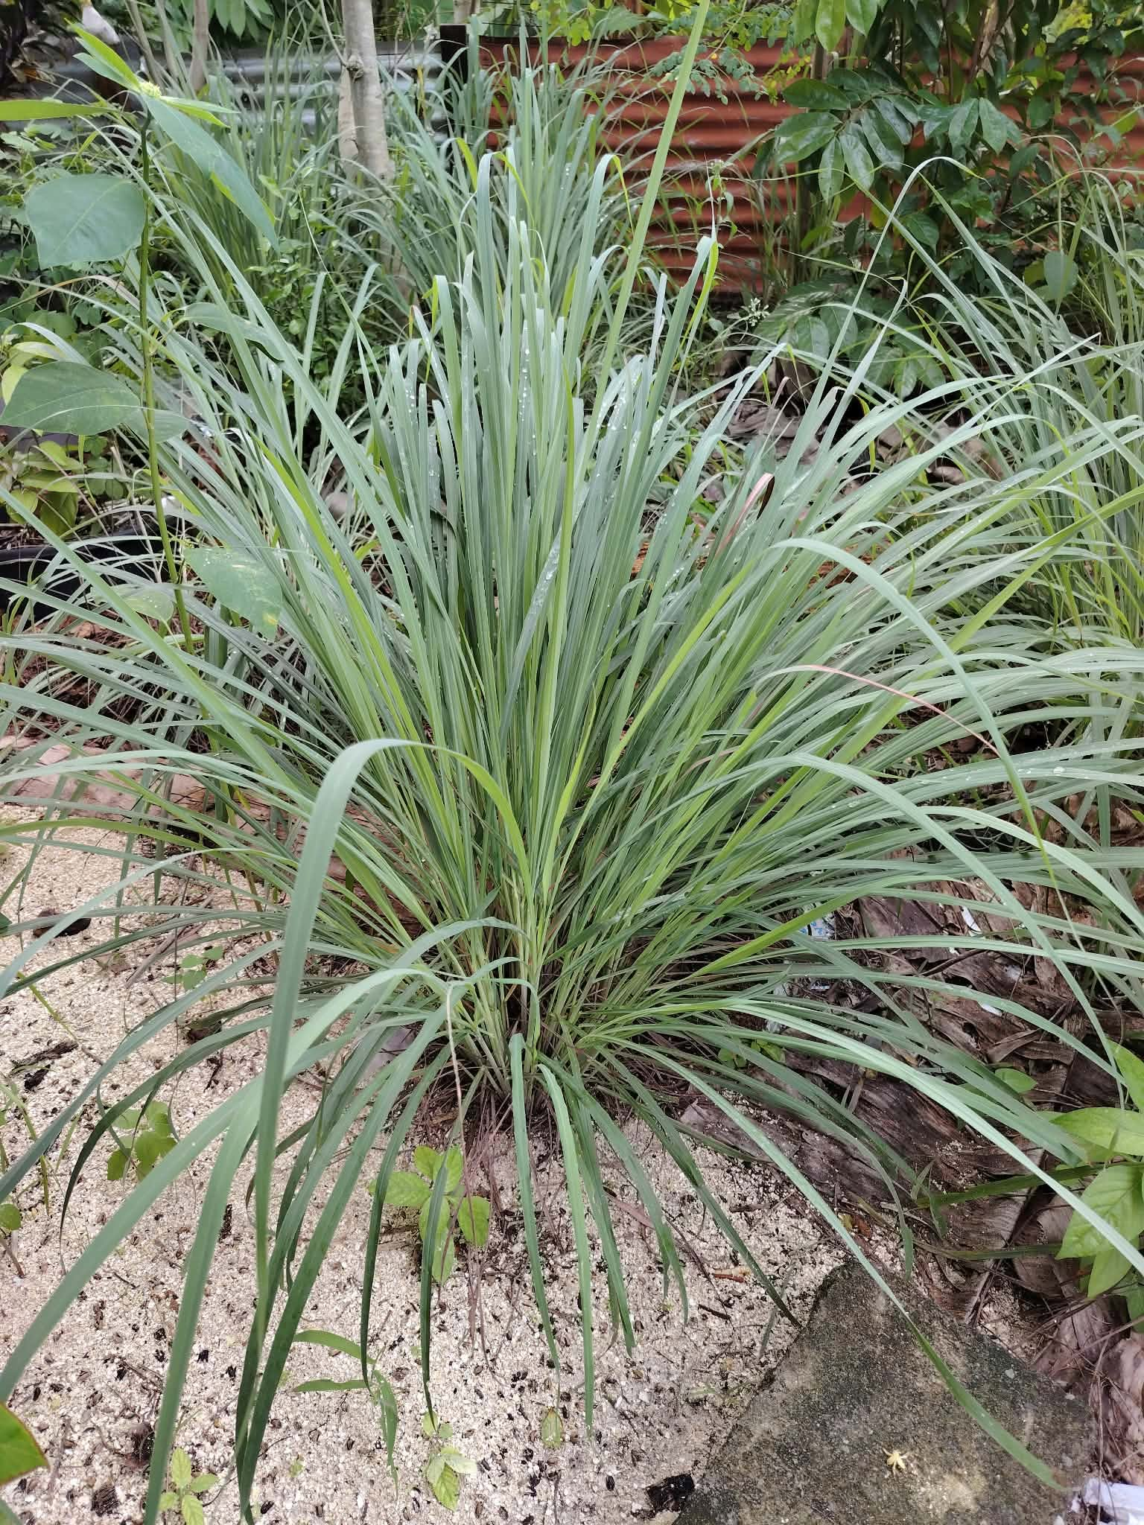

Plant Name: Lemongrass
Local Name: Tanglad
Scientific Name: Cymbopogon citratus
Family: Poaceae
Category: Herb
Location Found: Home gardens and farms in Pilar, Surigao del Norte
Origin: Southeast Asia.
Habitat: Grows in tropical climates with plenty of sunlight and well-drained soil.
Uses: Used as a cooking ingredient, herbal tea, and natural fragrance.
Description: Lemongrass(tangyad) is a grass-like plant with long, narrow green leaves. It has a fresh lemon-like smell and is commonly used in Filipino cooking.

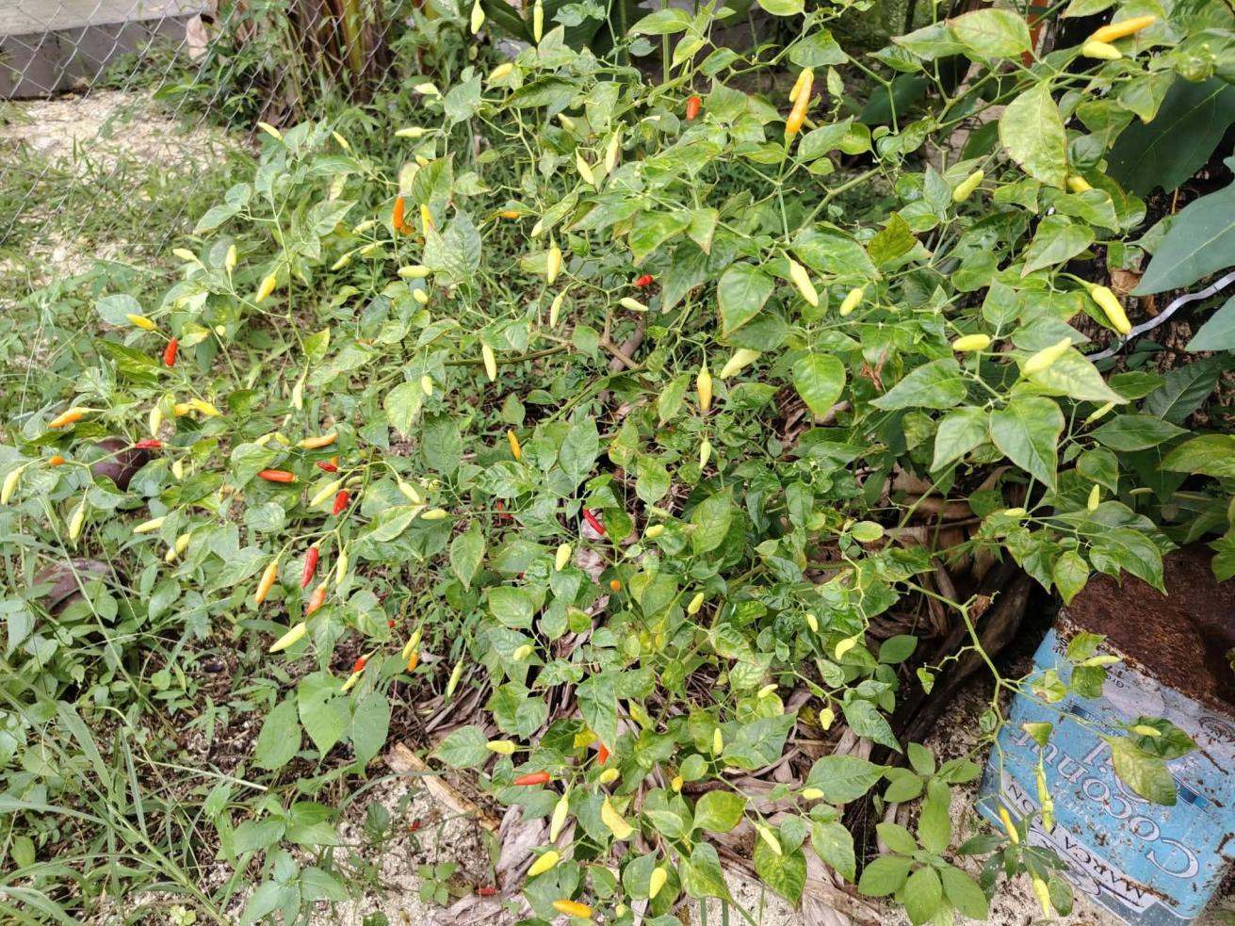
Plant Name: Chili Pepper
Local Name: Sili
Scientific Name: Capsicum frutescens
Family: Solanaceae
Category: Vegetable / Fruit
Location Found: Home gardens and farms in General Luna, Surigao del Norte.
Origin: Tropical America.
Habitat: Grows in warm climates with sunlight and fertile, well-drained soil.
Uses: Used as a spice in cooking and for adding a spicy flavor to food.
Description: Chili pepper (sili) is a small plant with green leaves and small fruits that turn red when mature. Its fruits have a hot and spicy taste.

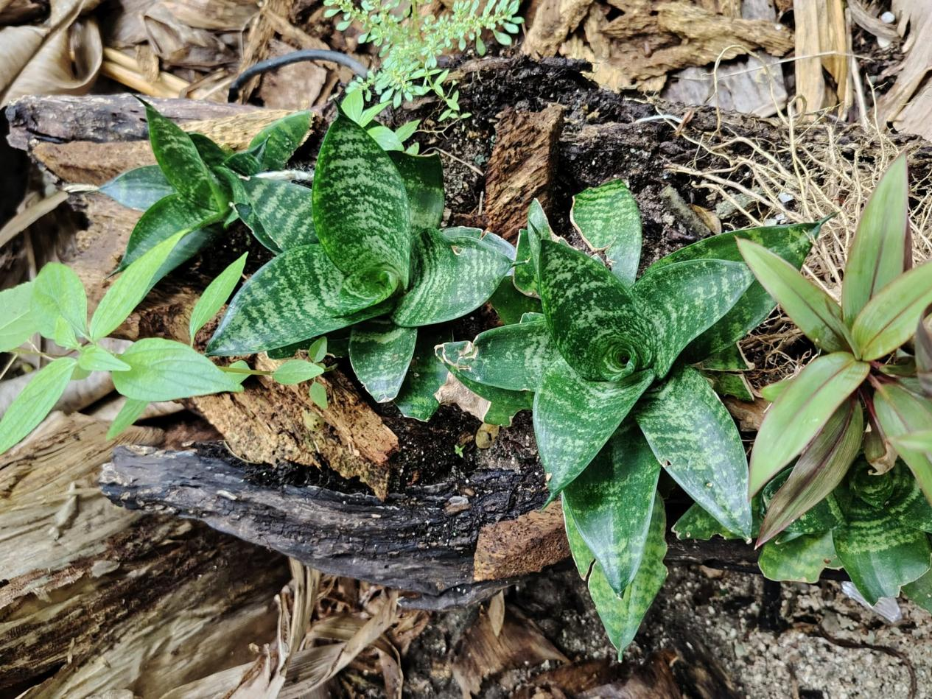
Plant Name: Snake Plant
Local Name: Sawa-Sawa
Scientific Name: Dracaena trifasciata
Family: Asparagaceae
Category: Ornamental Plant
Location Found: Home gardens and outdoor or indoor spaces in General Luna, Surigao del Norte.
Origin: Tropical West Africa.
Habitat: Grows in warm environments and can survive in dry soil with little water.
Uses: Used as an ornamental plant and for decoration.
Description: Snake (Sawa-Sawa) plant has long, upright, sword-shaped leaves with green and yellow patterns. It is easy to maintain and does not need frequent watering.

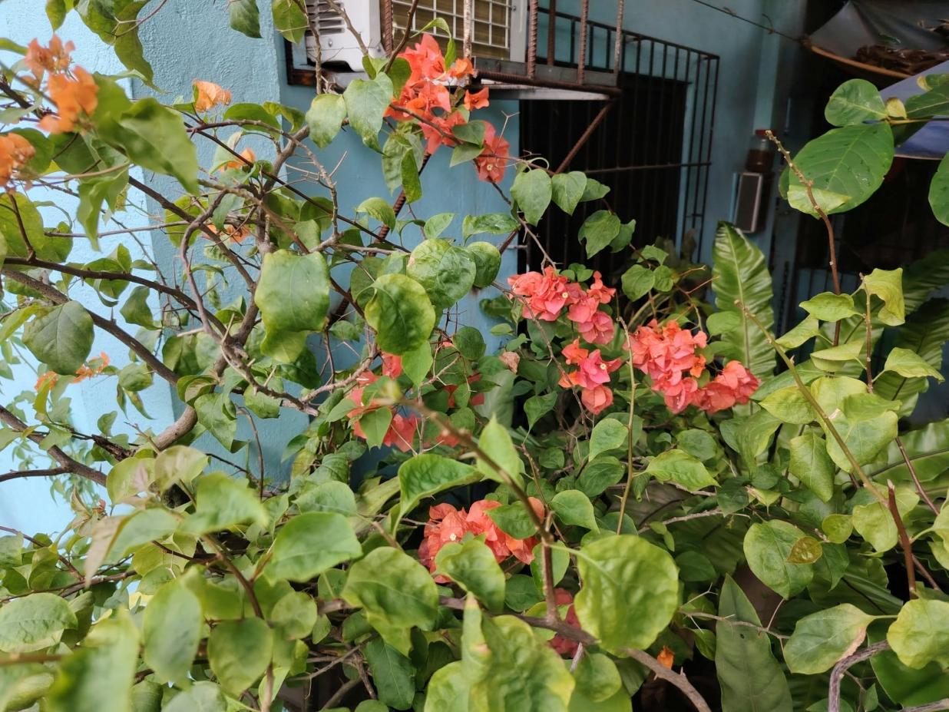
Plant Name: Paper Flower
Local Name: Bougainvillea / Bugambilya
Scientific Name: Bougainvillea glabra
Family: Nyctaginaceae
Category: Ornamental Plant
Location Found: Gardens, yards, and roadsides in Libertad, General Luna, Surigao del Norte.
Origin: South America.
Habitat: Grows in sunny places with well-drained soil.
Uses: Used for garden decoration, landscaping, and beautifying surroundings.
Description: Paper (Bagumbilya) flower is a climbing or bushy plant with colorful, paper-like leaves called bracts. Its colors include pink, purple, red, orange, and white.

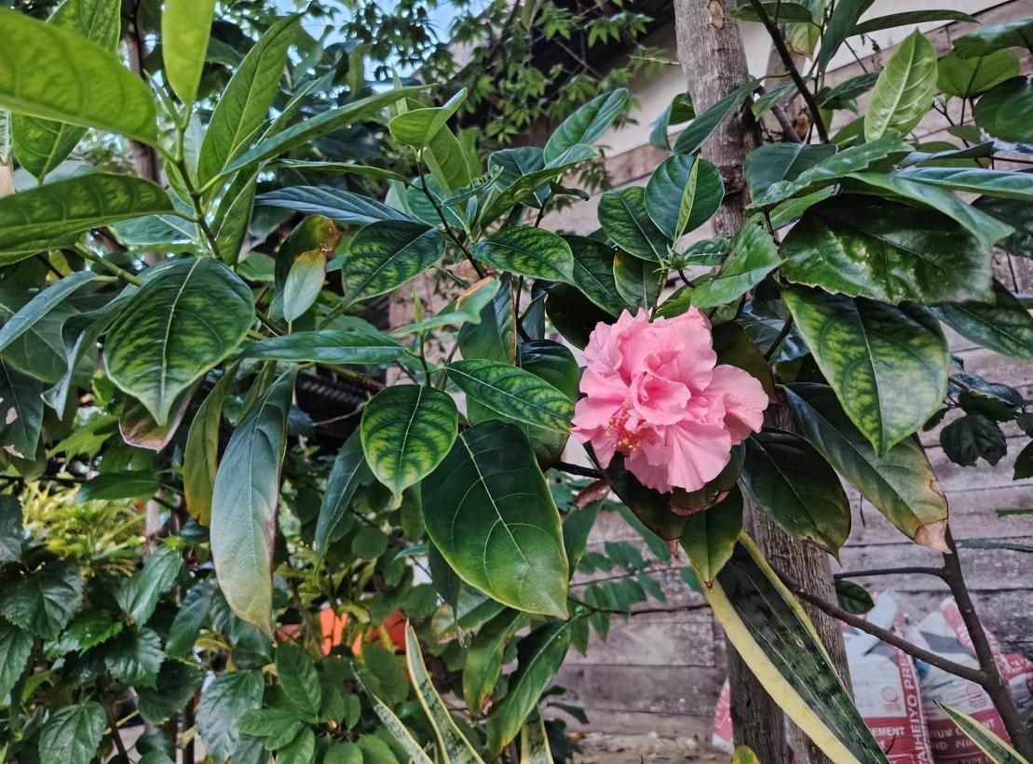

Plant Name: Double-Flowered Chinese Hibiscus
Local Name: Gumamela
Scientific Name: Hibiscus rosa-sinensis
Family: Malvaceae
Category: Ornamental Plant
Location Found: Home gardens and landscaped areas in Libertad, General Luna, Surigao del Norte.
Origin: Tropical Asia, with its exact original native range uncertain.
Habitat: Grows in tropical climates with sunlight, regular watering, and fertile soil.
Uses: Used as an ornamental plant for garden decoration and landscaping.
Description: Double-flowered Chinese hibiscus (Gumamela) is a flowering shrub with large, colorful flowers containing several layers of petals. It commonly produces red, pink, orange, or yellow flowers.

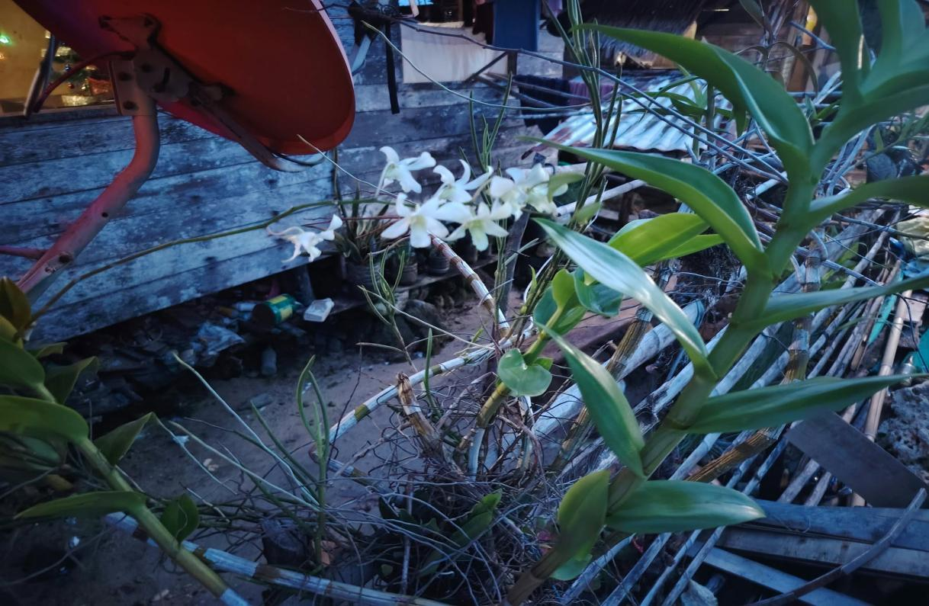
Plant Name: Orchids
Local Name: Orkid / Orchids
Scientific Name: Orchidaceae (family; exact species depends on the plant)
Family: Orchidaceae
Category: Ornamental Plant
Location Found: Dapa Surigao del Norte
Origin: Found naturally in many parts of the world, especially tropical regions.
Habitat: Commonly grows in tropical environments. Some orchids grow on tree branches, while others grow in soil.
Uses: Used for decoration, landscaping, flower arrangements, and collection.
Description: Orchids are flowering plants known for their beautiful and unique flowers. They come in different colors, shapes, and sizes. Some grow attached to trees while others grow in pots or soil.

