Siargao Flora — Working System Demonstration
System Integration and Architecture · Final Project
This document shows the working Siargao Flora system and serves as the script for the live demonstration. It explains how to set up and run the system, then walks through every feature with screenshots taken from the running system, and shows which part of the demonstration proves each project requirement.
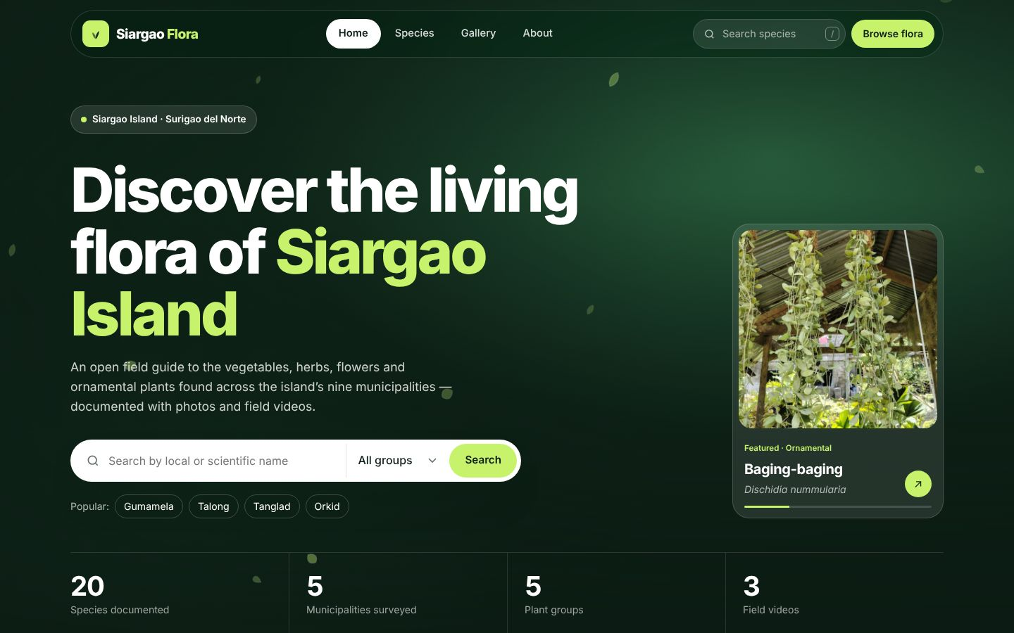
Figure 1. Siargao Flora home page (running on localhost).
Item | Details
System | Siargao Flora — web-based information system on the flowers and plants of Siargao Island
Website URL | http://localhost/flower&plant/
API base URL | http://localhost/flower&plant/api/
Database | siargao_flora (MySQL) — 20 species, 5 plant groups, 9 municipalities, 20 photos, 3 videos
Data source | Field data gathered in Dapa, Del Carmen, General Luna, Pilar and San Isidro

1. System requirements
Software | Purpose
XAMPP (Apache + PHP 8) | Web server that runs the website and the PHP REST API. Only Apache is started.
MySQL Server 8 + MySQL Workbench | Database server and the tool used to create and view the database.
Web browser (Chrome or Edge) | Opening the website.
Postman | Testing the API endpoints.
Git | Getting the latest project files from GitHub.
Python 3 (optional) | Running the command-line reuse demo.

2. Setting up and running the system
- Copy or clone the project into C:\xampp\htdocs\flower&plant (git pull for the latest version).
- Open MySQL Workbench → File → Open SQL Script → database\siargao_flora.sql → Execute (⚡). This creates the database with all records.
- Create api\config.local.php with the MySQL user, password, port, 'db_name' => 'siargao_flora' and the API key.
- Open the XAMPP Control Panel and start Apache.
- Check the API: open http://localhost/flower&plant/api/ — it must show "status": "ok", "database": "connected", "species": 20.
- Open the website: http://localhost/flower&plant/. The About page shows "Connected — this website is reading live data from the REST API."

Before the presentation
Start Apache and keep MySQL Server running.
Open the intro with http://localhost/flower&plant/index.php?intro=1 so it plays again.
Click anywhere on the page once before scrolling to the videos, so they play with sound.
In Postman, set the X-API-Key header value to the key in api/config.local.php.

3. Demonstration walkthrough
Follow these steps in order. Each step lists what to do, a screenshot of the expected result, and what it demonstrates.

3.1 Logo intro
- Open http://localhost/flower&plant/index.php?intro=1. The animated logo plays for about 5 seconds, then the home page appears.

Figure 2. Animated Siargao Flora logo intro.

3.2 Home page
- Point out the search bar, the featured plant card and the statistics (species, municipalities, plant groups, videos) — all loaded from the API.
- Scroll down to "Commonly found on the island" and click the group tabs (Vegetable, Herb, Ornamental, Fruit, Palm).
- Show "Browse by group" with the number of species in each group.
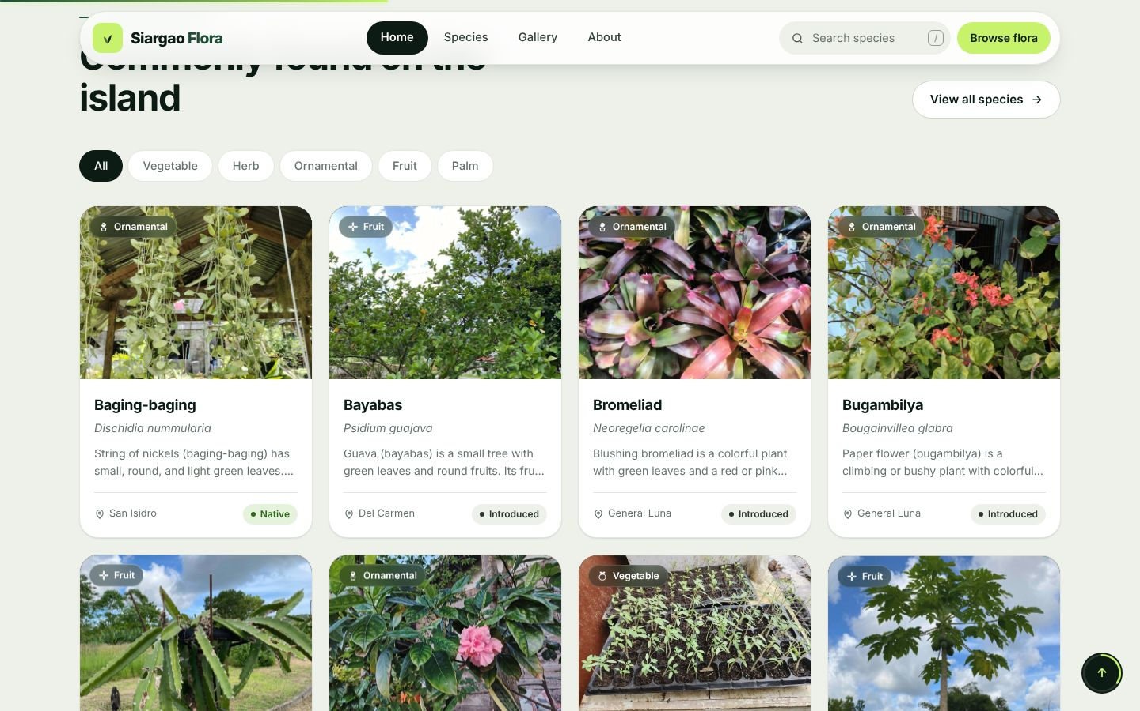
Figure 3. Featured species with plant-group tabs.
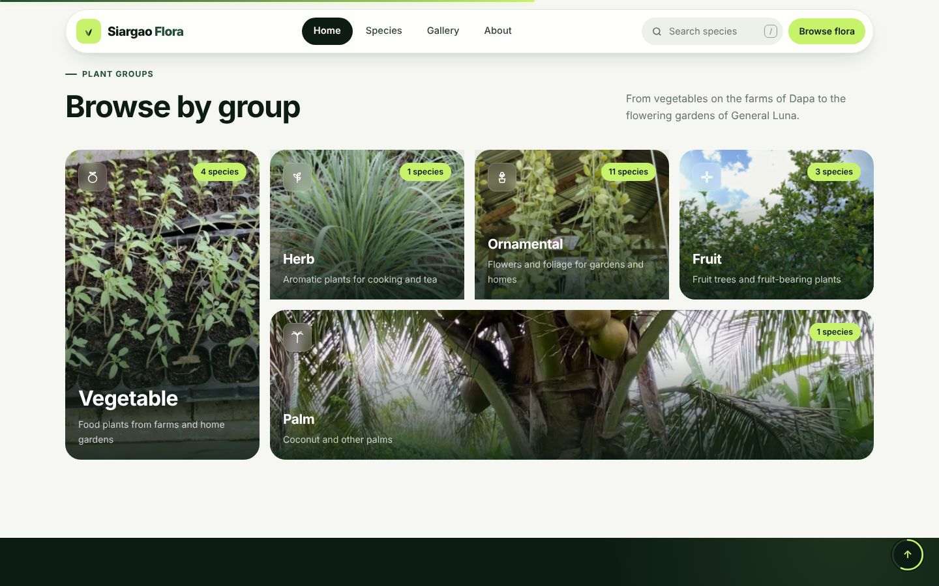
Figure 4. Plant groups with species counts.
- Scroll to "See them where they grow": the field video plays automatically when it scrolls into view, and the next video starts when one ends.
- Scroll to "Recorded across nine municipalities": the bars show how many species were recorded in each town.
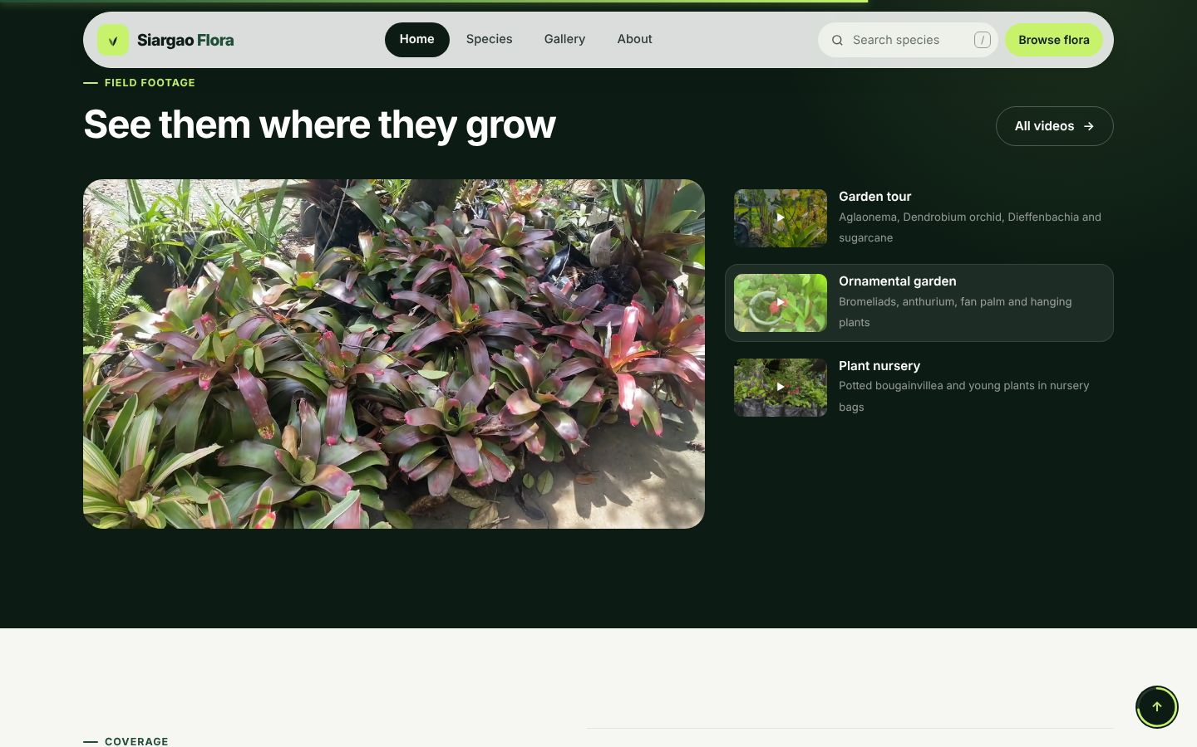
Figure 5. Field videos with autoplay and playlist.
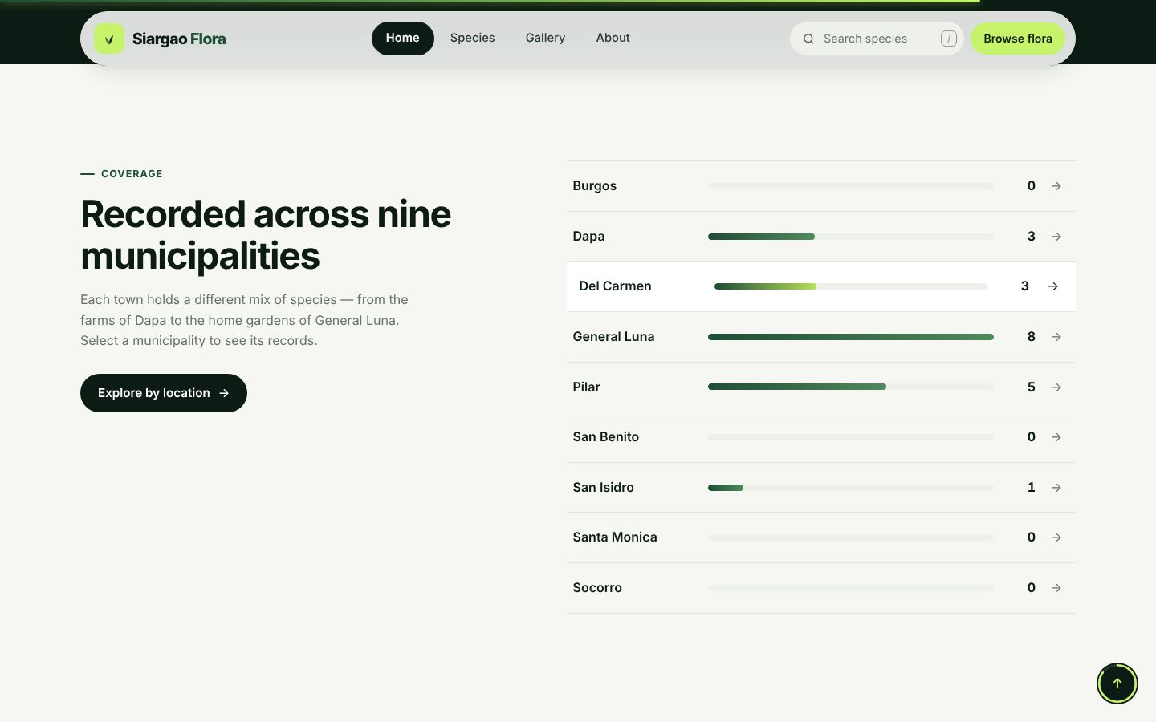
Figure 6. Species recorded per municipality.
What this demonstrates
✔ The website consumes its own API: every number, card and video comes from GET requests (JSON).
✔ Photos and videos gathered in the field are displayed.

3.3 Species directory — search, filter and pagination
- Click Species in the menu. It shows "10 of 20 species" per page.
- Scroll down and click Next → page 2 shows the other 10 species.
- Use the filters: click "Fruit" under Plant group, choose a municipality, or type a name in the search box (e.g. "gumamela").
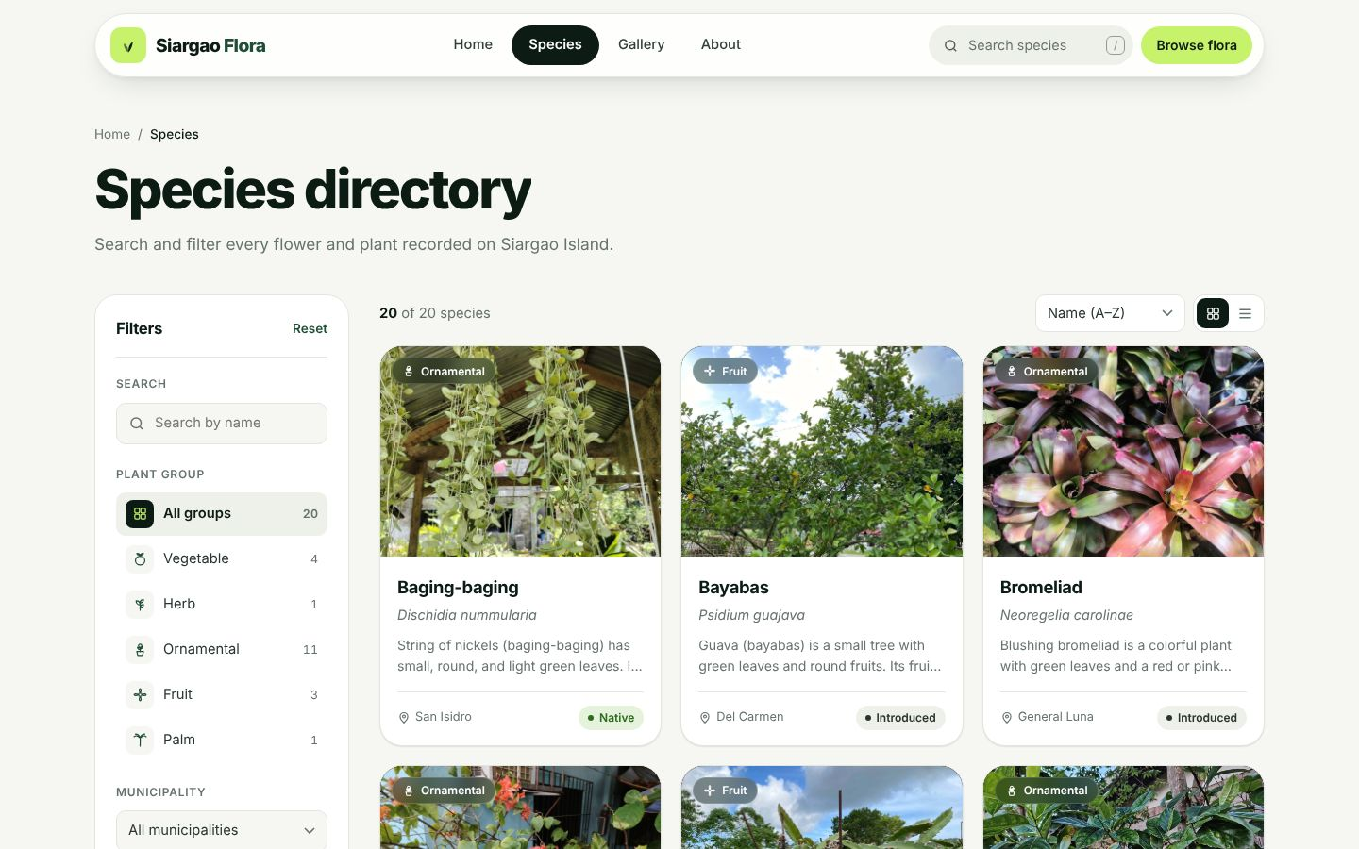
Figure 7. Species directory with filters.
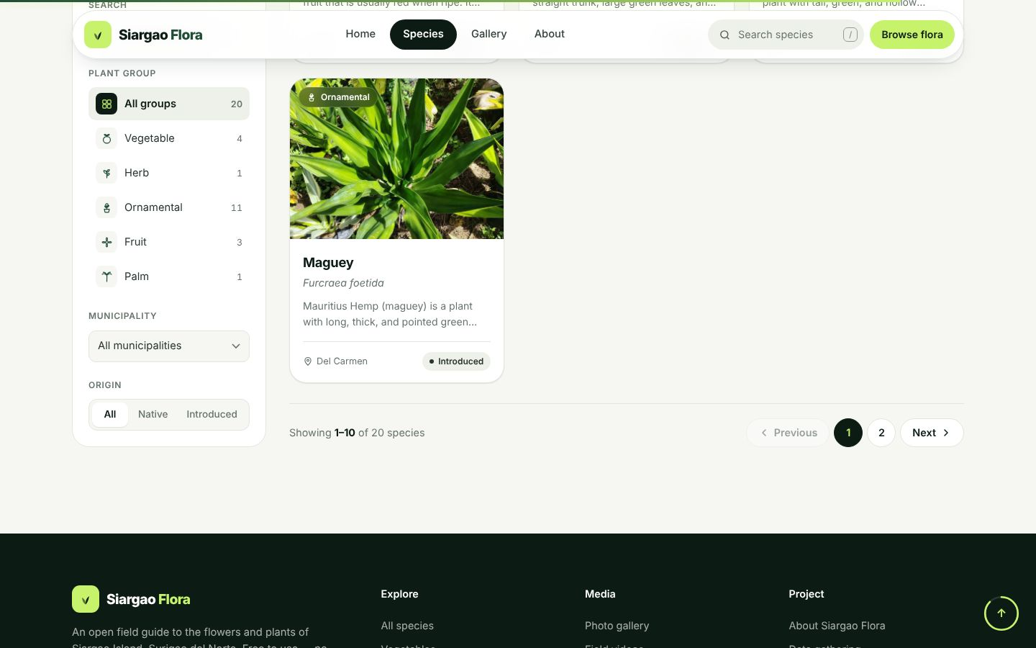
Figure 8. Pagination: 10 species per page with Previous / Next.
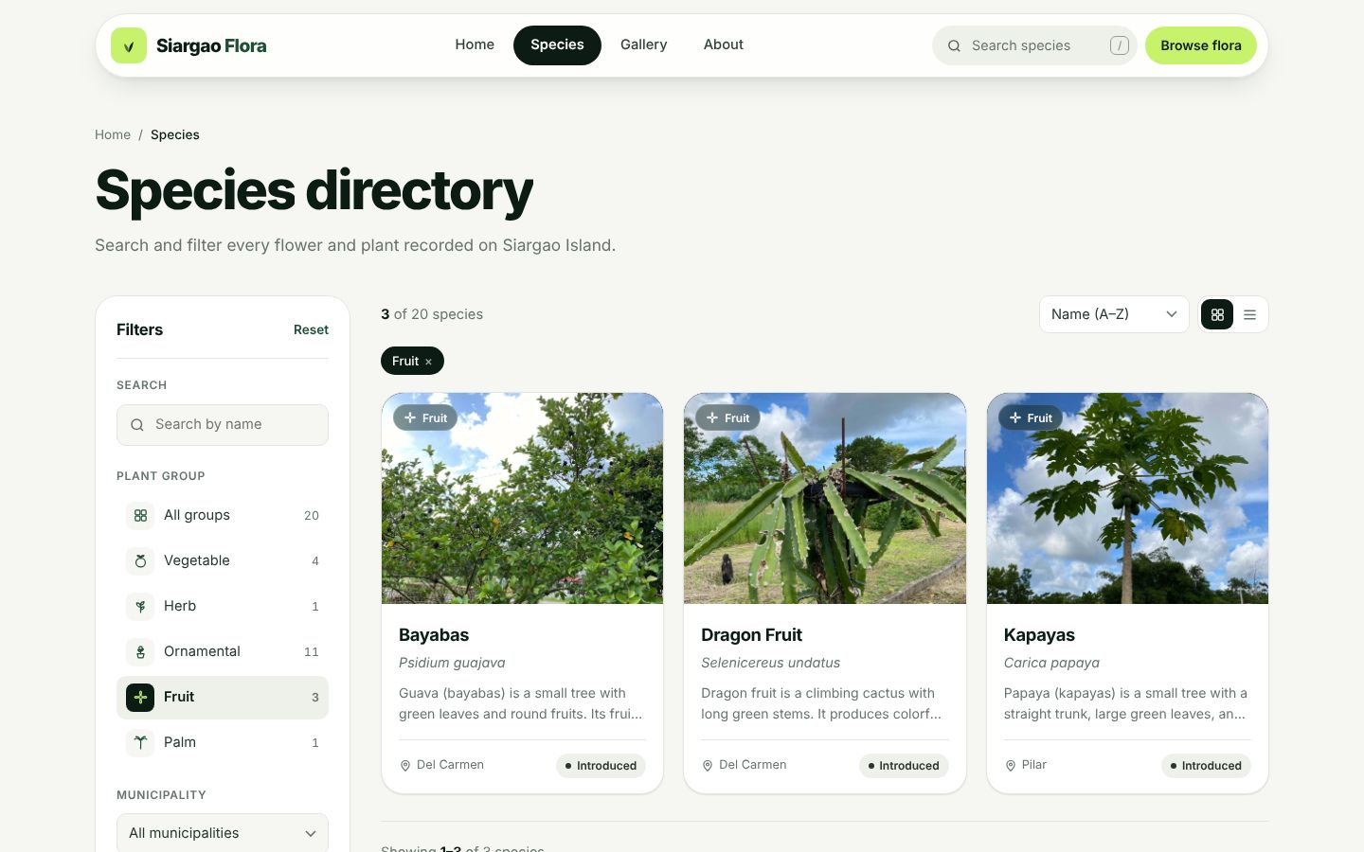
Figure 9. Filtered by the Fruit group.
What this demonstrates
✔ GET request for all records, with filters.
✔ Pagination of the collected records.

3.4 Species page — one record
- Click any plant (e.g. Gumamela). The page shows its photo, names, description, quick facts, uses and the municipalities where it was recorded.
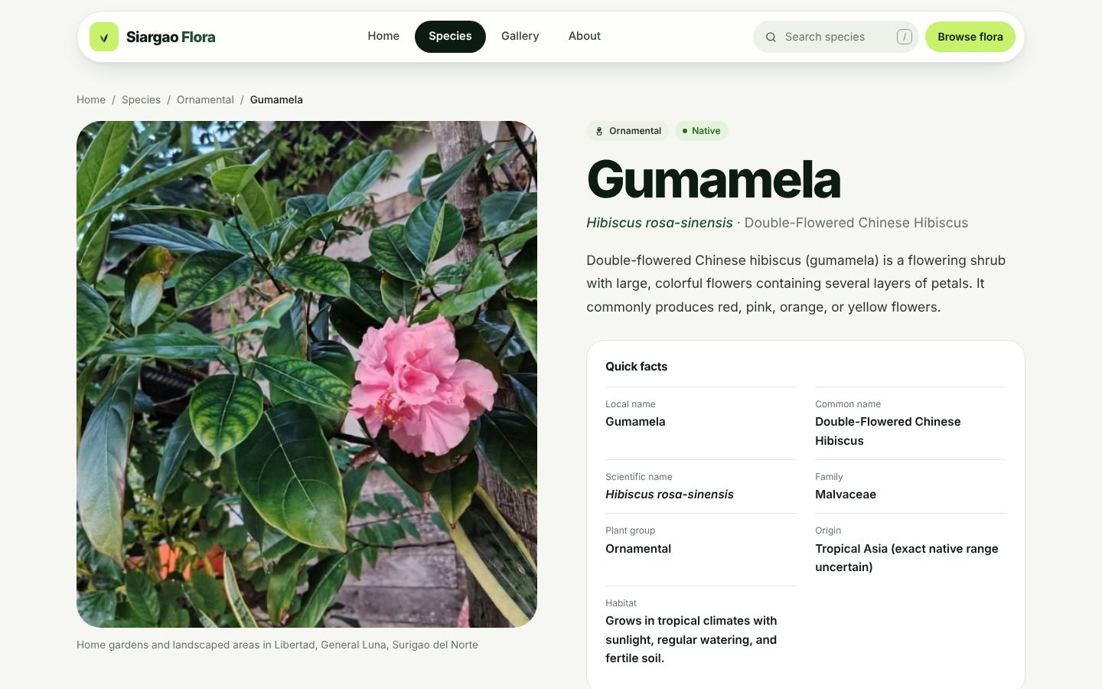
Figure 10. Detail page of a single species.
What this demonstrates
✔ GET request for a specific record (api/species.php?id=gumamela).

3.5 Gallery
- Click Gallery. Use the All / Photos / Videos tabs.
- Click a photo: the viewer shows the photo on the left and the plant information on the right. Use the arrows or the keyboard to move to the next item.
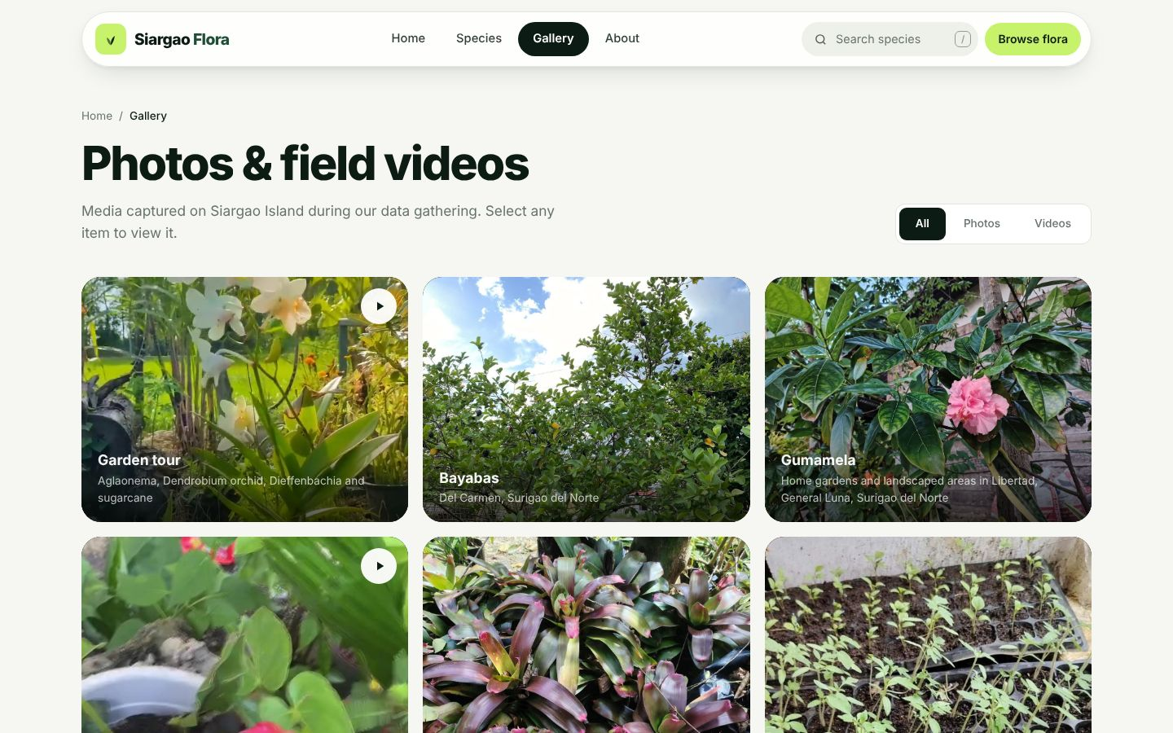
Figure 11. Gallery of field photos and videos.
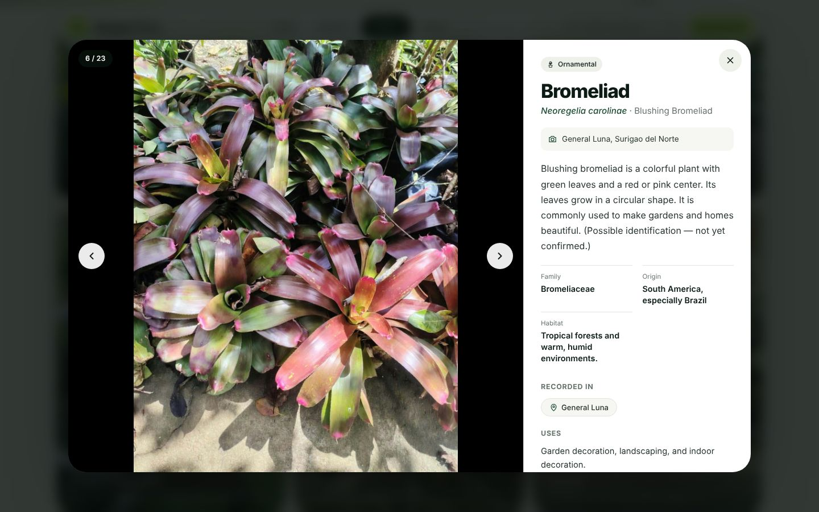
Figure 12. Gallery viewer with plant information.

3.6 About page — live API tester and ERD
- Open About and scroll to "Try the API live". Click the preset buttons (All species, One species, Categories, 404 error) to send real requests and show the JSON response and status code.
- Scroll to "How the data is organized" to show the database structure (ERD).
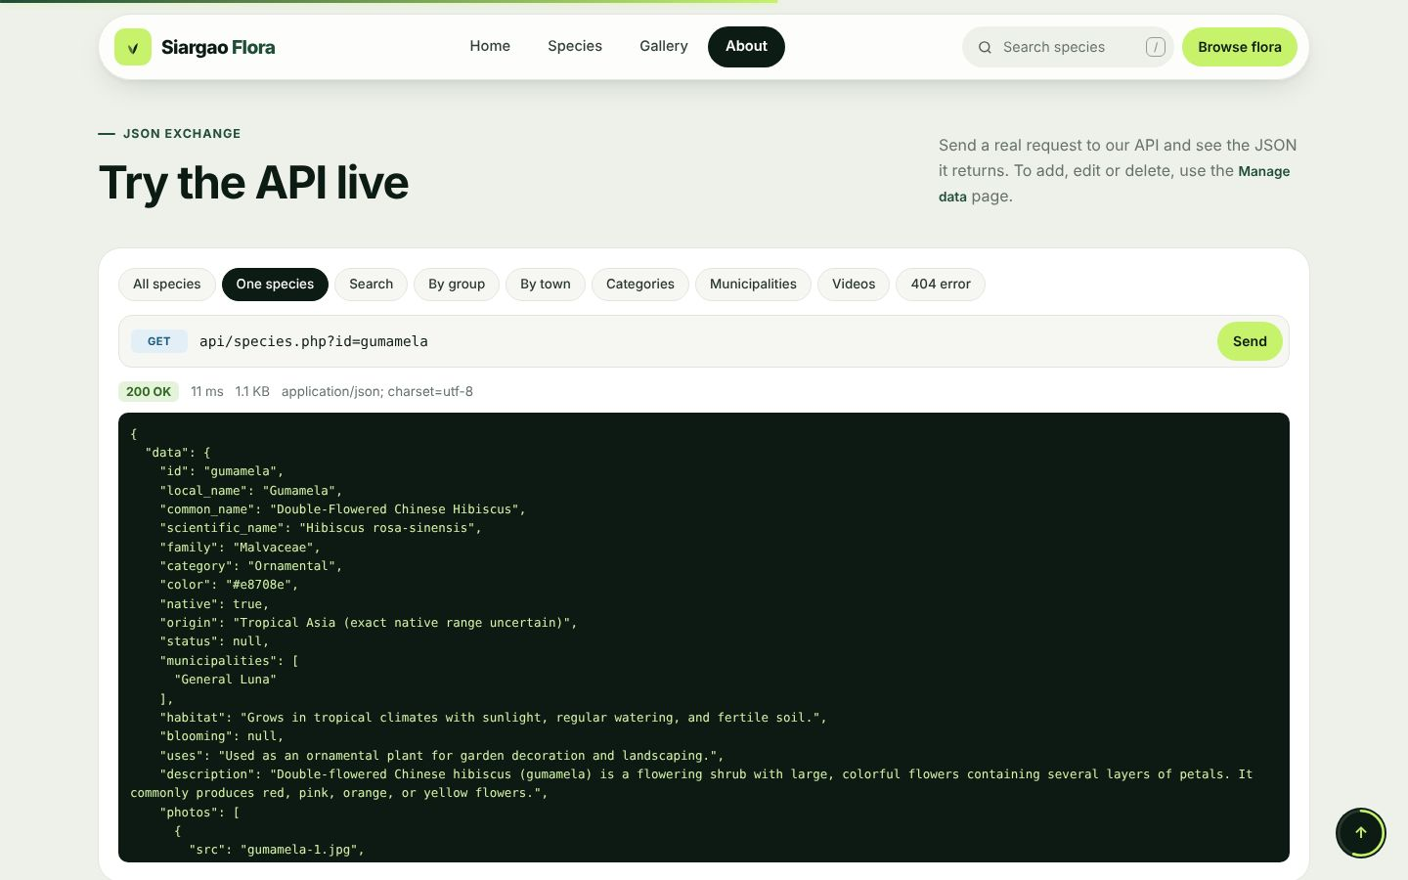
Figure 13. Live API tester showing the JSON response.
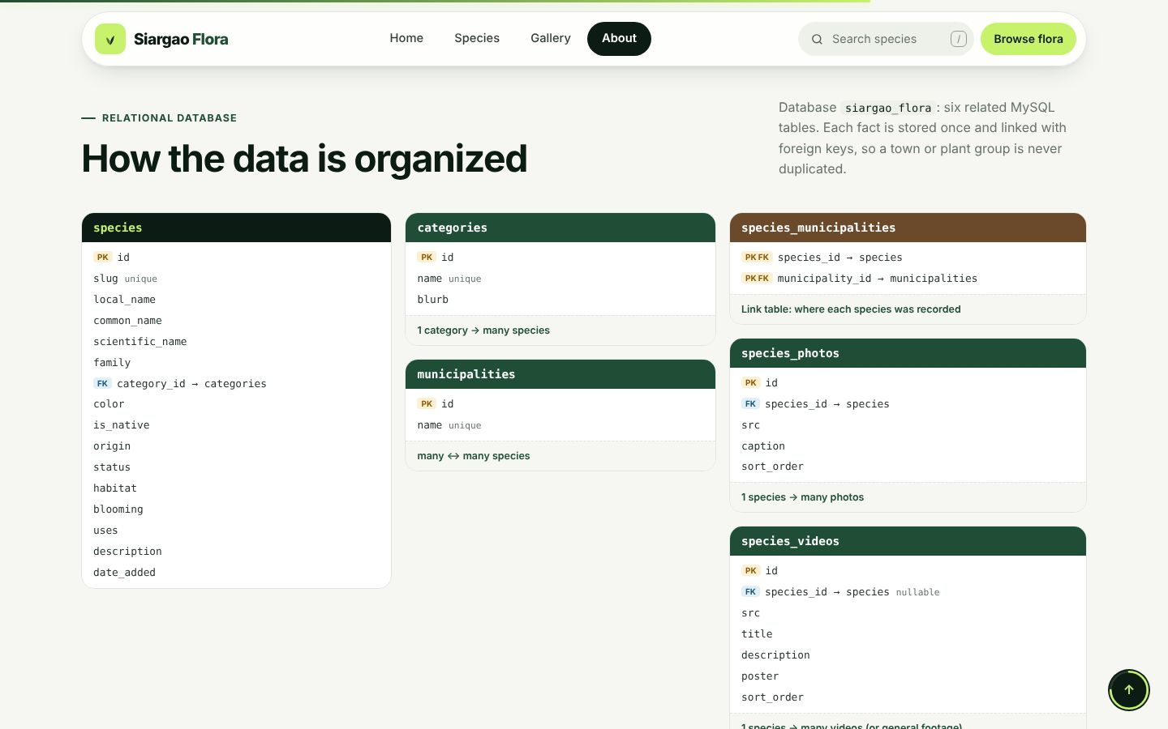
Figure 14. Database structure on the About page.
What this demonstrates
✔ JSON is the data exchange format between the website and the API.
✔ The relational database design (6 tables, foreign keys).

3.7 Manage data — POST, PUT and DELETE from the website
- Open the footer link Manage data. Enter the API key and click Use key.
- Click + Add species, fill in the form (e.g. Kalamansi, Citrus microcarpa, group Fruit, town Dapa) and click Save species → POST, status 201.
- Change a field (e.g. Status) and click Update species → PUT, status 200.
- Click the trash icon next to the species and confirm → DELETE, status 200.
- Show the API log at the bottom: each request's method, URL, status, JSON body and JSON response.
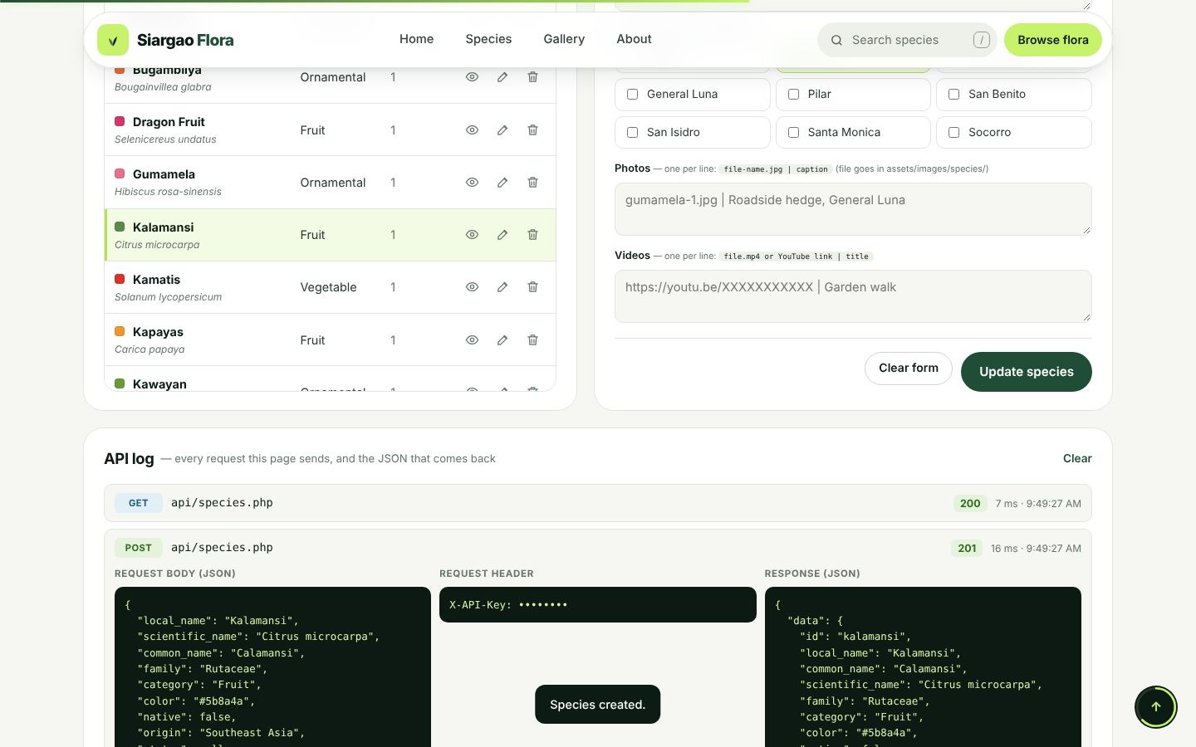
Figure 15. Manage data page after creating a species (POST).
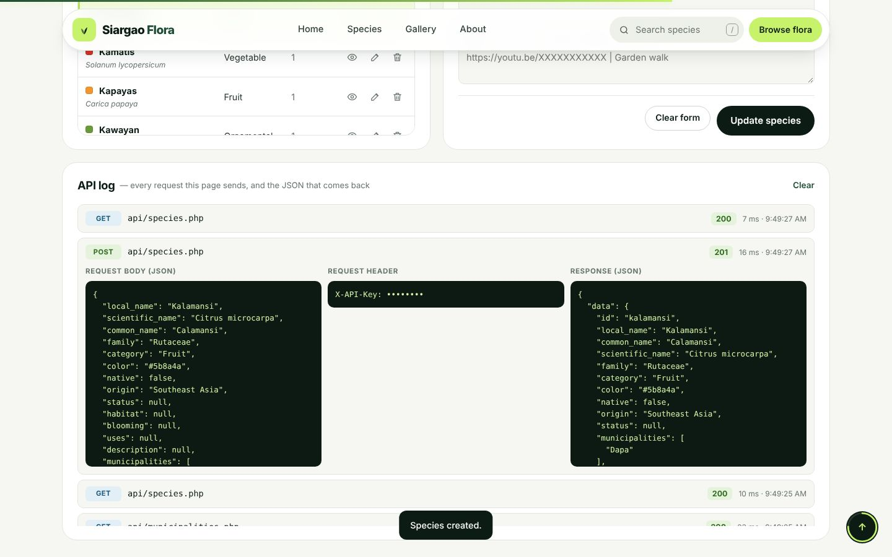
Figure 16. API log with the JSON request and response.
What this demonstrates
✔ POST, PUT and DELETE requests from the website.
✔ API key protection: without the key the API answers 401 Unauthorized.

3.8 API reused by other applications
- Open http://localhost/flower&plant/examples/. These three programs share no code with the website — they only call the API.
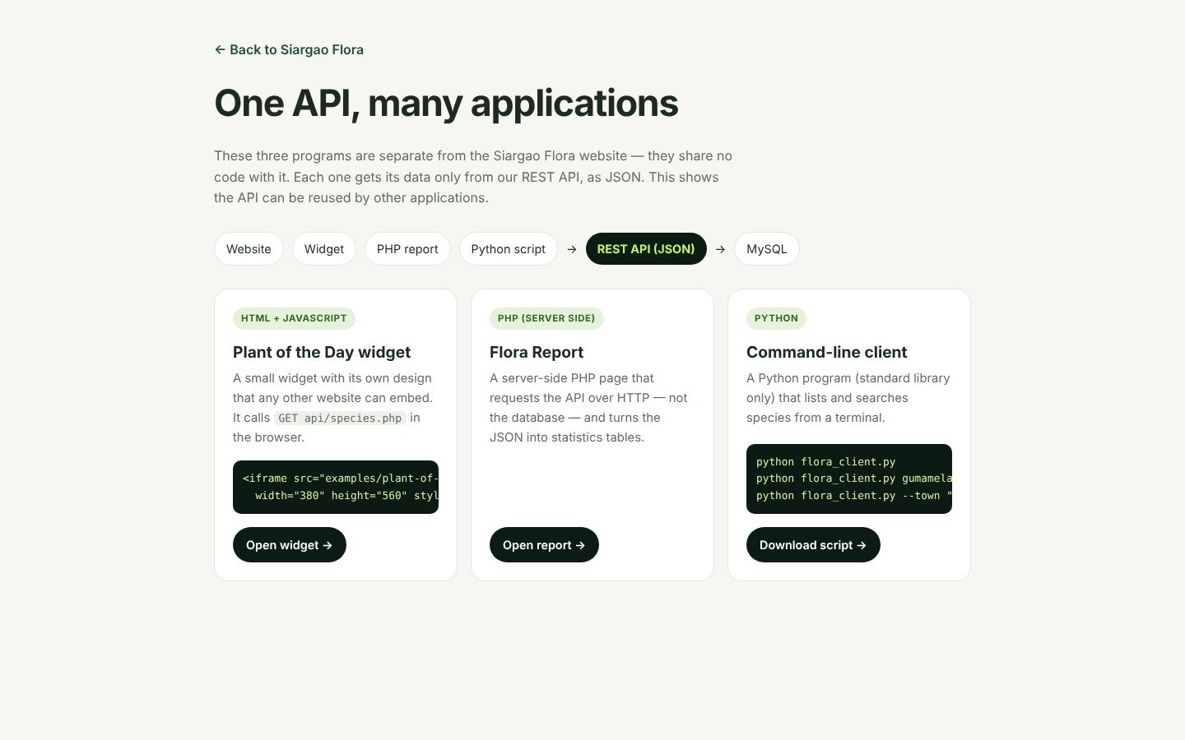
Figure 17. Overview of the API reuse demos.
- Open the Plant of the Day widget (an embeddable HTML + JavaScript app with its own design). Click "Show another".
- Open the Flora Report (a server-side PHP application that builds statistics from the API).
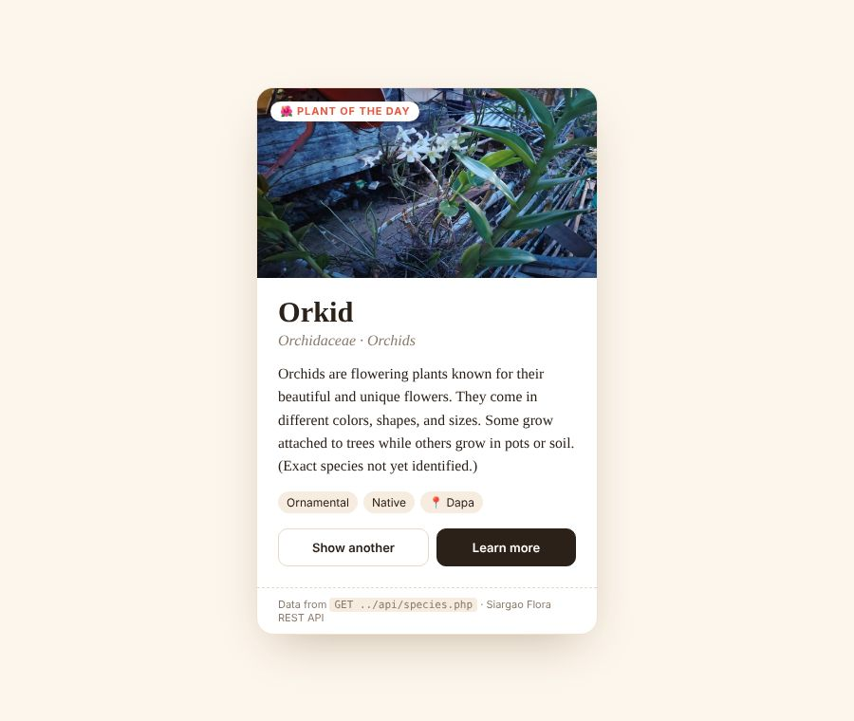
Figure 18. Plant of the Day widget (JavaScript).
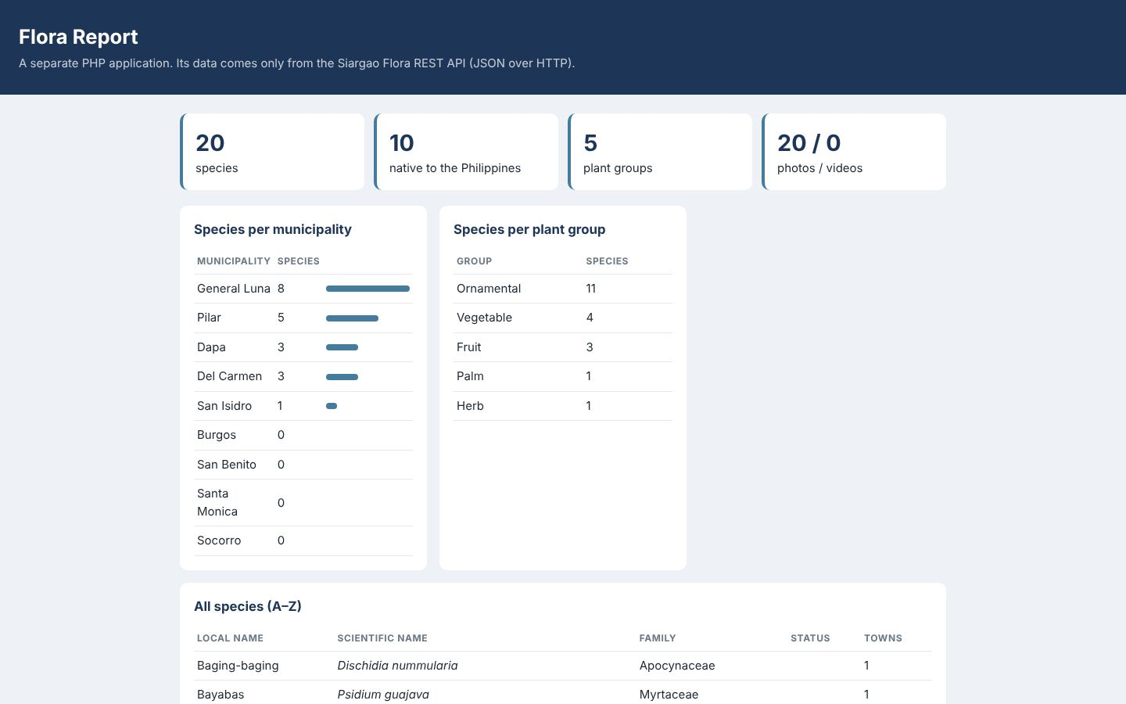
Figure 19. Flora Report (server-side PHP).
- Optional: run the Python client in a terminal: python examples\flora_client.py --town "Pilar"
Species recorded in Pilar (5)
----------------------------------------------------------------
Kapayas Carica papaya Fruit introduced
Kawayan Bambusa vulgaris Ornamental native
Sahod-Yaman Thaumatophyllum bipinnatifidum Ornamental introduced
Tangkong Ipomoea aquatica Vegetable native
Tanglad Cymbopogon citratus Herb native

What this demonstrates
✔ The same API is reused by applications written in JavaScript, PHP and Python.

3.9 Testing with Postman
- Import postman\Siargao-Flora.postman_collection.json and the environment file. Set apiKey to your key.
- Run the collection: 23 requests, 90 automatic tests — all pass.
- Show single requests: GET all, GET one, POST, PUT, DELETE, and invalid requests (401, 404, 409, 422, 400, 405).
Folder | Requests | Result
1. Health check | API status | Pass
2. Read data (GET) | List, search, filter by group and town, categories, municipalities, videos | Pass
3. Create, read, update, delete | POST → GET → PUT → GET → DELETE → GET (404) | Pass — data left unchanged
4. Error handling | 404, 401 (no key, wrong key), 422 (missing field, unknown group), 400, 405, 409 | Pass

3.10 Responsive design
The website adapts to phones and tablets. Open it on a phone, or press F12 in the browser and switch to a phone view.
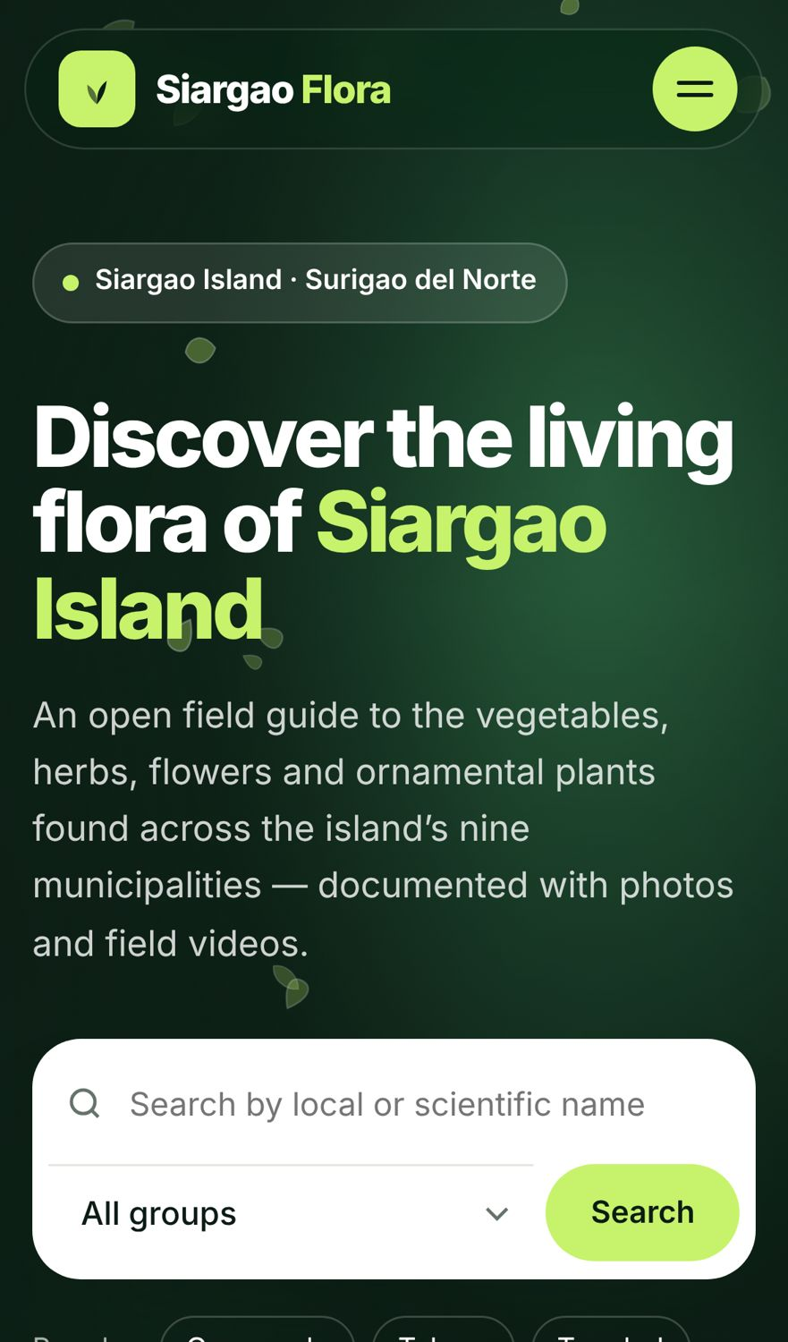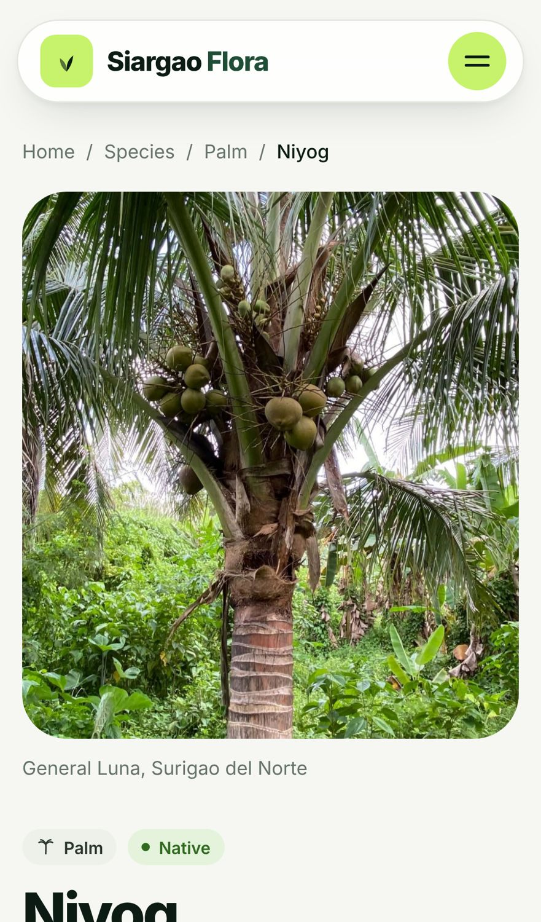
Figure 20. Home page and a species page on a phone.

4. Requirements demonstrated
Requirement | Where it is shown
Information gathered from Siargao organized in a database | 20 species with photos and videos; database siargao_flora (Section 3.2–3.5, Figure 14)
Relational database with keys and relationships | About → ERD; database/siargao_flora.sql (Figure 14)
RESTful API in PHP and MySQL | api/ folder; About → Try the API live (Figure 13)
GET request for all records | Species directory (Figures 7–9); Postman
GET request for a specific record | Species page (Figure 10); Postman
POST, PUT and DELETE requests | Manage data page (Figures 15–16); Postman
JSON responses | API tester and API log (Figures 13, 16); Postman
Appropriate responses for invalid requests | API tester "404 error"; Postman error folder; Manage page without key (401)
Website consumes its own API | Every page; About shows "Connected" (Section 3.2)
API tested with Postman | Section 3.9 — 23 requests, 90 tests
API reused by other applications | Widget, PHP report, Python client (Section 3.8)

5. Suggested demonstration order (about 10 minutes)
# | Part | Time | Section
1 | Logo intro and home page | 1.5 min | 3.1–3.2
2 | Species directory, filters and pagination | 1.5 min | 3.3
3 | Species page and gallery | 1.5 min | 3.4–3.5
4 | API tester and database design | 1.5 min | 3.6
5 | Manage data: POST, PUT, DELETE | 2 min | 3.7
6 | API reuse demos and Postman | 2 min | 3.8–3.9

6. Troubleshooting
Problem | Solution
API shows "Database connection failed" | Check user, password, port and db_name in api/config.local.php; make sure MySQL Server is running.
Website shows old or missing data | Run database/siargao_flora.sql again in Workbench, then press Ctrl + F5 in the browser.
401 Unauthorized in Postman or on Manage data | Header key must be exactly X-API-Key and its value must match api_key in config.local.php.
Page shows "Not Found" | Check the folder name in the URL (flower&plant) and that Apache is started.
Video plays without sound | Browsers block sound until the page is clicked — click once on the page, or press "Tap for sound".
Intro does not play | It plays once per browser session — add ?intro=1 to the URL.

