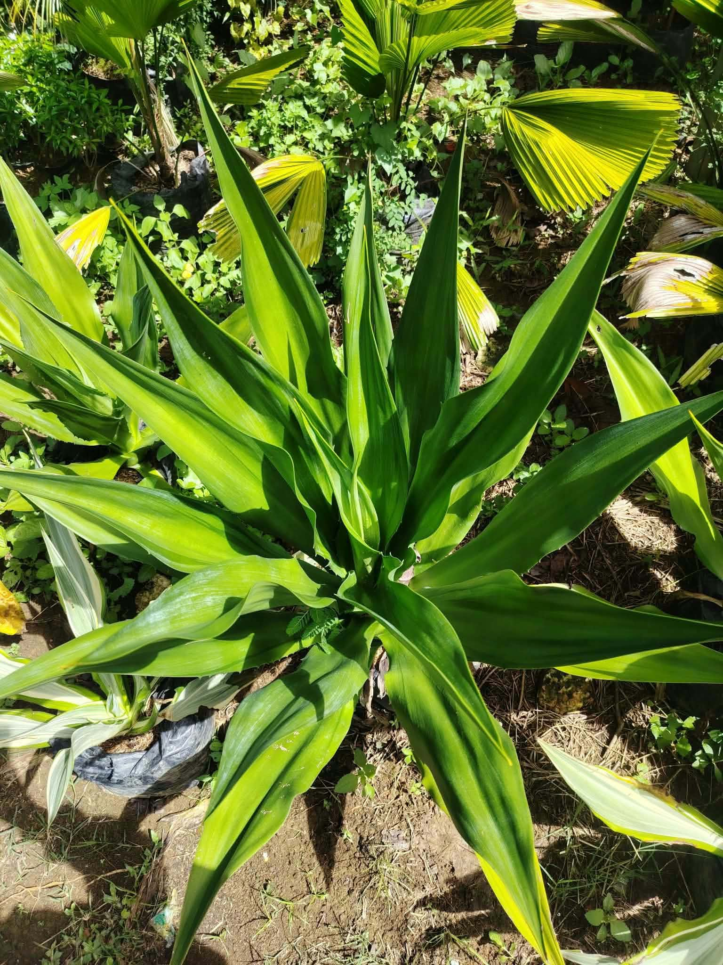

Plant Name: Mauritius Hemp
Local Name: Maguey
Scientific Name: Furcraea foetida (possible identification)
Family: Asparagaceae
Category: Ornamental and Fiber Plant
Location Found: Del Carmen S,D, N
Origin: Caribbean and northern South America
Habitat: Tropical and subtropical areas, especially sunny and dry places
Uses: Garden decoration and fiber production
Description: Mauritius Hemp is a plant with long, thick, and pointed green leaves. It can grow in hot and dry places. Its leaves can be used to produce natural fibers.
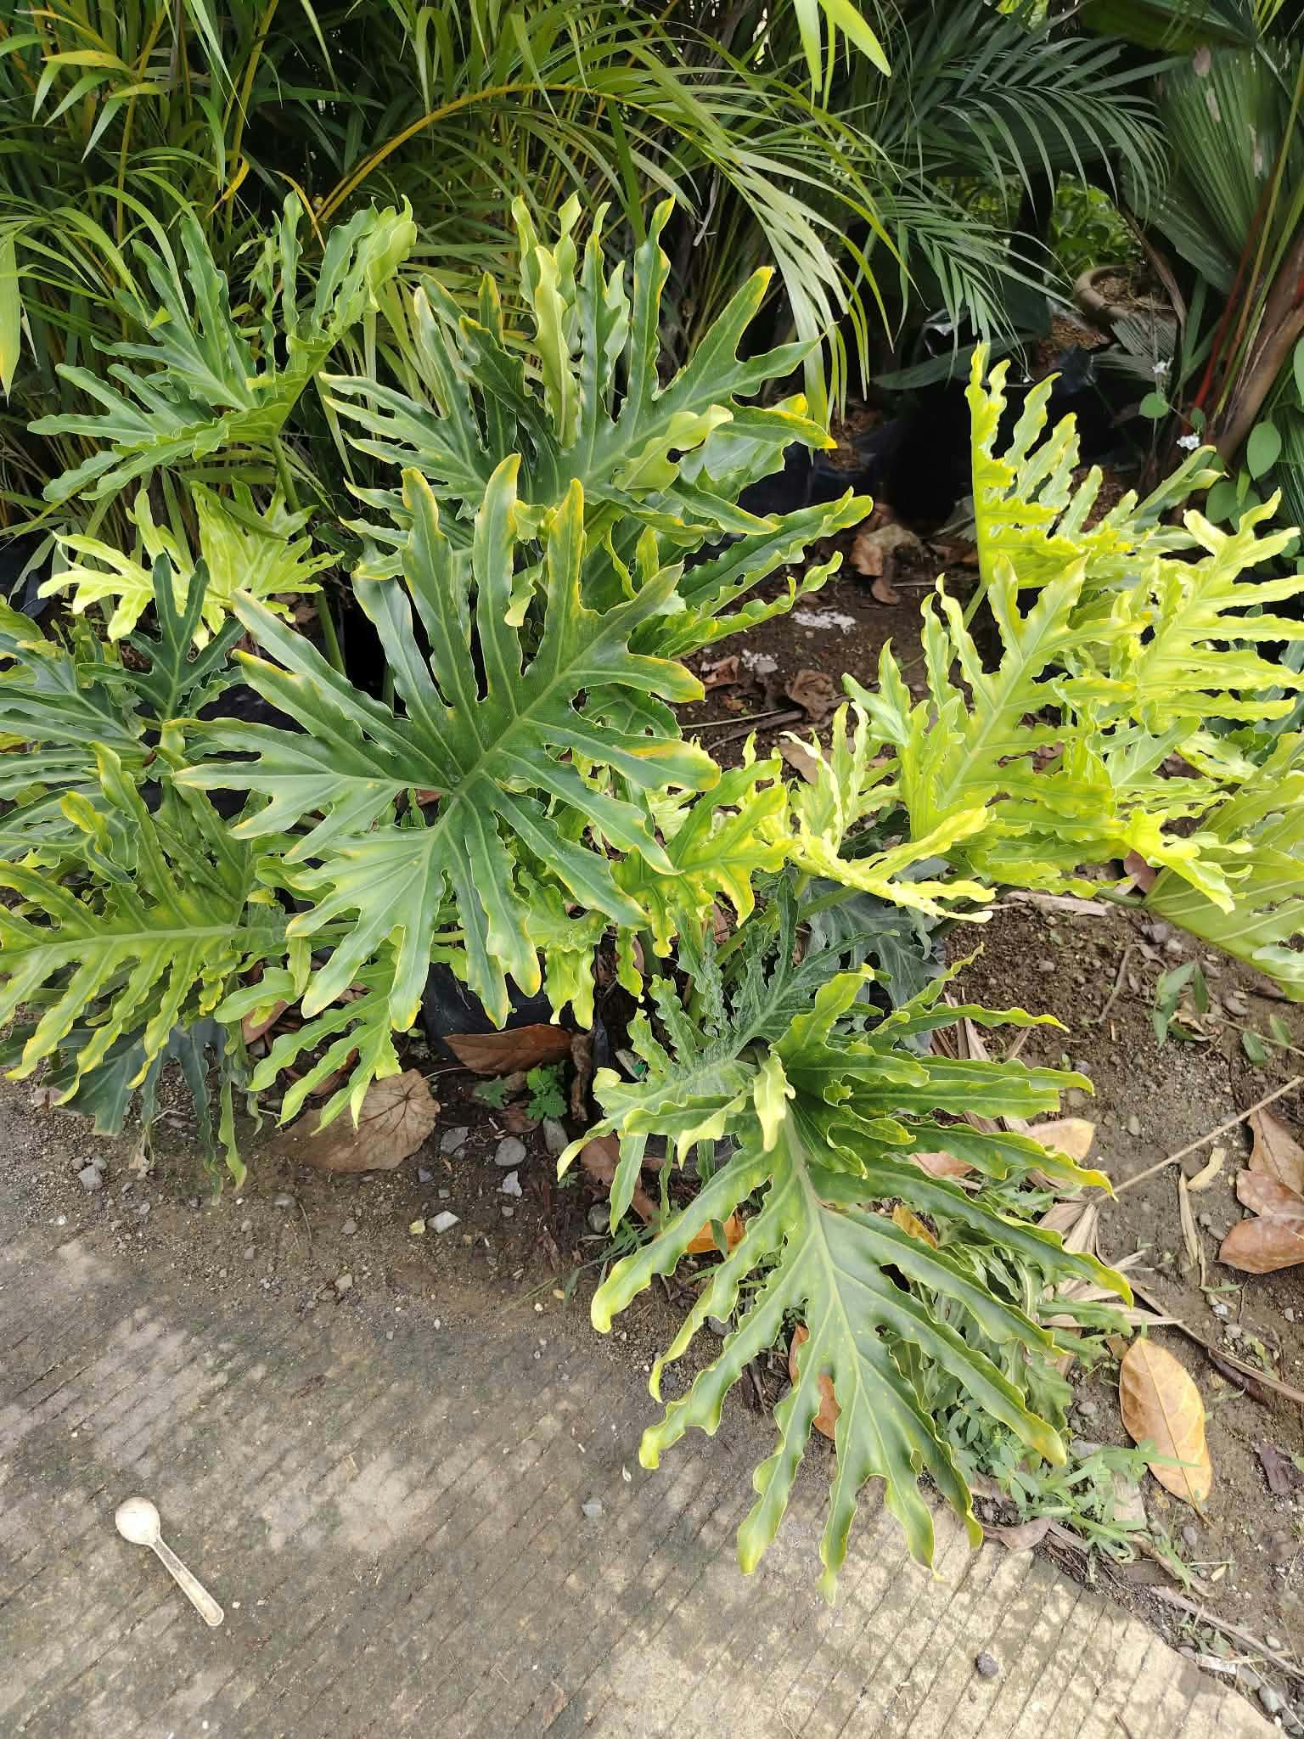

Plant Name: Tree Philodendron
Local Name: Sahod-Yaman
Scientific Name: Thaumatophyllum bipinnatifidum
Family: Araceae
Category: Ornamental Plant
Location Found: Pilar S,D,N
Origin: South America
Habitat: Tropical forests with moist soil and partial shade
Uses: Garden decoration and landscaping
Description: This plant has large green leaves with deep cuts along the edges. It grows well in warm places and makes gardens look beautiful.

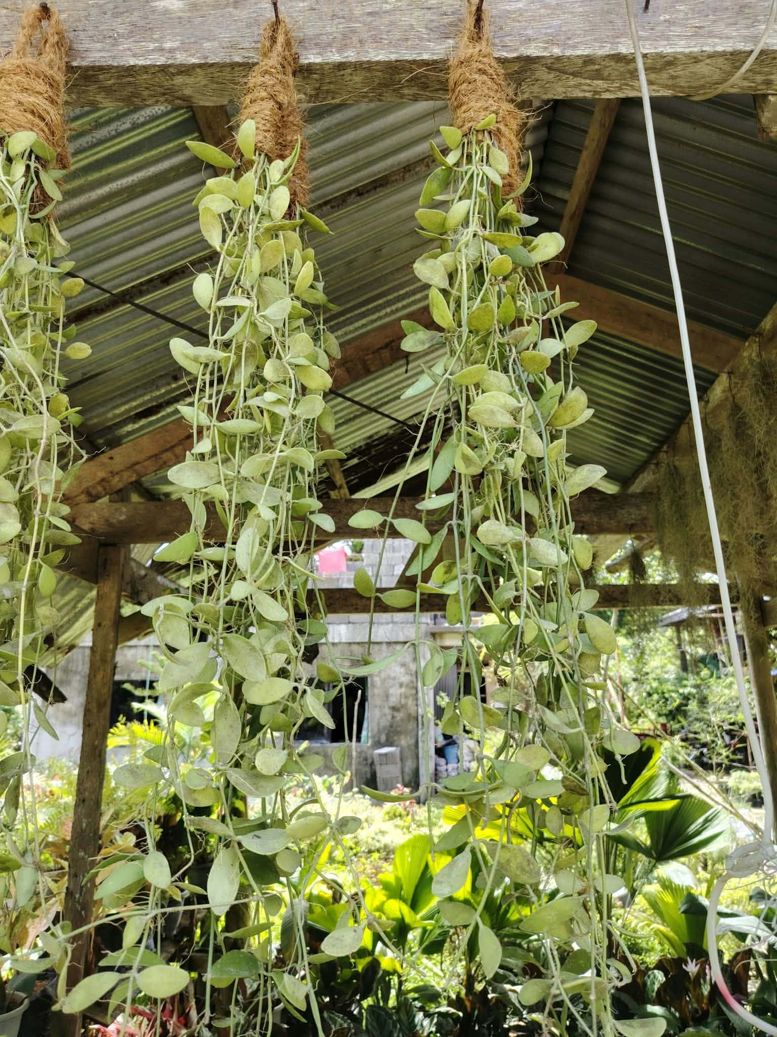
Plant Name: String of Nickels
Local Name: Baging-baging (local name may vary)
Scientific Name: Dischidia nummularia
Family: Apocynaceae
Category: Ornamental Hanging Plant
Location Found: San Isidro S,D,N
Origin: Southeast Asia and Australia
Habitat: Tropical forests, usually growing on tree branches
Uses: Hanging decoration and landscaping
Description: This plant has small, round, and light green leaves. Its long stems hang down, making it beautiful for hanging pots.

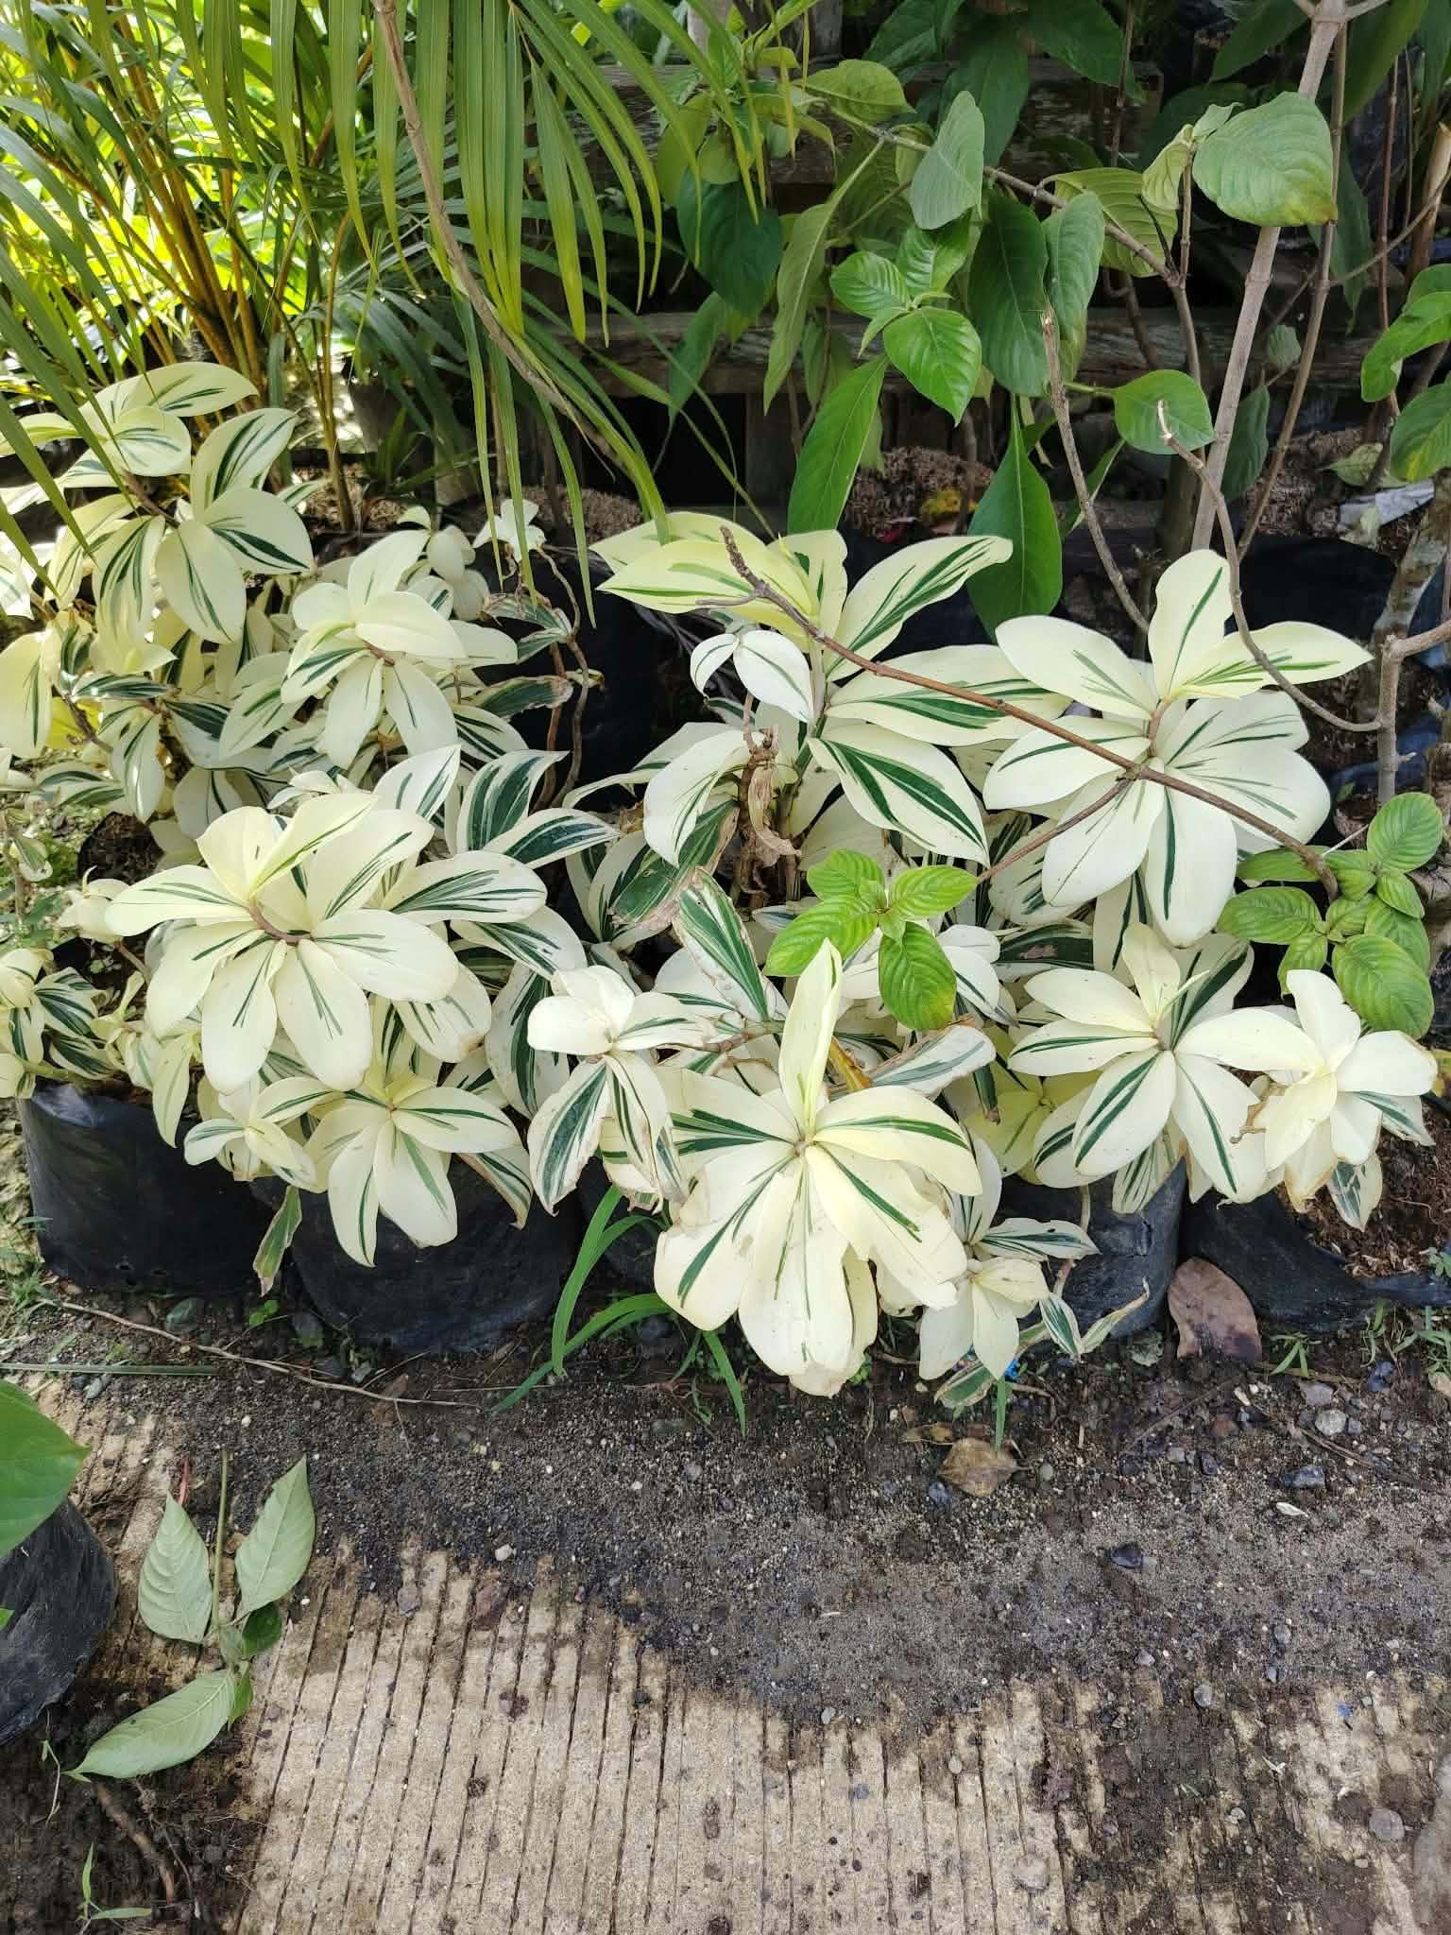
Plant Name: Variegated Dwarf Umbrella Plant
Local Name: Umbrella Plant
Scientific Name: Heptapleurum arboricola (formerly Schefflera arboricola)
Family: Araliaceae
Category: Ornamental Plant
Location Found: General luna S,D,N
Origin: Taiwan and Hainan, China
Habitat: Tropical and subtropical forests
Uses: Garden decoration, landscaping, and indoor decoration
Description: This plant has green and creamy white leaves. Its leaves grow in groups and look like a small umbrella. It is commonly planted to make gardens and homes beautiful.

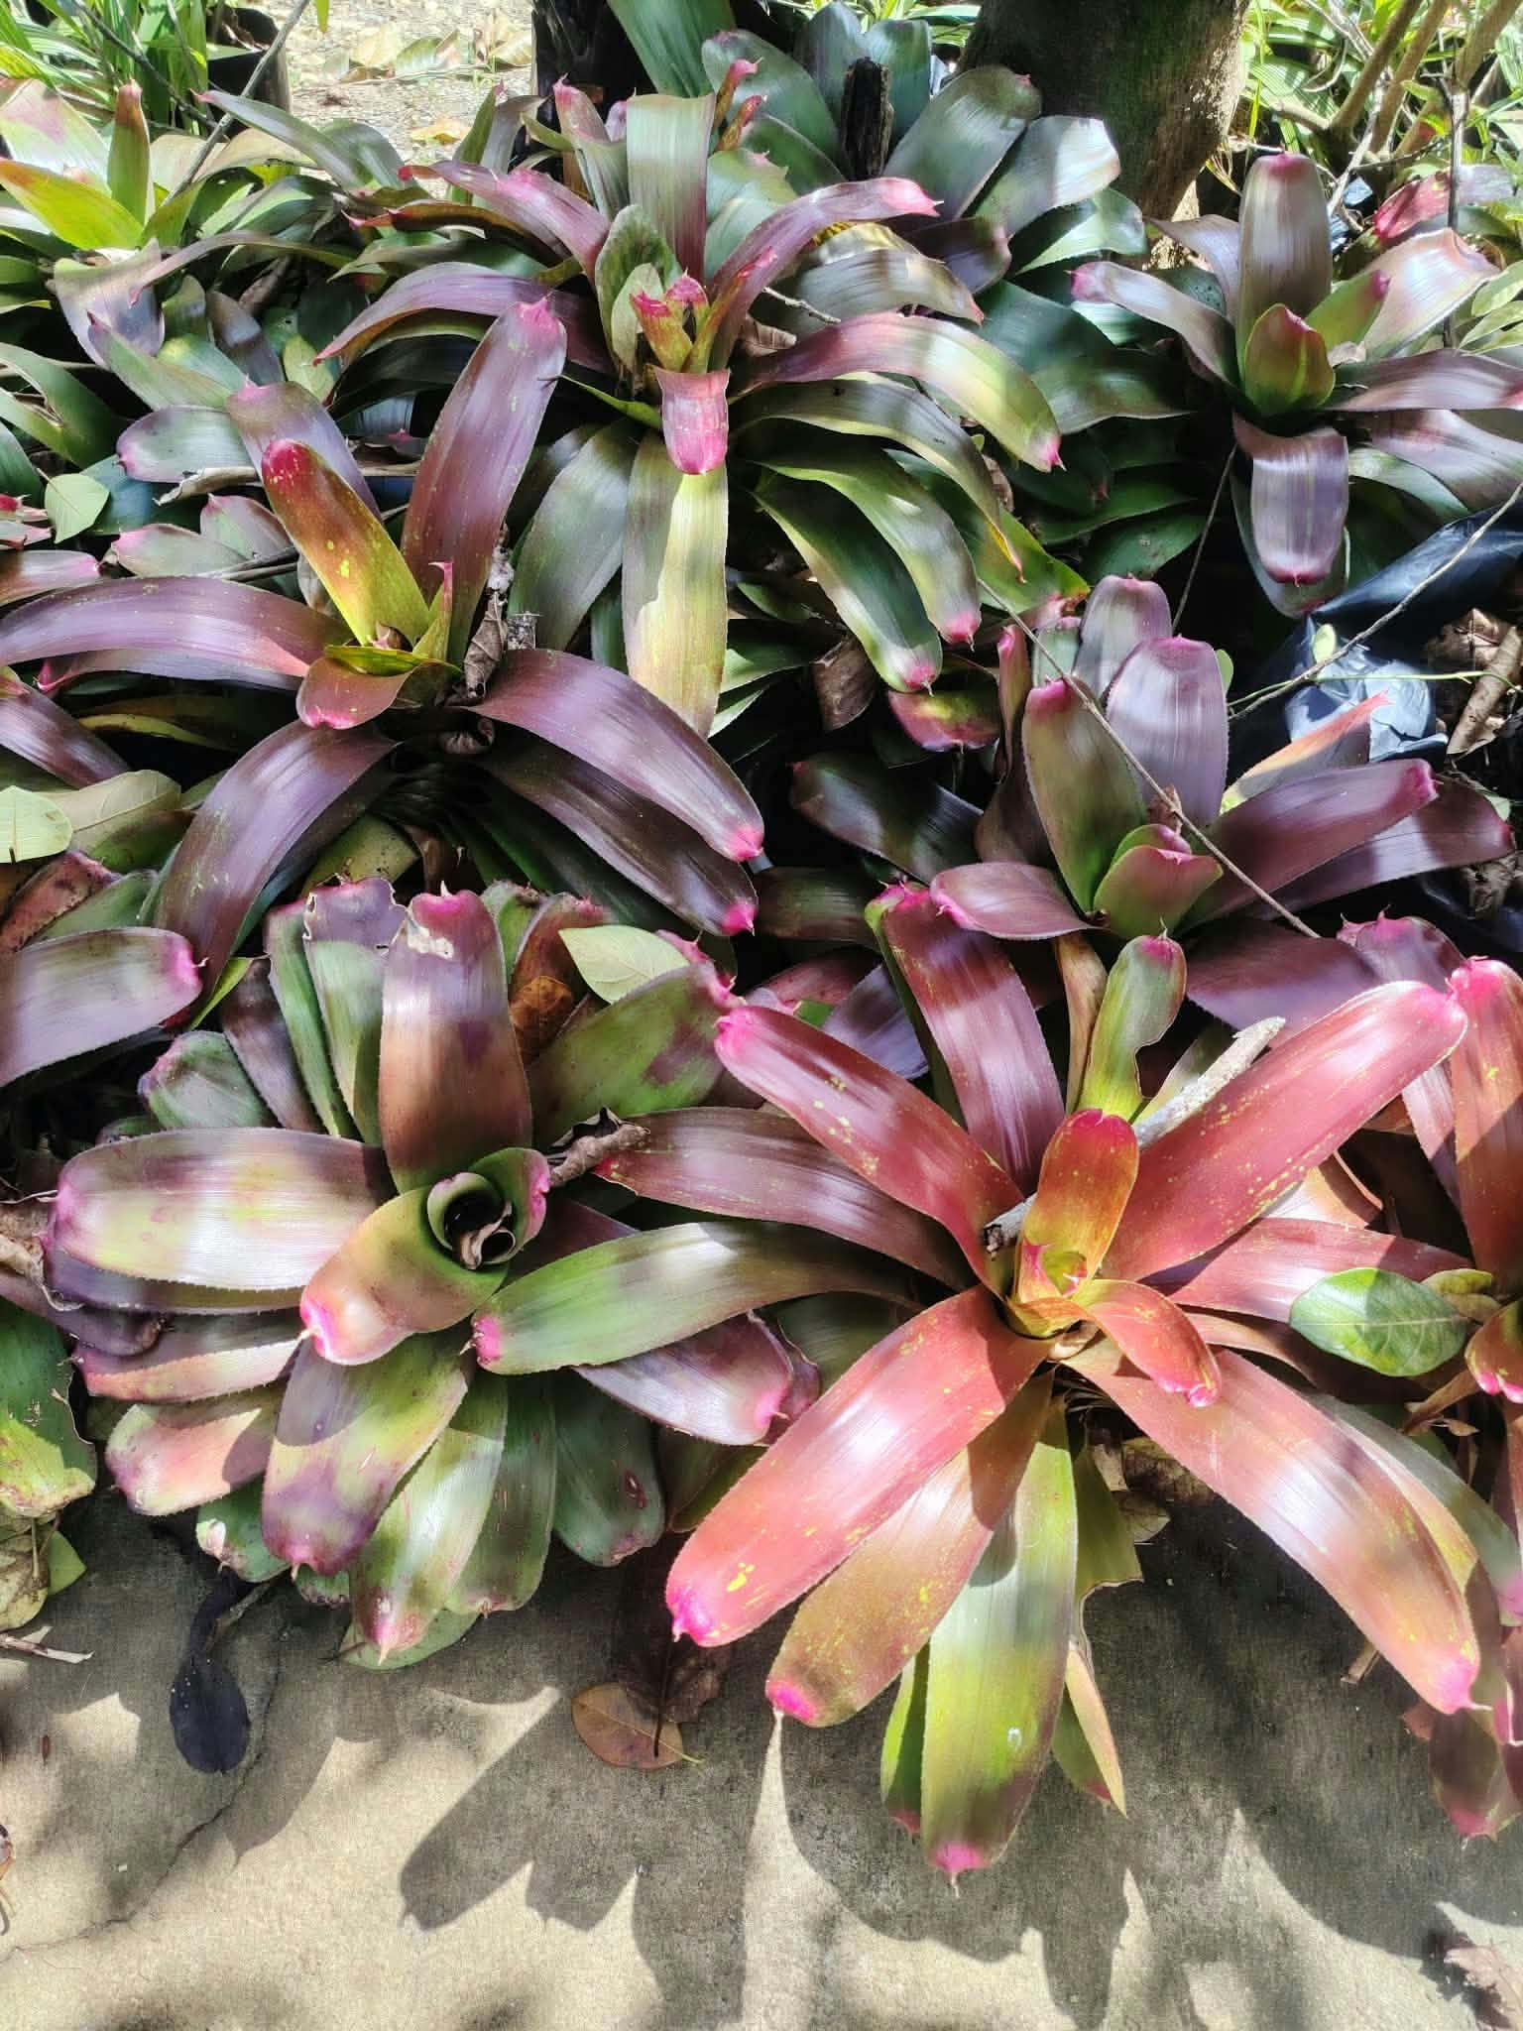

Plant Name: Blushing Bromeliad
Local Name: Bromeliad
Scientific Name: Neoregelia carolinae (possible identification)
Family: Bromeliaceae
Category: Ornamental Foliage Plant
Location Found: General luna S,D,N
Origin: South America, especially Brazil
Habitat: Tropical forests and warm, humid environments
Uses: Garden decoration, landscaping, and indoor decoration
Description: Blushing Bromeliad is a colorful plant with green leaves and a red or pink center. Its leaves grow in a circular shape. It is commonly used to make gardens and homes beautiful.
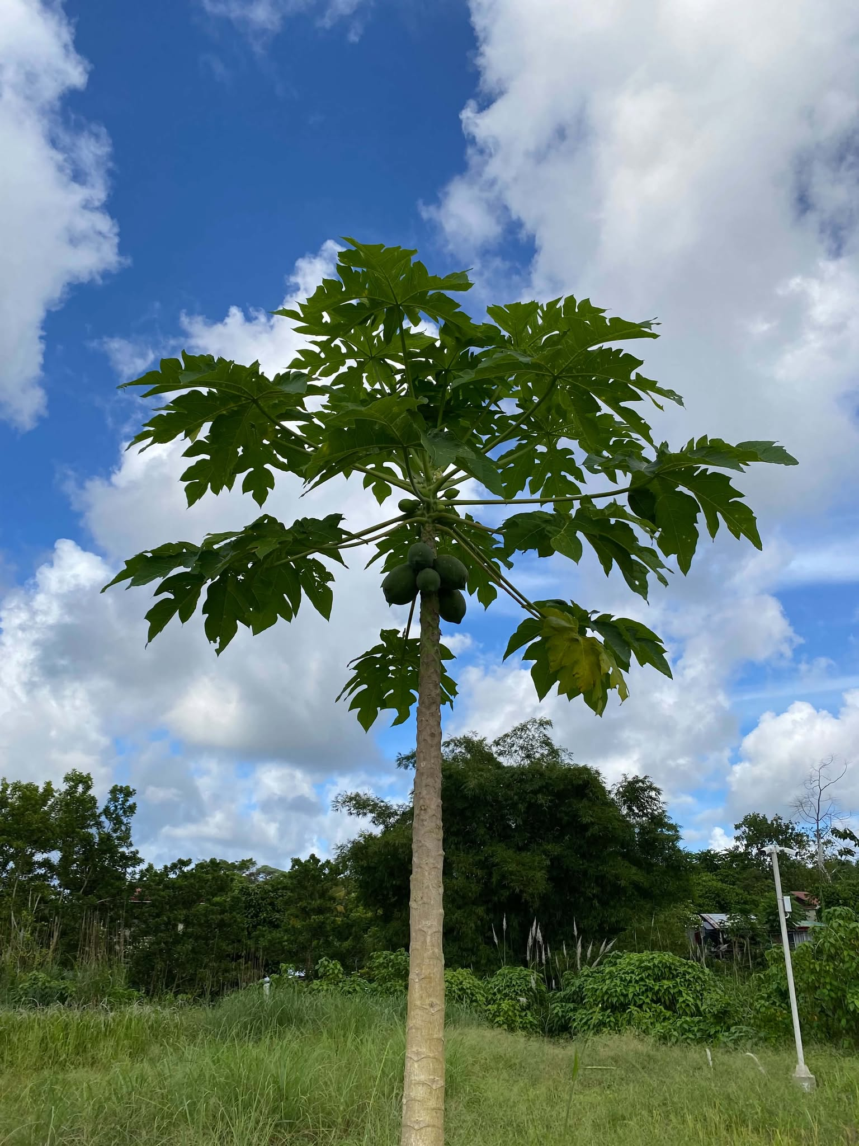

Plant Name : Papaya
Local Name : Kapayas
Scientific Name : Carica papaya
Family : Caricaceae
Category : Fruit Tree
Location Found : Pilar S,D,N
Origin : Central America and Southern Mexico
Habitat: Tropical and warm places
Uses: Its fruit is eaten fresh and used in cooking.
Description: Papaya is a small tree with a straight trunk, large green leaves, and oval fruits. Its fruit is green when unripe and yellow or orange when ripe.

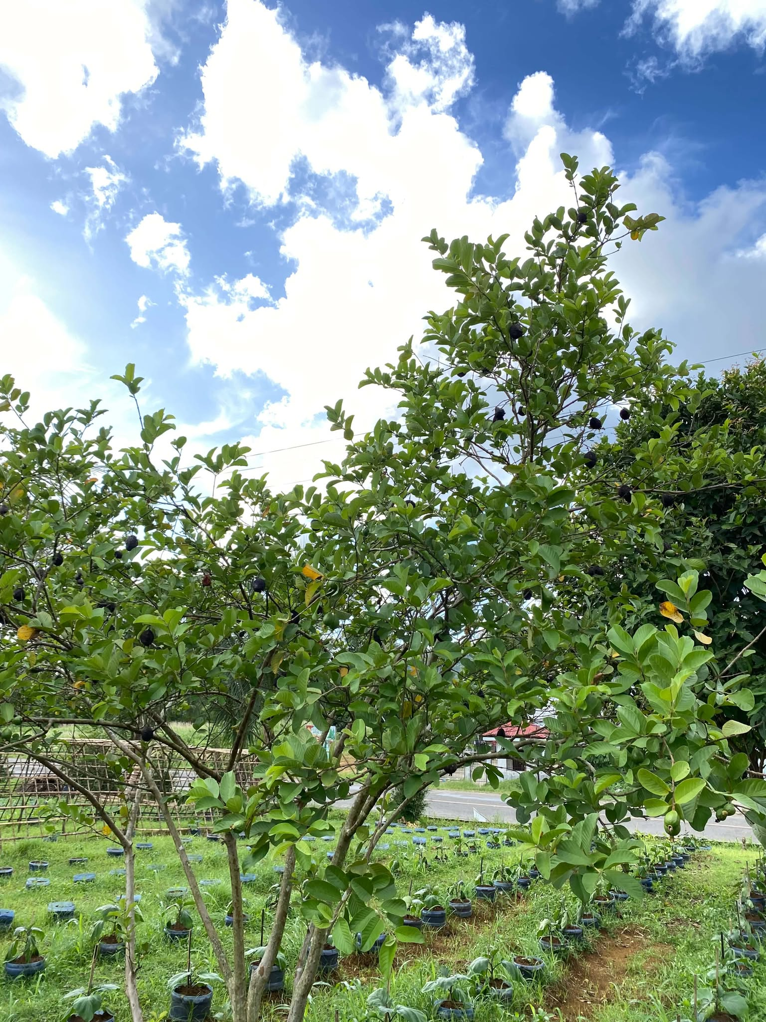

Name: Guava
Local Name: Bayabas
Scientific Name: Psidium guajava
Family: Myrtaceae
Category: Fruit Tree
Location Found: Del Carmen S,D,N
Origin: Tropical America
Habitat: Tropical and subtropical areas
Uses: Its fruit is eaten, and its leaves are traditionally used for herbal preparations.
Description: Guava is a small tree with green leaves and round fruits. Its fruits can be green or yellow when ripe.
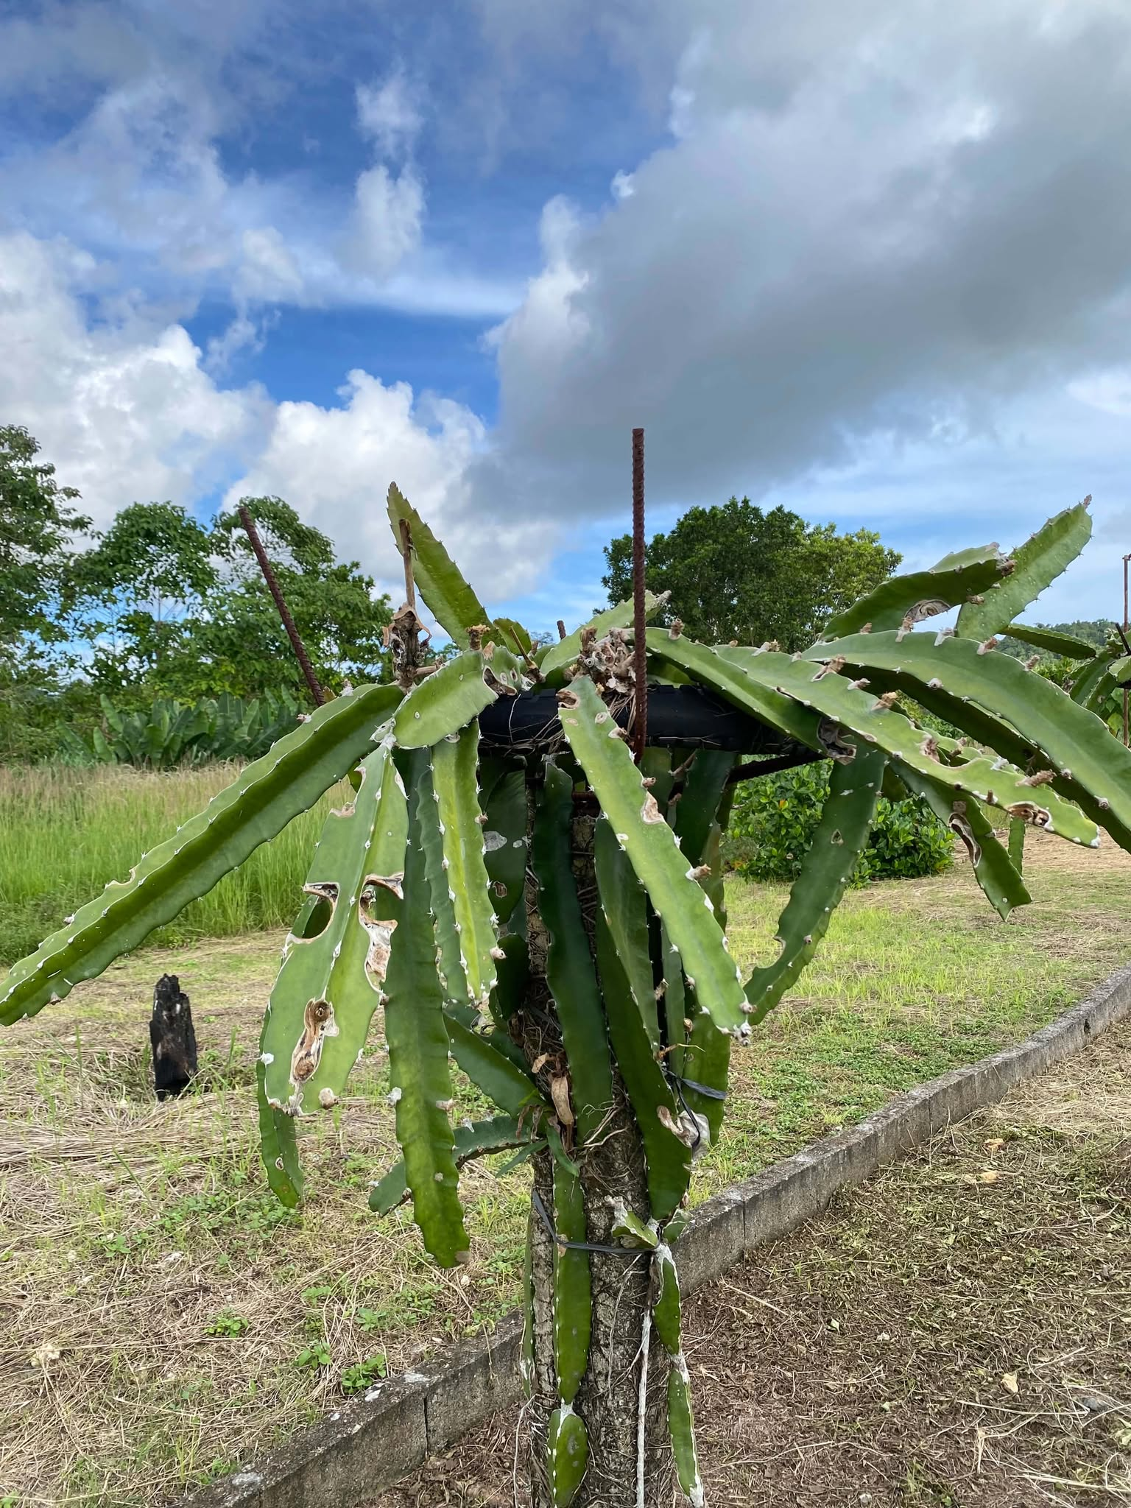

Plant Name: Dragon Fruit
Local Name: Dragon Fruit
Scientific Name: Selenicereus undatus
Family: Cactaceae
Category: Fruit-bearing Cactus
Location Found: Del Carmen S,D,N
Origin: Central America
Habitat: Warm tropical and subtropical areas
Uses: Its fruit is eaten fresh and used in juices and desserts.
Description: Dragon fruit is a climbing cactus with long green stems. It produces colorful fruits with white or red flesh.

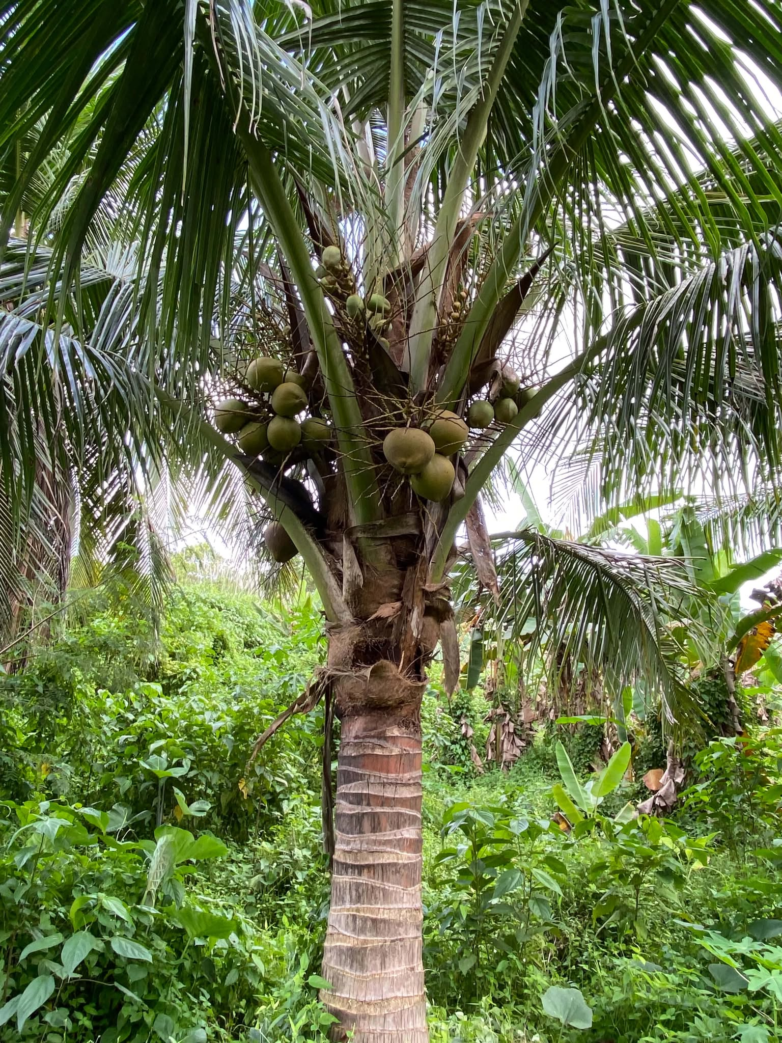

Plant Name: Coconut
Local Name: Niyog
Scientific Name: Cocos nucifera
Family: Arecaceae
Category: Palm Tree
Location Found: General luna S,D,N
Origin: Indo-Pacific Region
Habitat: Tropical areas, especially coastal places
Uses: Used for coconut water, milk, oil, food, and building materials.
Description: Coconut is a tall palm tree with a long trunk, large leaves, and round fruits.
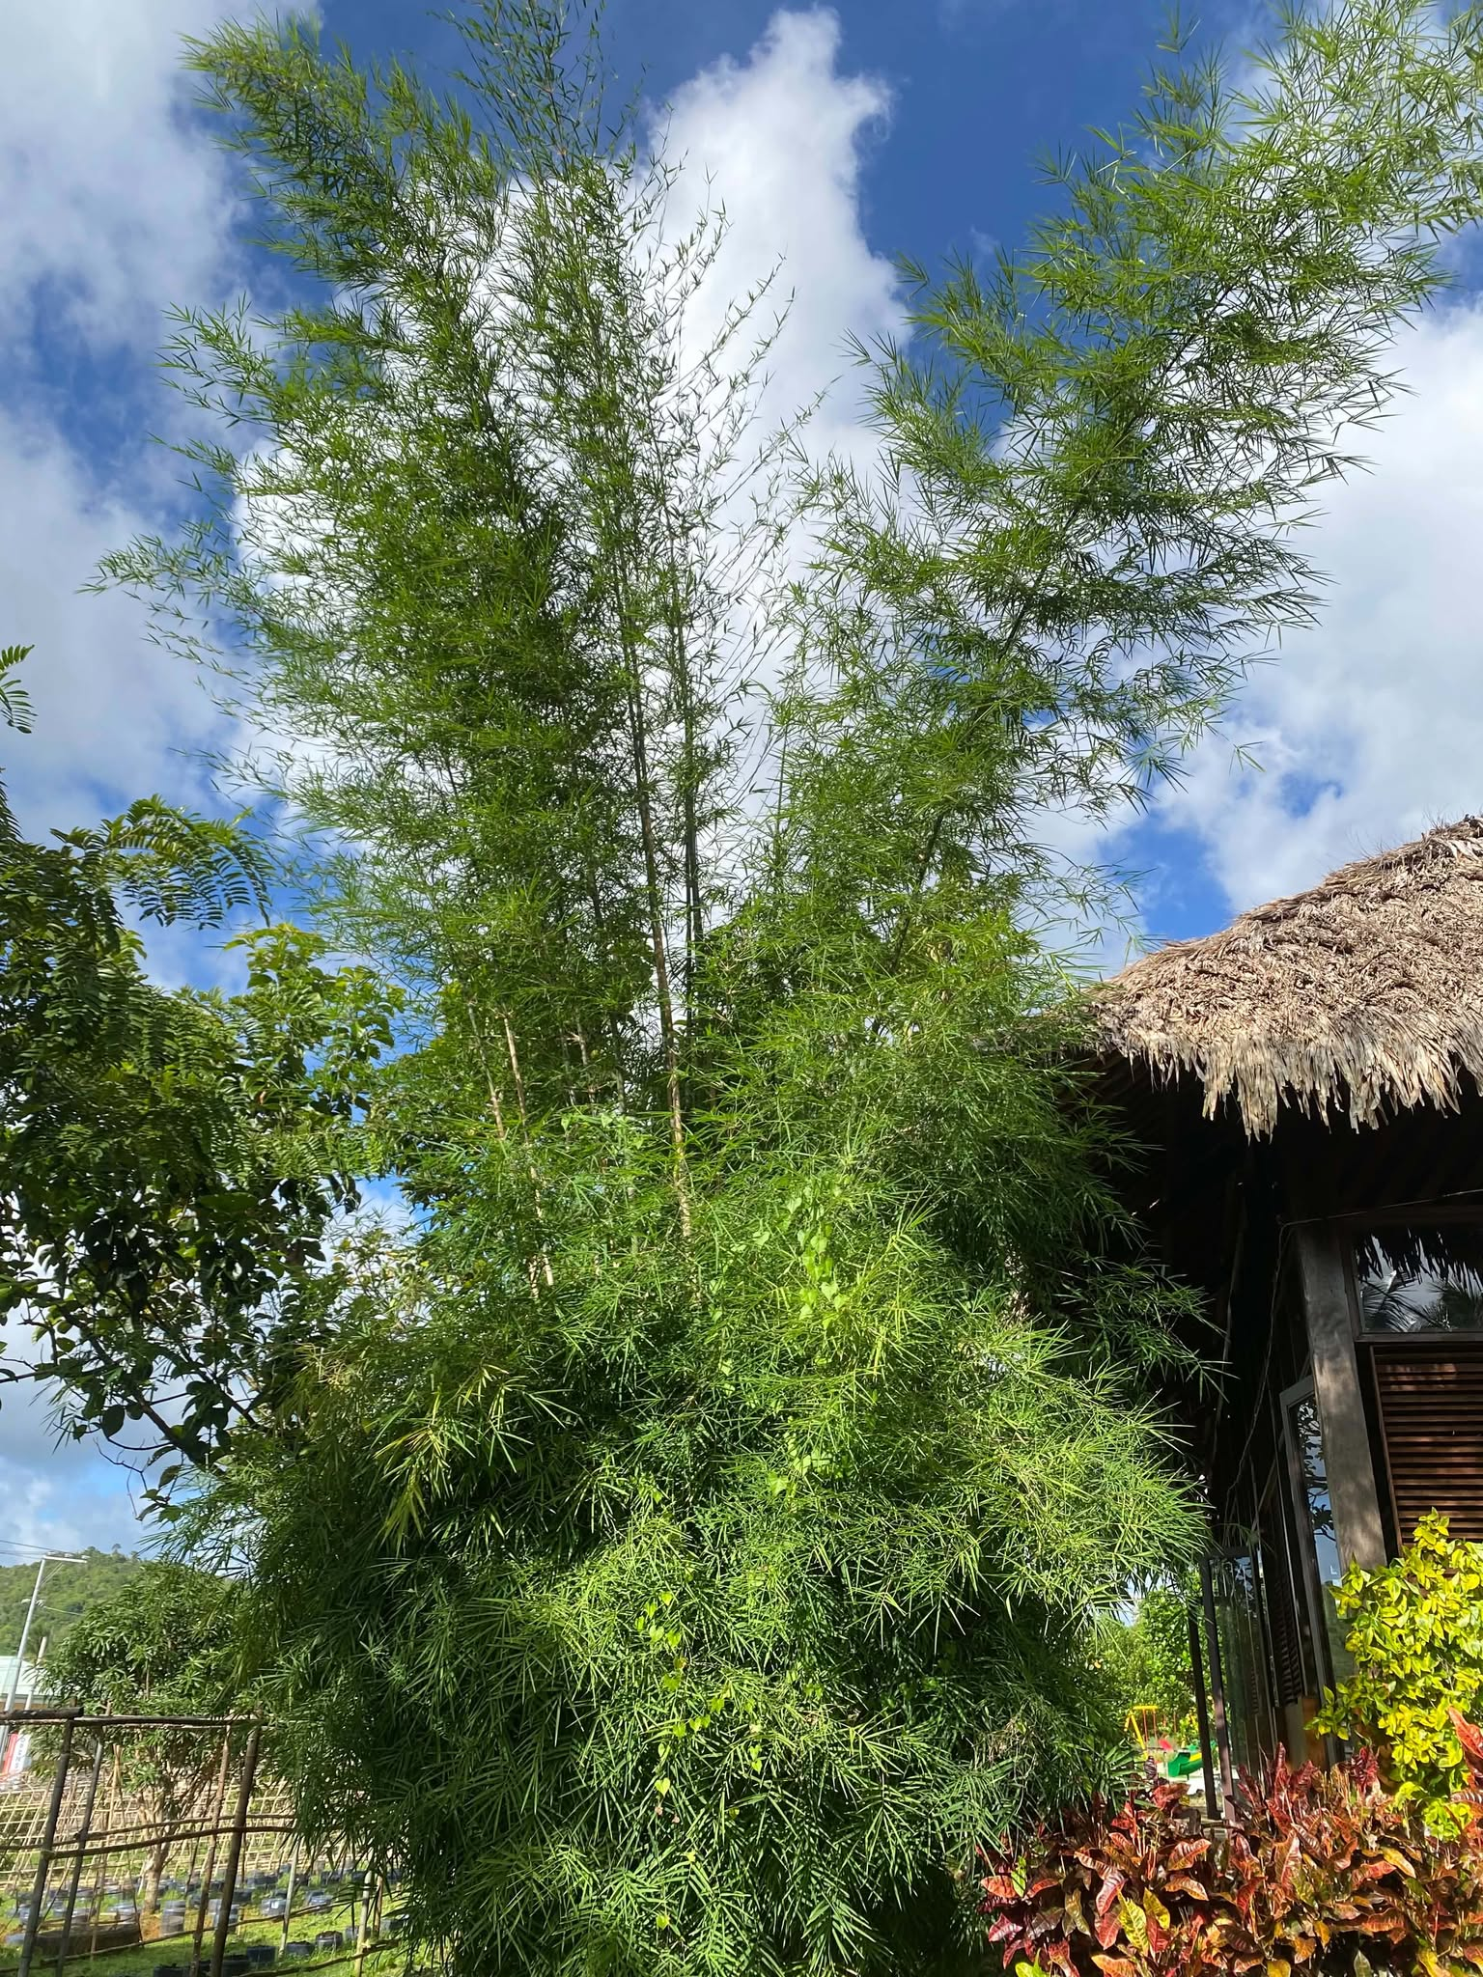
Plant Name: Bamboo
Name: Kawayan
Scientific Name: Bambusa vulgaris
Family: Poaceae
Category: Ornamental Plant / Grass
Location Found: Pilar S,D,N
Origin: Tropical Asia
Habitat: Tropical and subtropical areas with moist soil and enough sunlight.
Uses: Used for building houses, making furniture, fences, baskets, and other handicrafts. It is also used for garden decoration.
Description: Bamboo is a fast-growing plant with tall, green, and hollow stems. It has long, narrow leaves and grows in groups. It is strong and useful for many things, such as building materials and furniture.

