Siargao Flora — Entity Relationship Diagram (ERD)
System Integration and Architecture · Final Project · Database: siargao_flora (MySQL)
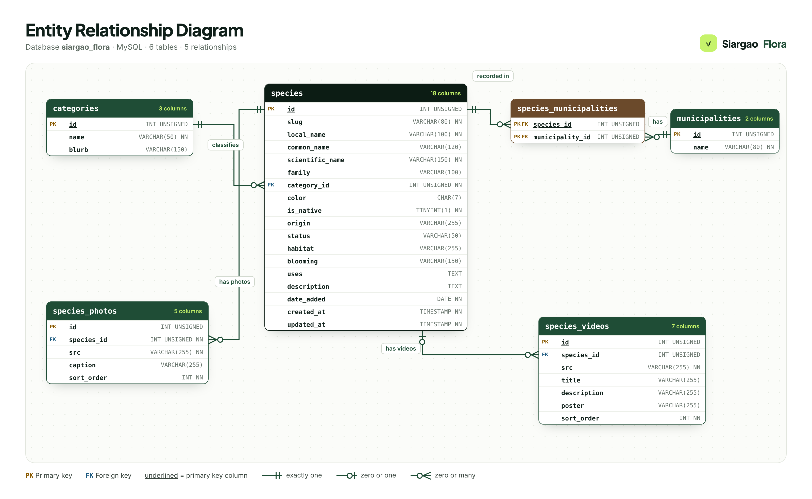
Figure 1. Entity Relationship Diagram of the siargao_flora database (crow’s-foot notation).

1. Overview
The Siargao Flora database documents the flowers and plants gathered on Siargao Island, Surigao del Norte. It is organized into six related tables. Each fact is stored only once and the tables are linked with primary and foreign keys.
Entity (table) | Description | Records
categories | Plant groups used to classify the species (Vegetable, Herb, Ornamental, Fruit, Palm). | 5
municipalities | The nine municipalities of the Siargao island group where plants can be recorded. | 9
species | The main entity: one row for each plant or flower documented during data gathering. | 20
species_municipalities | Associative (link) entity that resolves the many-to-many relationship between species and municipalities. | 20
species_photos | Photos of each species, with a caption describing where the photo was taken. | 20
species_videos | Field videos. A video may belong to one species, or to none (general field footage). | 3

2. Notation (legend)
- PK — primary key: uniquely identifies each row. Underlined in the diagram.
- FK — foreign key: refers to the primary key of another table.
- NN — NOT NULL: the value is required.
- Two short bars (||) — exactly one.
- Circle and bar (o|) — zero or one (optional).
- Circle and crow’s foot (o<) — zero or many.

3. Relationships
Relationship | Cardinality | Foreign key | Meaning
categories → species | One-to-many (1 : 0..*) | species.category_id → categories.id | Each species belongs to exactly one plant group; a plant group can have zero or many species.
species ↔ municipalities | Many-to-many (via species_municipalities) | species_municipalities.species_id → species.id; species_municipalities.municipality_id → municipalities.id | A species can be recorded in many municipalities, and a municipality can have many species. The link table uses a composite primary key (species_id, municipality_id).
species → species_photos | One-to-many (1 : 0..*) | species_photos.species_id → species.id | A species can have zero or many photos; each photo belongs to exactly one species.
species → species_videos | One-to-many, optional (0..1 : 0..*) | species_videos.species_id → species.id (nullable) | A species can have zero or many videos. A video with no species (NULL) is general field footage, such as the garden tour.
Referential actions: deleting a species also deletes its municipality links, photos and videos (ON DELETE CASCADE). A plant group cannot be deleted while species still use it (ON DELETE RESTRICT).

4. Entities and attributes

4.1 categories
Plant groups used to classify the species (Vegetable, Herb, Ornamental, Fruit, Palm).
Attribute | Data type | Null | Key | Description
id | INT UNSIGNED | No | PK | Primary key
name | VARCHAR(50) | No | UNIQUE | Group name, e.g. Ornamental
blurb | VARCHAR(150) | Yes |  | Short description of the group

4.2 municipalities
The nine municipalities of the Siargao island group where plants can be recorded.
Attribute | Data type | Null | Key | Description
id | INT UNSIGNED | No | PK | Primary key
name | VARCHAR(80) | No | UNIQUE | Municipality name, e.g. General Luna

4.3 species
The main entity: one row for each plant or flower documented during data gathering.
Attribute | Data type | Null | Key | Description
id | INT UNSIGNED | No | PK | Primary key
slug | VARCHAR(80) | No | UNIQUE | URL identifier, e.g. gumamela (species.php?id=gumamela)
local_name | VARCHAR(100) | No |  | Local (Bisaya/Filipino) name
common_name | VARCHAR(120) | Yes |  | English common name
scientific_name | VARCHAR(150) | No |  | Scientific (Latin) name
family | VARCHAR(100) | Yes |  | Botanical family
category_id | INT UNSIGNED | No | FK → categories.id | FK → categories.id (plant group)
color | CHAR(7) | Yes |  | Hex colour used for the website illustration
is_native | TINYINT(1) | No |  | 1 = native to Asia, 0 = introduced
origin | VARCHAR(255) | Yes |  | Where the plant originally comes from
status | VARCHAR(50) | Yes |  | Optional status, e.g. Endangered
habitat | VARCHAR(255) | Yes |  | Where it grows
blooming | VARCHAR(150) | Yes |  | Blooming / fruiting season
uses | TEXT | Yes |  | Uses and significance
description | TEXT | Yes |  | Description of the plant
date_added | DATE | No |  | Date the record was added
created_at | TIMESTAMP | No |  | Row created
updated_at | TIMESTAMP | No |  | Row last changed

4.4 species_municipalities
Associative (link) entity that resolves the many-to-many relationship between species and municipalities.
Attribute | Data type | Null | Key | Description
species_id | INT UNSIGNED | No | PK, FK → species.id | PK + FK → species.id
municipality_id | INT UNSIGNED | No | PK, FK → municipalities.id | PK + FK → municipalities.id

4.5 species_photos
Photos of each species, with a caption describing where the photo was taken.
Attribute | Data type | Null | Key | Description
id | INT UNSIGNED | No | PK | Primary key
species_id | INT UNSIGNED | No | FK → species.id | FK → species.id
src | VARCHAR(255) | No |  | File name in assets/images/species/ or a full URL
caption | VARCHAR(255) | Yes |  | Caption, usually where the photo was taken
sort_order | INT | No |  | Display order (0 = main photo)

4.6 species_videos
Field videos. A video may belong to one species, or to none (general field footage).
Attribute | Data type | Null | Key | Description
id | INT UNSIGNED | No | PK | Primary key
species_id | INT UNSIGNED | Yes | FK → species.id | FK → species.id (NULL = general field footage)
src | VARCHAR(255) | No |  | File name in assets/videos/, a full URL or a YouTube link
title | VARCHAR(255) | Yes |  | Video title
description | VARCHAR(255) | Yes |  | What the video shows
poster | VARCHAR(255) | Yes |  | Cover image file name in assets/videos/
sort_order | INT | No |  | Display order

