Siargao Flora — System Architecture Diagram
System Integration and Architecture · Final Project
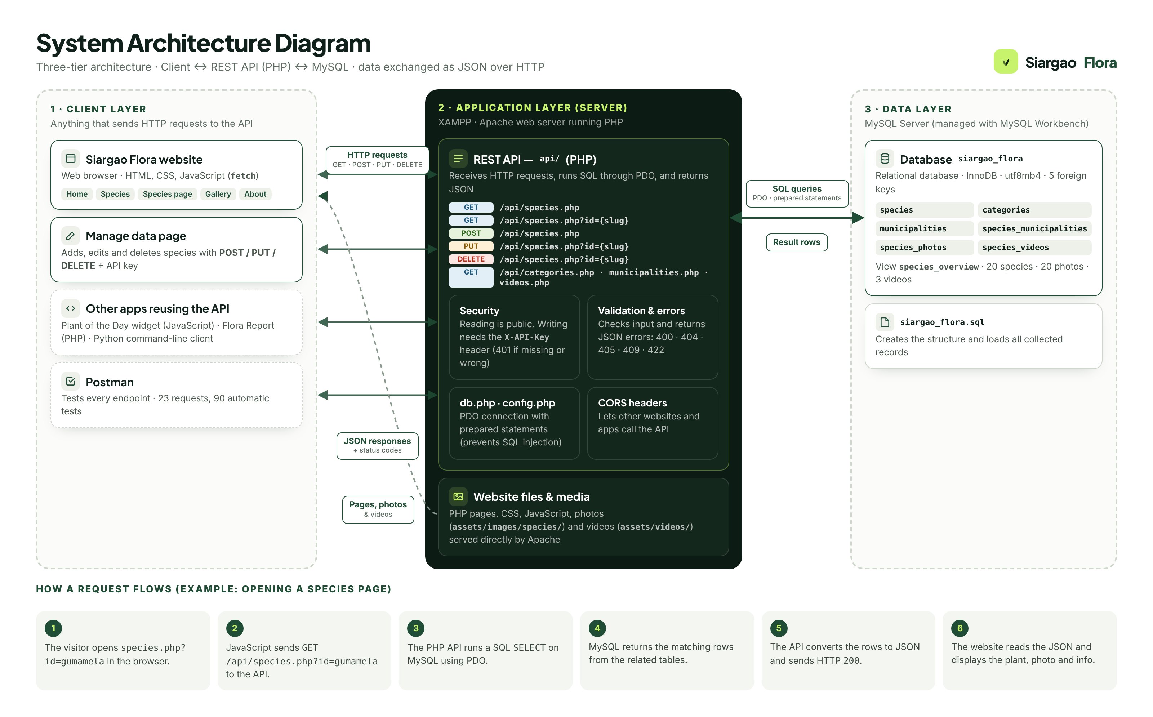
Figure 1. System architecture of Siargao Flora (three-tier: client, application, data).

1. Overview
Siargao Flora uses a three-tier client–server architecture. The website never connects to the database directly. Every application — the website, the Manage data page, the reuse demos and Postman — talks to the same PHP REST API over HTTP, and the API is the only part of the system that reads from and writes to the MySQL database. Data is exchanged in JSON format.
- Client layer — presents the data and sends HTTP requests.
- Application layer — the REST API that applies the rules (validation, security) and runs the SQL.
- Data layer — the MySQL database siargao_flora that stores the collected records.

2. Components
Layer | Component | Role
Client | Siargao Flora website | Pages (Home, Species, Species page, Gallery, About) built with HTML, CSS and JavaScript. JavaScript uses fetch() to request JSON from the API and renders it.
Client | Manage data page | Adds, edits and deletes species by sending POST, PUT and DELETE requests with the API key, and shows each JSON request and response in a live log.
Client | Reuse demos | Plant of the Day widget (JavaScript), Flora Report (server-side PHP) and a Python command-line client. They share no code with the website and use only the API.
Client | Postman | Tests and validates every endpoint: 23 requests with 90 automatic tests, including error cases.
Application | Apache web server (XAMPP) | Serves the website files, photos and videos, and runs the PHP API.
Application | REST API (api/ folder, PHP) | Endpoints for species, categories, municipalities and videos. Validates input, checks the API key for write requests, runs SQL through PDO and returns JSON with HTTP status codes.
Application | db.php · config.php | Database connection settings and a shared PDO connection using prepared statements, which protects against SQL injection.
Data | MySQL Server (MySQL Workbench) | Hosts the relational database siargao_flora: 6 tables linked by 5 foreign keys, plus the species_overview view.
Data | siargao_flora.sql | Script that creates the database structure and loads all collected records (20 species, 20 photos, 3 videos).

3. Technologies
Technology | Used for
HTML, CSS, JavaScript | Website pages, layout, animations and calling the API (fetch).
PHP 8 | Website page templates and the REST API.
Apache (XAMPP) | Web server that runs PHP and serves files.
MySQL Server + MySQL Workbench | Relational database and the tool used to create and manage it.
PDO (PHP Data Objects) | Secure database access from PHP with prepared statements.
JSON over HTTP | Data format and protocol between every client and the API.
Postman | Testing and validating the API endpoints.
Git and GitHub | Version control and sharing the project within the group.

4. REST API endpoints
Method | Endpoint | Purpose | Responses
GET | /api/ | Health check (API and database status) | 200
GET | /api/species.php | List species (optional q, category, municipality) | 200
GET | /api/species.php?id={slug} | One species with towns, photos and videos | 200, 404
POST | /api/species.php | Create a species (JSON body + X-API-Key) | 201, 401, 409, 422
PUT | /api/species.php?id={slug} | Update a species (only the fields sent) | 200, 401, 404, 422
DELETE | /api/species.php?id={slug} | Delete a species | 200, 401, 404
GET | /api/categories.php | Plant groups with species counts | 200
GET | /api/municipalities.php | Municipalities of Siargao | 200
GET | /api/videos.php | All videos, including general field footage | 200

5. Request flow

Reading data (example: opening a species page)
- The visitor opens species.php?id=gumamela in the browser. Apache returns the page.
- JavaScript sends GET /api/species.php?id=gumamela to the API.
- The PHP API runs a SQL SELECT on the MySQL database through PDO.
- MySQL returns the matching rows from species, categories, species_municipalities, species_photos and species_videos.
- The API combines the rows into one JSON object and sends it with HTTP status 200.
- The website reads the JSON and displays the plant, its photo and its information. The photo file itself is loaded directly from Apache.

Changing data (example: adding a species on the Manage data page)
- The user fills in the form and clicks Save. JavaScript sends POST /api/species.php with a JSON body and the X-API-Key header.
- The API checks the key (401 if wrong) and validates the fields (422 if invalid, 409 if the species already exists).
- The API inserts the species, its municipalities and photos in one database transaction.
- The API returns the new record as JSON with status 201 Created, and the page refreshes the list.

6. Reusability
Because the API uses standard HTTP and JSON, any application can use it, whatever language it is written in. The project shows this with three separate programs that reuse the same API: an embeddable Plant of the Day widget, a server-side PHP report, and a Python command-line client. The same endpoints are tested in Postman.

