How the Siargao Flora System Works
System Integration and Architecture · Final Project
This document explains how the parts of the system work together: the website, the PHP REST API, and the MySQL database. Each section points to the file and line in the project where it happens.

The big picture
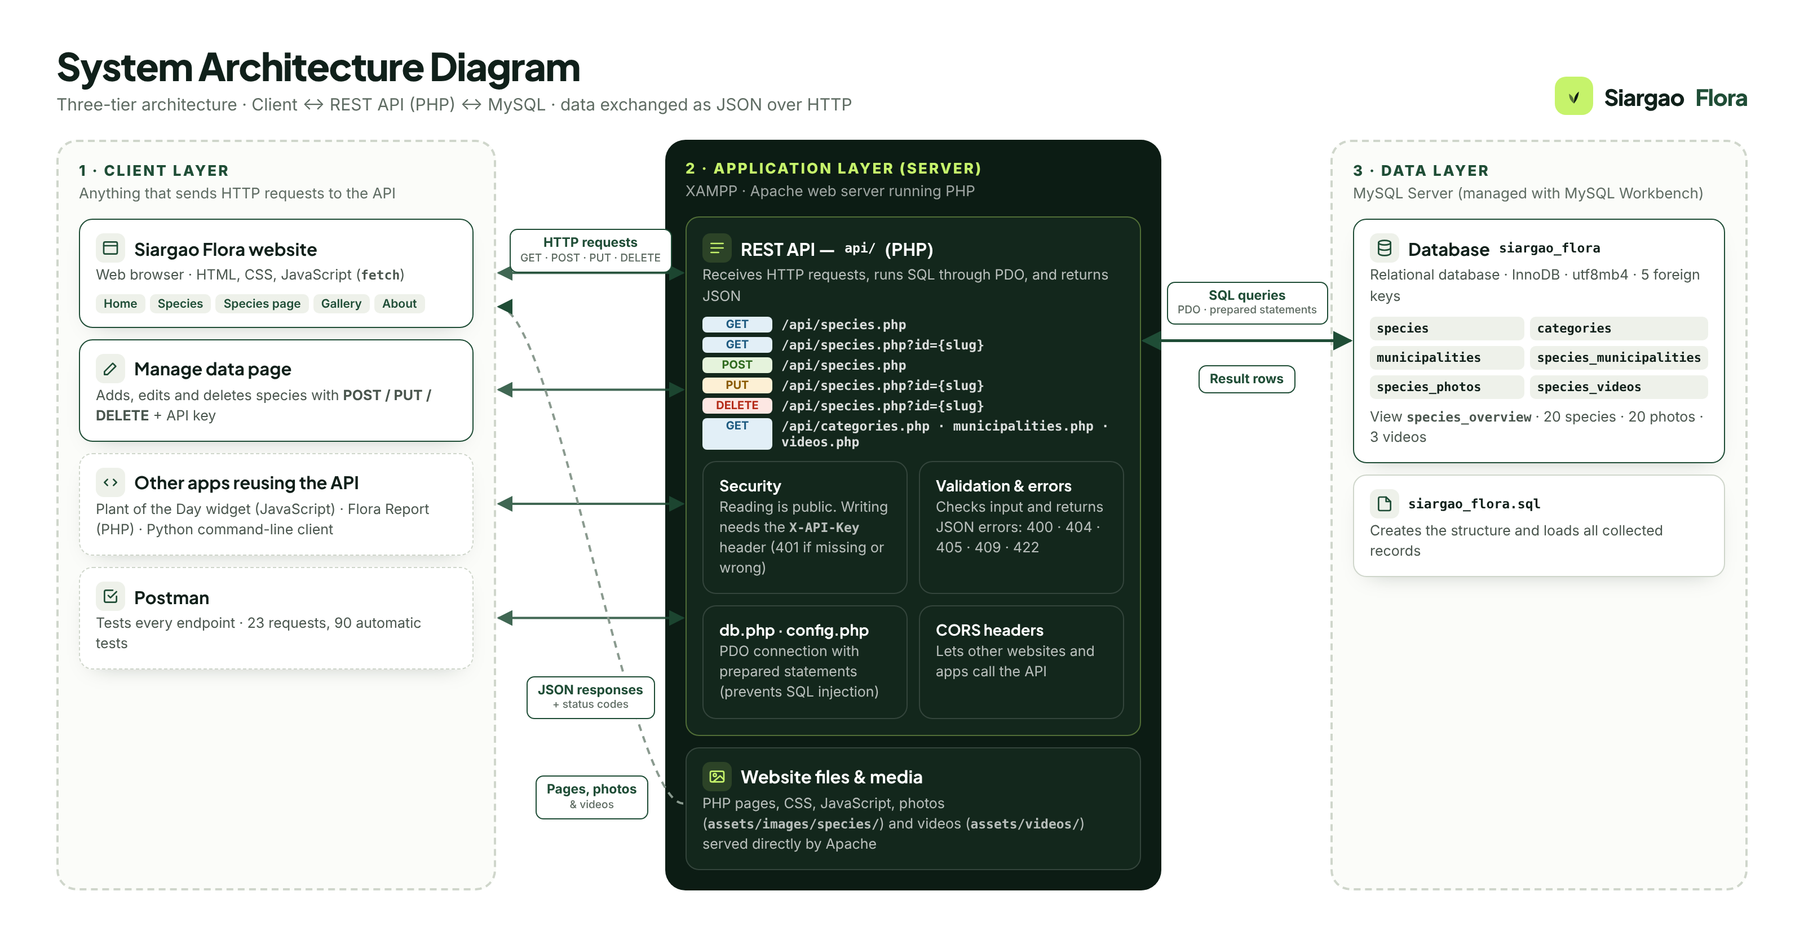
Website ──HTTP request──▶ PHP REST API ──SQL──▶ MySQL (siargao_flora)
◀──JSON response── ◀──rows──

The website never talks to MySQL directly. It only talks to the API, and only the API talks to the database.

1. How the website retrieves information from the API
- The visitor opens a page, for example species.php?id=gumamela. Apache sends back the page layout (HTML, CSS, JavaScript) — no plant data yet.
- JavaScript on the page then asks the API for the data (assets/js/app.js, line 516):
API.getSpeciesById(id)

- That function sends an HTTP GET request using fetch() (assets/js/api.js, line 21):
const res = await fetch(url, { headers: { Accept: 'application/json' } });
The URL called is api/species.php?id=gumamela. The API address is set in assets/js/config.js (API_BASE: 'api').
- The API answers with JSON. JavaScript reads it (res.json(), api.js line 23) and builds the page from it: name, photo, facts and towns.
Every page works the same way: the home page, species list, gallery and About page all call the API first, then display what comes back.

2. How the API communicates with the MySQL database
- Connecting: api/db.php (lines 33–41) opens one connection to MySQL using PDO (PHP Data Objects). The login details come from api/config.local.php.
- Querying: api/species.php builds a SQL query and runs it as a prepared statement (line 87):
$st = db()->prepare('SELECT ... FROM species s JOIN categories c ... WHERE s.slug = ?');
$st->execute([$slug]);
The ? is filled in by MySQL, not pasted into the text. This protects against SQL injection: harmful SQL typed into the URL cannot break the query.
- Joining related tables: one plant's data is spread over 5 related tables — species and categories, species_municipalities and municipalities, species_photos and species_videos. The API reads them (hydrate() at species.php line 33) and combines them into one plant record.

3. How information is exchanged using JSON
JSON is the common language between the website and the API.
- API → website (responses): PHP turns the database rows into JSON text with json_encode() (api/db.php line 23) and sends the header Content-Type: application/json.
{ "data": { "id": "gumamela", "local_name": "Gumamela",
"category": "Ornamental", "municipalities": ["General Luna"] } }

- Website → API (requests): when adding or editing a plant, JavaScript sends the form as JSON in the request body. PHP reads it with json_decode() (api/db.php line 59).
- Errors are JSON too, with an HTTP status code, for example 404 → { "error": "Species not found." }.
Because JSON is plain text that any language can read, the website, Postman, PHP and Python can all use the same API.

4. How POST, PUT and DELETE affect the database
All three first check the X-API-Key header (api/db.php lines 65–69). A wrong or missing key returns 401 and nothing in the database changes.
Request | What happens in MySQL | Code
POST (add) | Adds 1 new row to species, plus rows in species_municipalities (its towns) and species_photos. Returns 201 Created. | species.php 209–227 — INSERT INTO species …
PUT (edit) | Updates only the fields sent: UPDATE species SET … WHERE id = ?. If towns or photos are sent, those rows are replaced. Returns 200 OK. | species.php 231–247
DELETE (remove) | Removes the row: DELETE FROM species WHERE slug = ?. MySQL then automatically deletes its towns, photos and videos, because the foreign keys use ON DELETE CASCADE. Returns 200 OK. | species.php 252–254

Safety: POST and PUT run inside a transaction (beginTransaction() … commit()). If anything fails halfway — for example an unknown town — nothing is saved, so the database is never left half-updated.
Show it live
Add a plant on the Manage data page, then run SELECT * FROM siargao_flora.species_overview; in MySQL Workbench — the new row appears. Delete it, run the query again — it is gone.

5. How another application could consume the API
Any program that can send an HTTP request and read JSON can use the API — in any language, without access to the database or the website's code. The project includes three:
Application | Language | How it calls the API
Plant of the Day widget (examples/plant-of-the-day.html, line 78) | JavaScript (browser) | fetch('../api/species.php') — shows one plant per day
Flora Report (examples/php-report.php, lines 14, 39) | PHP (server) | api_get(…/api/species.php) using curl — counts plants per town and group
Python client (examples/flora_client.py, line 29) | Python (terminal) | urllib.request.urlopen(…/api/species.php) — prints a table

Postman is a fourth example: a separate application sending the same requests.
Two settings make reuse possible:
- CORS headers (api/db.php) let websites on other addresses call the API.
- Reading is public, writing needs the API key — other apps can safely read the data but cannot change it.

Summary
The website and any other app send HTTP requests to our PHP REST API; the API safely queries MySQL with prepared statements and sends the results back as JSON. The database is only ever touched by the API, and any program that understands JSON can reuse it.

