Siargao Flora — System Demo
Working system demonstration · System Integration and Architecture · Final Project
A short walkthrough of the working system in 8 steps. The orange numbers on each screenshot point to what to show.
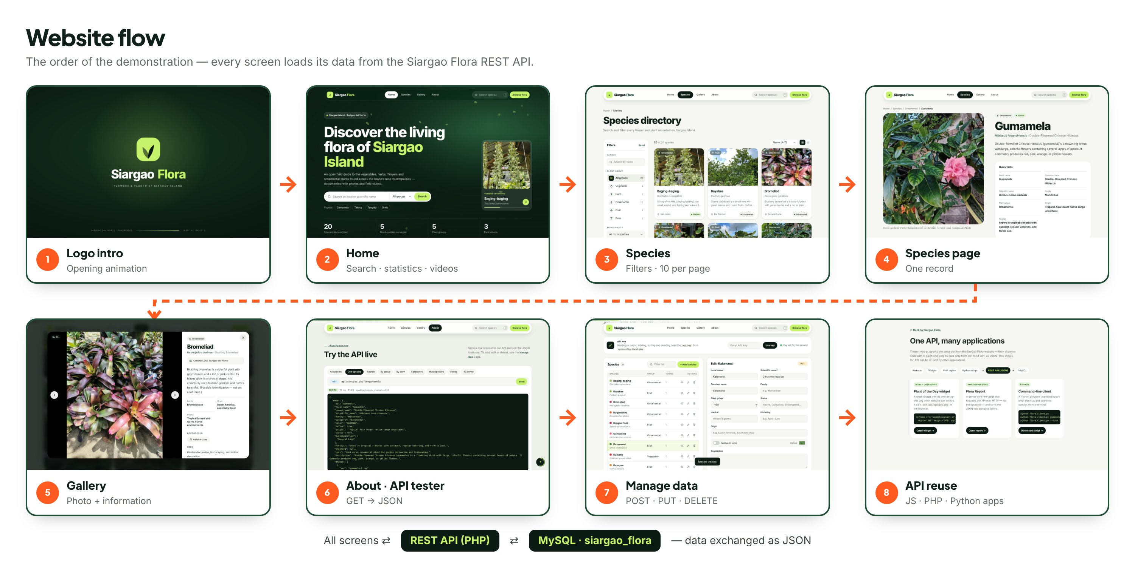
Before you start: start Apache (XAMPP) and MySQL · run database/siargao_flora.sql once · open http://localhost/flower&plant/index.php?intro=1 · click the page once so videos play with sound.

Step 1 Logo intro
The animated logo plays for about 5 seconds, then the home page opens. http://localhost/flower&plant/index.php?intro=1
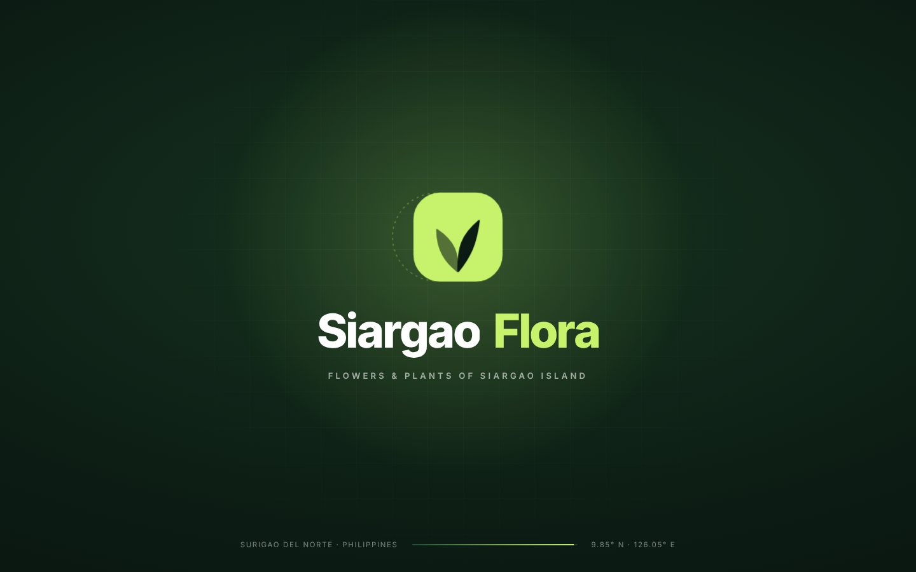

Step 2 Home page
Everything on the page is loaded from the REST API. http://localhost/flower&plant/
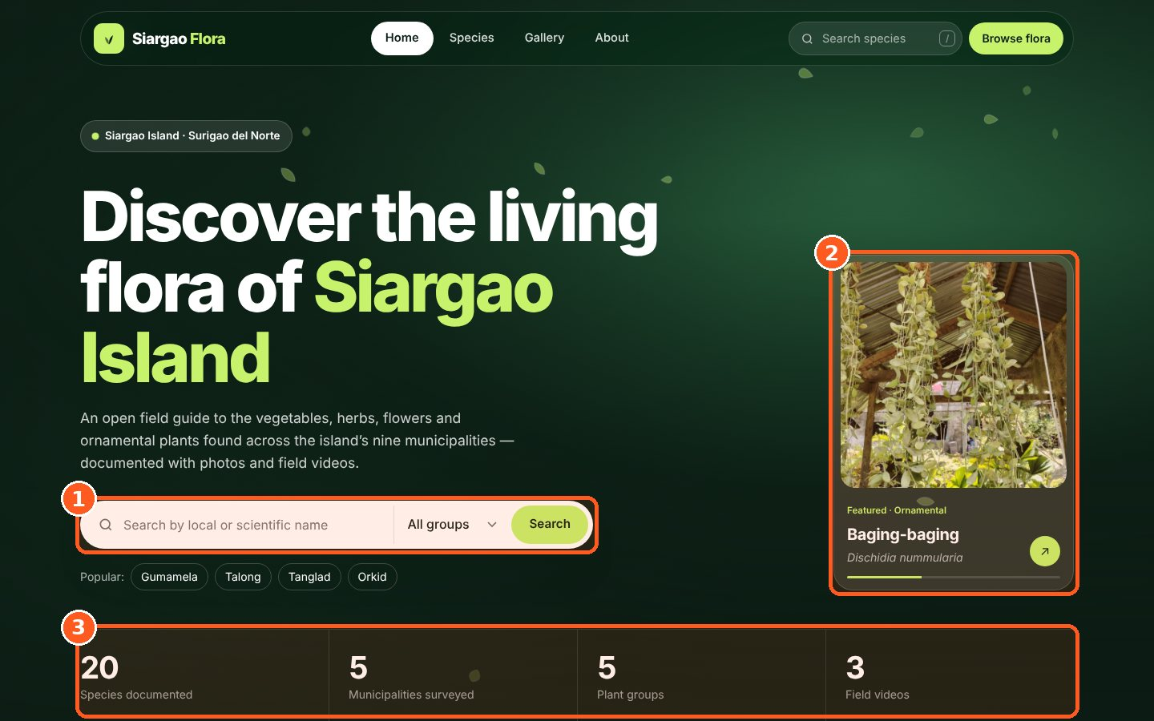
1 Search by name or plant group
2 Featured plant (rotates every few seconds)
3 Live statistics loaded from the API

Step 3 Species directory
GET all records: search, filter and browse 10 plants per page (Next → page 2). http://localhost/flower&plant/explore.php
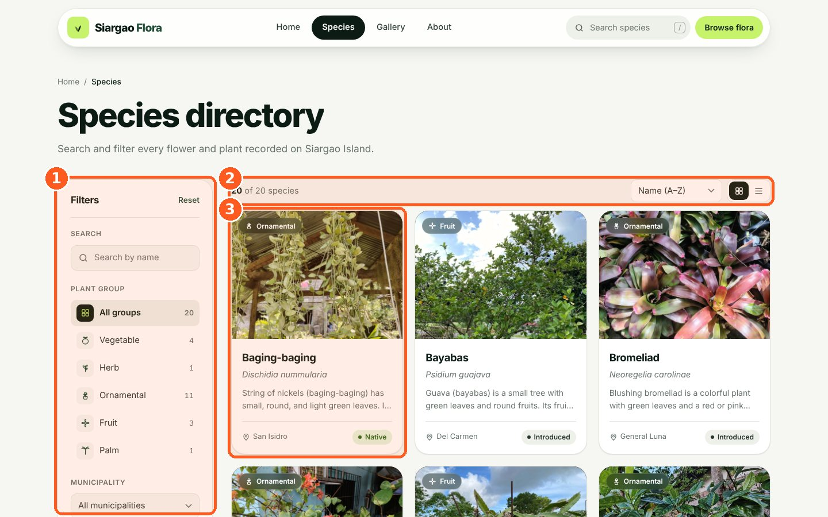
1 Filters: search, plant group, municipality, origin
2 Result count and sorting (10 per page)
3 Plant card — click to open

Step 4 Species page
GET one record: open any plant to see its photo and details. http://localhost/flower&plant/species.php?id=gumamela
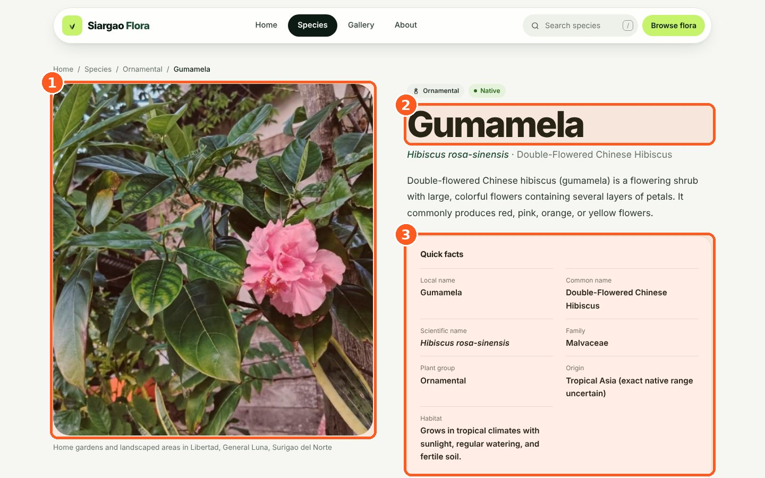
1 Field photo
2 Local name, scientific name and description
3 Quick facts from the database

Step 5 Gallery
Click a photo: the plant information appears beside it. http://localhost/flower&plant/gallery.php
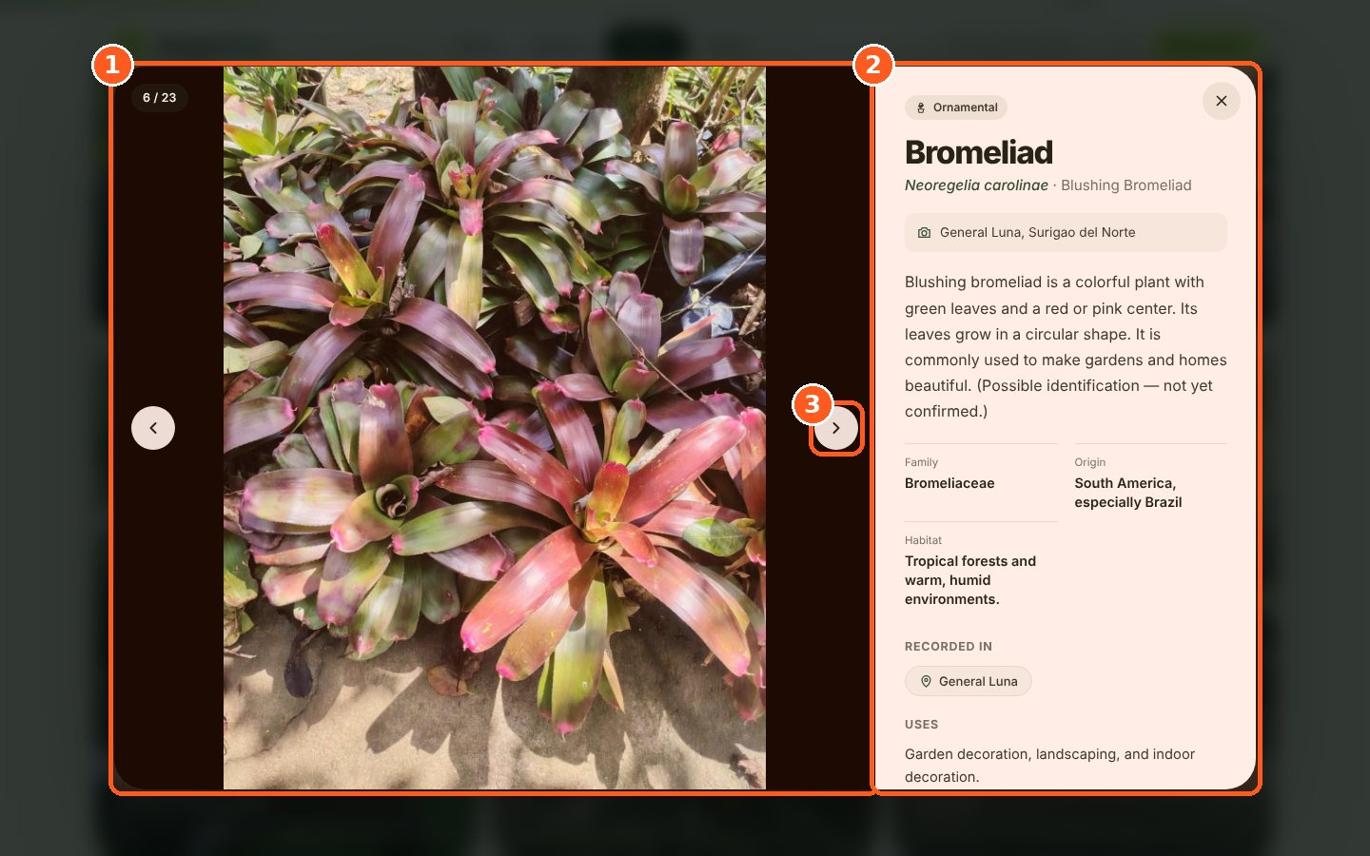
1 Photo or video
2 Plant information
3 Next item

Step 6 API tester (About page)
Send a real request and show the JSON the API returns. http://localhost/flower&plant/about.php#try
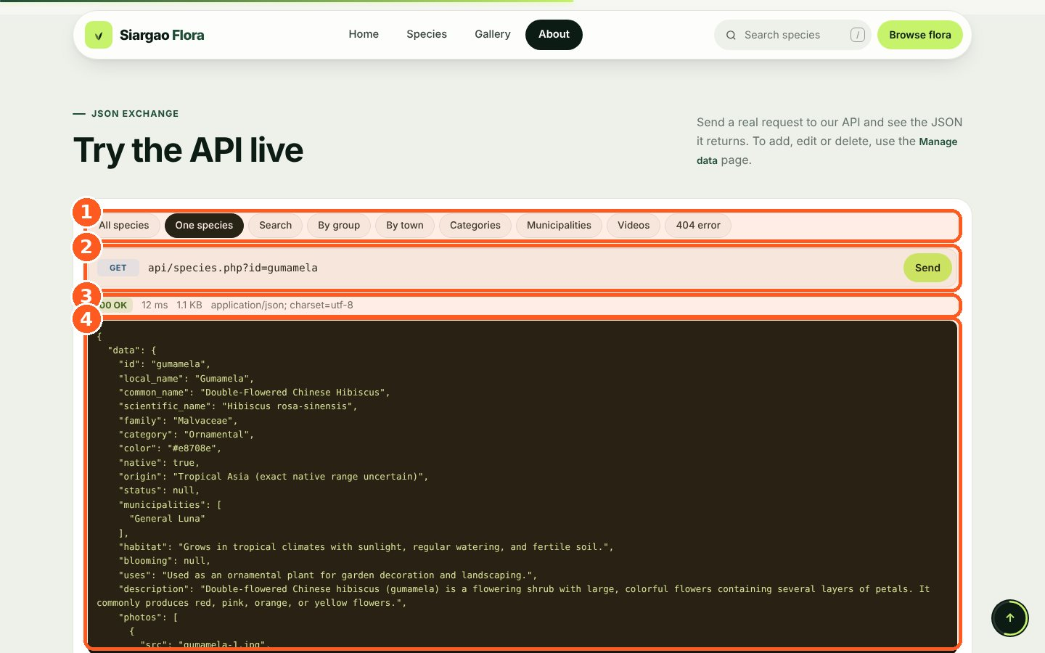
1 Choose a request
2 GET request sent to the API
3 Status 200 OK
4 JSON response

Step 7 Manage data — POST, PUT, DELETE
Enter the API key, add a plant (POST), edit it (PUT) and delete it (DELETE). The API log shows the JSON. http://localhost/flower&plant/manage.php
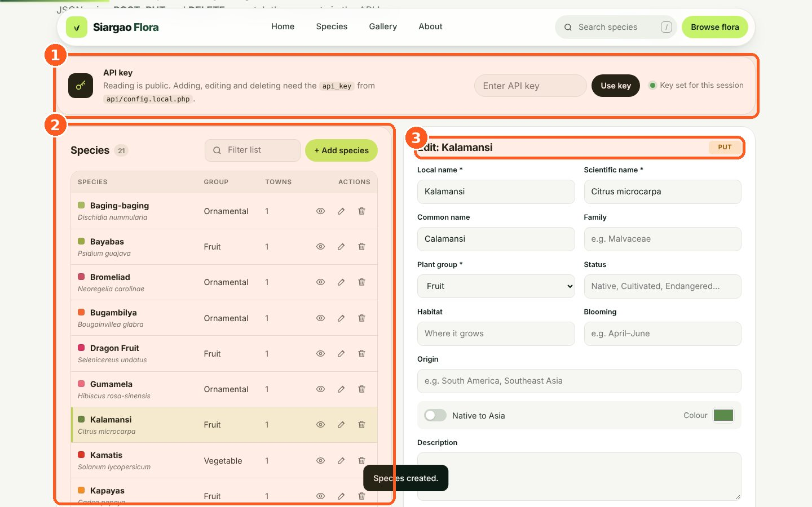
1 API key (required for POST, PUT, DELETE)
2 Records with Edit (PUT) and Delete (DELETE)
3 Form: Save = POST, Update = PUT

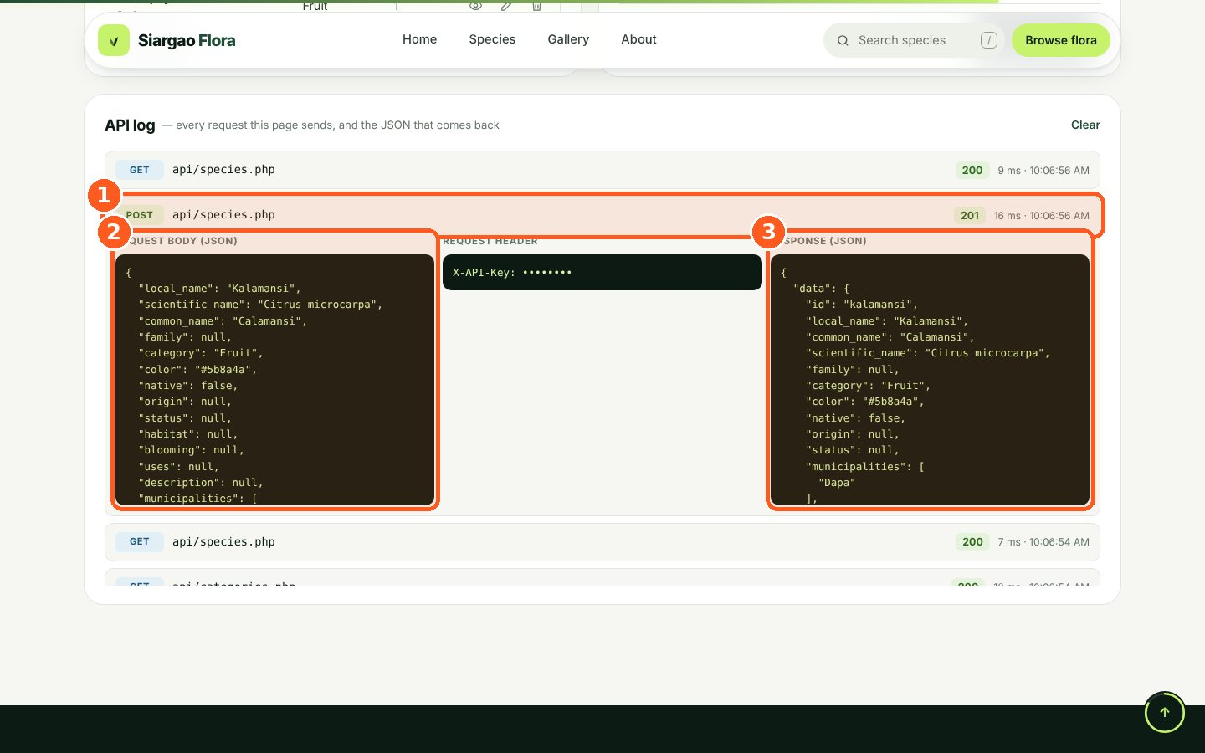
1 POST request — 201 Created
2 JSON sent to the API
3 JSON returned by the API

Step 8 API reused by other applications
Three separate programs use the same API: a JavaScript widget, a PHP report and a Python client. http://localhost/flower&plant/examples/
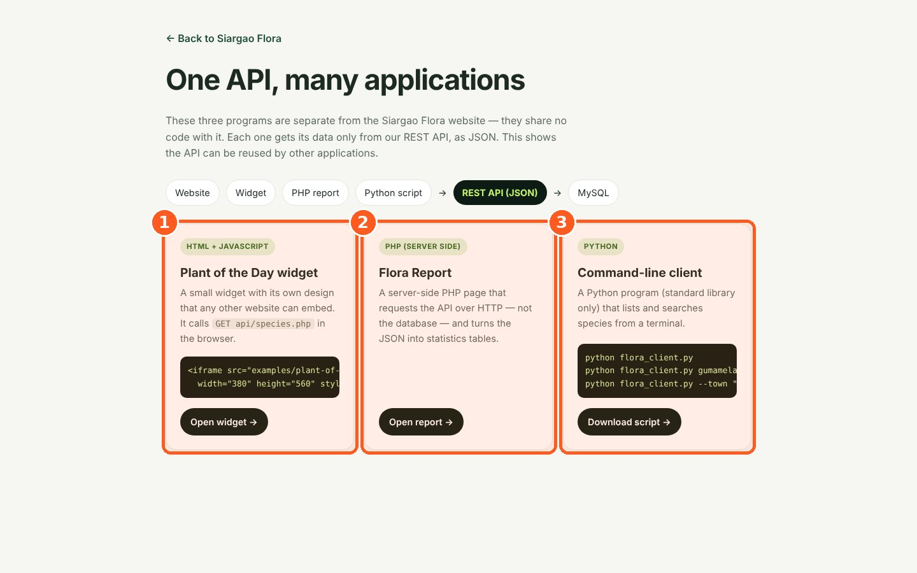
1 Widget (JavaScript)
2 Report (server-side PHP)
3 Command-line client (Python)

Requirements shown
Requirement | Step
Website consumes its own REST API | 2 – 6
GET request for all records | 3
GET request for a specific record | 4
JSON responses | 6, 7
POST, PUT and DELETE requests | 7
API reused by other applications | 8

