**CHAPTER 3**

**METHOD RESEARCH**

This chapter discusses the research methodology and the procedures to gather the data and information needed to successfully finish and create the Pacac High School Student Portal.

**METHOD RESEARCH**

This study collected data on the community advantages of the Student Portal using a combination of qualitative and quantitative study methods. The Student Portal of Pacac High School study employed mixed-methods research to collect and review quantitative data on portal usage and preferences. Structured instruments like as surveys and questionnaires made it easier to collect quantitative data, while focus groups and open-ended inquiries provided important qualitative information on students' thoughts and experiences of the site.

The type of research that uses both quantitative and qualitative research methods to analyze a specific research issue" is how George (2016) described a mixed-method study. This method focuses and investigates both subjective observations and objective measurement. While open-ended questions and focus groups provide a subjective picture of students' opinions of the site, CNP-based formal instruments with closed-ended questions gather objective, general data from students. According to Rubin et al. (2013), A more comprehensive knowledge of a single quantitative or qualitative assessment is the objective of mixed-discipline research. Instead of depending just on the advantages of one strategy, the potential of both is used.

**RESEARCH DESIGN**

Pacac High School used a descriptive-developmental design while developing their student portal. According to Tashakkori and Creswell, developmental research is the methodical study of creating, implementing, and assessing educational processes, products, and programs that must keep to internal standards of efficiency and coherence.

Because the proponents could explain the final results using the respondents' standards, descriptive research was suitable in this particular study. Developmental research was also appropriate because it allowed the supporters to create the website (Creswell and Creswell, 2018).

**RESEARCH LOCALE**

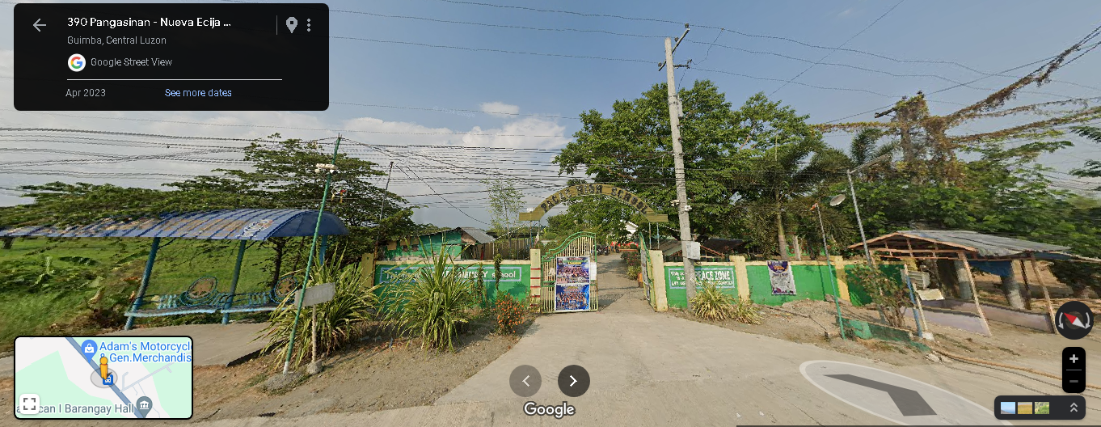The research will be conducted at Pacac High School situated in Barangay Pacac, Guimba, Nueva Ecija, Philippines. All phases of this project, from the development to assessment of the student portal, were conducted in the municipality of Guimba in Nueva Ecija. The rural setting of the Philippines school poses peculiar challenges and opportunities to the full implementation and use of the student portal. Hence, the research was conducted in the right environment.

**Figure 1. Pacac High School**

**RESPONDENTS**

A total number of 100 respondents composed of 50 IT students, 3 IT professionals that are currently participating in this study, 3 Parents, 3 Teachers, 1 Principal and 40 Students.

IT Professionals were involved in the evaluation of the technical qualities of the developed website together with the IT student. On the other hand, 50 were end-users and 3 Teachers were involved as the administrator of the system.

**RESEARCH INSTRUMENT**

The "Software Product Quality Requirements and Evaluation (SQuaRE)" standard, or more exactly ISO 25010, as stated by Bevan and Macleod, serves as the foundation for the evaluation instrument. The ISO 25010 was established by the International Organization for Standards and provides guidelines to evaluate software product quality. ISO 25010, which is based on ISO/IEC software engineering standard 12119, provides a set of requirements for software products in addition to methods for evaluation and guidelines. Since ISO 25010 provides for the establishment of standards and a consistent framework for assessment and evaluation, its implementation in the research contributes to the improvement of the student portal's quality.

The users have completed the questions. The study's proponents evaluate Pacac High School's Student Portal using ISO 25010. Included are functional compatibility, efficaciousness of performance, integration, security, maintainability, and portability. Combining the objects was done using a 5-point rating system: 1.00 - 2.59 for poor, 1.80 - 2.59 for fair, 2.60 - 3.39 for good, 3.40 - 4.19 for very good , and 4.20 - 5.00 for excellent, functional, suitability, performance effectiveness, compatibility, security, maintainability, and portability are all covered. A 5-point system of evaluation was used to group the items: 5 for excellent, 4 for very good, 3 for good, 2 for fair, and 1 for poor. In 1951, Cronbach introduced Cronbach's alpha. It is a statistical term that is used to evaluate how well a survey or test instrument corresponds. This type of coefficient is only concerned with the internal consistency between items. This statistical concept is widely used in both social and behavioral sciences to test the reliability of survey instruments. These survey instruments could either be tests or questionnaires.

**REFERENCES**

**George, M. (2016). Introduction to research methods. SAGE Publications.**

**Rubin, A., Babbie, E., & Waters, F. (2013). Research methods for criminal justice and criminology. Wadsworth.Creswell, J. W., & Creswell, J. D. (2018). Research design: Qualitative, quantitative, and mixed methods approaches. SAGE Publications.**

**Tashakkori, A., & Creswell, J. W. (2017). SAGE handbook of mixed methods in social and behavioral research. SAGE Publications.**

**Bevan, N., & Macleod, R. (2012). ISO 25010: Systems and software engineering—Product quality. John Wiley & Sons.**

**Cronbach, L. J. (1951). Coefficient alpha and the internal structure of tests. Psychometrika, 16(3), 297-334.**

**International Organization for Standardization (ISO). (2011). ISO/IEC 25010: Systems and software engineering—Systems and software quality requirements and evaluation (SQuaRE)—System and software quality models. ISO.Rubin, A., Babbie, E., & Waters, F. (2013). Research methods for criminal justice and criminology. Wadsworth.**

**Creswell, J. W., & Creswell, J. D. (2018). Research design: Qualitative, quantitative, and mixed methods approaches. SAGE Publications.**

**Tashakkori, A., & Creswell, J. W. (2017). SAGE handbook of mixed methods in social and behavioral research. SAGE Publications.**

**Bevan, N., & Macleod, R. (2012). ISO 25010: Systems and software engineering—Product quality. John Wiley & Sons.**

**Cronbach, L. J. (1951). Coefficient alpha and the internal structure of tests. Psychometrika, 16(3), 297-334.**

**International Organization for Standardization (ISO). (2011). ISO/IEC 25010: Systems and software engineering—Systems and software quality requirements and evaluation (SQuaRE)—System and software quality models. ISO.**