**To Run On Simulator Using Xcode**

1. Navigate to the downloaded and unzipped project folder and open the project located at FieldMargin/FieldMargin.xcodeproj
2. Select the “FieldMargin” target a shown in the image below. Select the simulator you wish to run the build on (iPhone or iPad)
3. Click the “Run” button (the “play” button below)



1. If the build is successful, this will launch the simulator

**To Run Unit Tests Using Xcode**

1. Select the “FieldMarginTests” target



1. Open the “Test Navigator” in the left hand menu and Press the “Play” button to run all the tests

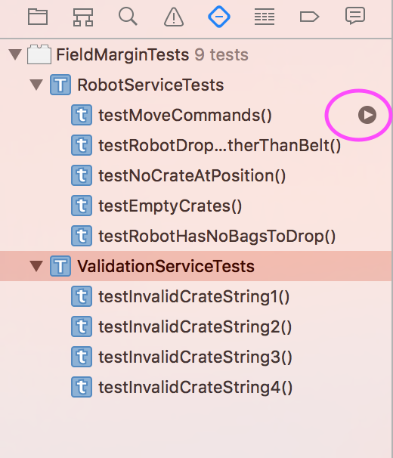

1. Successful tests are marked with a green tick and failed tests with a red cross

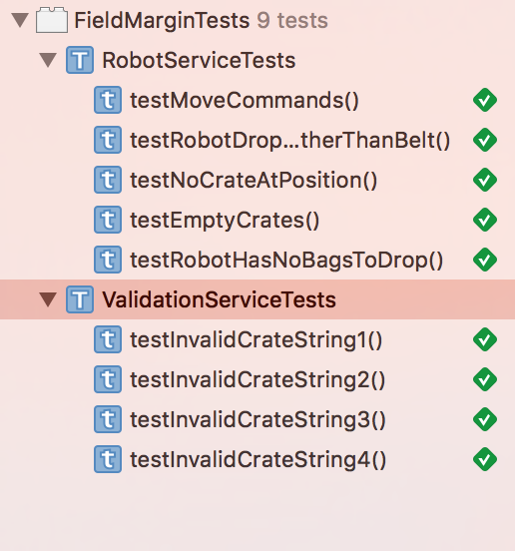

**Assumptions**:

* The robot can only carry one bag at a time
* If the robot is not carrying any bags, it does not shortcircuit if it tries to drop a bag.
* If more than 1 crate exists at a position, the code will only ever look at the first crate at that position
* Crates, belts, robots can over lap
* The submit button clears all previously submitted commands
* Only works in Portrait orientation

**Still To Do:**

* More unit testing of RobotService and ValidationService
* Unit testing of all ViewModels
* Info screen explaining inputs and commands
* Scrollable view so you can scroll to bottom of screen while still viewing the keyboard.
* Use BezierPaths to draw actual path of robot for better understanding to the user.
* Validation to update while typing. At the moment if you make an error and the text goes red, you need to move to the next text box or dismiss the keyboard to update the validation.
* Implement better rules around positioning. I.e. at the moment it is assumed that a robot, a crate and the conveyer belt can occupy the same position.