Project 1 - Documentation

(CMPG 323)

**C. Klein**

Student number: 31902278

TABLE OF CONTENTS

1.1 ERD DIAGRAM 1

2.1 USE CASE DIAGRAM 1

3.1 FLOWCHARTS 2

3.1.1 Add service 2

3.1.2 View service 2

3.1.3 Subtract service 2

List of FIGURES

Figure 1‑1: ERD diagram for Project 1 1

Figure 2‑1: Use case diagram for Project 1 1

Figure 3‑1: Flowchart for Add service 2

Figure 3‑2: Flowchart for View service 2

Figure 3‑3: Flowchart for Subtract service 2

## ERD DIAGRAM

# Heading 1 won’t print. Don’t delete – doing so will lead to incorrect numbering.

Figure 1‑1: ERD diagram for Project 1

## USE CASE DIAGRAM

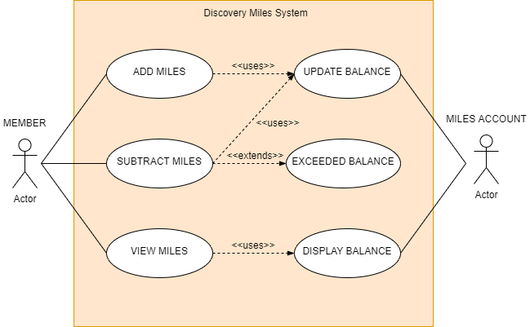

**Figure 2‑1: Use case diagram for Project 1**



## FLOWCHARTS

### Add service



**Figure 3‑1: Flowchart for Add service**

### View service



**Figure 3‑2: Flowchart for View service**

### Subtract service

**Figure 3‑3: Flowchart for Subtract service**