**URPP Tutorial: Genomic Visualization I, UZH**

**Session I. Genome Browsers**

**Part 1. UCSC Genome Browser**

1. **Navigating the Browser:**

* Open your internet browser of choice (Firefox, Chrome, Opera, Safari)
* Go to <https://genome-euro.ucsc.edu/>
* Click on “**Genome Browser”**

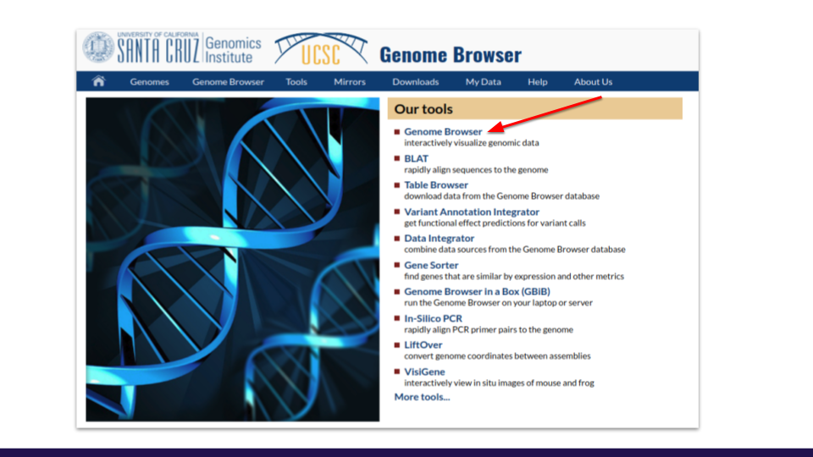

* Select “**Human Assembly**” (usually it’s selected by default)
* Type **BRCA1** on the “**Position/Search Term**” field in the browser gateway and click “**GO**”. Look at the default tracks and try to answer the following questions:

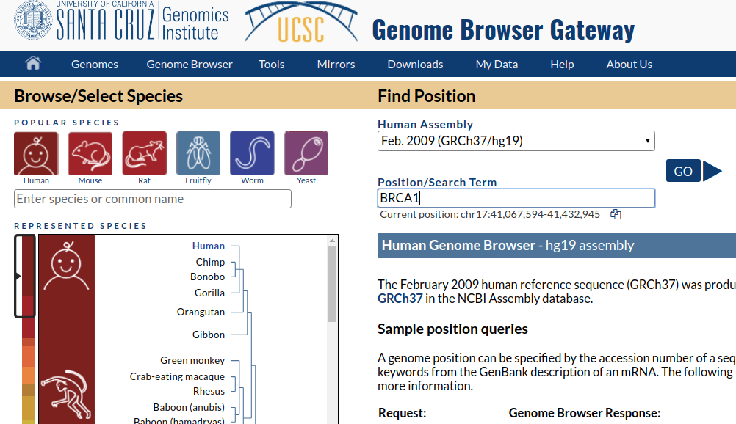

* Which is the transcript with more exons? (hint: hover over the last exon of the isoforms)

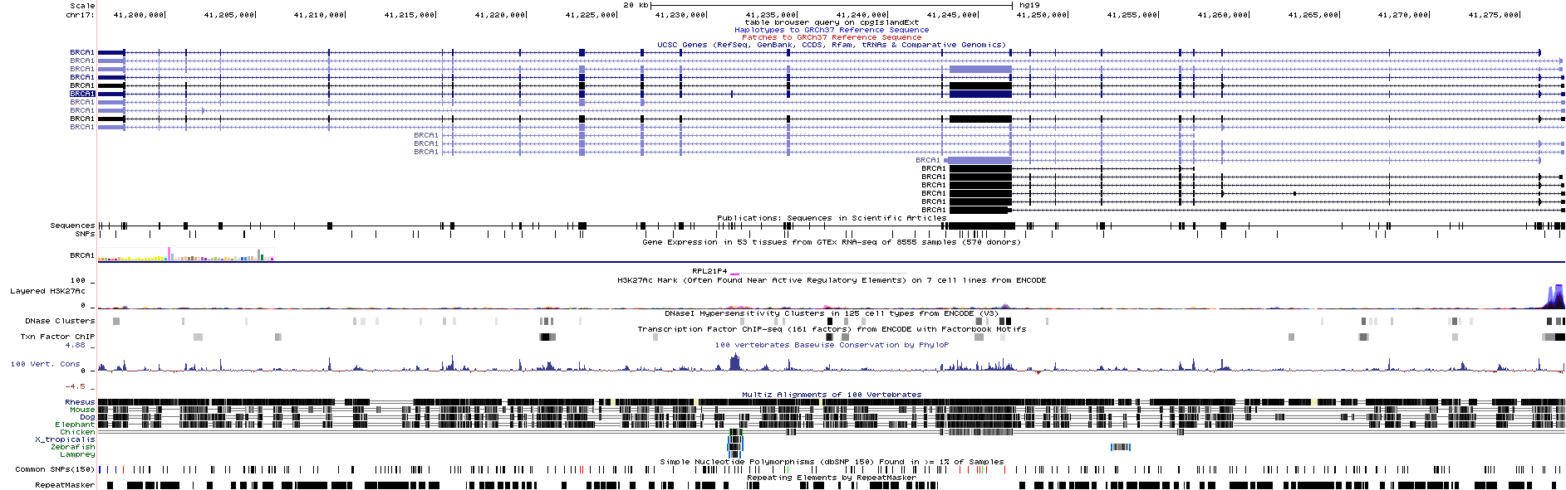

* Which are the **two closest** genes to BRCA1? (hint: zoom-out and look immediate left and right of the gene)

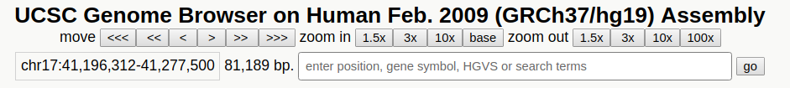

* In which tissue it has the **highest** expression? And **lowest**? (hint: click on the expression plot from GTEx)
* Hide all tracks **except** the **Gencode** track (hint: right click with the mouse of the left panels and hide the tracks)

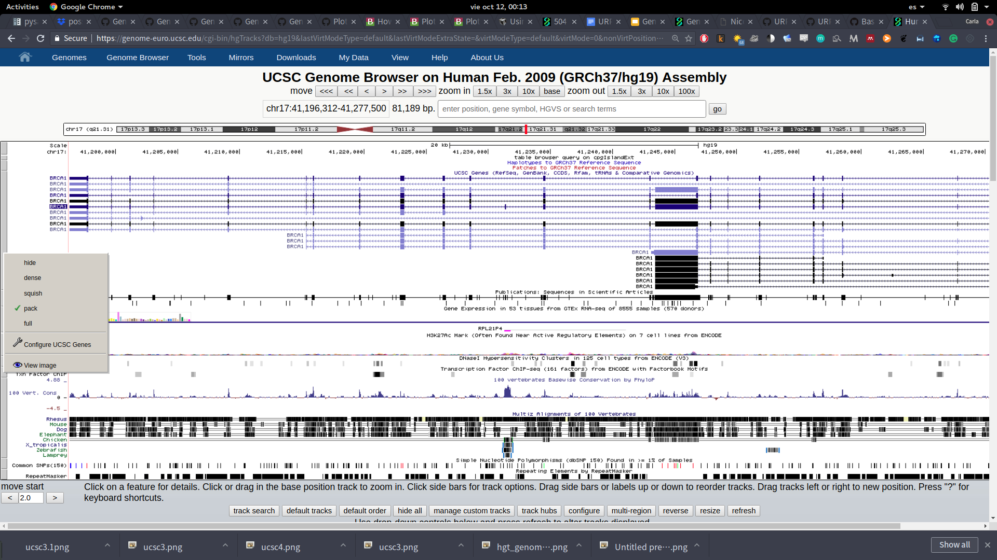

* Activate the track “**GWAS Catalog**” (Hint: Check the “Phenotype and Literature” track)

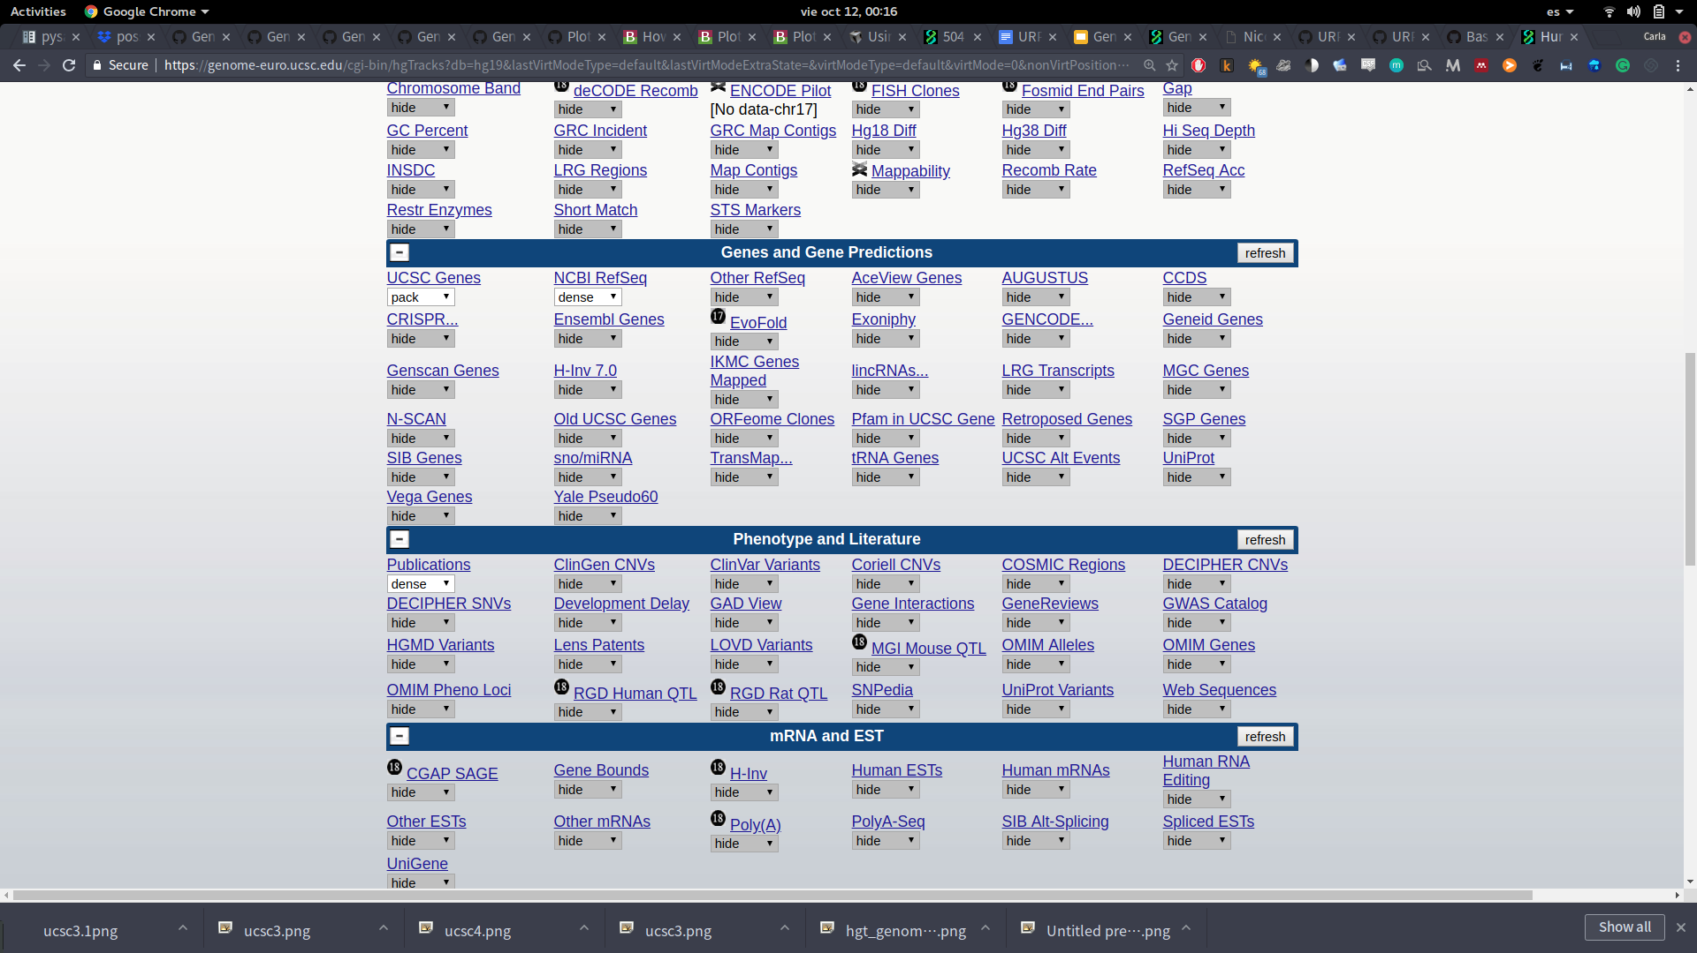

* Can you identify the SNP ID? (Hint: Hover over it)



* What’s the latest study about? (Hint: click directly on the SNP)
* What conclusions can you draw about this gene regarding its function?

**Part 1.1. UCSC Table Browser**

1. Go to **Tools** >**Table Browser**
2. Create a **custom** track: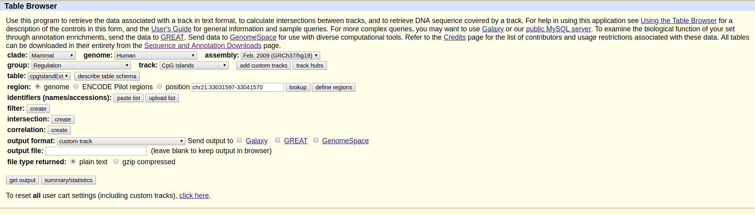

* Use the **human CRCh37/h19 assembly**.
* Select → **Group**: **regulation** and **Track: CpG Islands**
* **Import** the custom track to the **UCSC** **Genome browser** by changing the output format to **custom track** and clicking on **get output → get custom track in genome browser**

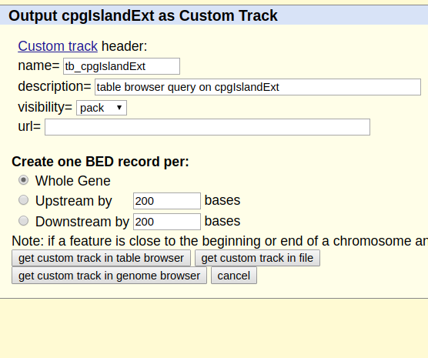

* Is there any **CpG island in or near BRCA1**? (hint: remember to zoom-out)

**Part 1.3 UCSC Genome Graphs**

1. Go to **Tools** > **Genome Graphs > import**

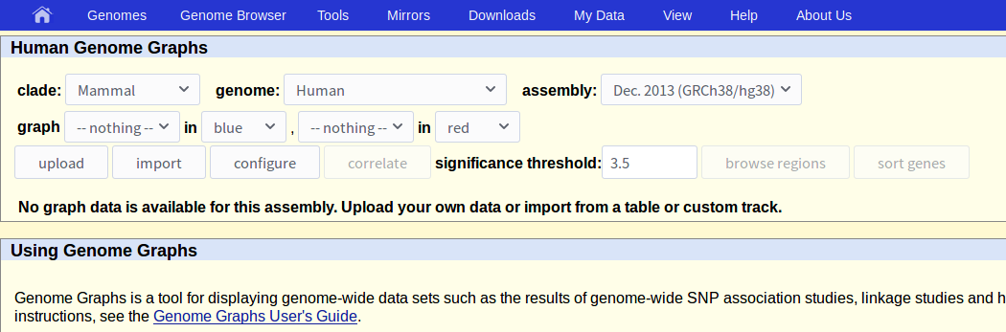

1. Import the **knownGene track** by clicking on import (remember to name it!)

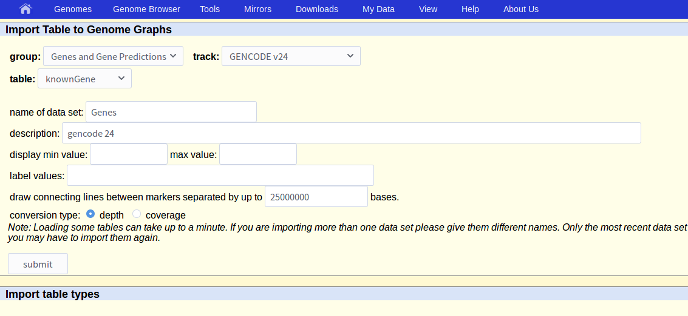

1. Load the **Genes track.** Click on **configure.**

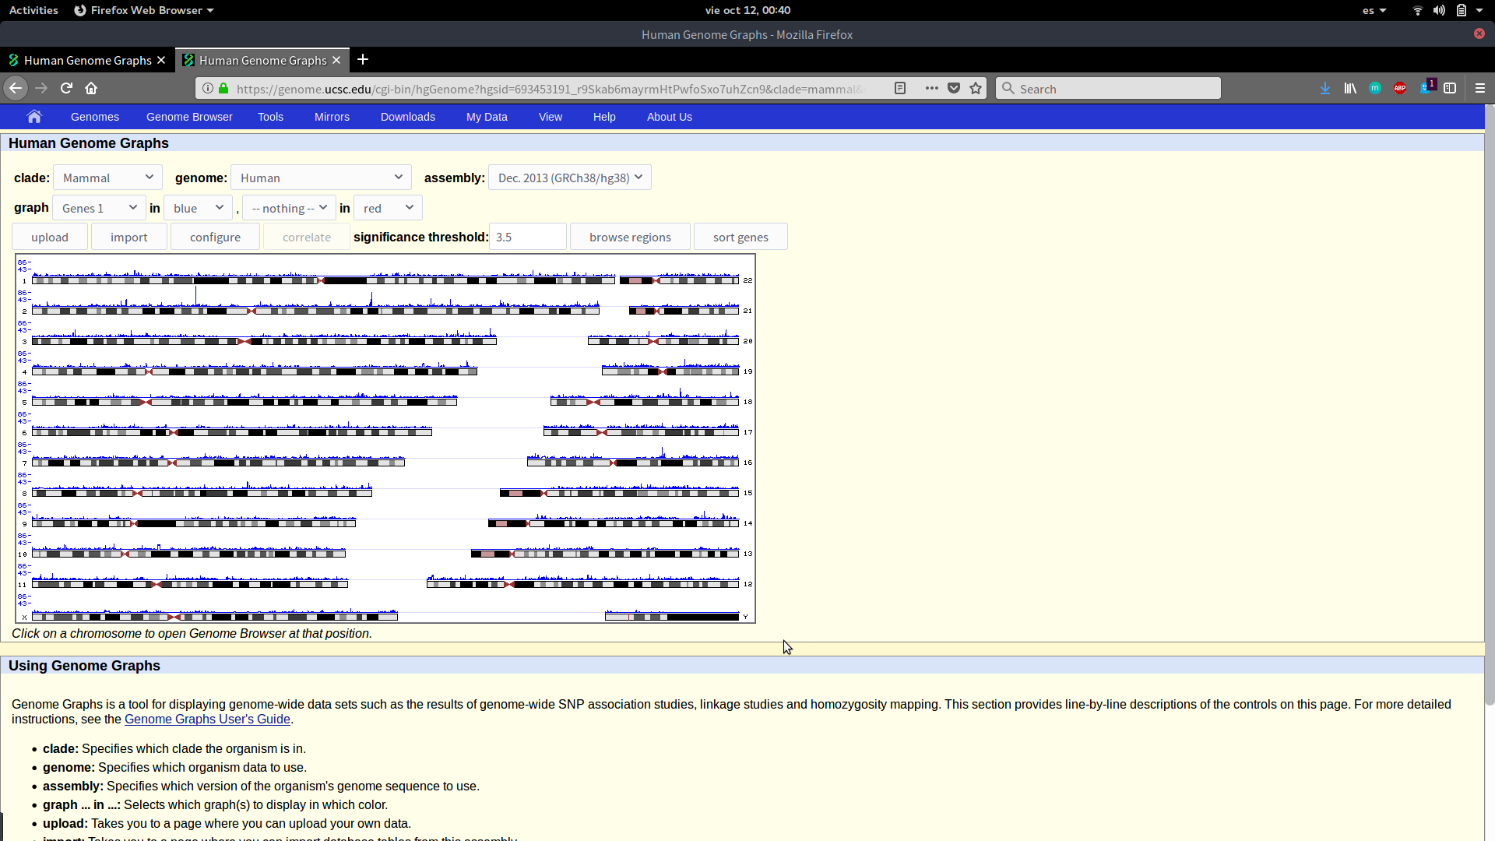

1. Change the **chromosome layout** to **one per line**.
2. Change the **width** to 2000 and change the **number of graphs** and **number of lines** to two.
3. Now **import the track of repetitive elements** (Repeats) by doing the same that we previously did to upload the track of genes.
4. Remember to load the tracks, you can customize the **colours** and **overlap** graphs. You can upload custom tracks as well.
5. Can you conclude anything about the repetitive elements around the centromeres?

**Part 2. Ensembl Browser**

1. Go to <https://www.ensembl.org/>
2. In the **Search** select human and type your favorite gene (i.e. BRCA1) and click on “**Go**”

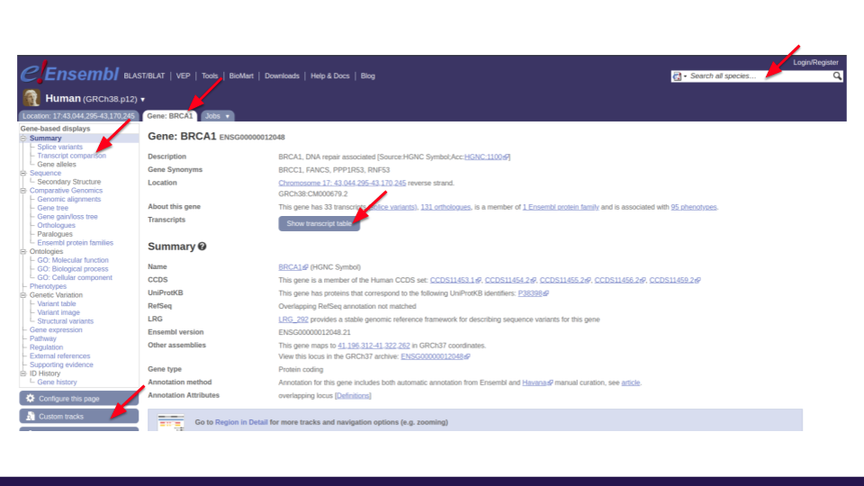

* How many transcripts does BRCA1 has?
* How many transcripts are annotated as non-coding?
* How many **one-to-one** orthologs? (hint: click on orthologues)

1. Go to menu on the left and click on **Genomic alignments** (under **Comparative Genomics**) and select: **Multiple** > **12 Primates EPO** >[**View an image of this alignment**](https://www.ensembl.org/Homo_sapiens/Location/Compara_Alignments/Image?align=1134;db=core;g=ENSG00000012048;r=17:43044295-43170245)

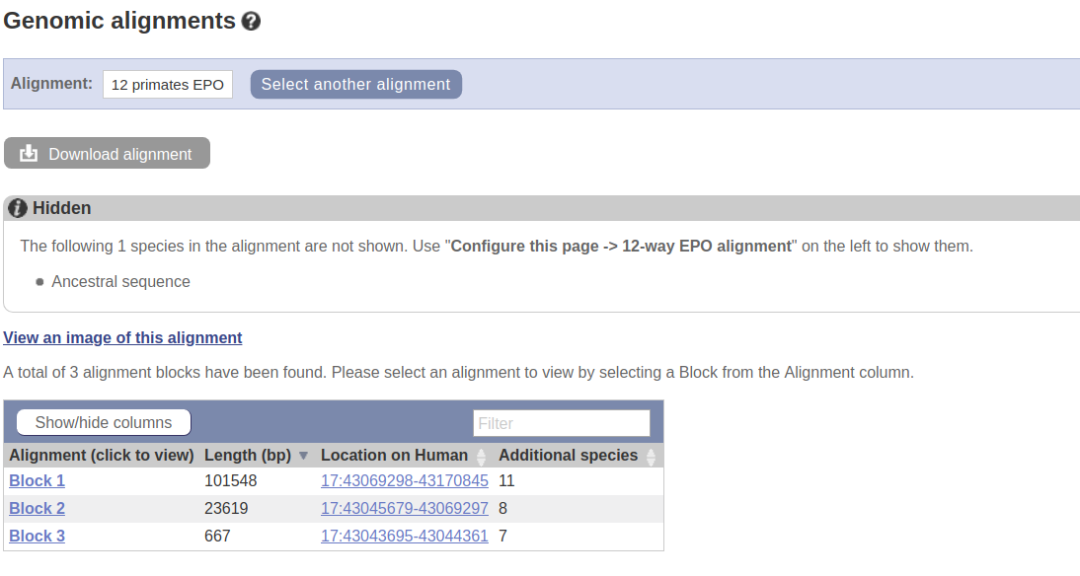

1. You can either **download the data** for further use or **quickly** assess if your gene of interest is **conserved** or/and **syntenic** among species of interest.

**Part 2. BioMart**

1. **Go to** **BioMart** by clicking **BioMart** on the ensembl webpage



1. Create a BED file using BioMart.
2. Select **Ensembl Genes 94**
3. Choose your favorite species
4. Click on **filter** and select **protein_coding**

1. Click on “**count**” and see how many protein-coding genes are (hint: look next to Dataset). 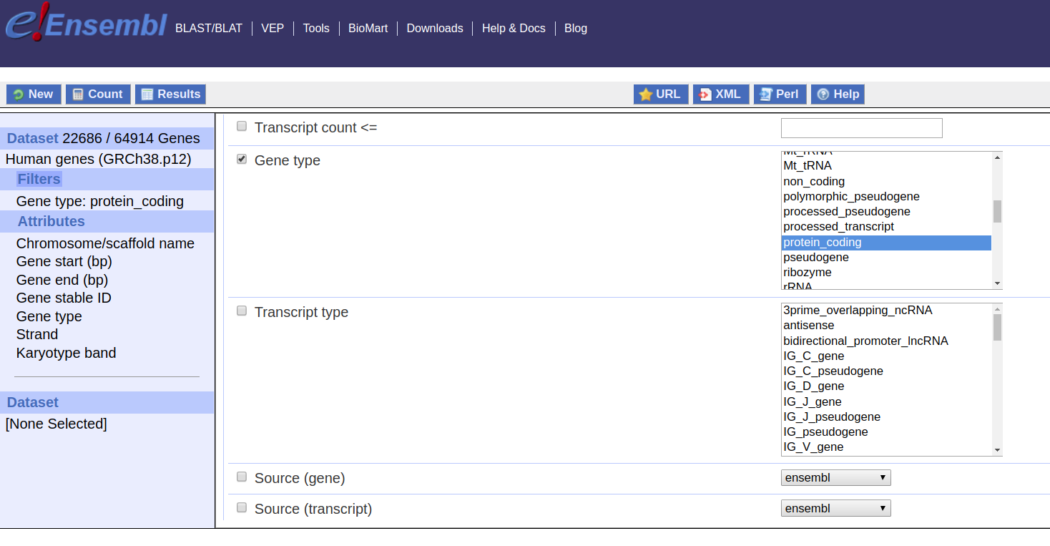
2. Now click on **Attributes** and **unselect** everything
3. Select with this specific order**: Chromosome/scaffold name** > **Gene start (bp)** > **Gene end (bp)** > **Gene stable ID** > **Gene type** > **Strand**

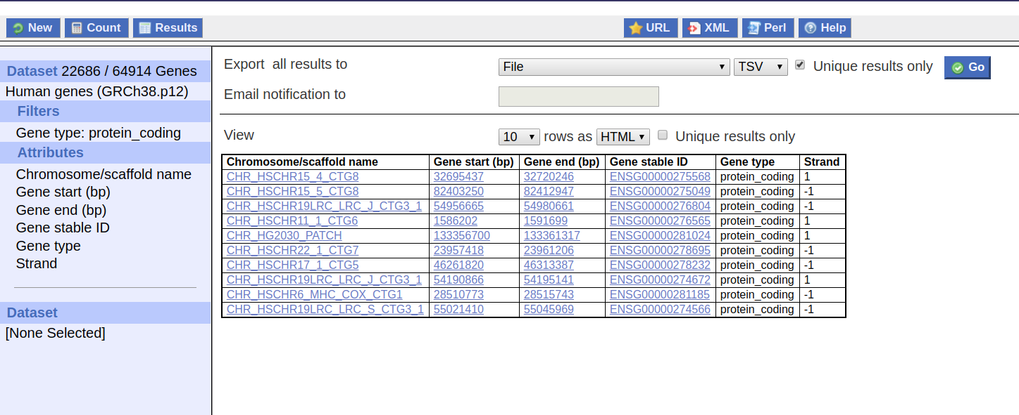

1. Click on **Results**
2. Mark “**unique results only**” > **Go**
3. The download will start and you will have a bed file.
4. You can create multiple files with lots of information.

* If you selected human as your favorite species --can you find genes only involved in Schizophrenia? (hint: go to **filters** > **phenotype**). How many genes did you find?

13. You can explore other phenotypes, protein features and additional external information.

**NOTE**: There is **Ensembl Bacteria**: <https://bacteria.ensembl.org/index.html> for bacterial species.

**Part 3. Integrative Genome Viewer**

1. If you have the **VM** from other courses IGV is under **home/student/software**
2. Else **download** and **install** **IGV**:

* **For Windows/Mac/Linux:**

<https://software.broadinstitute.org/software/igv/download>

* **From the command:**

wget \ <http://data.broadinstitute.org/igv/projects/downloads/2.4/IGV_2.4.14.zip>

unzip [IGV_2.4.14.zip](http://data.broadinstitute.org/igv/projects/downloads/2.4/IGV_2.4.14.zip)

**- Run IGV from within the installed distribution:**

./igv.sh

* **Or if you are in Linux:**

sudo apt-get install igv #install

Igv #run

3. You will work with data from the 1000 Genomes Project:

* Download the .**bam file** and its **index .bai** (the \ is to be careful of the space, there cannot be any newlines when you copy it in the command line):

wget \ ftp://[ftp.1000genomes.ebi.ac.uk/vol1/ftp/phase3/data/HG00096/exome_alignment/HG00096.chrom11.ILLUMINA.bwa.GBR.exome.20120522.bam](http://ftp.1000genomes.ebi.ac.uk/vol1/ftp/phase3/data/HG00096/exome_alignment/HG00096.chrom11.ILLUMINA.bwa.GBR.exome.20120522.bam)

wget \ ftp://[ftp.1000genomes.ebi.ac.uk/vol1/ftp/phase3/data/HG00096/exome_alignment/HG00096.chrom11.ILLUMINA.bwa.GBR.exome.20120522.bam.bai](http://ftp.1000genomes.ebi.ac.uk/vol1/ftp/phase3/data/HG00096/exome_alignment/HG00096.chrom11.ILLUMINA.bwa.GBR.exome.20120522.bam.bai)

**Note**: Both files have to be in the same folder.

* Load the files on IGV: **File** > **Load from folde**r > **exome_alignment/HG00096.chrom11.ILLUMINA.bwa.GBR.exome.20120522.bam**
* Navigate to the gene **SSRP1** in chr11. Remember what **the colours meant**?
* Look at the neighboring gene **P2RX3**. Is there anything curious about the way the reads are distributed?

4. Load the data from the server:

**Load from server** > **1000 Genomes > Phase 3 sites > Phase 3 Genotypes**

* Navigate to **BRCA1**. What can you tell about the allele frequencies?

**Part 4. Circos (*we will not use it*)**

1. Download Circos:

wget <http://circos.ca/distribution/circos-0.69-6.tgz>

tar zxvf circos-0.69-6.tgz #unzip

* Check for missing Perl modules:

sudo perl -MCPAN -e shell

install Config::General

…

exit

* If the installation of modules fails:

sudo apt-get install libgd-perl

* Run Circos within your distribution:

bin/circos