**Start with a Wireframe! Agile is not an excuse to start coding without a plan**.  
Remove the confusion over the ability to be Agile (as in flexible) while being firm on Delivery

Written by Carl Boudreau, Software Architect for Modern Clinical Delivery  
carl_boudreau@optum.com

*If you haven’t read my article “****Create Order with OnPage Loads & OnClick Events in your Agile Project****” I would recommend you read it and save you and your team a lot of frustrations while developing your application.*

Once of the most misinterpreted ideas in Agile is the meaning of being flexible on requirements while setting the expectation of the Deliveries. For example John D. imagined a log in page that had a user name, password, submit button with some helpful information on the side then written a User Story title and description. Jane D, imagined a log in page that had a user name, password, submit button with some helpful information on the side then written the acceptance criteria. Devon Developer read the User Story and imagined a log in page that had a user name, password, submit button with some helpful information on the side.

John pictured this when he was writing his User Story.  
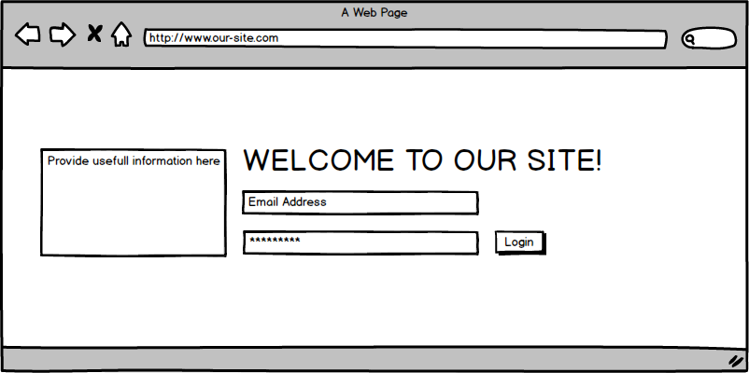

Jane pictured this when he was writing her User Story.  
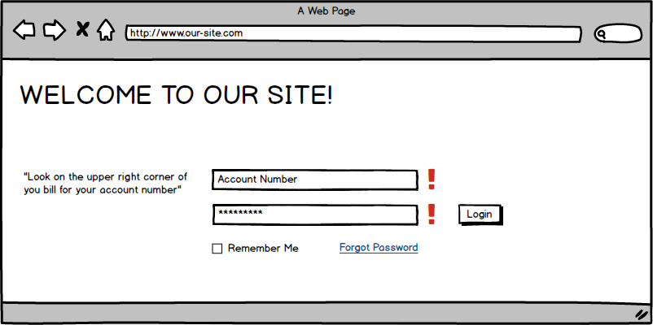

The Devon pictured this when he read the User Story.  
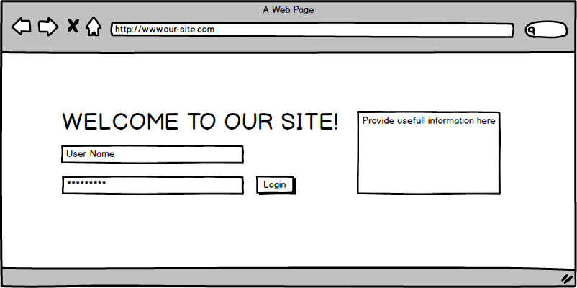

Application interfaces can be complex. A picture helps reduce Complex Projects into smaller digestible chunks for a human reader and an Agile Feature or User Story. The image below can be very intimidating to capture within a Feature or User Story within AGILE Management Software.

**A picture is worth a 1000 words**  
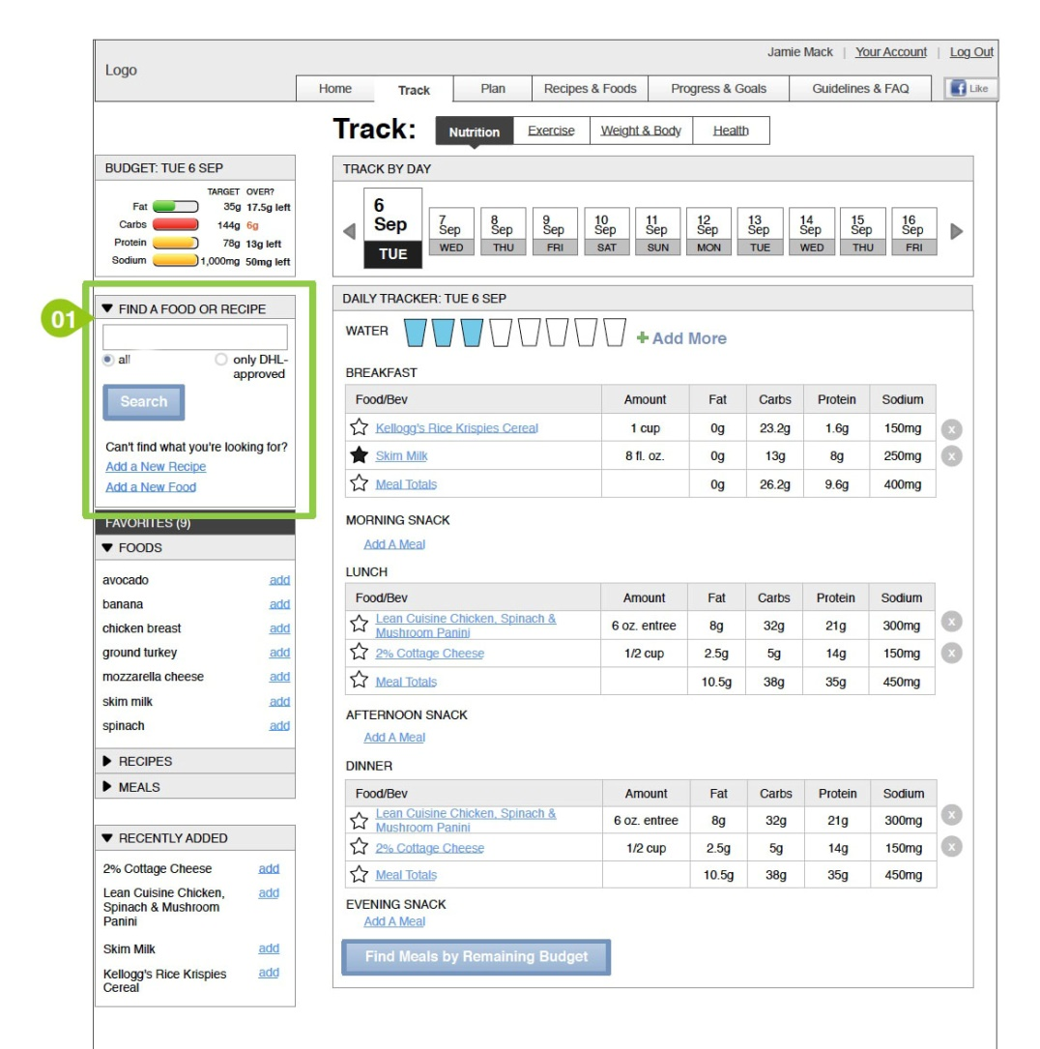

We can divide a large complex screen into smaller parts that can be delivered in a two week for a user acceptance demonstration. This division also encourages delivery speed. The page might the “Track” Feature and the “Budget”, “Find a Food or Recipe”, “Track Per Day”, “Daily Tracker”, “Favorites” and “Recently Added” might be User Stories. Each of the User Stories can be worked simultaneously and also broken into smaller tasks for the UI Designer, Developer, Database Programmer, Quality Engineer, and the User Acceptance Member. Now once the page is divided logically, the Product Owner can simply slide the User Story up or down to set her or his priority needs and help the SCRUM team meet or exceed the Business Expectations in a uniformed delivery time frame.

Following this idea fits the goal of AGILE by showing the Customer demonstrable progress; while getting feedback along the way. The four screen shots below shows 4 Acceptance Meetings between the Scrum Team and the Product Owner that demonstrates progress of their product over for sprints.