Your Customer wants an iPad Application developed; But do they?

Written by Carl Boudreau, Software Architect for Modern Clinical Delivery  
carl_boudreau@optum.com

When I hear my customers asking for iPAD Applications I ask why. And the justification doesn’t fit the strategic direction to reduce the cost of healthcare. Just because “iPad Application” is a buzz word or it looks cool, is not enough justification to develop a native application for an iPad. One should consider the cost of the equipment and the cost of the hardware and limitations of investing into Native Application Development for IOS and an iPad.

Based on the costs below that were found 23 Feb 2019 the cost of an iPad is about double of that of an Android tablet. Maybe $150 dollar difference is not much for one, but if you are planning on buying 500 of them for team members to use that is $75,000 in hardware alone.

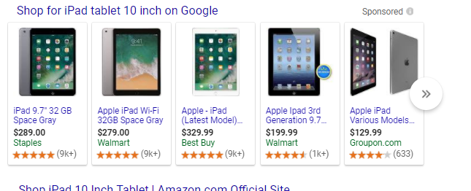

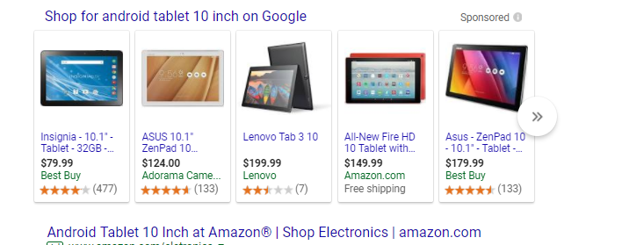

Native, Hybrid, and Web Application Development

My first question to my customers is “Does the Functionality and Business Needs meet the requirements for a Native Application?” If the functionality requires the use of hardware resources like the Camera, Microphone, GPS (location), CDMA/GSM (phone) or “Push Notification” functionality maybe. But maybe a Hybrid Application might be quicker and cheaper and faster to deliver to more devices like Android and Windows Mobile in addition to an Apple Device.

Hybrid applications are like a web browser with the ability to use the hardware resources like the Camera, Microphone, GPS and CDMA/GSM (phone) or “Push Notification” functionality without the need for a Native Application and the specialized teams. The applications are coded once and compiled for Android, IOS and Windows Mobile Devices using the same coding effort. Where a native application for iPad, Android Windows needs a specialized team with special IDE(Integrated Development Environments) the Hybrid Developer only need a text editor and a free open source compiler.

Web Applications are the most common, and the most cost effective means to deliver and collect alphanumeric content. If the application is not interfacing with hardware resources like the Camera, Microphone, GPS and CDMA/GSM (phone) or “Push Notification” functionality; then the Web Application is the best choice. In addition the Web Application uses HTML to provide UI functionality to the user on most all platforms eliminating the need to push software out to the hardware. If you’re not pushing software you don’t have to worry if the application was deployed correctly or is the right version being used by the User. Your Application will look and feel the same maintaining your Corporate Branding needs across all devices like a Desktop, Laptop, Tablet, or Phone used to run your Application.

Another factor to consider before making a huge investment and hire an iOS team to make a Native Application is the market space the devices has in the market. As of the 22 Feb 2018 you can see below of the OS Platforms the Mobile Platforms has 7.7% of the OS Platform Statistics.  
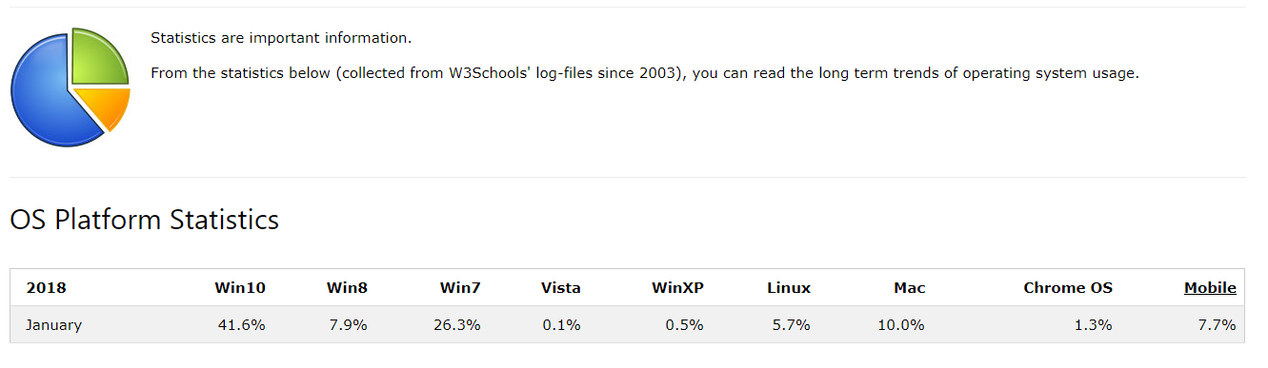

Looking at the Mobile Device Statistics below you can see that Android has 6.29% OS Platform and iOS(iPad, iPhones,…) has 1.21% of the market space.  
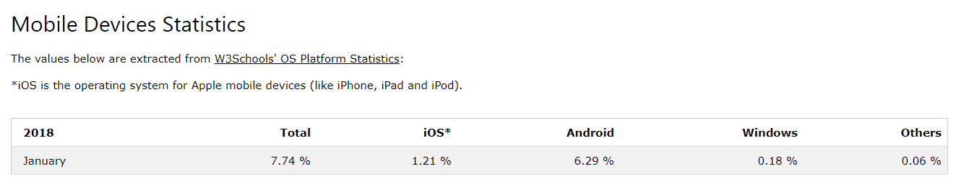

Your Customer’s first choice should be a Web Application. If they need to use hardware resources, consider a Hybrid Application that can be coded one and compiled for any devices. Developing a Native Application for an iPad should be a “Last Resort” plan if you are committed to reducing the cost of healthcare.

Below are some very good applications to research and consider adoption for your Development Environment

Cordova - <https://cordova.apache.org/>

Unity – <https://unity3d.com/>

Iconic – <https://ionicframework.com/>

Phone Gap – <https://phonegap.com/>

Xameran - <https://visualstudio.microsoft.com/xamarin/>