Incomplete

Data Contracts – Divide and Conquer Agile User Stories in an Multiple Application Impacts to organize your Features and Stories that can be worked in parallel between 2 multiple application teams.

Written by Carl Boudreau, Technology Senior Principal Engineer | Software Architect for Modern Clinical Delivery  
carl_boudreau@optum.com

*If you haven’t read my article “Converting Project Failure to Production Success!” it is a true story of how one project destine to fail was turned into a successful deploy to production with Zero Defects using Agile.*

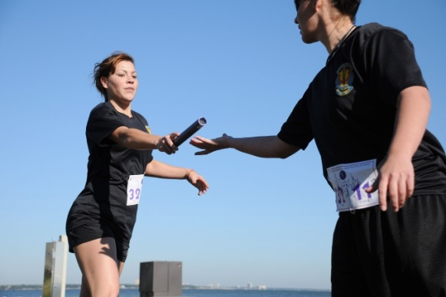The old Waterfall Process was a Relay Race Event. Business would complete the analyst for new software and then pass the baton to the next Runner down the track to write SOD, which would be passed on and on and on till the Developers had the entire project specs fully completed and flushed out. However the Relay Race method did not work very well. Requirements changed or they were not well written to where everyone would extrapolate the same mental picture of the Project. In an Agile Project and we need to figure out how to divide the old Waterfall Process into digestible parts so we can build the application in smaller demonstrable iterations.

**There is power in parallel processing!**

Data Contracts is the tool used to plan the divide, produce & merge work efforts; to assure we can conquer the Feature/User Story. Some times when a couple goes shopping, they agree to take half of the shopping list and then meet up at the checkout once complete. The Couple started at the entrance to the store dividing the work (User Story/Tasks) and came together at the exit with hopefully the work of shopping complete {Insert funny story about husband adding beer to his list here}

Our Couple for the sake of this example is one or more Application Teams impacted in the Project. If App Team 1 and App Team 2 could agree to where to meet and what they will return with; they could go their separate ways to do their work. When completed return to each other put their work together to complete and conquer the User Story.

Software applications are just tools that move data from one computer to another. So it makes since that after the wireframes have been delivered, the Data Contracts would then be created any tie data is moved from one systems to another.