The Forge Site Plan

Bryson Carlton

WDD 130

Overview

Purpose

“The Forge” is a daily site built for men who value discipline, resilience, and reason. Each day, it delivers a quote from Stoic thinkers, philosophers, and modern leaders — paired with a short reflection on applying it to real life. The site includes the daily quote, author. What makes The Forge unique is its focus on timeless masculine principles — not as motivation hype, but as daily training for the mind and character.

Audience
Built for those obsessed with building themselves to become greater every day through stoicism, invalidating your emotions, and ancient philosophy.

Branding

Website Logo

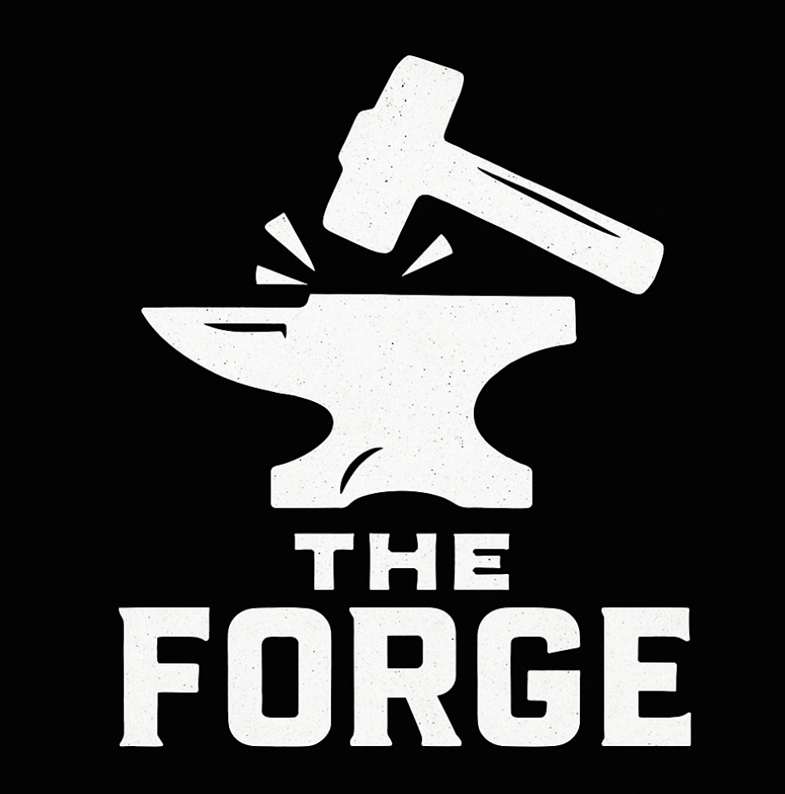

Style Guide

Color Palette
Primary | Secondary | Accent 1 | Accent 2
#090B0B | #999999 | #0D1759 | #CACFD6

Typography

Heading Font: Bebas Nue

Paragraph Font: Inter

Navigation
Home Page2 Page3

Content

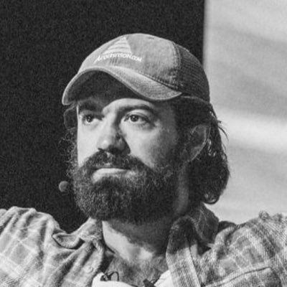 Alex Hormozi
“The single greatest skill you can develop is the ability to stay in a great mood in the absence of things to be in a great mood about.”
“No matter what your goal is, you will suffer to achieve it. So pick a goal big enough it’s worth suffering for.”
“The lazy don’t know how to start. The losers don’t know how to finish. The legends don’t know how to stop”

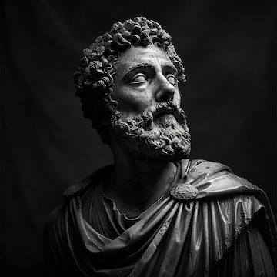Marcus Arealius
“What are you so afraid of losing when nothing in this world belongs to you?”
“The soul becomes dyed with the colour of its thoughts.”
“The best revenge is to be unlike him who performed the injury.”

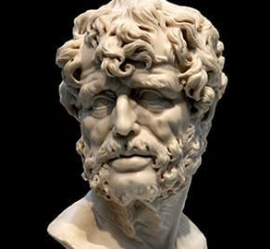Seneca
“No person has the power to have everything they want, but it is in their power not to want what they don’t have, and to cheerfully put to good use what they do have”
“He who fears death will never do anything worthy of a man who is alive.”
“We are more often frightened than hurt; and we suffer more in imagination than in reality.”

Wireframes

Home

https://wireframe.cc/sLNWF3
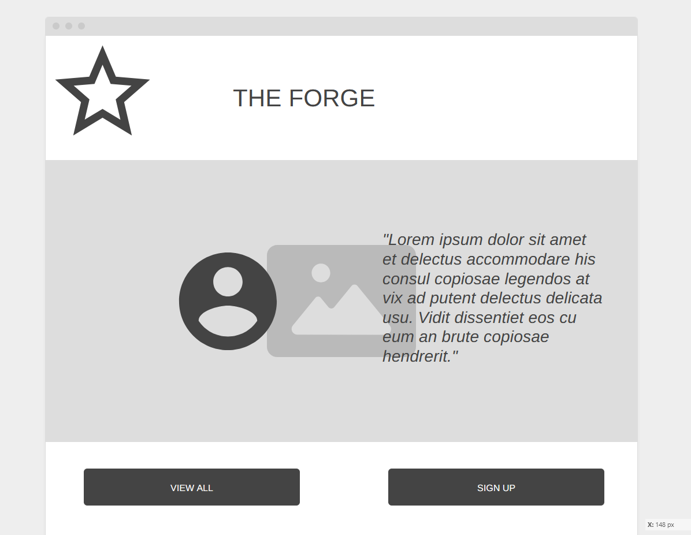

https://wireframe.cc/HJ3uqf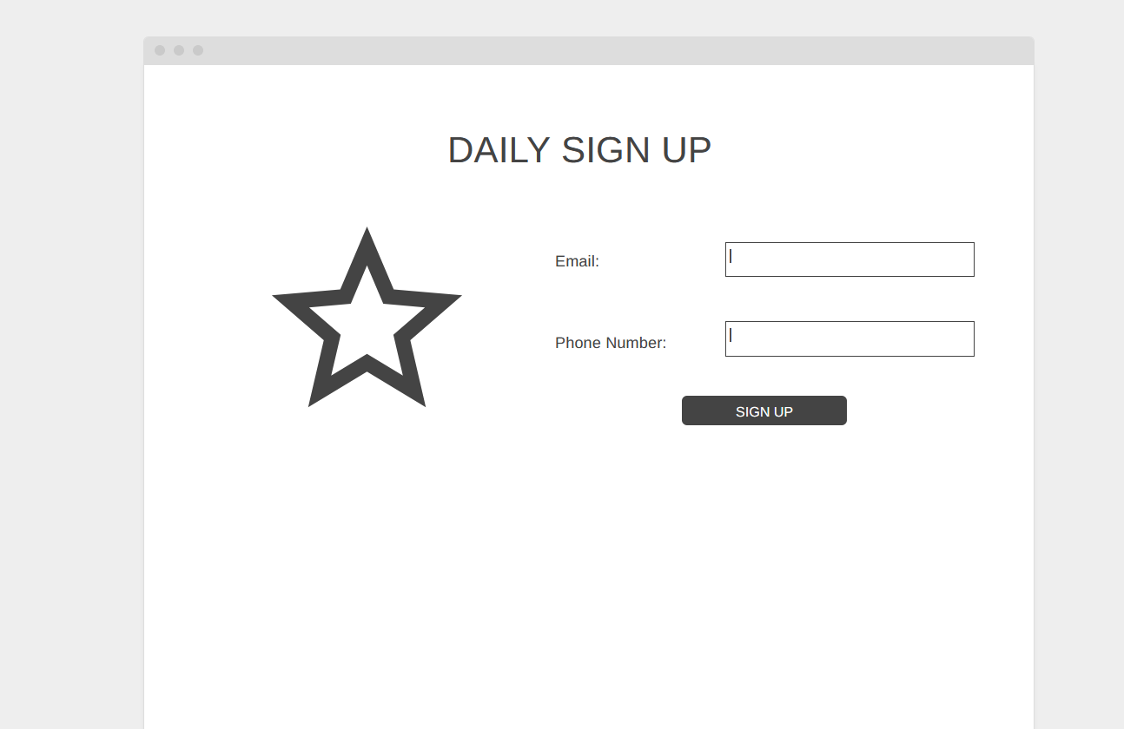

https://wireframe.cc/NPd7Er
