RESEARCH PROPOSAL

|  |  |
| --- | --- |
| **Research title (Vietnamese)** | Kiến trúc mô hình căn hộ cho thuê thông minh dựa trên Blockchain |
| **Research title (English)** | Architecture for Smart Rental Apartment Model Based on Blockchain |
| **Sub-committee** | FGW |
| **Group name** | TheGreBoys |
| **Authors** | 1. Nguyễn Duy Quang 2. Nguyễn Quốc Thông 3. Đỗ Hữu Duy 4. Đặng Nguyễn Đăng Khôi 5. Hứa Nguyên Khang |
| **Supervisors** | 1. Nguyễn Trung Việt (Main supervisor) 2. Nguyễn Hùng Dũng (Co-supervisor) |

# Abstract

The research topic that we pursue and conduct research on is the study of the smart apartment rental model applying Blockchain technology. With this research, our goal is to apply Blockchain technology to the apartment rental model instead of using the traditional model as before, which will help both tenants and landlords save money, time, and risks when signing a contract because there will be no face-to-face meeting because this process will be done based on the Blockchain system. To carry out this study, we will apply the secondary research method to collect relevant data to serve the research process. In this research, we have the following research question:

**RQ1:** What happens when the tenant of the apartment leaves before the due date and does not pay the owner of the apartment?

**RQ2:** How will the Blockchain system help in the process of creating contracts and handling disputes that arise?

**RQ3:** How can blockchain increase convenience and transparency between landlords and tenants?

**Key words:** blockchain; smart contract; hyperledger; smart rental apartment

# Introduction

* 1. **Literature review**

The Architecture for Smart Rental Apartment Model Based on Blockchain aims to explore the potential benefits of Hyperledger Fabric as a blockchain framework for the rental industry. Specifically, it seeks to design and implement a smart rental apartment model based on Hyperledger Fabric to enhance the transparency, security, and efficiency of the rental process.

An overview of Blockchain and Hyperledger Fabric: Blockchain, also known as Distributed Ledger Technology, enables individuals to record and access a consistent view of a system's status across a network. This creates numerous opportunities for peer-to-peer value transfer, reliable and immutable registries, and secure execution of contracts via smart contracts. In essence, Blockchain is considered a tool to establish trust, transparency, dependability, efficiency, and speed in automated and peer-to-peer transactions [1].

Hyperledger Fabric is a permissioned blockchain framework that stands out for its use of general- purpose programming languages like Go, Node.js, and Java to implement smart contracts, known as chain code in Hyperledger Fabric. This feature is advantageous because it allows potential developers to leverage their existing knowledge of these programming languages, and development tools may already be available for them [2].

Several studies have been conducted on the use of blockchain technology in the real estate industry, both in Vietnam and abroad. These studies have explored various aspects of blockchain technology, such as its potential to increase transparency and security, reduce costs, and improve efficiency in real estate transactions:

“Legal challenges and opportunities of blockchain technology in the real estate sector” by Rosa M. Garcia-Teruel. The focus of this paper is to evaluate the current role of intermediaries in the European Union (EU) real estate sector, including their functions, and explore the potential of blockchain technology to enhance transaction security and reduce processing time. The author employs a legal methodology to examine this issue in detail. There are some challenges that be addressed in the article, including the costs associated with smart contracts and scalability issues - a smart contract through Ethereum interested party needs Gas (transaction value) [3]. Additionally, the scalability of the system: the more transactions, the more rewards are given to miners to ensure that the transaction is concluded [3]. Many programmers and researchers are attempting to solve this issue, and some of them think they have. (e.g. the fee-less IOTA, a cryptocurrency for the Internet of things, with the Tangle system, where no miners exist).

Blockchain technology has been gaining traction across various industries, including finance, healthcare, and supply chain management [4]. However, there is still limited research on its use in the rental property market, especially in the Vietnamese context. Despite the global pandemic disrupting the real estate industry, the Vietnamese property market has remained resilient, with the demand for rental properties increasing in recent years, Various prop-tech startups and traditional real estate firms aim to leverage technology to improve their operations and competitive edge by providing practical solutions. It enhances home buying, selling, renting, and living experiences in Vietnam [5]. However, the rental market in Vietnam is not without its challenges, including the lack of transparency, inefficient payment methods, and disputes

between landlords and tenants. the use of blockchain technology could potentially offer a solution to some of the challenges faced by the rental property market.

It presents general information on the growing popularity of blockchain technology across various industries and highlights the challenges faced by the rental property market in Vietnam.

“Legal challenges and opportunities of blockchain technology in the real estate sector” by Rosa M. Garcia-Teruel, provides a detailed analysis of the current role of intermediaries in the European Union real estate sector and the potential of blockchain technology to improve transaction security and processing time. The paper employs a legal methodology, which may limit its scope in exploring technical aspects of blockchain technology. However, the author addresses some of the challenges associated with smart contracts and scalability issues, providing insights into potential obstacles to the widespread adoption of blockchain technology in the real estate sector.

Therefore, future research could focus on investigating the potential applications and benefits of blockchain technology in the rental property market in Vietnam. Additionally, more research is needed on the technical and practical challenges associated with implementing blockchain technology in the real estate sector, including issues related to smart contracts and scalability.

There is limited research on the use of blockchain technology in the rental property market, particularly in the Vietnamese context. There are some challenges that could be addressed by the use of blockchain technology, such as the lack of transparency, inefficient payment methods, and disputes between landlords and tenants.

Furthermore, the review highlights the potential of blockchain technology to enhance transaction security and reduce processing time in the real estate sector - there are still some challenges associated with smart contracts, such as costs and scalability issues.

In conclusion, there are opportunities for the use of blockchain technology in the rental property market in Vietnam.

# The necessity of the research

Because of the rental property market in Vietnam faces several challenges, including the lack of transparency, inefficient payment methods, and disputes between landlords and tenants.

Besides that, blockchain technology has shown potential in addressing some of these challenges in other industries, and it is important to explore its potential in the rental property market.

Therefore, the research also contributes to the existing literature on the use of blockchain technology in various industries in Vietnam. While blockchain technology has been gaining traction across various industries in Vietnam, there is still limited research on its use in the rental property market. The research can potentially provide insights into the feasibility and effectiveness of using blockchain technology in the rental property market in Vietnam and contribute to the development of the broader blockchain ecosystem in the country.

# Feasibility of research

Researching this topic is feasible, but there are some factors that should be considered before proceeding.

* To begin with it is important to ensure that there is enough literature and research on the topic to provide a foundation for our research. We need to conduct a literature review to ensure that you are up-to-date with current research on blockchain-based smart rental apartments.
* Futhermore, we will need to have a good understanding of blockchain technology and its potential applications in the real estate industry. This includes understanding the benefits and limitations of blockchain for rental apartment models, as well as the technical aspects of blockchain implementation.
* Lastly, we will conduct field research to gather data on the feasibility of the proposed architecture for a smart rental apartment model. This may include interviewing industry experts and stakeholders, as well as conducting surveys or focus groups with potential tenants.

Overall, researching this topic is feasible, but it will require a significant amount of time and effort to ensure that your research is thorough and accurate.

# Research objectives

Our research topic is based on Web3. First, we need to find out “What is Web3?”

Web3 is a new internet paradigm that is decentralized, open, and community-driven. Unlike the current web, which is largely controlled by centralized organizations and powered by proprietary technologies, Web3 is built on open-source, blockchain-based technologies that enable greater security, privacy, and user control [6].

While Web3 promises to address issues such as data privacy and security, it also raises new challenges around governance, interoperability, and usability. Moreover, Web3 is still in its early stages of development and lacks the user adoption and infrastructure required for it to achieve mainstream success [7].

Why did we choose to build in Web3? Web3 offers several key advantages over the current web, including greater security, privacy, and user control, as well as the potential to create new business models and revenue streams. Moreover, Web3 is still in its early stages of development, which means there is an opportunity for innovative entrepreneurs to shape its trajectory and influence its evolution [8].

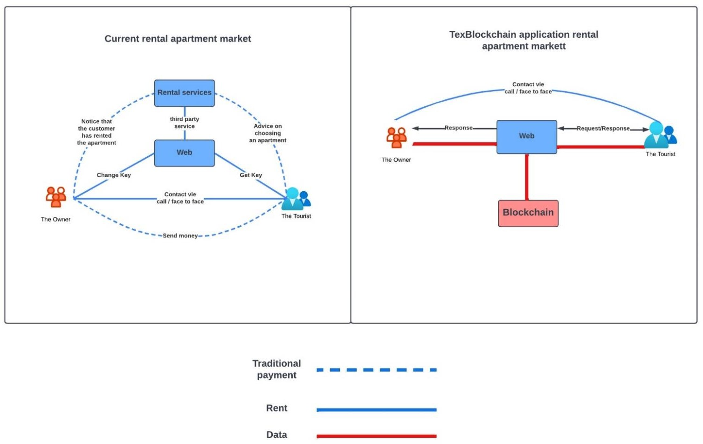

*Figure 1: The difference between traditional apartment rental and blockchain-based smart apartment rental*

As you can see in Figure 1. For the current rental market, the process is quite complicated. Travelers must access the web, and it may be linked to 3rd parties (possibly rental services). When tourists do not know which apartment to choose, they will contact the rental service and they will advise. After the consultation is complete and the customer agrees, the rental service will contact the owner of the apartment so that the two parties can sign a contract. After that, the apartment owner will hand over the key to the customer and the customer will pay the money. At the end of the contract, the customer must return the key to the apartment owner. This process is quite complicated.

On the contrary, when blockchain is involved, the process is quite quick and convenient. Customers only need to visit the website and select the apartment to rent. Then fill in all the necessary information in the booking and payment form. At this point, all data will be saved to the smart contract. When due, the smart contract will automatically execute the pre-established contract. The password key will be delivered to the customer and the money will be transferred to the apartment owner's account. During the customer's stay, the only customer knows the lock password, and the apartment owner will not know. This increases privacy and security for customers. When the contract expires, the smart contract continues to change the old password for the apartment owner.

In general, when blockchain is applied to apartment rental, the process will become easier, safer, and more secure. Besides, the cost is also less expensive because there is no 3rd party intervention.

Here are our team's research objectives:

* Applying blockchain technology in a smart apartment rental model.
* Helping save time and minimize interference and face-to-face meetings between hosts and tourists. From there, it helps to simplify the signing process. Travelers and hosts can sign contracts faster without having to spend time meeting face-to-face to sign a contract, all through the model’s automated contracting.
* Reduce the risks and limitations of the traditional model. For example, the tenant does not pay the rental fee, or the lessor does not deliver the correct key, or cancels the contract midway. When the contract is signed successfully, the amount and key will be saved to the blockchain, when the contract comes into effect if both the host and the tourist comply with the agreement, the money will be transferred to the owner of the house, and the key will be delivered to the tourist. Otherwise, the money will be returned to the tourists and the key will not be transferred to the traveler.
* Limiting 3rd party interference. Registration, rental, and payment are all automated by the blockchain system, so with this model, it is possible to minimize third-party interference in signing contracts between host and tourist. It also saves costs on paying 3rd parties. Moreover, limiting 3rd party interference also reduces the risk of leaking sensitive information of travelers and hosts when required such information from a third party.
* Improve security for both landlords and tenants. The security key will provide the key to the tourist and only that guest can know (the landlord cannot change the contract while the contract is still valid) after the end of the lease, the key will be changed to the homeowner's key. This ensures that the landlord cannot unilaterally terminate the contract and change the key while the contract is still valid and ensures the security and safety of the homeowner when the contract expires.
* Transparency of contracts will be enhanced. When applying blockchain to the rental model, the contract information will not be changed. This makes disputes between hosts and tourists easier to resolve

# Research scope

* Key study topics: Improving the limitations of the traditional rental model such as dependence on 3rd parties, limiting face-to-face, holes in the contract signing process between landlords and guests tourism. In addition, improving security and transparency when signing contracts between landlords and tourists by applying blockchain technology to smart apartment rental models.
* Scope: This model is only applicable in the territory of Vietnam.
* Assumption: All rental houses are smartly locked in suitable models with the model available automatic payment and collection methods.

# Approach and Method

* Approach: We see the development, benefits, and future of Blockchain. At the same time, through practical experiences and realizing the risks in the current rental process. Therefore, we have conducted this research and proposed a smart home rental model by applying Blockchain technology.

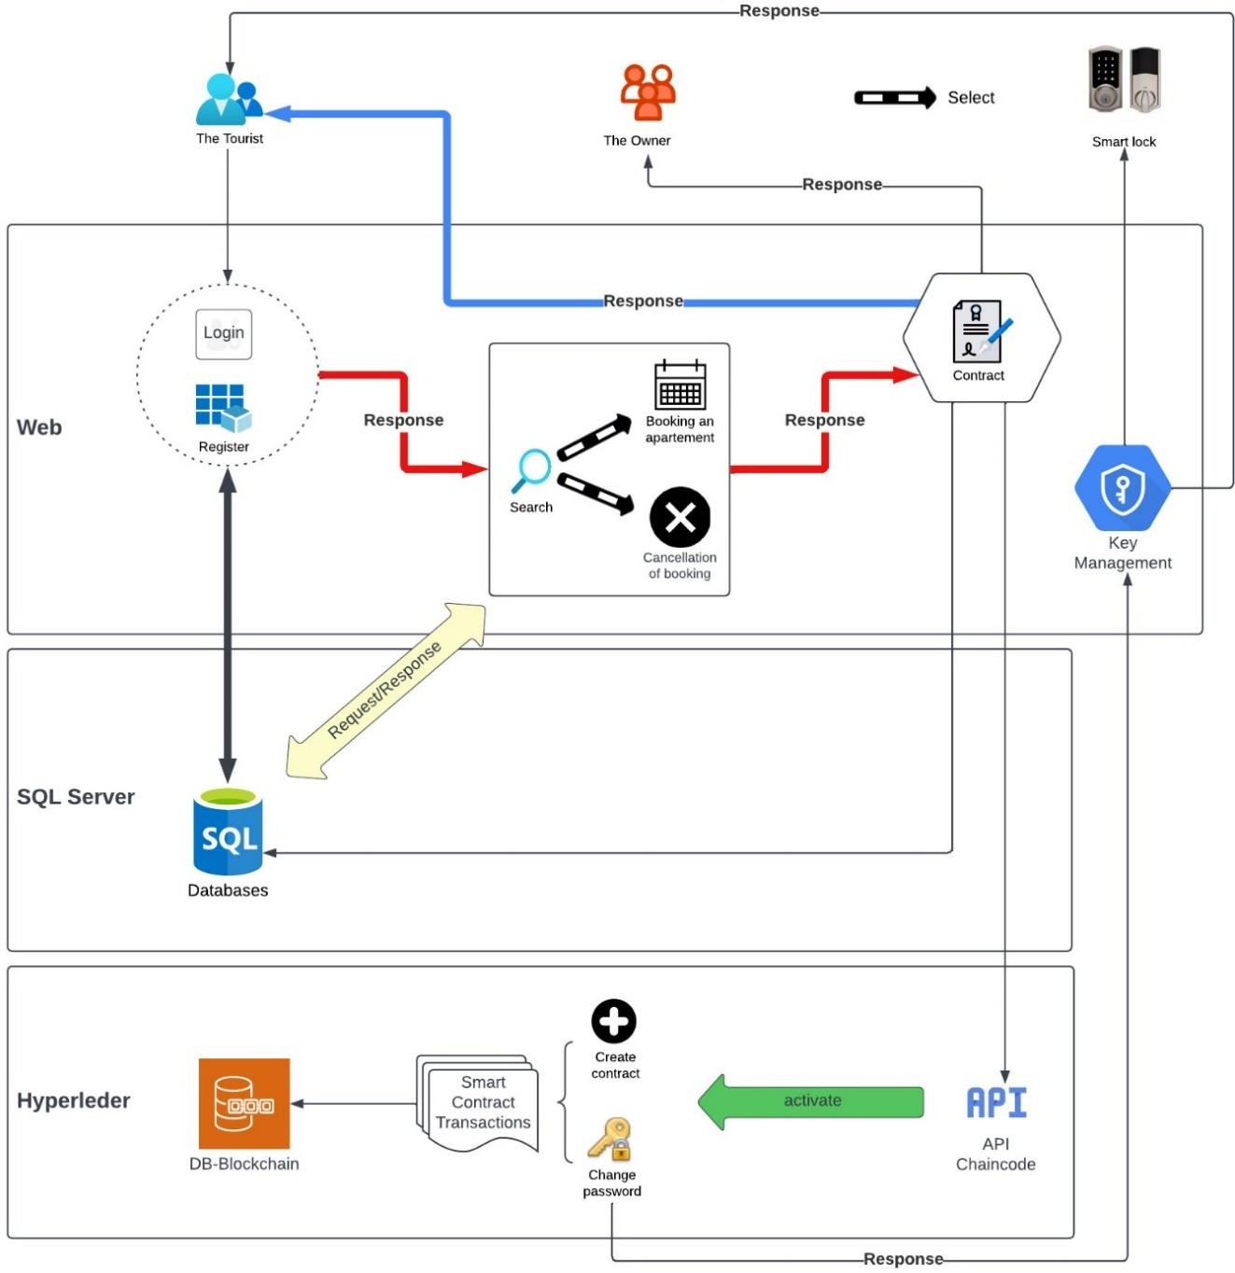

*Figure 2: Smart Rental Apartment Model utilizes replaceable units to track transactions from tenants and apartment owners. They are conceptually organized into three classes.*

Tourists (customers) register and log in to the website, then they can search for apartments to rent. At this point, the traveler can make a reservation or cancel the booked room. All are saved in the database, and transactions will be made by calling the API to the Chaincode written in Hyperledger. When the smart contract expires, it will be executed. The key will be sent to the customer and the money will be transferred to the apartment owner.

* Research methods: Secondary research.
* Expertise:
  + Model design: Lucidchart
  + Contract handling: Hyperledger
  + Web back-end user account management: ASP.Net core
  + UI: HTML, CSS, Bootstrap

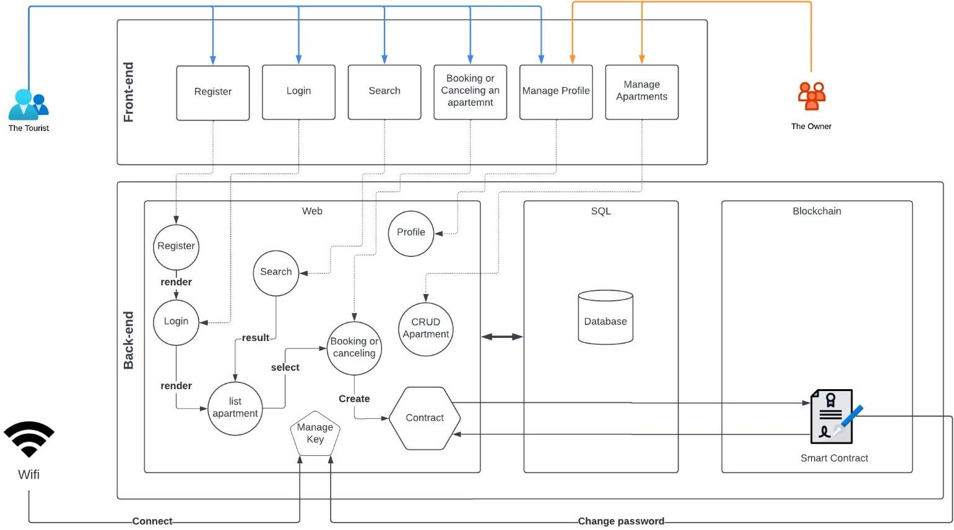

*Figure 3: Smart rental apartment architecture using MVC model*

# Research plan

***Table 1:*** *Describe the research plan*

|  |  |  |  |  |
| --- | --- | --- | --- | --- |
| **No.** | **Date** | **Task** | **Output** | **Person in charge** |
| 1. | 14/03/2023  - 31/03/2023 | Literature Review and Research Design | During this period, we could conduct an extensive literature review to identify the key themes and trends in blockchain-based rental models. Based on the literature review, we could develop a research design that outlines the research questions, research objectives, methodology, data collection, and data analysis techniques. | Quang |

|  |  |  |  |  |
| --- | --- | --- | --- | --- |
| 2. | 1/4/2023  - 30/4/2023 | Data Collection and Analysis | During this period, we could collect data from a range of sources, including interviews with landlords, tenants, and real estate professionals, surveys, and secondary data sources. We use qualitative and quantitative data analysis techniques to analyze the data and identify key themes  and patterns. | Thông, Khang |
| 3. | 1/5/2023  - 30/6/2023 | Model Development and Testing | During this period, we develop and test a prototype blockchain-based rental model. The model could be designed to address key issues such as lease agreements, maintenance, and dispute resolution. We could work with real estate professionals, landlords, and tenants to test the model and gather feedback on its  effectiveness. | Quang, Thông, Duy, Khôi, Khang |
| 4. | 1/7/2023  - 15/8/2023 | Results and Recommendations | During this period, we analyze the results of the data collection and model testing, and use the findings to develop  recommendations for the development and  implementation of blockchain-based rental models. | Quang, Thông, Khang |

|  |  |  |  |  |
| --- | --- | --- | --- | --- |
| 5. | 16/8/2023  - 19/8/2023 | Report Writing and Submission | During this period, we write the final report, which summarizes the research objectives, theoretical, methodology, practical implications, plans to apply this research in practical, findings, and  recommendations. | Duy, Khôi |

# Expected results

The expected research results for the topic “Architecture for Smart Rental Apartment Model Based on Blockchain” could include:

* **Theoretical Contributions:** The research could contribute to the existing literature on blockchain technology and its potential applications in the real estate industry. It could provide insights into the advantages and disadvantages of using blockchain technology in the rental process and explore the theoretical frameworks that underpin smart rental apartment models based on blockchain.
* **Methodological Contributions:** The research could also contribute to the development of new research methodologies for studying blockchain-based rental models. It could explore the challenges and opportunities of using blockchain technology for data collection, analysis, and visualization in the real estate industry.
* **Practical Applications:** The research could have practical implications for real estate professionals, landlords, and tenants. It could provide guidance on how to design and implement blockchain-based rental models, highlighting the key features and functionalities that are necessary for success. It could also explore the potential challenges and barriers to adoption of blockchain-based rental models in practice.
* **Applicability in Practice:** The research could investigate the practical applicability of blockchain- based rental models in different real estate markets and contexts. It could identify the factors that affect the adoption and success of blockchain-based rental models, such as legal and regulatory frameworks, market demand, and technological infrastructure.
* **Increased transparency:** The use of blockchain technology can increase transparency in the rental process by creating an immutable record of all transactions, making it easier for landlords and tenants to track payments and other important information.
* **Enhanced security:** Blockchain technology can provide enhanced security features that make it more difficult for hackers to tamper with data. This can help prevent fraud and ensure the safety of sensitive information.
* **Greater efficiency:** By automating many of the rental processes using smart contracts, the rental process can become more efficient, reducing the need for intermediaries and streamlining communication between landlords and tenants.
* **Lower costs:** The increased efficiency of the rental process and the reduction in intermediaries can lead to lower costs for both landlords and tenants.
* **Improved tenant experience:** The use of smart contracts and other blockchain-based technologies can provide tenants with greater control over the rental process and make it easier for them to communicate with landlords and resolve disputes. This can lead to a more positive rental experience overall.

**References**

|  |  |
| --- | --- |
| [1] | S. Meunier, "Chapter 3 - Blockchain 101: What is Blockchain and How Does This Revolutionary Technology Work?," in *Transforming Climate Finance and Green Investment*  *with Blockchains*, A. Marke, Ed., Academic Press, 2018, pp. 23-34. |
| [2] | K. Yamashita, Y. Nomura, E. Zhou, B. Pi and S. Jun, "Potential Risks of Hyperledger Fabric Smart Contracts," *2019 IEEE International Workshop on Blockchain Oriented Software Engineering (IWBOSE),* pp. 1-10, 2019. |
| [3] | R. M. Garcia-Teruel, "Legal challenges and opportunities of blockchain technology in the real  estate sector," *Journal of Property, Planning and Environmental Law,* vol. 12, no. 2, p. 129– 145, 2020. |
| [4] | N. T. H. H., L. M. A., L. N. Á. and P. T. M. T., "Công nghệ Blockchain thành tựu và khả năng ứng dụng tại Việt Nam," Khoa học và Kỹ thuật, 2020. [Online]. Available: [http://repository.vnu.edu.vn/handle/VNU_123/132357.](http://repository.vnu.edu.vn/handle/VNU_123/132357) [Accessed 20 April 2023]. |
| [5] | M. I. I. Report, "Vietnam Residential Real Estate Market Size & Share Analysis - Industry Research Report - Growth Trends," Mordor Intelligence, 2023. |
| [6] | T. Stackpole, "What Is Web3?," *Harvard Business Review,* 2022. |
| [7] | M. Bennett, "Web3 Isn’t Going To Fix The Shortcomings Of Today’s Web," *Forrester,* 2022. |
| [8] | J. Esber and S. D. Kominers, "Why Build in Web3," *Harvard Business Review,* 2022. |